Grazioso Salvare – Animal Shelter CRUD Python Module

CS 340 – Client/Server Development | Module Four Milestone: Create & Read
Eric Shadwick

About the Project/Project Title

This project delivers a reusable CRUD (Create, Read, Update, Delete) Python module that connects client-side code to a MongoDB database for Grazioso Salvare, an international rescue-animal training company. The module wraps a MongoDB connection inside an AnimalShelter class and exposes simple methods so other programs such as the interactive dashboard built later in the course can store and retrieve animal records without re-implementing data-access logic. This Module Four milestone delivers the Create (C) and Read (R) operations against the Austin Animal Center (AAC) Outcomes data set, imported into the aac database under the animals collection. Update and Delete are added in Project One.

Motivation

Grazioso Salvare identifies shelter dogs that are strong candidates for search-and-rescue training, which requires a fast, programmatic way to query thousands of intake and outcome records by breed, outcome type, age, and other attributes. MongoDB’s document model fits the varied, semi-structured AAC data more naturally than a rigid relational schema and scales horizontally as the collection grows. Encapsulating the database operations in a standalone module also separates data access from presentation, so the same module can back command-line scripts today and the Dash dashboard in Project Two. That separation-of-concerns principle keeps the client code clean and the module reusable across projects.

Getting Started

Database and user authentication (Module Three)
The AAC Outcomes data set (aac_shelter_outcomes.csv) was loaded into MongoDB with the mongoimport utility, targeting database aac and collection animals. A single-field index was created on breed and a compound index on breed + outcome_type to support the dashboard’s lookups; each was verified with explain("executionStats"), confirming an IXSCAN rather than a full collection scan. A dedicated least-privilege user, aacuser, was created with the readWrite role scoped to the aac database — instead of reusing the admin account — and authentication was confirmed with the connectionStatus command.

Building the Create and Read methods
The AnimalShelter class accepts the aacuser username and password as constructor arguments, so no credentials are hard-coded and the module stays portable. create() validates that its input is a dictionary, calls PyMongo’s insert_one(), and returns the result’s acknowledged flag. read() validates that the query is a dictionary, calls find(), and converts the returned cursor into a list so the caller receives a concrete, reusable result.

Challenges and how they were resolved
An early version hard-coded the connection string; this was refactored so credentials are passed in at instantiation. During the import, the shell interpreted a placeholder “<password>” literally and treated the angle brackets as a redirect, fixed by removing the brackets and supplying the real password on one line. The first index test returned a COLLSCAN; once the index matched the query prefix, the plan switched to the expected IXSCAN. The hardest bug was an “Authentication failed, code 18” error on the first insert even though the client connected: PyMongo authenticates lazily, and the connection string defaulted to the admin database. Adding authSource=aac to the URI — the driver equivalent of the shell’s --authenticationDatabase aac flag — resolved it. Finally, both methods were wrapped in try/except blocks around PyMongoError so a failed operation returns a safe value (False or an empty list) instead of crashing the caller.

Installation
The module relies on the following tools, each chosen for a specific reason:
- MongoDB — the document-oriented database storing the animals collection. Its flexible schema accommodates the semi-structured AAC records better than a fixed relational table.
- PyMongo — the official Python driver for MongoDB. It supplies the MongoClient connection object and the insert_one() and find() operations the module is built on. Installed with pip install pymongo.
- Python 3 — the implementation language: readable, widely supported, and clean to integrate with both Jupyter and the Dash framework used later.
- Jupyter Notebook — used to import the module and exercise create() and read() interactively, and to capture the screenshots below.
- mongosh & mongoimport — the MongoDB shell and import tool used to load the data set, build the indexes, and configure the aacuser authentication account.

Usage
The module is meant to be imported by client-side code. Instantiate the AnimalShelter class with the aacuser credentials, then call create() to insert documents and read() to query them. The examples below show both operations and the tests that verify them.

Code Example
from CRUD_Python_Module import AnimalShelter

# Instantiate with the aacuser credentials from Module Three
shelter = AnimalShelter("aacuser", "yourPassword")

# CREATE — insert a new animal document
new_animal = {
"animal_id": "A123456",
"animal_type": "Dog",
"breed": "Labrador Retriever Mix",
"name": "Rex",
"outcome_type": "Adoption"
}
print(shelter.create(new_animal)) # -> True on success

# READ — query for matching documents
results = shelter.read({"breed": "Labrador Retriever Mix"})
for doc in results:
print(doc)

Tests
Each method is exercised in the Jupyter test notebook. The CREATE test inserts a known record and prints the boolean return; a successful insert prints Create returned: True. The READ test queries for that same record and prints the matching document(s) from the returned list, confirming the data round-trips correctly. Because both methods catch PyMongoError, a failed call prints the error and returns False or an empty list rather than raising, which itself verifies the error handling.
# CREATE test
print("Create returned:", shelter.create(new_animal))

# READ test
print(shelter.read({"animal_id": "A123456"}))

Screenshots
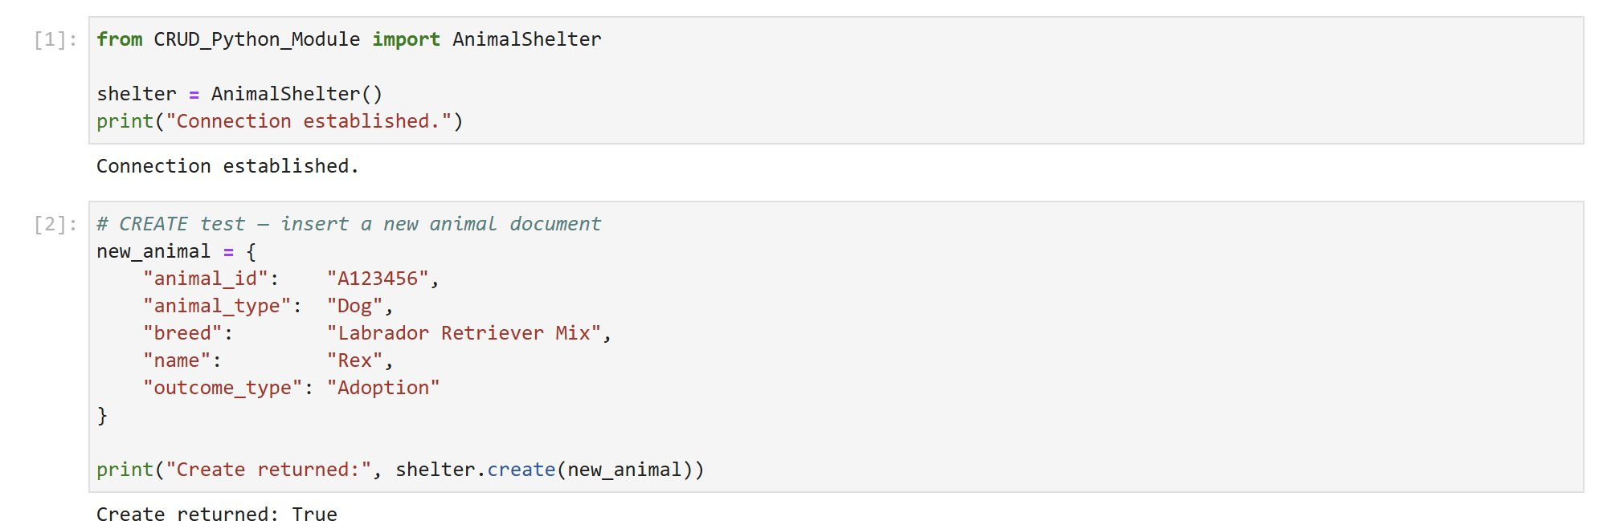
Figure 1. CREATE test in Jupyter — create() returns True on a successful insert.
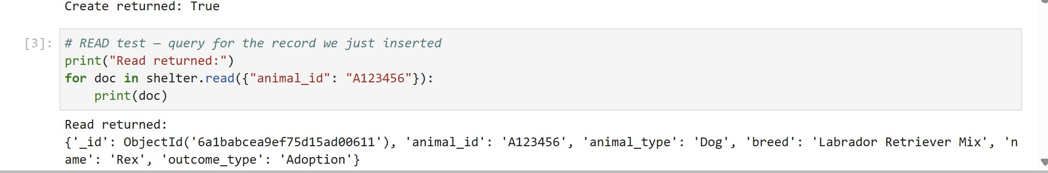
Figure 2. READ test in Jupyter — read() returns the inserted document in a list.

Roadmap/Features (Optional)
Project One adds the Update (U) and Delete (D) methods to complete full CRUD. Project Two layers a Dash/Plotly dashboard on top of this module, using the existing read() method to drive interactive filtering, a sortable data table, and a geolocation map of rescue candidates. A known consideration is widening index coverage as new dashboard query patterns emerge, to keep lookups on IXSCAN rather than COLLSCAN.

Contact
Your name: Eric Shadwick

Acknowledgments
Generative AI (Anthropic’s Claude) was used to assist with drafting and organizing this README. All technical content reflects the author’s own MongoDB database and CRUD module developed for the Module Three and Module Four milestones.
Anthropic. (2026). Claude (Opus 4.8) [Large language model]. https://claude.ai

