GV-NAP File Sharing System

CIS457: Project 2 Fall 2016
Due Date: 11/08/2016
Percentage Complete: 100%

By: Jordan Zomerlei
& Evan Stedman

Purpose:
The purpose of this assignment is to develop a Napster inspired peer-to-peer file sharing system. The way this is done is by creating a centralized server that User’s connect to and upon connecting each user will upload files they designated in an xml structure as being files they wish to share. The server will store the User information as well as the files associated with each User. After connecting, Users may then do a keyword search for file descriptions, also stored in the xml structure, to locate the corresponding Users where they can retrieve the file. After determining the location of the file, the User can use an FTP client associated with the user, to actually make the calls that retrieve the file.

Design:
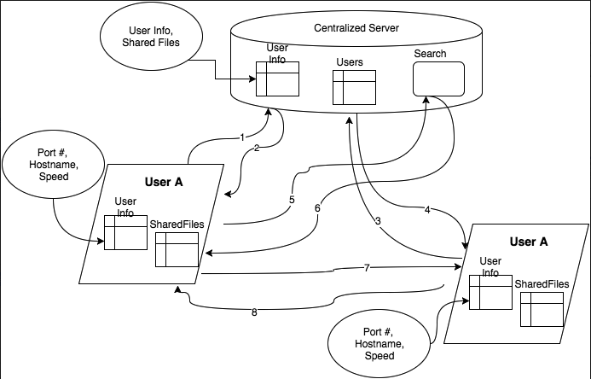

- A user connects to the centralized server
  - User sends filelist.xml with shared files
  - User also sends information (speed, IP, port)
- The Server replies with an acknowledgment
- Another user connects to the central server
  - same as 1.
- Server also replies to the new user
- User A query’s for files with the keyword
- Server sends back the information of the where to get the files
- User A connects to User B to retrieve the file
- User B sends the file to user A

CENTRALIZED SERVER OUTLINE

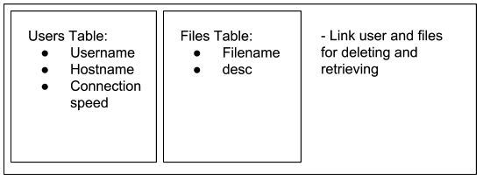

Functions/Components:
- Track user and files
- Keyword search
- Multithreaded
  - Users can upload files and query at same time

Outline/Steps:
User Registration
- Once connection initiated store username, hostname, and connection speed in a “users” table
- Acknowledge to host that received info
- Wait for shared file list and put in “files” table

Keyword search
- Search in “files” table for matching description
- If found send hostname, port #, filename, and connection speed
  - Connection speed and hostname/port will be stored in “users” table

User unregisters
- If user unregisters then delete their files and user info from tables

HOST: GUI APPLICATION OUTLINE

FTP
client
FTP
server
Query Manager
Username, Hostname, Connection speed
filelist.xml

Functions/Components:
- Query Server for files from other users
- Client: send files to other users
- Server: Retrieve files from other users

Outline/Steps:
- User enters Hostname & port number to server to connect to it
- Server sends back data pieces to display:
  - Username: defined by user
  - Hostname: ip and port
  - Connection speed
- Upload file description (ex. filelist.xml)
  - Includes file name and description of each shared file
- Keyword searches
  - Search execution
  - Gets back list of host and file names of all matching files from server

Features:
This peer-to-peer system uses a GUI interface on the User’s end to connect to the central server and make all end user calls. Once a user connects to the Central sever via a connect button, they are able to make keyword searches through another interface in the GUI. Upon retrieving a list of matching files and corresponding users from the search, the GUI contains an FTP client object for retrieving the files after initiating a connect command. When disconnecting from the server the ftp client will also disconnect from any attached users since they are no longer part of the peer-to-peer system.

Problems:
The Project as a whole was pretty difficult. While grasping the process was much easier, implementing the necessary functions to operate as expected proved difficult. One of the larger challenges was that only one of us recalled enough of the Java swing library to proficiently implement a GUI structure. On a more specific level, having the functions that were autonomous such as uploading the shared files list as well as the files themselves challenging because there was not a lot of room for making adjustments since it all needed to be done without user input. We tried to implement a better structure for storing the user information and users but were unable to get it to function properly. Given more time we would have liked to also improve the user interface to make it look and behave a little more user friendly.

Summary:
After completing this project we have gained a better understanding of the complexities of a peer-to-peer network with a structure similar to Napster. This, being the first GUI application we have developed for this class has shown us more of a resemblance of what an end product may look like as well as how it would feel to an actual user. The biggest take away from this however, is the idea of being able to put all these different structures and objects into an application and how difficult it can be to manage all of them. The system we built would be useful to small network or team of users that wanted to maintain a network of shared files so they could either ensure that all members are up to date with files or if they wanted to spread out their files to free up their personal computers from hosting all the files
Example:
