BB84 Quantum Key Simulation
Simulation method, experiment results, and model limits

Summary
This project implements a Java teaching simulator for the BB84 quantum key distribution protocol. It models Alice, Bob, and an optional intercept-and-resend Eve, then sifts matching bases and estimates errors using a public test sample. The batch experiment completed 3,600 runs across all 36 required parameter combinations. With full interception and no added noise, mean test QBER was 26.22% at N=200, 25.03% at N=1,000, and 25.16% at N=5,000, consistent with the ideal model’s 25% expectation within sampling variation.

Objective and protocol model
The simulator demonstrates how basis choices affect measurement and how intercept-and-resend eavesdropping can introduce detectable errors. Alice independently chooses a random bit and a Z or X basis. Eve intercepts each state with probability f; if she intercepts, she measures using a random basis and prepares a replacement state. Bob independently chooses a basis and measures. When bases differ from the prepared state basis, the measurement result is random. An independent noise probability may then flip Bob’s measured bit.
Alice and Bob publicly compare their bases and retain positions where the bases match. The simulator randomly selects ceil(20% of the sifted positions) for testing. It calculates QBER from those compared test bits and removes them from candidate material. The educational rule rejects a run when QBER is greater than 8%; a run with no test data is marked insufficient_data.

Experiment settings
Parameter | Values used
Transmission length N | 200, 1,000, 5,000
Eve interception probability f | 0, 0.25, 0.5, 1
Independent bit-flip noise | 0, 0.01, 0.03
Runs per combination | 100, each with a distinct recorded seed
Test sample / rejection rule | 20% rounded up / reject if QBER > 8%

The full experiment contains 36 configurations and 3,600 individual runs. The per-run data is stored in bb84_experiment_runs.csv.

Results and interpretation
The measured sifted fraction is close to the expected 50% across the experiment (about 49.8–50.3% in the highlighted N=1,000 cases). In the clean channel, all 100 runs at each tested size were accepted with zero measured QBER. When Eve intercepts every state and no noise is added, mean QBER approaches 25% as N increases, while the variation between runs decreases.
N=1,000 scenario | Mean QBER ± SD | Rejected runs
No Eve, no noise | 0.00% ± 0.00% | 0 / 100
Eve f=0.5, no noise | 12.43% ± 3.27% | 88 / 100
Eve f=1, no noise | 25.03% ± 4.37% | 100 / 100
No Eve, noise=0.03 | 3.20% ± 2.04% | 3 / 100

At N=200 with f=1 and no noise, mean QBER was 26.22% with a 9.99 percentage-point standard deviation; 98 of 100 runs were rejected. At N=5,000, mean QBER was 25.16% with a 1.72-point standard deviation and all 100 runs were rejected. This illustrates why one small sample should not be treated as an exact estimate. Noise alone can also cause rejection: with N=1,000 and noise=0.03, 3% of the no-Eve runs exceeded the fixed threshold.
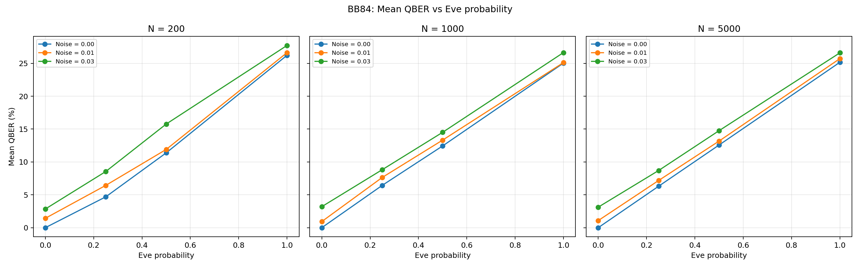
Figure 1. Mean test QBER versus Eve interception probability; panels show N and lines show noise settings.
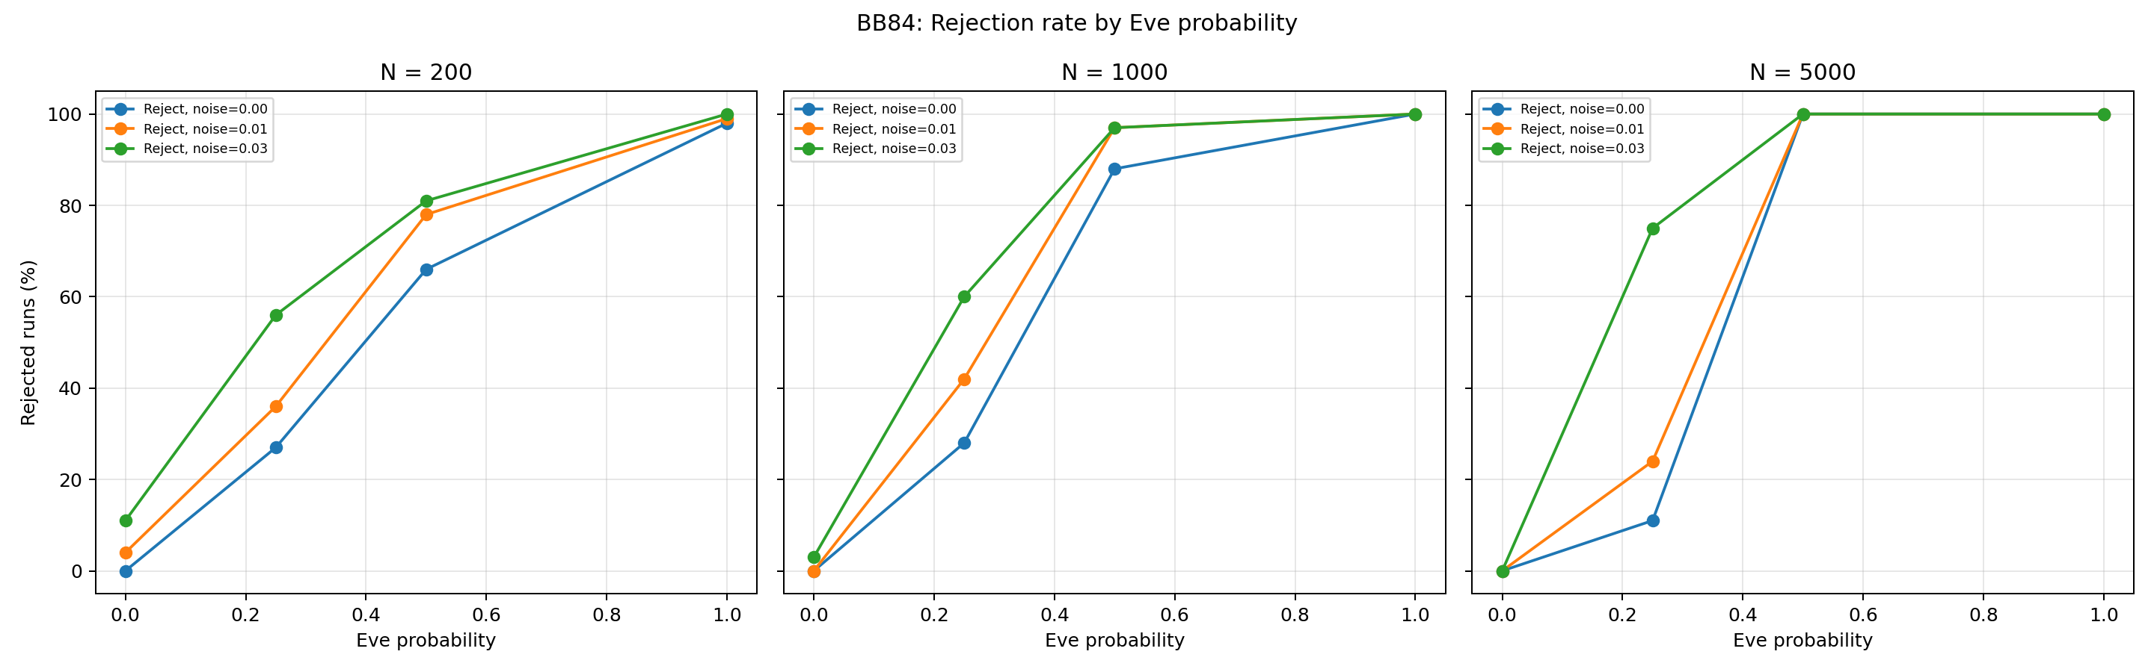
Figure 2. Rejection rate by Eve probability and noise setting. Rejection includes all runs in each configuration.

Measurement method and limits
Each simulation call was timed with Java System.nanoTime(), a monotonic timer. The existing batch runner records one elapsed duration per run and uses 100 runs per configuration. Across all Eve and noise settings, the observed mean call time was approximately 0.027 ms at N=200, 0.262 ms at N=1,000, and 0.288 ms at N=5,000. Figure 3 shows these values. These are exploratory timings: the current runner does not perform separate warm-up calls, and measurements may be affected by JIT compilation and runtime conditions. They should not be read as a controlled benchmark.
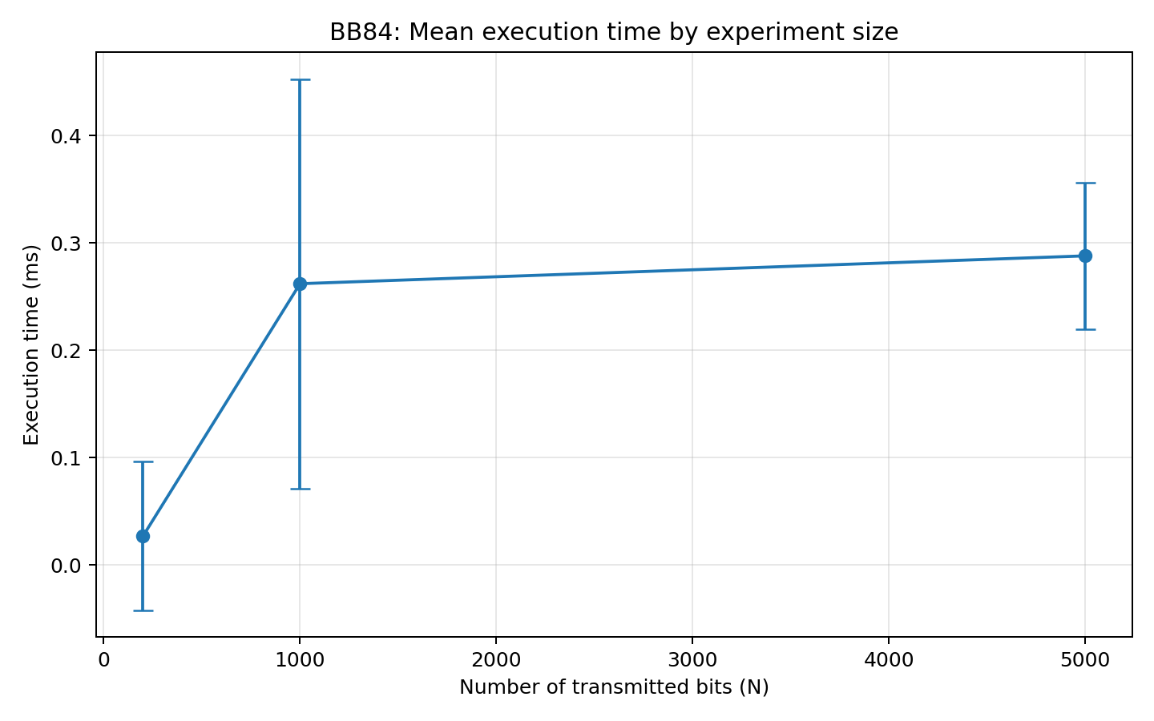
Figure 3. Mean recorded simulation-call time by N; all Eve and noise configurations are pooled.

Environment
Component | Measured environment
Operating system / hardware | macOS 26.6.2; MacBook Air, Apple M5, 10 CPU cores, 16 GB RAM
Java | OpenJDK 26.0.2.1
Plotting environment | Python 3.9.6; pandas 2.3.3; matplotlib 3.9.4

Limitations and conclusion
This is a classical simulation of BB84 measurement rules, not a physical photon transmission or a proof of security. The independent bit-flip noise model is simplified. The test sample is finite, so measured QBER varies between runs. A candidate bit sequence is not a secure final key: this project does not implement error correction, privacy amplification, or authentication of the classical channel. The seeded java.util.Random generator is used for reproducible educational runs and is not suitable for cryptographic key generation.
The experiment demonstrates the central teaching result: intercept-and-resend increases the observed error rate, and larger transmissions make the mean estimate more stable. The simulator, CSV dataset, three plots, and 18 passing automated checks provide a reproducible software baseline. A graphical step-by-step view and a warmed timing protocol would improve the demonstration and experimental methodology.

