**Create Database**



**Create Tables**

Create Table S

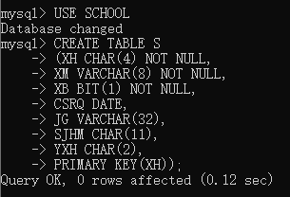

CREATE DATABASE S (

XH CHAR(4) NOT NULL,

XM VARCHAR(8) NOT NULL,

XB BIT(1) NOT NULL,

CSRQ DATE,

JG VARCHAR(32),

SJHM CHAR(11),

YXH CHAR(2),

PRIMARY KEY (XH));

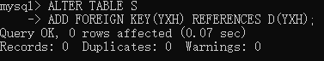

在开始建立TABLE时不能直接建立外键YXH，因为对应的主键不存在。首先建立TABLE D之后再修改TABLE建立外键YXH。

ALTER TABLE S

ADD FOREIGN KEY(YXH) REFERENCES D(YXH)

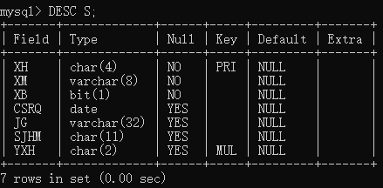

Create Table D

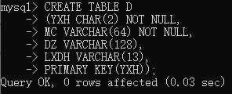

CREATE TABLE D (

YXH CHAR(2) NOT NULL,

MC VARCHAR(64) NOT NULL,

DZ VARCHAR(128),

LXDH VARCHAR(11),

PRIMARY KEY (YXH));

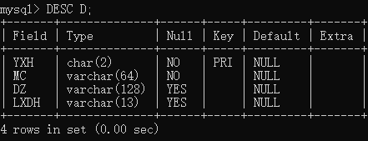

Create Table T

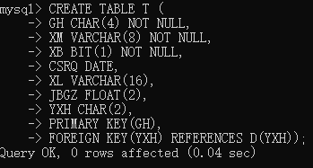

CREATE TABLE T (

GH CHAR(4) NOT NULL,

XM VARCHAR(8) NOT NULL,

XB BIT(1) NOT NULL,

CSRQ DATE,

XL VARCHAR(16),

JBGZ FLOAT(2),

YXH CHAR(2),

PRIMARY KEY(GH),

FOREIGN KEY(YXH) REFERENCES D(YXH));

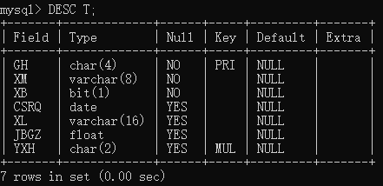

Create Table C

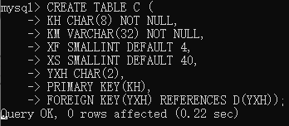

CREATE TABLE C (

KH CHAR(8) NOT NULL,

KM VARCHAR(32) NOT NULL,

XF SMALLINT DEFAULT 4,

XS SMALLINT DEFAULT 40,

YXH CHAR(2),

PRIMARY KEY(KH),

FOREIGN KEY(YXH) REFERENCES D(YXH));

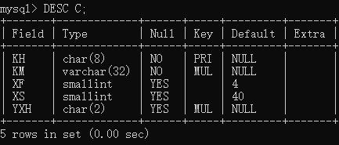

Create Table O

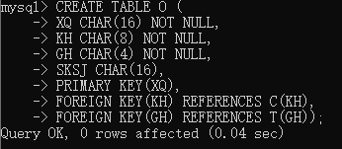

上图中的SQL语句不正确，没有考虑到多个属性作为主键的情况。修正后如下：

CREATE TABLE O (

XQ CHAR(16) NOT NULL,

KH CHAR(8) NOT NULL,

GH CHAR(4) NOT NULL,

SKSJ CHAR(16),

PRIMARY KEY(XQ,KH,GH),

FOREIGN KEY(KH) REFERENCES C(KH),

FOREIGN KEY(GH) REFERENCES T(GH));

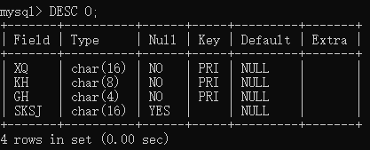

Create Table E

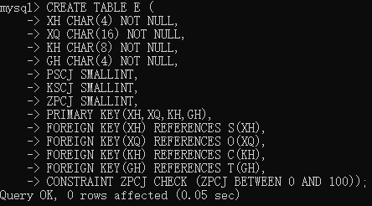

CREATE TABLE E (

XH CHAR(4) NOT NULL,

XQ CHAR(16) NOT NULL,

KH CHAR(8) NOT NULL,

GH CHAR(4) NOT NULL,

PSCJ SMALLINT,

KSCJ SMALLINT,

ZPCJ SMALLINT,

PRIMARY KEY(XH,XQ,KH,GH),

FOREIGN KEY(XH) REFERENCES S(XH),

FOREIGN KEY(XQ) REFERENCES O(XQ),

FOREIGN KEY(KH) REFERENCES C(KH),

FOREIGN KEY(GH) REFERENCES T(GH),

CONSTRAINT ZPCJ CHECK (ZPCJ BETWEEN 0 AND 100));

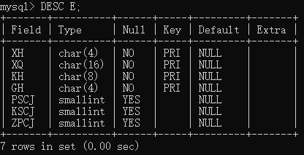

**Create Index**

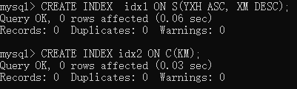

CREATE INDEX idx1 ON S(YXH ASC,XM DESC);

CREATE INDEX idx2 ON C(KM);

**Show Index**

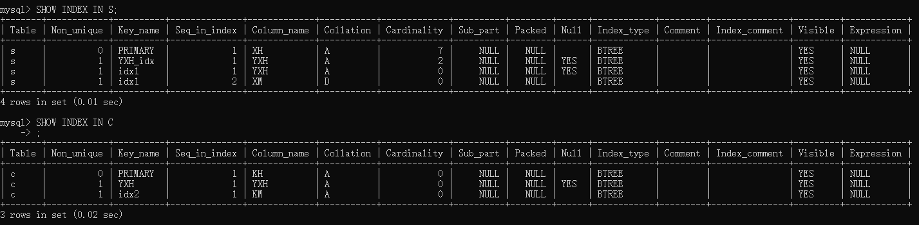

**Show Tables**

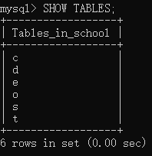

**Insert Data**

Use Python Script

import mysql.connector

def saveDataBase(table_name, datalist): # 保存数据到数据库

print('saving to table ' + table_name)

db = mysql.connector.connect(host="localhost", user="root", passwd="123456", database="SCHOOL") # 连接到数据库

cursor = db.cursor() # 获取游标

for data in datalist:

if data != ['']:

try:

sql = 'INSERT INTO ' + table_name + ' VALUES (' + str(data) + ');'

cursor.execute(sql) # 插入数据

db.commit()

except:

pass

db.close() # 关闭数据库

print('saving complete!')

s = ["'1101','李明',1,'1993-03-06','上海','13613005486','02'",

"'1102','刘晓明',1,'1992-12-08','安徽','18913457890','01'",

"'1103','张颖',0,'1993-01-05','江苏','18826490423','01'",

"'1104','刘晶晶',0,'1994-11-06','上海','13331934111','01'",

"'1105','刘成刚',1,'1991-06-07','上海','18015872567','01'",

"'1106','李二丽',0,'1993-05-04','江苏','18107620945','01'",

"'1107','张晓峰',1,'1992-08-16','浙江','13912341078','01'"]

d = ["'01','计算机学院','上大东校区三号楼','65347567'",

"'02','通讯学院','上大东校区二号楼','65341234'",

"'03','材料学院','上大东校区四号楼','65347890'"]

t = ["'0101','陈迪茂',1,'1973-03-06','副教授',3567.00,'01'",

"'0102','马小红',0,'1972-12-08','讲师',2845.00,'01'",

"'0201','张心颖',0,'1960-01-05','教授',4200.00,'02'",

"'0103','吴宝钢',1,'1980-11-06','讲师',2554.00,'01'"]

c = ["'08305001','离散数学',4,40,'01'",

"'08305002','数据库原理',4,50,'01'",

"'08305003','数据结构',4,50,'01'",

"'08305004','系统结构',6,60,'01'",

"'08301001','分子物理学',4,40,'03'",

"'08302001','通信学',3,30,'02'"]

o = ["'2012-2013秋季','08305001','0103','星期三5-8'",

"'2012-2013冬季','08305002','0101','星期三1-4'",

"'2012-2013冬季','08305002','0102','星期三1-4'",

"'2012-2013冬季','08305002','0103','星期三1-4'",

"'2012-2013冬季','08305003','0102','星期五5-8'",

"'2013-2014秋季','08305004','0101','星期二1-4'",

"'2013-2014秋季','08305001','0102','星期一5-8'",

"'2013-2014冬季','08302001','0201','星期一5-8'"]

e = ["'1101','2012-2013秋季','08305001','0103',60,60,60",

"'1102','2012-2013秋季','08305001','0103',87,87,87",

"'1102','2012-2013冬季','08305002','0101',82,82,82",

"'1102','2013-2014秋季','08305004','0101',null,null,null",

"'1103','2012-2013秋季','08305001','0103',56,56,56",

"'1103','2012-2013冬季','08305002','0102',75,75,75",

"'1103','2012-2013冬季','08305003','0102',84,84,84",

"'1103','2013-2014秋季','08305001','0102',null,null,null",

"'1103','2013-2014秋季','08305004','0101',null,null,null",

"'1104','2012-2013秋季','08305001','0103',74,74,74",

"'1104','2013-2014冬季','08302001','0201',null,null,null",

"'1106','2012-2013秋季','08305001','0103',85,85,85",

"'1106','2012-2013冬季','08305002','0103',66,66,66",

"'1107','2012-2013秋季','08305001','0103',90,90,90",

"'1107','2012-2013冬季','08305003','0102',79,79,79",

"'1107','2013-2014秋季','08305004','0101',null,null,null"]

saveDataBase('d', d)

saveDataBase('s', s)

saveDataBase('t', t)

saveDataBase('c', c)

saveDataBase('o', o)

saveDataBase('e', e)

**Show Data**

