1. **查询2011年进校年龄大于20岁的男学生的学号与姓名。**

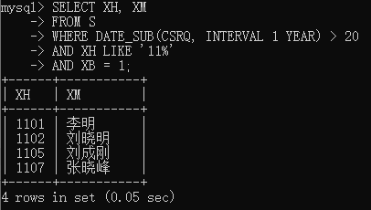

SELECT XH, XM

FROM S

WHERE DATE_SUB(CSRQ, INTERVAL 1 YEAR) > 20

AND XH LIKE '11%'

AND XB = 1;

1. **检索刘晓明不学的课程的课程号。**

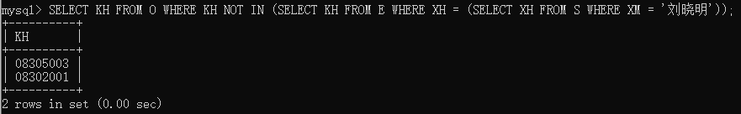

SELECT KH

FROM O

WHERE KH NOT IN (

SELECT KH

FROM E

WHERE XH = (

SELECT XH

FROM S

WHERE XM = '刘晓明'));

SELECT KH

FROM O

WHERE KH NOT IN (

SELECT KH

FROM E,S

WHERE E.XH = S.XH

AND S.XM = '刘晓明');

1. **检索马小红老师所授课程的学年，学期，课程号，上课时间。**

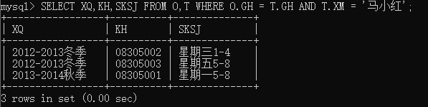

SELECT XQ, KH, SKSJ

FROM O, T

WHERE O.GH = T.GH

AND T.XM = '马小红';

1. **查询计算机学院男生总评成绩及格、教授开设的课程的课程号、课名、开课教师姓名，按开课教师升序，课程号降序排序。**

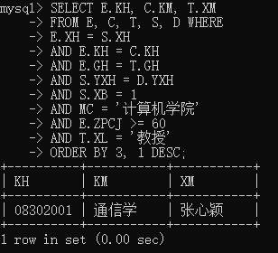

对原始数据表进行了一定修改。更改了学号为1105的学生的成绩。

SELECT E.KH, C.KM, T.XM

FROM E, C, T, S, D WHERE

E.XH = S.XH

AND E.KH = C.KH

AND E.GH = T.GH

AND S.YXH = D.YXH

AND S.XB = 1

AND MC = '计算机学院'

AND E.ZPCJ >= 60

AND T.XL = '教授'

ORDER BY 3, 1 DESC;

1. **检索学号比张颖同学大，年龄比张颖同学小的同学学号、姓名。**

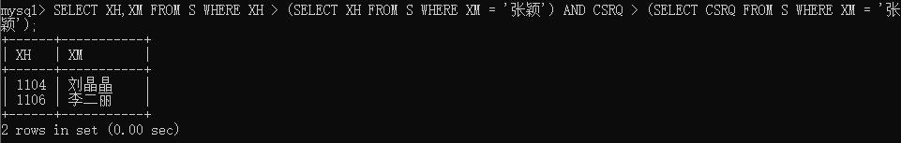

SELECT XH, XM

FROM S

WHERE XH > (

SELECT XH

FROM S

WHERE XM = '张颖')

AND CSRQ > (

SELECT CSRQ

FROM S

WHERE XM = '张颖');

1. **检索同时选修了“08305001”和“08305002”的学生学号和姓名。**

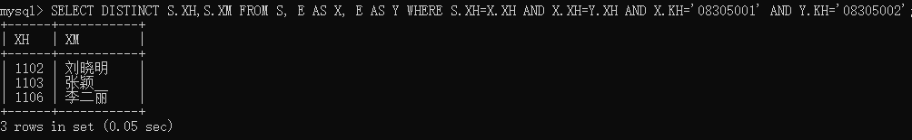

SELECT DISTINCT S.XH, S.XM

FROM S, E AS X, E AS Y

WHERE S.XH = X.XH

AND S.XH = Y.XH

AND X.KH = '08305001'

AND Y.KH = '08305002';

1. **验证在1000万个以上记录时在索引和不索引时的查询时间区别。**

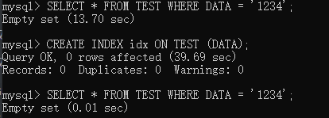

使用Python脚本插入数据。

def saveDataBase1(table_name, datalist): # 保存数据到数据库

for data in datalist:

if data != ['']:

sql = 'INSERT INTO ' + table_name + '(ID,DATA) VALUES ' + str(data) + ';'

print(sql)

cursor.execute(sql) # 插入数据

db.commit()

for i in range(10000):

q = []

print(i/10000)

sql = ""

for j in range(1000):

if j > 0:

sql = sql + ','

sql = sql + "('" + str(1000*i + j) + "','" + str(np.random.randint(1, 10000000)) + "')"

q.append(sql)

saveDataBase('TEST', q)

1. **查询每个学生选课情况（包括没有选修课程的学生）。**

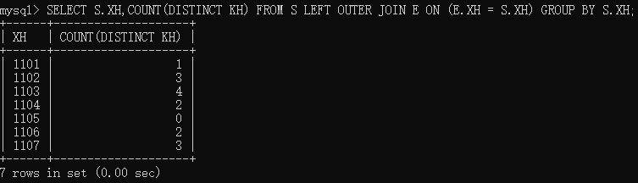

SELECT S.XH,COUNT(DISTINCT KH) FROM S LEFT OUTER JOIN E ON (E.XH = S.XH) GROUP BY S.XH;

1. **检索所有课程都选修的的学生的学号与姓名。**

查找学生所有课程都选修=查找学生不存在课程不选修。

SELECT XH, XM FROM S WHERE NOT EXISTS (SELECT KH FROM O WHERE NOT EXISTS(SELECT * FROM E WHERE E.XH = S.XH AND E.KH = O.KH));

SELECT S.XH, XM FROM S LEFT OUTER JOIN E ON (E.XH = S.XH) GROUP BY S.XH HAVING COUNT(DISTINCT E.KH) = (SELECT COUNT(DISTINCT KH) FROM O);

对数据表进行一定修改，插入新的学生选修所有课程。

