1. 检索选修课程包含1106同学所学全部课程的学生学号和姓名。

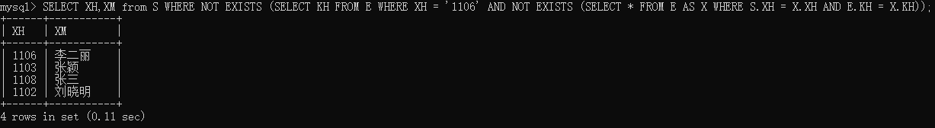

学生所选的课程没有一门是1106不选的

SELECT XH,XM

FROM S

WHERE NOT EXISTS (

SELECT KH

FROM E

WHERE XH = '1106'

AND NOT EXISTS (

SELECT \*

FROM E AS X

WHERE S.XH = X.XH

AND E.KH = X.KH));

1. 查询每门课程中分数最高的学生学号和学生姓名。

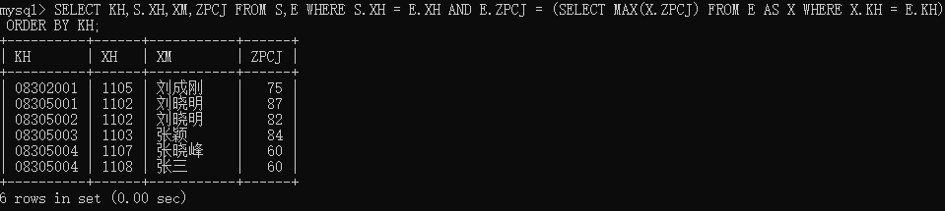

SELECT KH,S.XH,XM,ZPCJ

FROM S,E

WHERE S.XH = E.XH

AND E.ZPCJ = (

SELECT MAX(X.ZPCJ)

FROM E AS X

WHERE X.KH = E.KH)

[ORDER BY KH];

1. 查询年龄小于本学院平均年龄，所有课程总评成绩都高于所选课程平均总评成绩的学生学号、姓名和平均总评成绩，按年龄排序。

首先获取每门课程的平均成绩

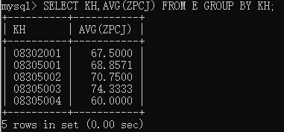

SELECT KH,AVG(ZPCJ) FROM E GROUP BY KH;

将课程的平均成绩拼接到E表中

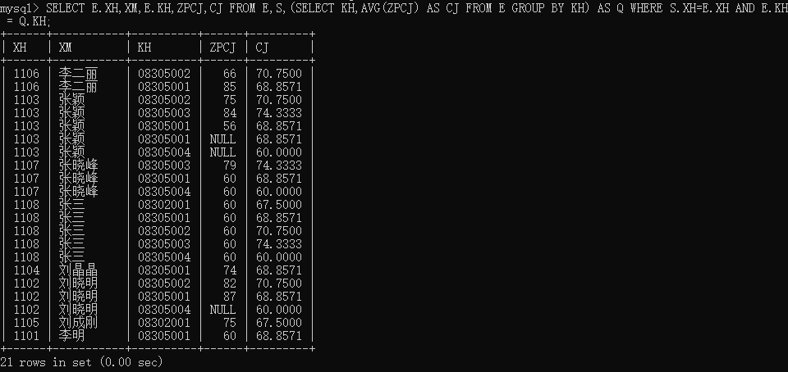

SELECT E.XH,XM,E.KH,ZPCJ,CJ FROM E,S,(SELECT KH,AVG(ZPCJ) AS CJ FROM E GROUP BY KH) AS Q WHERE S.XH=E.XH AND E.KH = Q.KH;

筛选成绩比平均成绩高的情况

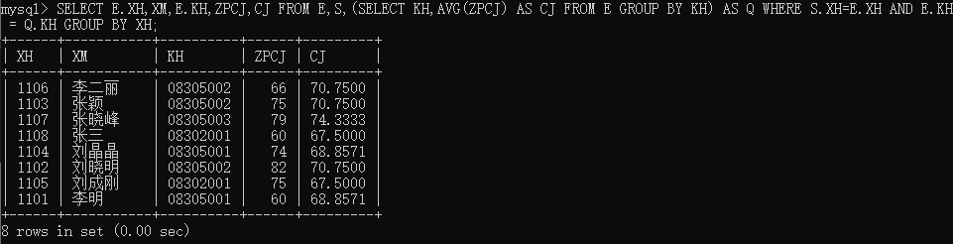

SELECT E.XH,XM,E.KH,ZPCJ,CJ FROM E,S,(SELECT KH,AVG(ZPCJ) AS CJ FROM E GROUP BY KH) AS Q WHERE S.XH=E.XH AND E.KH = Q.KH GROUP BY XH;

统计每个学生选课比平均分高的数量

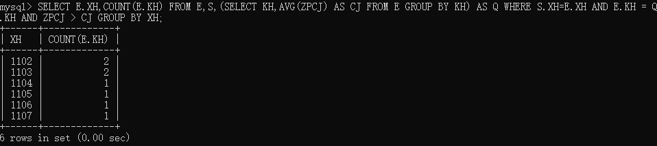

SELECT E.XH,COUNT(E.KH) FROM E,S,(SELECT KH,AVG(ZPCJ) AS CJ FROM E GROUP BY KH) AS Q WHERE S.XH=E.XH AND E.KH = Q.KH AND ZPCJ > CJ GROUP BY XH;

将这个数量与选课总数作比较

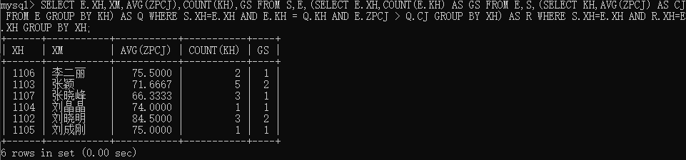

SELECT E.XH,XM,AVG(ZPCJ),COUNT(KH),GS FROM S,E,(SELECT E.XH,COUNT(E.KH) AS GS FROM E,S,(SELECT KH,AVG(ZPCJ) AS CJ FROM E GROUP BY KH) AS Q WHERE S.XH=E.XH AND E.KH = Q.KH AND E.ZPCJ > Q.CJ GROUP BY XH) AS R WHERE S.XH=E.XH AND R.XH=E.XH GROUP BY XH;

得到结果，按格式输出

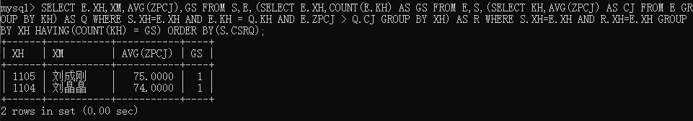

SELECT E.XH,XM,AVG(ZPCJ),GS FROM S,E,(SELECT E.XH,COUNT(E.KH) AS GS FROM E,S,(SELECT KH,AVG(ZPCJ) AS CJ FROM E GROUP BY KH) AS Q WHERE S.XH=E.XH AND E.KH = Q.KH AND E.ZPCJ > Q.CJ GROUP BY XH) AS R WHERE S.XH=E.XH AND R.XH=E.XH GROUP BY XH HAVING(COUNT(KH) = GS) ORDER BY(S.CSRQ);

SELECT E.XH,XM,AVG(ZPCJ),GS

FROM S,E,

(SELECT E.XH,COUNT(E.KH) AS GS

FROM E,S,

(SELECT KH,AVG(ZPCJ) AS CJ

FROM E

GROUP BY KH)

AS Q

WHERE S.XH=E.XH

AND E.KH = Q.KH

AND E.ZPCJ > Q.CJ

GROUP BY XH)

AS R

WHERE S.XH=E.XH

AND R.XH=E.XH

GROUP BY XH

HAVING(COUNT(KH) = GS)

ORDER BY(S.CSRQ);

1. 建立计算机学院总评不及格成绩学生的视图，包括学生学号、姓名、性别、手机、所选课程和成绩。

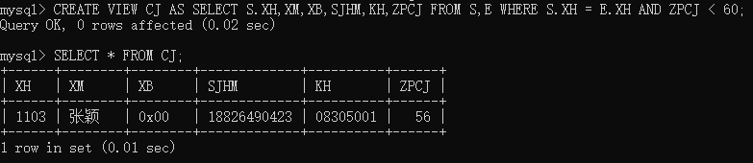

CREATE VIEW CJ

AS SELECT S.XH,XM,XB,SJHM,KH,ZPCJ

FROM S,E

WHERE S.XH = E.XH

AND ZPCJ < 60;

1. 在E表中插入记录，把每个学生没学过的课程都插入到E表中，使得每个学生都选修每门课。

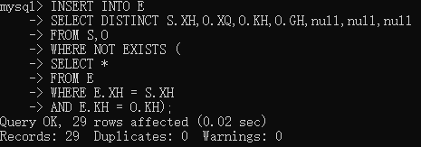

INSERT INTO E

SELECT DISTINCT S.XH,O.XQ,O.KH,O.GH,null,null,null

FROM S,O

WHERE NOT EXISTS (

SELECT \*

FROM E

WHERE E.XH = S.XH

AND E.KH = O.KH);

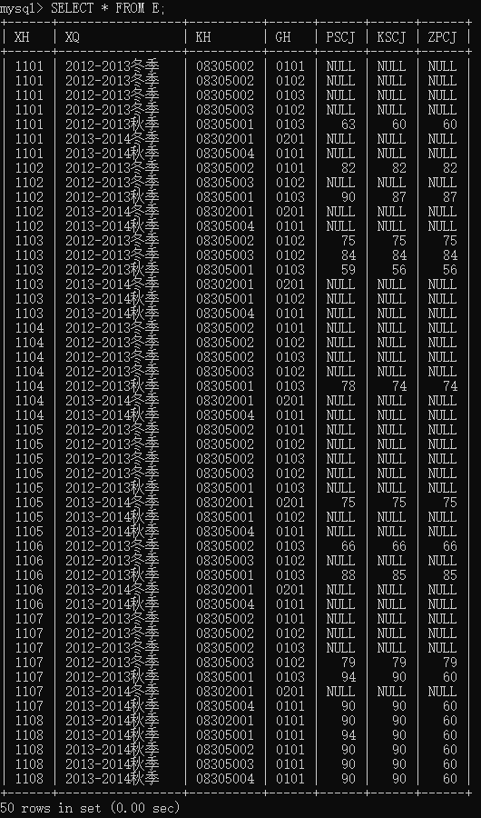

1. 求年龄大于所有女同学年龄的男学生姓名和年龄。

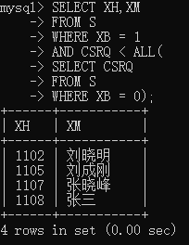

SELECT XH,XM

FROM S

WHERE XB = 1

AND CSRQ < ALL(

SELECT CSRQ

FROM S

WHERE XB = 0);

1. 在E表中修改08305001课程的平时成绩，若成绩小于等于75分时提高5%，若成绩大于75分时提高4%。

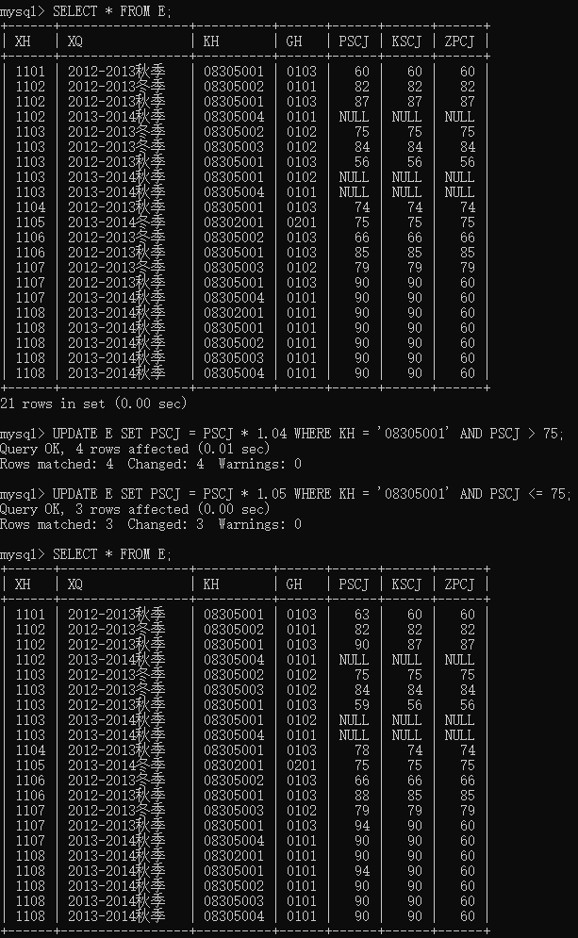

UPDATE E SET PSCJ = PSCJ \* 1.04 WHERE KH = '08305001' AND PSCJ > 75;

UPDATE E SET PSCJ = PSCJ \* 1.05 WHERE KH = '08305001' AND PSCJ <= 75;

1. 删除没有开课的学院。

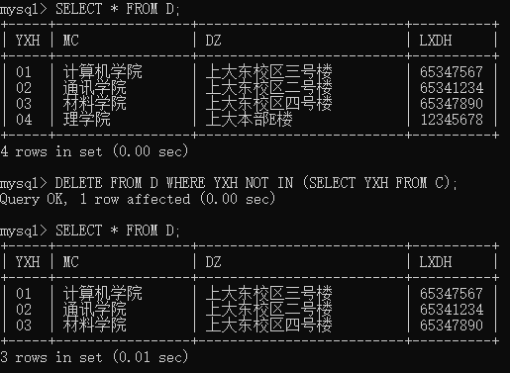

DELETE FROM D

WHERE YXH NOT IN (

SELECT YXH FROM C,O WHERE C.KH = O.KH);

为绕过外键限制，对表作出了修改，新增理学院不开课，为材料学院开课防止删除出错。

1. 查询优、良、中、及格、不及格学生人数。

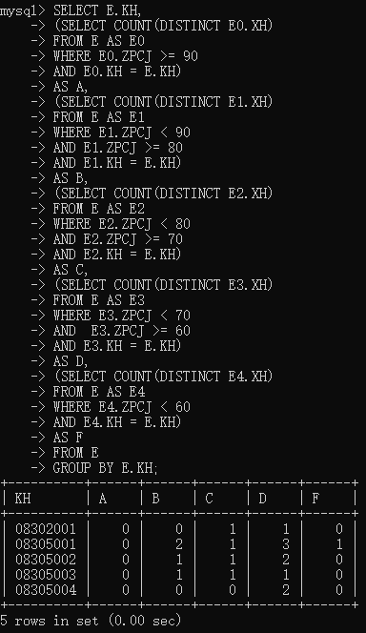

SELECT E.KH,

(SELECT COUNT(DISTINCT E0.XH)

FROM E AS E0

WHERE E0.ZPCJ >= 90

AND E0.KH = E.KH)

AS A,

(SELECT COUNT(DISTINCT E1.XH)

FROM E AS E1

WHERE E1.ZPCJ < 90

AND E1.ZPCJ >= 80

AND E1.KH = E.KH)

AS B,

(SELECT COUNT(DISTINCT E2.XH)

FROM E AS E2

WHERE E2.ZPCJ < 80

AND E2.ZPCJ >= 70

AND E2.KH = E.KH)

AS C,

(SELECT COUNT(DISTINCT E3.XH)

FROM E AS E3

WHERE E3.ZPCJ < 70

AND E3.ZPCJ >= 60

AND E3.KH = E.KH)

AS D,

(SELECT COUNT(DISTINCT E4.XH)

FROM E AS E4

WHERE E4.ZPCJ < 60

AND E4.KH = E.KH)

AS F

FROM E

GROUP BY E.KH;