WORLD METEOROLOGICAL ORGANIZATION

----------------------------------------

Meeting report:
Expert Team on Climate Data Development and Stewardship (ET-DDS)
Standing Committee on Climate Services (SC-CLI)
SERCOM
4 March 2026, 13:00 – 15:00 Geneva time

References

Github: https://github.com/ET-DRC
Wiki general: https://github.com/ET-DRC/Home/wiki
Wiki DAYCLI: https://github.com/ET-DRC/DAYCLI-message/wiki
Shared drive, see at:
https://community.wmo.int/en/governance/commission-membership/sercom-management-group/standing-committee-climate-services/expert-team-climate-data-development-and-stewardship

Agenda

1 Consultation on homogenization 2
2 INFCOM ET-IM latest news 2
3 Assessment of European data portal 2
4 DAYCLI 2
5 Which scenario for ET-DDS? 3
6 Any other Business 4
7 Date of next meeting 4
8 Coming events 4

Participants:

Name | P* | Name | P* | Name | P*
Mr Alessandro Spinuso | P | Mr Jose Guijarro | P | Ms Sandhya Dindyal
Mr Ali Eddenjal |  | Mr Markus ZIESE | P | Mr Tursyn Tillakarim,
Mr Axel Andersson | P | Mr Peer Hechler | P | Mr Urip Haryoko
Ms Cathy Smith | P | Mr Rachid Sebbari |  | Mr William Wright | P
Mr Denis Stuber | P | Mr Reinaldo Silveira | P | Mr Byungjun Kim | P
Ms Ge Peng | P | Mr Robert Dunn | P

Invited: Dave Berry (WMO Secretariat)

*P: Present
Notes: actions and agreements highlighted in bold.

Consultation on homogenization
Jose presented the analysis of the survey on homogenization. This will be presented at the Homogenization Seminar to be held on May 5-8 in Budapest. See the presentation at: https://climatol.eu/survey.pdf

INFCOM ET-IM latest news
The Chair of ET-IM, Mrs Peng, summarized the tasks status of the two Sub-group, SG1 and SG2.

WMO-No. 1238, High-Quality Global Data Management Framework for Climate, is ready to be reviewed chapter by chapter.

Dave said that WMO-No-1238 will be presented during INFCOM-4. Denis added that It will be also wise to present this document during SERCOM-4. This will greatly participate to the communication plan, to Members, of this new important edition.

Dave Berry proposed a joint meeting of ET-IM and ET-DDS in early May to review the document, and ET-DDS members expressed positive support for this suggestion.

ET-IM SG1: Harmonization of the standard and recommended practices related to climate data and observations across the Technical Regulations.
ET-IM SG2: Identify and prioritize essential functional requirements for a climate data management system (CDMS) based on the revised CDMS specifications (WMO-No. 1131).
Presented by Robert and Reinaldo.

Assessment of European data portal
Last week (25/02) some experts of ET-DDS attended the RA VI Work Group meeting on Services and Application. During this meeting, Ladislav Markovic presented an initial study covering 43 data portals of meteorological services in Region VI. The methodology is based on a four-level maturity scale applied to four main categories based on the WMO Maturity Matrix.

During the discussion the team considered two projects to tackle for INFCOM and SERCOM:
- Expand the WIS Discovery Metadata to include SMM-CD (INFCOM);
- Revise the SMM-CD (SERCOM).

References:
- Work presentation : https://github.com/ET-DRC/Home/blob/main/Meetings/2026/Unified%20Data%20Policy%20RAVI.pdf
- Excel table of NMHSs and assessments: https://github.com/ET-DRC/Home/blob/main/Meetings/2026/WMO%20RA%20VI%20-DATA%20ACCESS%20-%20Dashboard.xlsx
- Report of the WG of RA VI : https://github.com/ET-DRC/Home/blob/main/Meetings/2026/RA%20VI%20WG%20on%20Services%20and%20Applications%20Meeting%20on%2025%20February_%20Meeting%20summary.pdf

DAYCLI
ET-DATA STANDARD
Latest modification of the DAYCLI BUFR sequence (3 07 095): clarification on vocabulary
See https://github.com/wmo-im/BUFR4/pull/277, and https://github.com/wmo-im/BUFR4/pull/277
Planned for June for INFCOM-4.

ET-DDS
Draft of the DAYCLI guidelines that better addresses the needs of NMHSs climate service personnel who will be required to extract data and metadata for the DAYCLI message. It is therefore primarily a document that deals with “business” specifications rather than information technology or BUFR coding.

- Review by all ET-DDS Members and SC-CLI
- Review by ET-DATA STANDARD and other INFCOM experts

Final draft for early May 2026 and final review for early June 2026, ready to be presented for SERCOM-4 in October 2026 and INFCOM-4 in November 2026.

INFCOM SERCOM discussion
18/03/2026 Meeting initiated by Krunoslav Premec (WMO Secretariat) to discuss about DAYCLI: WMO Unified data policy, WIGOS Manual, HQGDMFC Manual, WIS Guide, Handbook on CLIMAT reporting, etc..

Which scenario for ET-DDS?
SERCOM Management Group 3rd face-to-face meeting (December 2025)

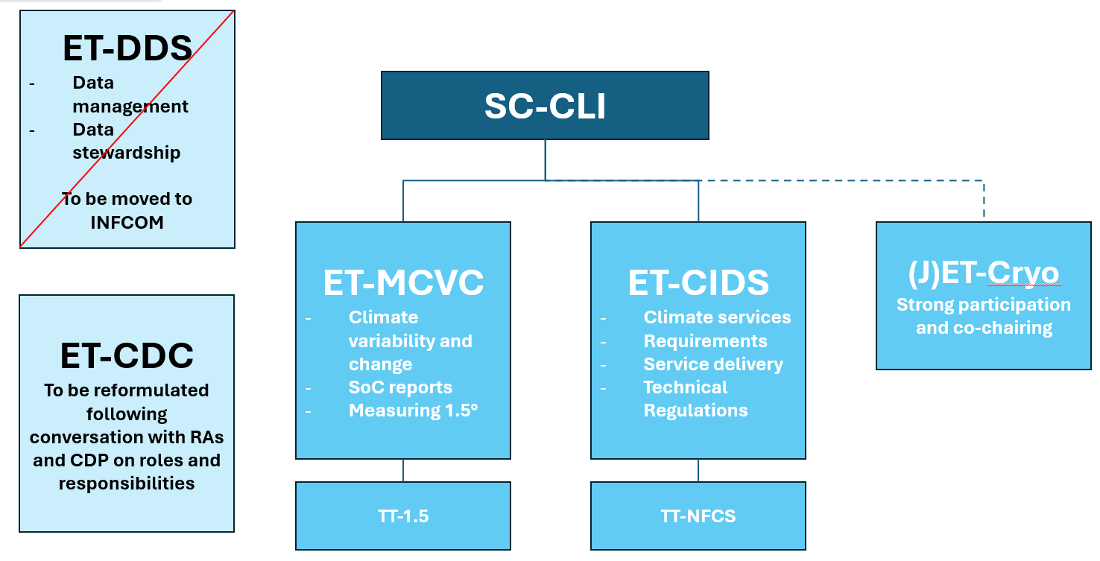

ET-CDC: Expert Team on Capacity Development for Climate Services and Communication. Co-chairs: Wassila Thiaw (USA) and Charlotte McBride (South Africa).
ET-MCCVC: Expert Team on Monitoring and Communication Climate Variability and Change
ET-CIDS: Expert Team on Climate Services Information Systems for Decision Support
------------------------------------------------------------------------------------------------------------------------
Following the decision of the 3rd SERCOM Management Group meeting (December 2025), ET-DDS was invited to propose scenarios for the transfer of its activities to INFCOM.
ET-DDS discussed the possible options and proposed the following scenario for the period 2026–2027.
Proposed approach: Transfer ET-DDS as a whole to INFCOM until the end of the current intersession (2027).
Rationale:
- ensure continuity of ongoing work;
- preserve team expertise and engagement with Members;
- allow completion of current deliverables before any restructuring in the next intersession.
Main activities to be continued:
- Data Rescue ;
- DAYCLI requirements, implementation and guidelines ;
- Data catalog and Stewardship Maturity Matrix for Climate Data (SMM-CD);
- Consultations with Members on climatological practices;
- Collaboration with ET-IM on WMO regulatory material and technical specifications for CDMSs.
Links with SC-CLI
• The two ET-DDS Co-Chairs remain members of the SC-CLI Management Group until 2027 (as suggested by SERCOM).
• Coordination maintained with:
- ET-MCCVC (datasets catalog, SMM-CD)
- ET-CIDS (regional climate data exchange, DAYCLI, Data Rescue implications)
- SC-CLI initiatives related to climate services standardization (in link with the parallel European project).
• ET-DDS members may:
- remain within ET-DDS under INFCOM, or
- join SC-CLI expert teams depending on future responsibilities.
Objective: ensure continuity of work, institutional clarity and preservation of expertise during the transition period.

Any other Business
Markus:
- Meeting with TT-GloHyDaC to bring the data centers for hydrological parameters together and try to find out how they can better be involved in data exchange via WIS2.0 and HydroSOS.
- TT-GloHyDaC about the Stewardship Maturity Matrix. Invite one or two members from TT-GloHyDaC to join our task on updating the SMM?

Date of next meeting
1st April 2026 13:00-15:00 Geneva Time

Coming events
- 9-13 March 2026: INFCOM MG
- May 2026: 12th Seminar for Homogenization and Quality Control in Climatological Databases and the 7th Interpolation Conference in Budapest
- May 2026: EGU, European Geosciences Union, Historical Weather Data Rescue and Methodologies Focusing on Data-sparse Regions (Vienna)
- September 2026: ACRE, Atmospheric Circulation Reconstructions over the Earth (Rome)
- October 2026: SERCOM-4
- November 2026: INFCOM-4

