DAYCLI Guidelines
Guidelines for the International Exchange of Daily Climate Data

Publication
Edition : 2026 ?
WMO-No.: ?
DOI: ?
CC by 4.0 licence: ?

Acknowledgement
These Guidelines are the result of a multidisciplinary collaboration involving expertise in climatology, climate data management, metadata, and international data exchange, bringing together experts from National Meteorological and Hydrological Services (NMHSs), the WMO Secretariat and several WMO expert teams. The preparation, coordination and editorial development of these Guidelines were led by lead authors Denis STUBER (Météo-France) and William WRIGHT (retired; formerly Bureau of Meteorology, Australia), whose commitment, expertise and sustained collaboration throughout the project are gratefully acknowledged.
This publication was prepared under the leadership of the Standing Committee on Climate Services (SC-CLI) of the WMO Services Commission (SERCOM). The authors sincerely acknowledge the valuable contributions of the members of the Expert Team on Data Development and Stewardship (ET-DDS), whose expertise helped shape the climatological concepts, information requirements and guidance presented throughout these Guidelines.
At the time of publication, the Expert Team on Data Development and Stewardship (ET-DDS) consisted of Reinaldo SILVEIRA (Brazil) and Denis STUBER (France) as Co-Chairs, together with Axel ANDERSSON (Germany), Sandhya DINDYAL (Mauritius), Robert DUNN (United Kingdom), Ali EDDENJAL (Libya), Jose GUIJARRO (Spain), Urip HARYOKO (Indonesia), Ge PENG (United States of America), Rachid SEBBARI (Morocco), Maria SKANSI (Argentina), Cathy SMITH (United States of America), Alessandro SPINUSO (Netherlands), Tursyn TILLAKARIM (Kazakhstan), William WRIGHT (Australia) and Markus ZIESE (Germany).
The authors also express their sincere appreciation to colleagues from the WMO Infrastructure Commission (INFCOM), particularly the Standing Committee on Information Management and Technology (SC-IMT) and the Expert Team on Data Standards (ET-Data Standards), for their essential contribution to the development, validation and maintenance of the DAYCLI BUFR sequence, based on the DAYCLI information model.
Special thanks are extended to Qingchen CHAO, Chair of SC-CLI, for her continual encouragement, guidance and support throughout the preparation of these Guidelines, and to Peer HECHLER (WMO Secretariat) for his coordination, constructive advice and continued support.
The authors also gratefully acknowledge the important technical contributions of Anna MILAN (WMO Secretariat), Mariana CREPULJA (Chair, ET-Data Standards), Jitsuko HASEGAWA (former Chair, ET-Data Standards) and Dave INGLIS BERRY (WMO Secretariat), together with the many experts of the ET-Data Standards who contributed to the review, validation and continuous improvement of the DAYCLI BUFR representation.
Particular recognition is given to Sergio FERREIRA (National Institute for Space Research – INPE, Brazil; ET-Data Standards), who led the design of the DAYCLI BUFR sequence and the development of the associated encoding and decoding software that supported its validation and operational implementation.
The authors also express their sincere gratitude to all reviewers whose comments and recommendations significantly improved the technical quality, clarity and consistency of these Guidelines, with particular thanks to Emilie MALLET (Météo-France, France), Marisol OSMAN (CIMA, Argentina), Xavier PERROT (Météo-France International, France), Elke ROBKAMP (DWD, Germany) and Blair TREWIN (Bureau of Meteorology, Australia).
Finally, the authors wish to thank all colleagues who contributed through technical discussions, practical implementation experience, and constructive comments during the development of these Guidelines. Their collective expertise has helped produce a publication that reflects both the scientific principles of climatology and the practical realities of operational international climate data exchange.

Preface
Noting the increasingly important focus on climate extremes and their socio-economic impacts resulting from climate variability and change, the WMO community recognized the need to exchange data on at least the most significant climate variables on daily time-scales. This was the rationale for the development of the DAYCLI message. This publication describes the concepts, information requirements and methodology for exchanging this information in a form that enables its consistent interpretation, while also ensuring consistency with long-standing National Meteorological and Hydrological Services observational and climate practices.

Table of contents

Publication 2
Acknowledgement 3
Preface 4
Guiding Principles 9
Executive Summary 10
Glossary 11
Part I - Foundations 14
1 Purpose of the DAYCLI Guidelines 14
2 Intended audience and scope 15
3 Conceptual Framework of DAYCLI 16
3.1 Daily Climate Data are Fundamentally Different from Instantaneous Observations 16
3.2 National Climatological Practices Legitimately Differ 16
3.3 Why Preserving the National Temporal Reference Matters? 16
Part II - Information Required to Preserve the Integrity of National Daily Climate Datasets 18
4 Preserving Dataset Integrity 18
4.1 Information Families 18
Part III - Organization and Information Model of the DAYCLI Message 19
5 Structure of the DAYCLI Message 19
5.1 Introduction 19
5.2 General Organization of the DAYCLI Message 19
5.3 Design Principles 20
5.4 Information Families within a DAYCLI Record 21
5.5 Daily Climate Variables 21
5.6 Station Information 22
5.6.1 WIGOS Station Identifier (WSI) 22
5.6.2 WMO Block and Station Number 23
5.6.3 Station Location 23
5.6.4 Station Elevation 23
5.7 Observation and Processing Information 25
5.7.1 National Temporal Reference (NTR) 25
5.7.2 Local Meteorological Time Zone 25
5.7.3 Attribution Day 25
5.7.4 Time Period (Climatological Day) 26
5.7.5 Observation Time 26
5.7.6 Relationship Between the Attribution Day and the Climatological Day 26
5.7.7 Siting Classification 27
5.7.8 Measurement Quality Classification 28
5.7.9 Mean Temperature Calculation Method 28
5.7.9.1 How to handle missing data 30
5.7.9.1.1 Daily mean from 1 440 one-minute observations 30
5.7.9.1.2 Daily mean from 24 hourly observations 30
5.7.9.1.3 Daily mean from eight three-hourly observations 31
5.7.9.1.4 Daily mean from four six-hourly observations 31
5.7.9.1.5 Summary of illustrative criteria 31
5.8 Quality Information 32
5.8.1 Quality Control (QC) and Validation 32
5.8.2 Assigning QC flags 32
5.8.3 Representation of Quality Information and QC Flags 33
5.8.3.1 Data checked and declared "Good" 33
5.8.3.2 Data checked and declared "Suspect" 34
5.8.3.3 Data checked and declared "Aggregated" 34
5.8.3.4 Data checked and declared "Out of instrument range / Instrument failure" 34
5.8.3.5 Data checked and declared "Aggregated and out of instrument range" 34
5.8.3.6 Parameter is not measured at the station 35
5.8.3.7 Daily value not provided 35
5.8.3.8 Data unchecked 35
5.8.3.9 Quality control information unavailable 35
5.8.4 Illustrative Examples of QC Flag Assignment 35
5.8.4.1 Use case: Parameter not measured at the station 36
5.8.4.2 Use case: Parameter measured at the station, but the daily value is not provided 36
5.8.4.3 Use case: QC information not provided 36
5.8.4.4 Use case: Out of instrument range / Instrument failure 37
5.8.4.5 Use case: Aggregation 37
5.8.4.6 Use case: Aggregation with instrument unavailable 38
5.8.4.7 Use case: Solid precipitation aggregation with subsequent snowmelt 39
5.8.4.8 Use case: Incomplete observations for the computation of a daily climate value 40
Part IV - BUFR Representation of DAYCLI Information 41
6 From the DAYCLI Information Model to the BUFR Representation 41
6.1 BUFR Descriptor Types 43
6.2 BUFR Sequence Descriptors 44
6.3 BUFR Encoding Mechanisms 44
6.3.1 Replication descriptors 44
6.3.2 Associated Fields and Operator Descriptors 45
7 BUFR Representation of DAYCLI Information 47
7.1 Station Information 47
7.1.1 Summary of BUFR Descriptor Characteristics 47
7.1.2 WIGOS Station Identifier 48
7.1.3 WMO Block Number and Station Number 48
7.1.4 Latitude/Longitude (High Accuracy) 49
7.1.5 Station Elevation 49
7.2 Observation and Processing Information 49
7.2.1 Summary of BUFR Descriptor Characteristics 49
7.2.2 Siting and Measurement Quality Classification for Temperature 50
7.2.3 Siting and Measurement Quality Classification for Precipitation 51
7.2.4 Method Used to Calculate the Average Daily Temperature 51
7.2.5 Time Difference against UTC (LMTZ–UTC) 51
7.2.6 Attribution Day 52
7.2.7 Example of the BUFR Representation of Observation and Processing Information 52
7.3 Climate Variables 53
7.3.1 Summary of BUFR Descriptor Characteristics 53
7.3.2 Total Snow Depth (Instantaneous Measurement) 54
7.3.3 BUFR Representation of the Time Period 55
7.3.4 Total Accumulated Precipitation 56
7.3.5 Depth of Fresh Snow 57
7.3.6 Maximum Daily Temperature 58
7.3.7 Minimum Daily Temperature 58
7.3.8 Average Daily Temperature 59
Part V - Implementation 61
8 Preparing for DAYCLI Implementation 61
8.1 Understanding National Climatological Practices 61
8.2 Understanding the National Operational Workflow 61
8.3 Identifying Existing Documentation and Information Sources 64
8.4 Identifying Knowledge Holders and Operational Expertise 65
8.5 Documenting and Preserving National Climatological Knowledge 65
9 Integrating DAYCLI into Existing Operational Environments 65
9.1 General Integration Principles 66
9.2 Identifying Sources of DAYCLI Information 66
9.3 Mapping National Information to the DAYCLI Specification 67
9.4 Managing Missing or Unavailable Information 67
9.5 Implementing DAYCLI Encoding and Decoding 68
9.6 Validation Before Operational Exchange 68
10 Information Requirements for International Exchange 69
11 International Exchange and Use of DAYCLI Data 70
11.1 International Exchange of DAYCLI Messages 70
11.2 Collection by Regional and Global Centres 71
11.3 Supporting Climate Services 71
12 Annex A - References 73
12.1 WMO regulatory and technical documents 73
12.2 BUFR software and implementation resources 73
13 Annex B - Example Implementation of DAYCLI Production Using Existing Software (INPE, Brazil) 75
13.1 Context and objectives 75
13.2 Position within NMHS workflows 75
13.3 Input data formats and handling of observation time practices 75
13.4 Examples of input files for DAYCLI BUFR production 75
13.4.1 Format 1 – Fixed observation times 76
13.4.2 Format 2 -Explicit measurement intervals 77
13.5 Additional information 77
14 Annex C - Siting and Measurement Quality Classification for Temperature Code Table 0 08 095 78
15 Annex D - Siting and Measurement Quality Classification for Precipitation Code Table 0 08 096 79
16 Annex E - BUFR DAYCLI Template 80
Figures Content
Figure 5-1 Conceptual Organization of a DAYCLI Message 20
Figure 5-2 Information Families of a DAYCLI Record 21
Figure 5-3 Structure of a WIGOS Station Identifier 23
Figure 5-4 Relationship Between the Attribution Day and the Climatological Day 27
Figure 6-1 Conceptual Organization of the DAYCLI Message 42
Figure 6-2 Example of the replication mechanism used for the three daily temperature statistics 45
Figure 6-3 Use of Operator Descriptors to control the Associated Field mechanism 46
Figure 8-1 Generic Operational Workflow 63
Figure 11-1 Climate Information Value Chain Enabled by DAYCLI 72

Tables Content
Table 4-1 The Four Information Families of the DAYCLI Information Model 18
Table 5-1 Methods Used to Calculate Daily Mean Air Temperature (BUFR Code Table 0-08-094) 28
Table 5-2 Illustrative Examples of Operational Criteria Used by NMHSs for Handling Missing Observations 31
Table 5-3 DAYCLI QC flags 33
Table 6-1 BUFR Descriptor Types 43
Table 6-2 Examples of BUFR Descriptor Types Used in DAYCLI 43
Table 6-3 Sequence Descriptor Latitude/Longitude 44
Table 7-1 Summary of BUFR Descriptor for Station Information 47
Table 7-2 BUFR Representation of the WIGOS Station Identifier 48
Table 7-3 Descriptor Characteristics for Observation and Processing Information 50
Table 10-1 Core and Rich Information Associated with the DAYCLI Information Families 70

Guiding Principles
Daily climate data are essential for climate monitoring, climate services, climate research and the assessment of climate variability and change. Daily climate data are produced by National Meteorological and Hydrological Services (NMHSs) using observing practices, climatological conventions and operational procedures that have often evolved over many decades.
These practices legitimately differ between WMO Members. Differences in observation periods, attribution days, calculation methods, quality control procedures and observing environments may reflect historical continuity, operational requirements and national climatological policies. Preserving the homogeneity and scientific integrity of national climate records is therefore an essential consideration in international data exchange.
The purpose of DAYCLI is not to harmonize these national practices, but to provide a common international framework that enables their resulting daily climate information to be correctly interpreted, exchanged, compared and reused. The associated metadata provide the context needed to preserve the scientific meaning of the exchanged information.
DAYCLI is designed to support progressive implementation. Members may initially exchange a core set of essential information and progressively provide additional metadata as these become available, thereby enhancing the scientific value, traceability and interoperability of the exchanged data.
The Guidelines follow the same principle by distinguishing the climatological concepts and information requirements that define the meaning of daily climate information from their technical representation in the DAYCLI BUFR message. Readers can therefore understand the information required and its purpose before considering its encoding.

Executive Summary
Daily climate observations provide essential information for climate monitoring, climate services, climate research, and assessments of climate variability and change at a temporal resolution needed to properly analyze and understand climate extremes. They complement real-time observational messages and monthly climate summaries (CLIMAT).
The data exchanged in DAYCLI messages provide an account of weather and climate conditions on a daily basis across the globe. The six variables currently exchanged in a DAYCLI message are daily maximum temperature, daily minimum temperature, daily mean temperature, depth of fresh snow within 24 hours, daily total snow depth, and daily precipitation.
At the same time, daily climate observations are produced according to national climatological practices that have evolved over many decades. Differences between Members in observing periods, attribution days, calculation methods, quality control procedures and observing environments are legitimate and may be essential for preserving the homogeneity and scientific integrity of national climate records. The international exchange of daily climate information therefore requires more than the transmission of observed values alone. It also requires contextual information describing how those values were produced, so that they can be correctly interpreted, compared and reused beyond their national context.
Rather than seeking to harmonize national climatological practices, DAYCLI provides a common international framework that enables Members to exchange daily climate information while preserving their established practices and historical climate records.
These Guidelines follow the same philosophy. They distinguish the climatological concepts and information requirements that define the meaning of exchanged information from their technical representation in the DAYCLI BUFR message. Readers are first introduced to the scientific and operational concepts underpinning DAYCLI, followed by the information model, its BUFR representation and guidance for implementation.
The Guidelines are organized progressively from concepts to implementation and operational use. The first part explains the rationale for DAYCLI, the nature of daily climate information and the principles governing its international exchange. The following parts describe the DAYCLI information model, including the temporal, station, observation and processing, and quality information required to properly understand the meaning of daily climate data. The subsequent part describes how this information model is represented in the DAYCLI BUFR sequence (3 07 095), while the final sections address implementation and operational use.

Glossary
Attribution Day
The Attribution Day is the calendar day to which an NMHS assigns daily climate values, defined according to national climatological practices and referenced to a Local Meteorological Time Zone (LMTZ). An Attribution Day is defined for a given observing station and daily climate variable, recognizing that a national territory may include more than one LMTZ. The Attribution Day provides the calendar day reference used for daily climate data exchange and archiving.
BUFR
BUFR, Binary Universal Form for the Representation of meteorological data, is the name of a binary code for the exchange and storage of data and accompanying metadata.
Climate record
A set of long-term observations covering any or all of the atmosphere, ocean, land and water, cryosphere and space weather domains, with associated metadata, recorded according to standards and archived for climate purposes. It includes observations recorded on paper, as well as scanned and digitized records. At a minimum, the metadata document the what, who, when, where and how an observation was made or derived.
Climate Data Management System (CDMS)
A system used by NMHSs for the collection, quality control, validation, archiving and management of climate data. The CDMS constitutes the authoritative environment for the production of nationally validated daily climate datasets.
Climatological Day
The 24-hour time period (for instance midnight to midnight, 6am to 6am, 8pm to 8pm) over which a daily climate variable is observed, accumulated or derived according to national climatological practices. Depending on the variable and the observing station, the Climatological Day may differ from the civil calendar day, may differ between variables, and may differ from the Attribution Day.
DAYCLI record
The basic set of information exchanged via the DAYCLI message for one observing station and one Attribution Day. A DAYCLI Record contains the daily climate values together with associated metadata required for their correct interpretation.

Daily climate value
A value representing a climatological variable (e.g. temperature, precipitation, snow depth) attributed to a specific Attribution Day, according to national climatological practices.
Daily mean temperature
A daily climate value representing the mean air temperature associated with an Attribution Day, calculated according to national methods. Information on the calculation method should be provided as metadata where available.
INFCOM
Infrastructure Commission of the World Meteorological Organization (WMO), responsible for information management, data exchange standards and the WMO Information System (WIS).
Local Meteorological Time Zone (LMTZ)
The Local Meteorological Time Zone (LMTZ) is the local time reference adopted by an NMHS for producing, exchanging and interpreting its official national daily climate dataset for a given observing station. It provides the temporal reference used to define the Attribution Day and the observation periods associated with the daily climate variables. The LMTZ does not necessarily correspond to the civil or administrative time zone of the station location, and it may vary across different parts of the country represented by the NMHS, and seasonally where daylight saving time applies.
Measurement quality classification
A classification metric describing the overall quality of a measurement process and instrumentation, as defined in WMO-No. 8. It comprises four classes (A to D), where Class A represents the highest measurement quality.
National responsibility
The principle that NMHSs retain full authority over the definition, validation, interpretation and dissemination of their country’s national climatological data.
National Temporal Reference (NTR)
The temporal reference adopted by an NMHS for producing, exchanging and interpreting its official national daily climate datasets. It provides the temporal basis for defining the Climatological Day and assigning daily climate values to an Attribution Day. Within DAYCLI, the National Temporal Reference is represented by the Local Meteorological Time Zone (LMTZ) associated with each observing station.
OSCAR/Surface database
The WMO’s official global repository for metadata on surface-based observing stations and platforms, including their location, instrumentation, and operational details. It supports the registration and management of WIGOS Station Identifiers (WSI) and ensures standardized international data exchange.
QC flag
A code used to describe the outcome of quality control (QC) applied to a daily climate value. It is included as part of the metadata and provides information on the confidence one may place in the data, as well as other pertinent information about whether a stated daily value is aggregated, represents an overflow, etc. QC flags in DAYCLI represent the result of national quality control processes and do not replace national assessments.
Quality control (QC)
The process of ensuring that errors in the data are detected and flagged. It involves checking the data to assess representativeness in time, space and internal consistency, and flagging any potential errors, inconsistencies or special circumstances that may affect the interpretation of the data, such as instrumental limitations or incomplete data. The purpose of QC is to ensure that meteorological and climate data available to potential users are sufficiently reliable to be used with confidence. QC is therefore part of the overall data quality assessment.
SERCOM
Services Commission of the World Meteorological Organization (WMO), responsible for technical guidance requirements and standards supporting weather, climate, hydrological and related services.
Siting classification
A classification describing the exposure and environment of an observing station, as defined in the Guide to Instruments and Methods of Observation (WMO-No. 8). It quantifies the representativeness of an observing site, and comprises five classes (Class 1 to Class 5), where Class 1 represents optimal siting conditions.
Time Period
The interval between the beginning and end of the period over which a daily climate variable is observed, accumulated or derived. In general usage, a Time Period may be described by its beginning and end times without specifying whether the boundary instants are included. In DAYCLI, when a Time Period is explicitly represented with minute-level precision, both boundary times are included. The beginning and end times therefore identify the first and last minutes of the period, respectively. In the DAYCLI Guidelines, the Time Period corresponds to the Climatological Day associated with a reported daily climate variable.
WIGOS Station Identifier (WSI)
A unique identifier used to register an observing station or platform in the OSCAR/Surface database. It replaces the legacy WMO identifiers (5-digit numbers for synoptic and climate stations), which had limited capacity.
WIS2Box
An open-source software package developed under the WMO WIS 2.0 framework to facilitate the publication, discovery and exchange of meteorological and climatological data. It is referenced in these Guidelines as an example of a WMO community software initiative that is expected to the future implementation of DAYCLI by WMO Members.

Part I - Foundations

Purpose of the DAYCLI Guidelines
The increasing need to better understand climate variability, monitor climate change, analyze climate extremes, and support the growing range of climate services has highlighted the importance of the international exchange of official daily climate datasets. This need has been recognized by both the scientific community and the World Meteorological Organization (WMO). In particular, the Global Climate Observing System (GCOS) identified the scientific value of internationally exchanged daily climate observations for climate monitoring, research and climate services, leading to recommendations for strengthening their global exchange.
The increasing scientific interest in daily climate information has been driven in particular by the need to analyze climate variability and extremes at temporal scales that cannot be captured by monthly summaries alone. This need has been recognized by the climate research community and by GCOS, which highlighted the importance of internationally accessible daily climate datasets for climate monitoring, climate change assessment and climate services (Jones et al., 2012).
For many years, the international exchange of climate information has relied primarily on monthly CLIMAT reports. While these reports remain essential for climate monitoring, they do not provide the temporal resolution required to analyze daily climate variability and extremes.
Several initiatives explored the use of operational SYNOP messages to extend daily climate records and improve their spatial and temporal coverage. Although these studies demonstrated the scientific value of SYNOP observations for climate applications, they also highlighted that operational weather reports cannot fully represent officially validated national daily climate datasets together with their temporal reference, metadata and quality information (Van den Besselaar et al., 2012).
Responding to these scientific and operational needs, WMO has developed the DAYCLI message to support the routine international exchange of officially validated national daily climate information together with the temporal, station and quality information required for their correct interpretation. DAYCLI therefore complements, rather than replaces, existing WMO data exchange products by providing the operational framework for the routine international exchange of nationally validated daily climate datasets.
Unlike real-time meteorological observations, official daily climate values are produced according to well-established national climatological practices, which rely on definitions of the Climatological Day and Attribution Day specific to each NMHS. Their interpretation depends not only on the reported values themselves, but also on their temporal reference, associated metadata and quality information. Consequently, the challenge is not simply to exchange daily climate information, but to ensure that its climatological meaning is preserved and interpreted consistently by users worldwide.
The DAYCLI message is specified in the Manual on Codes (WMO-No. 306). The Guidelines complement the regulatory framework established by WMO publications, including the Manual on the WMO Integrated Global Observing System (WMO-No. 1160) and the Manual on the High-Quality Global Data Management Framework for Climate (WMO-No. 1238), by providing the conceptual framework and practical guidance necessary for the consistent implementation and interpretation of the DAYCLI message. These Guidelines provide a common framework that enables officially produced national daily climate datasets to be exchanged, interpreted and used consistently at the international level.
Having explained why DAYCLI was developed and the purpose of these Guidelines, the next section identifies the intended audience, defines the scope of the document, and explains how these Guidelines should be used.

Intended audience and scope
A DAYCLI message contains daily climate observations together with the contextual and quality information required for their correct interpretation. The daily climate data are produced and validated within the national climatological framework of the NMHS. The scope of these Guidelines is limited to daily climate observations from surface land stations and does not address marine, upper-air or remote-sensing observations.
The primary audience for these Guidelines is the NMHS climatology departments responsible for the production, validation, management and archiving of daily climate data derived from surface land stations. They are also intended for all organizations and experts involved in the production, publication, discovery, collection, exchange, management, archiving, dissemination and use of official daily climate data. Apart from the NMHSs themselves, these include Global, Regional and National Climate Data Centres, CDMS developers, observing network managers, software developers, universities, research institutes and other organizations that publish, receive, integrate or use DAYCLI data through WMO information systems or other data exchange infrastructures.
The Guidelines provide the conceptual background and practical guidance required to understand, implement and consistently interpret the DAYCLI message. They explain the principles governing the international exchange of official national daily climate datasets, including the temporal concepts and the observational and processing information, metadata and quality information needed to preserve their climatological meaning and to ensure that exchanged data can be correctly interpreted and reused by all organizations receiving DAYCLI messages.
These Guidelines complement the technical specifications contained in the Manual on Codes (WMO-No. 306) and the regulatory framework established by other relevant WMO publications as enunciated above. They do not replace existing WMO regulatory or guidance publications. They recognize that NMHSs employ diverse practices in the way they observe, record and process climate data, and for the sake of consistency, and therefore homogeneity, the Guidelines accommodate existing practices for the generation and exchange of daily climate parameters. They aim to support interoperability while preserving national responsibility for climatological practices.
These Guidelines are not intended to provide detailed instructions for developing or programming BUFR encoding or decoding software, although they do provide basic information on how the information is represented within the BUFR sequence. References to software libraries, implementation resources and open-source example applications are provided in the annexes for readers wishing to develop or adapt DAYCLI software.
Definitions of the key terms used throughout these Guidelines are provided in the glossary.
Having identified the intended audience and the scope of these Guidelines, the next section introduces the conceptual framework that underpins the DAYCLI message and presents the fundamental principles required for the consistent international exchange and interpretation of daily climate data.

Conceptual Framework of DAYCLI
DAYCLI provides a standardized framework for the international exchange of nationally validated daily climate information from surface fixed land stations. It enables NMHSs to exchange official daily climate datasets while preserving their national climatological practices and responsibilities.

Daily Climate Data are Fundamentally Different from Instantaneous Observations
Most WMO operational data exchange standards are designed to exchange observations referenced to a common time scale, typically UTC. These messages represent instantaneous or time-specific observations.
DAYCLI addresses a fundamentally different class of information. It exchanges nationally validated daily climate values that are produced according to established national climatological practices. Their scientific meaning depends not only on the reported values themselves but also on the nationally defined observation period used to produce them.

National Climatological Practices Legitimately Differ
It is recognized that NMHSs have developed their climatological observing practices over many decades: observation periods, operational constraints and historical practices legitimately differ between Members. These differences should be preserved rather than artificially set to a one-size-fits all standard, provided that they can be correctly understood by international users.
Consequently, the objective of DAYCLI is not to impose a standardized set of climatological practices but to preserve the scientific interpretation of the datasets produced under those practices.

Why Preserving the National Temporal Reference Matters?
The National Temporal Reference (NTR) incorporates two complementary temporal concepts:
- The start and end times of the 24-hour period over which means, extremes or aggregations (e.g. 24-hour rainfall) are defined (the Climatological Day);
- The specific calendar date to which a daily mean, extreme or aggregation is attributed (the Attribution Day).
Together, these temporal concepts ensure that receiving organizations correctly understand both the calendar day to which a reported value belongs and the period over which it was measured or calculated.
Preserving an NMHS’s National Temporal Reference (NTR) is essential for at least two reasons.
First, changing the temporal reference of an official national daily climate dataset to meet some uniform standard would alter the scientific consistency of long historical climate records. Many climate time series extend over several decades, and in some cases more than a century. Recomputing these datasets using a different temporal reference would produce different daily values and would therefore compromise the homogeneity and continuity of the historical climate record. Preserving the original national temporal reference is consequently essential to maintain the integrity and long-term internal consistency of climate datasets.
Second, in many cases such a conversion is simply impossible. Historical observations were often collected according to operational practices that provided only one accumulated or summarized measurement per day. For example, at many sites daily precipitation may be measured only once each day, representing the accumulation over a nationally defined observation period (e.g. 06:00–06:00 or 12:00–12:00 local time). Because the intermediate observations are not available, there is no mathematical or physical basis for reconstructing what the daily value would have been using a different observation period. The information required to perform such a transformation simply does not exist.
For these reasons, DAYCLI does not attempt to transform national daily climate datasets to a common temporal reference. Instead, it preserves the National Temporal Reference associated with each officially validated dataset so that its scientific meaning remains unchanged when exchanged and interpreted internationally.
Having established the conceptual principles that underpin DAYCLI, the next section introduces the DAYCLI information model and its organization.

Part II - Information Required to Preserve the Integrity of National Daily Climate Datasets

Preserving Dataset Integrity
For a complete understanding of the climate information contained within a DAYCLI message, several categories of information are required. These include the National Temporal Reference (NTR), as defined in Section 3, information on the observing station, the processing context under which the values were produced, and the quality information associated with their validation.
Preserving dataset integrity requires preserving the NTR adopted by each NMHS, as it provides the temporal context within which daily climate values are defined and interpreted, including the Attribution Day and Climatological Day.
Together with the daily climate values themselves, these categories of information form the four Information Families of the DAYCLI information model.

Information Families
The information exchanged through DAYCLI is organized into four complementary information families. Together, these families provide the information required to preserve the integrity and scientific interpretation of nationally validated daily climate datasets during international exchange. The four families are summarized in Table 4-1 below.
Table 4-1 The Four Information Families of the DAYCLI Information Model
Information Family | Purpose
Daily Climate Variables | Describe the nationally validated daily climate values being exchanged.
Station Information | Identify the observing station from which the reported values originate.
Observation and Processing Information | Describe the national observational, temporal and processing framework used to produce the reported daily climate values, including the NTR, observation times, calculation methods, and observing environment and measurement quality classifications.
Quality Information | Provide the quality information required for the correct interpretation and appropriate use of the reported values, including potentially useful information about any instrumental limitations.

Although these information families have distinct roles, they should not be regarded as independent components. Together they preserve the scientific integrity of nationally validated daily climate datasets and ensure that exchanged information can be interpreted consistently.
The following Parts describe each information family in detail before explaining how these concepts are represented within the DAYCLI message.

Part III - Organization and Information Model of the DAYCLI Message

Structure of the DAYCLI Message

Introduction
The information families introduced in Part II define what information is required to preserve the integrity of nationally validated daily climate datasets. Part III explains how these information families are organized within the DAYCLI message to support their consistent international exchange.
The DAYCLI message has been designed to exchange nationally validated daily climate datasets in a form that is interoperable, self-descriptive and easy to interpret by all users. Its organization is optimized for international data exchange rather than for reproducing the internal architecture of national CDMSs. Consequently, the organization of a DAYCLI message should not be interpreted as a recommended structure for national climate databases or processing systems.
Instead, the DAYCLI message is organized around a set of self-contained daily records. Each record groups together the daily climate values, metadata and quality information required for their independent interpretation. This design ensures that every exchanged record preserves not only the reported climate values themselves, but also the scientific context required for their correct interpretation.
The organization of the DAYCLI message enables description of the NTR plus the information required to describe the observing station, the observational and processing context, and the quality information associated with the reported daily climate values.
The following sections describe the general organization of the DAYCLI message, the design principles on which it is based, and the representation of the four information families introduced in Part II.
Importantly, a successful DAYCLI submission does not require information to be provided for every data and metadata element. Only the elements identified as mandatory are required, while additional information may be provided where available.

General Organization of the DAYCLI Message
A DAYCLI message contains a collection of DAYCLI records associated with a single observing station. Each DAYCLI record represents one Attribution Day and contains the daily climate values together with the associated information required for their correct interpretation.
Unlike many database structures, where metadata are stored separately from observations, DAYCLI intentionally associates each reported daily climate value with the contextual information required for its interpretation. This approach improves interoperability, simplifies international data exchange and facilitates long-term data preservation. The overall organization of a DAYCLI message is illustrated in Figure 5-1.
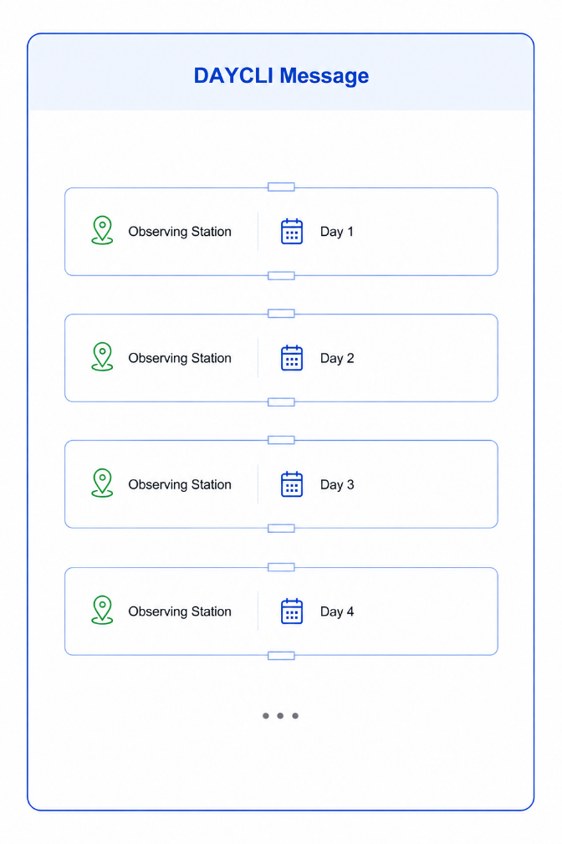
Figure 5-1 Conceptual Organization of a DAYCLI Message
Each DAYCLI record contains the four complementary information families introduced in Part II:
- Daily Climate Variables;
- Station Information;
- Observation and Processing Information;
- Quality Information.
Although some metadata are repeated from one record to another, this redundancy is intentional. It ensures that every DAYCLI record remains self-contained, allows for any changes in day to day metadata, and can be extracted, exchanged, archived and interpreted independently of any other record or external database.

Design Principles
The organization of the DAYCLI message is based on several fundamental design principles.
Self-contained records
Each DAYCLI record contains all the information required for its independent interpretation.
Preservation of scientific meaning
Daily climate values are always exchanged together with the contextual information necessary for their correct interpretation.
Preservation of national climatological practices
DAYCLI preserves the observational, temporal and processing framework used by each NMHS without attempting to standardize national climatological practices.
Intentional redundancy
All metadata are repeated across successive records in order to preserve record independence and simplify data exchange. This repetition also helps document and trace changes in relevant practices or metadata when they occur.
Interoperability
All Members exchange daily climate datasets using a common conceptual organization while preserving national specificities.
Extensibility
The DAYCLI structure has been designed so that in future possible new variables and metadata can be incorporated without modifying its overall architecture.

Information Families within a DAYCLI Record
Each DAYCLI Record combines the four Information Families introduced in Part II into a single self-contained structure. Together, they provide all the information required to correctly interpret the nationally validated daily climate values associated with one observing station and one Attribution Day.
Figure 5-2 illustrates the conceptual organization of a DAYCLI Record. The information is grouped into four complementary Information Families, each containing a number of information elements. The following sections describe these families in greater detail.
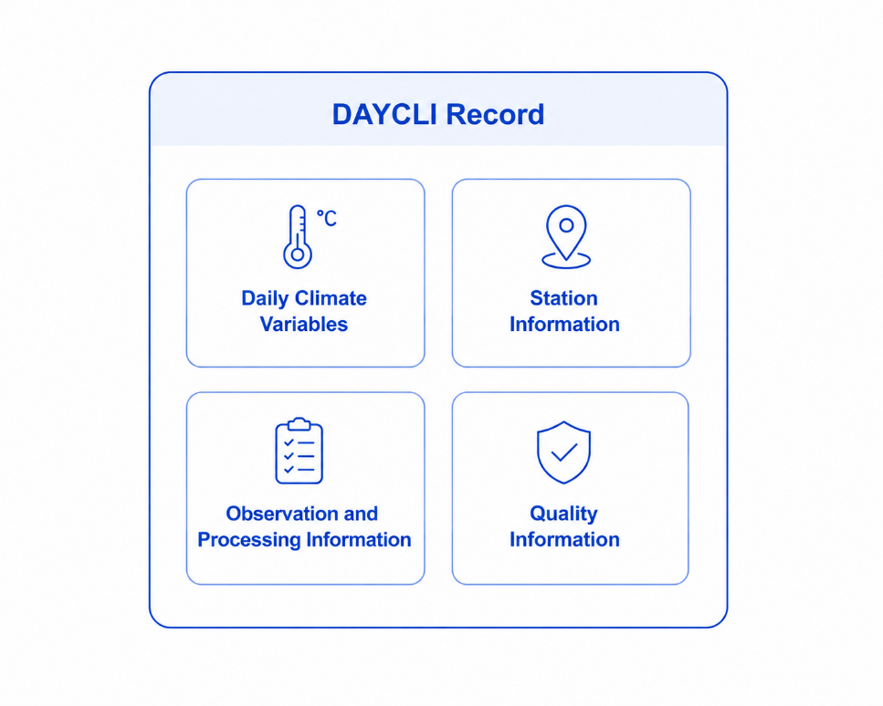
Figure 5-2 Information Families of a DAYCLI Record

Daily Climate Variables
The primary purpose of a DAYCLI Record is to exchange nationally validated daily climate variables. These variables represent the official daily climate information produced by NMHSs for a given observing station and Attribution Day.
The current DAYCLI specification supports the exchange of six core daily climate variables:
- Maximum temperature;
- Mean temperature;
- Minimum temperature;
- Daily precipitation;
- Fresh snow depth;
- Total snow depth.
These variables represent different types of daily climatological information:
- Daily temperature extremes, including the daily maximum and minimum temperatures;
- Daily mean values, represented by the daily mean temperature;
- Daily accumulations, including daily precipitation and fresh snow depth;
- Instantaneous daily measurements, represented by the total snow depth measured at a specified observation time.
The temporal and observational context required to correctly interpret these different types of variables is described in Subsection Observation and Processing Information.
Daily climate variables are exchanged together with the complementary Information Families required for their correct interpretation.
The following section describes the Station Information that uniquely identifies the observing station and provides the geographical context associated with each DAYCLI Record.

Station Information
Each DAYCLI Record is associated with a single observing station. The Station Information provides the information required to uniquely identify the station and to define its geographical location, thereby providing the spatial context necessary for the interpretation of the reported climate variables.

WIGOS Station Identifier (WSI)
The WIGOS Station Identifier (WSI) is mandatory in DAYCLI. The WSI is the unique identifier used to register an observing station or platform in the OSCAR/Surface database and is a fundamental component of the WMO Integrated Global Observing System (WIGOS).
The WSI follows the standard structure:
[WIGOS Identifier Series] – [Issuer of Identifier] – [Issue Number] – [Local Identifier]
For example:
0-20000-0-87585
identifies Buenos Aires Observatorio (Argentina).
The structure of the WSI is illustrated in Figure 5-3 below.
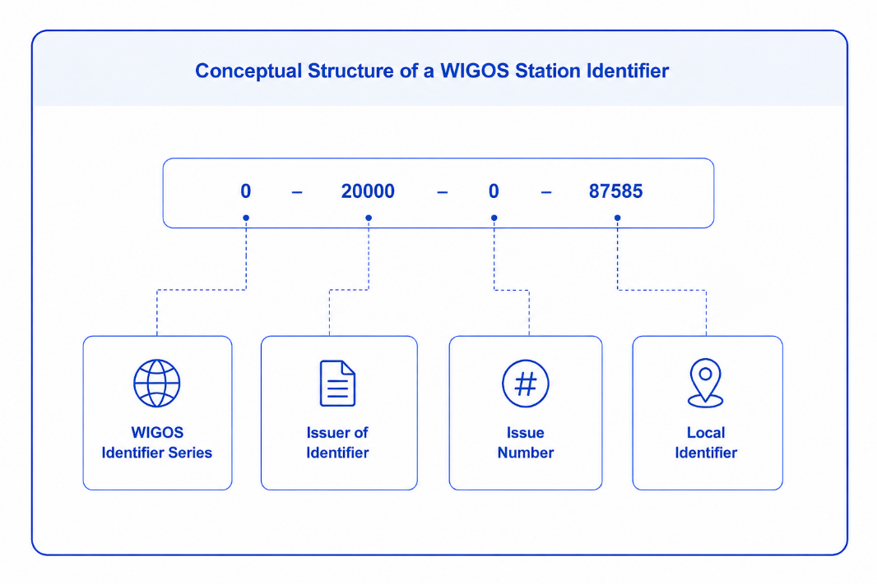
Figure 5-3 Structure of a WIGOS Station Identifier
The WSI is mandatory for all WMO Members. The allocation rules and structure of the WSI are defined in:
- Manual on the WMO Integrated Global Observing System (WMO-No. 1160, Edition 2024, Attachment 2.2);
- Guide to the WMO Integrated Global Observing System (WMO-No. 1165, Edition 2024, Chapter 9).

WMO Block and Station Number
The WMO Block Number and WMO Station Number correspond to the former traditional five-digit numerical identifier assigned by WMO to meteorological observing stations worldwide. They are retained in DAYCLI to facilitate compatibility with historical datasets and existing operational practices.
For example:
87585
identifies Buenos Aires Observatorio (Argentina).

Station Location
The geographical location of the observing station is defined by its latitude and longitude.
The default geodetic reference system for latitude and longitude is the World Geodetic System 1984 (WGS-84) combined with the Earth Gravitational Model 1996 (EGM96). This standard ensures global consistency and accuracy in geographic positioning. It is specified in the Guide to Instruments and Methods of Observation (WMO-No. 8, Volume I, Chapter 1, Section 1.3.3.2).
Within DAYCLI, latitude and longitude are encoded with a standard precision of 0.00001 degrees, corresponding to 1.11 metres at the equator.

Station Elevation
The height of station ground above mean sea level is defined as the height above mean sea level of the ground on which the rain gauge stands or, if there is no rain gauge, the ground beneath the thermometer screen. If neither a rain gauge nor a thermometer screen is present, it corresponds to the average terrain level in the vicinity of the station (Reference: WMO-No. 306, Manual on Codes, Volume I.2, descriptor 0 07 030, referring to WMO-No. 8, Guide to Instruments and Methods of Observation).
This definition is used to standardize observations and ensure the consistent comparison of atmospheric variables, such as pressure, temperature and humidity, among observing stations worldwide.
Since all daily climate variables contained in a DAYCLI Record originate from the same observing station, the Station Information is provided once and applies to every variable contained in that record.
The following section describes the observational and processing information required to correctly interpret how these daily climate variables were produced.

Observation and Processing Information
The daily climate variables exchanged through DAYCLI cannot be correctly interpreted without information describing the temporal reference system under which they were observed, and the methods used to derive them. Observation and Processing Information provides the contextual information required to ensure a consistent interpretation of daily climate data across NMHSs.
Unlike the Station Information, which applies to the entire DAYCLI Record, some Observation and Processing Information may vary between individual daily climate variables. This reflects the fact that different variables may be derived using different observation periods, measurement methods or processing procedures.
The following subsections describe the observation and processing information associated with a DAYCLI Record.

National Temporal Reference (NTR)
The NTR defines the temporal reference adopted by a WMO Member for producing and interpreting its official national daily climate dataset. It is established by each NMHS according to its national observing and climatological practices and, for each observing station, is specified by the associated Local Meteorological Time Zone (LMTZ).
The NTR may differ from the time reference used to record individual observations. For example, an observing system (e.g. network of automatic weather stations) may record observations in Coordinated Universal Time (UTC), while the NMHS defines the Climatological Day using a local time reference.
In DAYCLI, the NTR is represented through the Local Meteorological Time Zone (LMTZ) associated with each observing station (see Section 5.7.2). The LMTZ identifies the temporal reference used for the national daily climate dataset, while the corresponding time difference from UTC is encoded separately within the DAYCLI message.
See also National Temporal Reference (NTR) in the Glossary.

Local Meteorological Time Zone
The Local Meteorological Time Zone (LMTZ) is the local time reference adopted by an NMHS for producing, exchanging and interpreting its official national daily climate dataset for a given observing station. It provides the temporal reference used to define the Attribution Day and the observation periods associated with the daily climate variables (that is, the Climatological Day).
Although the term Local appears in its name, the LMTZ does not necessarily correspond to the civil or administrative time zone of the station location. Instead, it represents the temporal reference adopted by the NMHS for that station within the national daily climate dataset.
The LMTZ must not be confused with the numerical time difference from Coordinated Universal Time (UTC). The latter is a separate piece of information used to express the relationship between the LMTZ and UTC and is encoded independently in the DAYCLI message.

Attribution Day
Each DAYCLI Record is associated with a single Attribution Day.
The Attribution Day identifies the calendar day to which the reported daily climate information is assigned according to the national climatological practices of each NMHS.
The Attribution Day is established according to the NTR (see Section 5.7.1) and the associated LMTZ (see Section 5.7.2).
The Attribution Day should not be confused with either the civil calendar day or the observation period associated with a daily climate variable. These concepts are distinct, and may differ according to the observing and climatological practices adopted by the NMHS.

Time Period (Climatological Day)
For most daily climate variables, the reported value is derived from observations performed over a defined Time Period. Within the DAYCLI Guidelines, this Time Period represents the Climatological Day associated with the reported daily climate variable.
The Time Period (Climatological Day) specifies the beginning and the end of the observation interval from which the reported daily climate value has been derived. Its duration and temporal boundaries are established according to the climatological practices of the NMHS.
The Time Period is expressed in DAYCLI with a temporal precision of one minute. Its explicit representation in the DAYCLI BUFR message is described in Section 7.3.3.
Providing the Climatological Day associated with each daily climate variable enables users to correctly interpret the temporal representativeness of the reported value and facilitates meaningful comparisons between datasets originating from different observing networks and NMHSs.
Specifying the Climatological Day is very important, because the beginning and end of a 24 hour observing period vary considerably between NMHSs (and even within NMHSs for different variables, and even over the NMHS’s history). Such information is very helpful when it comes to ensuring meaningful comparison between DAYCLI datasets.

Observation Time
Alone among DAYCLI climate variables, total snow depth represents an instantaneous observation rather than a value derived over an Observation Period.
For this reason, total snow depth is specified for an exact time at which the measurement was made.

Relationship Between the Attribution Day and the Climatological Day
Examples illustrating the relationship between the Attribution Day, the Climatological Day and the Time Period are shown in Figure 5-4 below.
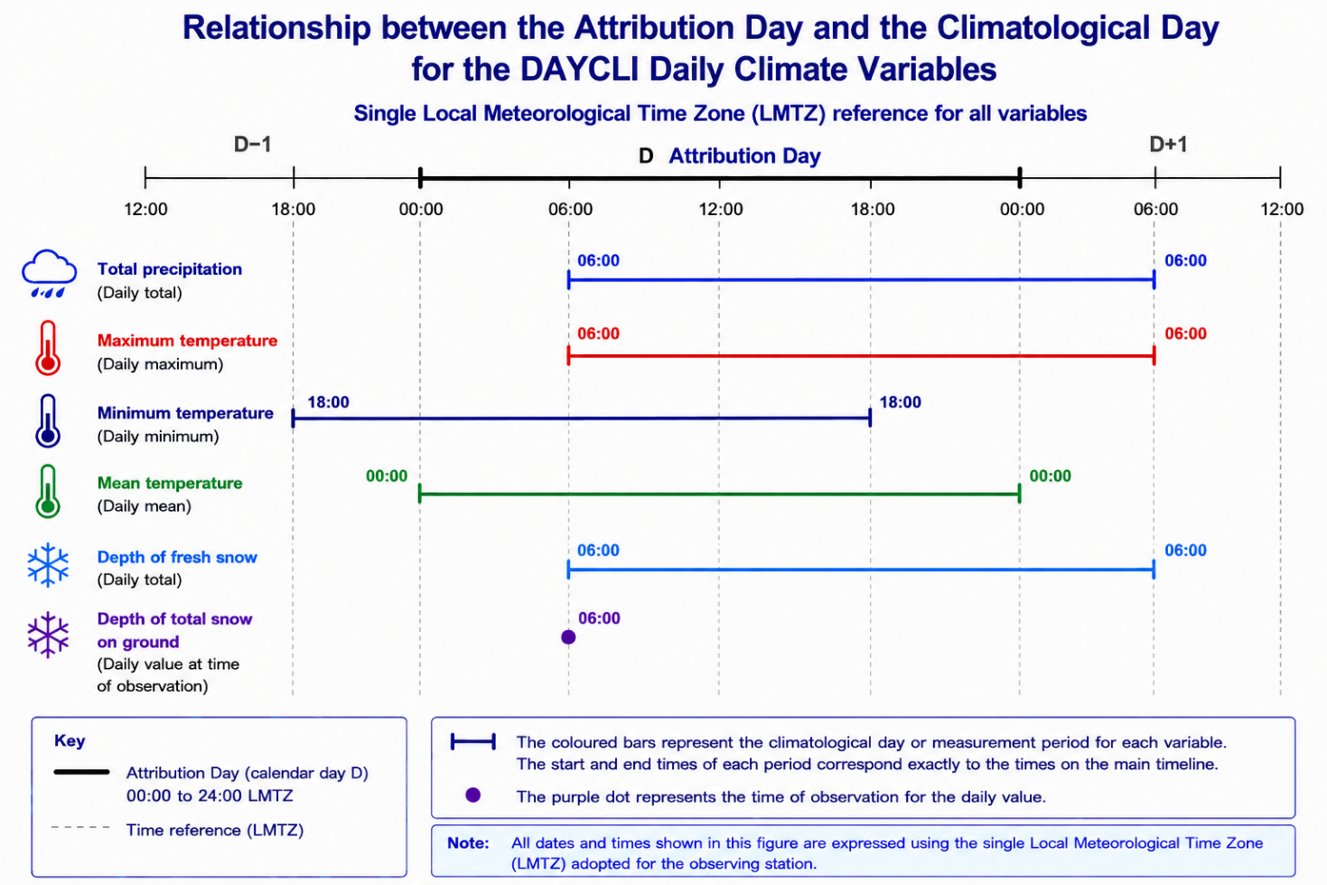
Figure 5-4 Relationship Between the Attribution Day and the Climatological Day
where:
- The Climatological Day for total precipitation, maximum temperature and depth of fresh snow is 06-06;
- The Climatological Day for minimum temperature is 18-18;
- The Climatological Day for mean temperature is 00-00;
- In each case the Attribution Day is D.
Further information specifying the Climatological Day is given in Section 7.3.

Siting Classification
For the operational international exchange of daily climate data through the DAYCLI BUFR message, the inclusion of standardized metadata is essential to ensure that temperature and precipitation observations are interpretable, comparable, and fit for use. Two key metadata elements are therefore defined in DAYCLI: siting classification and measurement quality classification.
Each precipitation sensor and each air temperature sensor are associated with both a siting classification and a measurement quality classification.
The siting classification provides information on the exposure and representativeness of the observing environment in which temperature and precipitation measurements are made. Its purpose is to inform users about the potential influence of local conditions (e.g. obstacles, surface characteristics, slope, urbanization, shielding, gauge exposure) on the measured values. This classification supports the correct interpretation of daily extremes and totals, helps users identify potential measurement biases, and improves the usability of the data for climate monitoring, climate modelling, climate services by indicating the overall representativeness of the site.
According to the Guide to Instruments and Methods of Observation (WMO-No. 8), Annex 1.D, the siting classification for surface observing stations on land comprises five classes (Class 1 to Class 5):
- Class 1 represents optimal siting conditions and the highest level of representativeness.
- Classes 2 and 3 indicate progressively increasing influence of local environmental factors.
- Classes 4 and 5 indicate significant siting limitations and reduced representativeness.

Measurement Quality Classification
The measurement quality classification describes the overall quality level assigned to the reported daily values based on observing practices, instrumentation and maintenance. Its purpose is to indicate the confidence that can be placed in the measurements and the extent to which they comply with recommended WMO practices. This information enables users to assess the suitability of the data for different applications, including climate monitoring, climate change analyses, climate services, and international data exchange.
According to the Guide to Instruments and Methods of Observation (WMO-No. 8), Annex 1.G, measurement quality is expressed using four classes (Class A to Class D):
- Class A represents the highest (optimum) measurement quality and precision, and full compliance with recommended WMO practices.
- Classes B and C reflect progressively lower levels of compliance or increasing measurement uncertainty.
- Class D indicates the lowest level of measurement quality.
For DAYCLI, these metadata are sought for:
- Air temperature (daily maximum, minimum, and mean values); and
- Precipitation (daily totals).
Members should ensure that the siting classification and measurement quality classification associated with each sensor and observing station are kept up to date.
Such siting or measurement quality classification information is strongly encouraged; however, their absence does not prevent the exchange of a DAYCLI message.
Detailed definitions, classification schemes, and implementation guidance are provided in the following WMO reference publications:
- Guide to Instruments and Methods of Observation (WMO-No. 8), especially Annexes 1.D and 1.G.
- Manual on Codes (WMO-No. 306), including the relevant BUFR specifications.

Mean Temperature Calculation Method
The daily mean air temperature is one of the most widely used climate variables. However, no single calculation method is universally applied by all WMO Members. Depending on historical observing practices, station instrumentation, and national climatological requirements, different methodologies may be used to estimate the daily mean temperature.
To ensure users understand the methodology by which a daily mean temperature was derived, DAYCLI includes metadata describing the method used to calculate the reported daily mean temperature.
The calculation methods currently defined in BUFR Code Table 0-08-094 are summarized in Table 5-1.
Table 5-1 Methods Used to Calculate Daily Mean Air Temperature (BUFR Code Table 0-08-094)
Code figure | Description
0 | Average of maximum and minimum values: Tm = (Tx + Tn)/2 (see Note*)
1 | Average of the 8 standard (see Note**) synoptic observations taken every three hours
2 | Average of 24-hourly values spaced one hour apart
3 | Weighted average of 3 observations: Tm = (aT1 + bT2 + cT3) (see Note*)
4 | Weighted average of 3 observations and also maximum and minimum values:  Tm = (aT1 + bT2 + cT3 + dTx + eTn) (see Note)
5 | Automatic weather station complete integration from one-minute data (1440 minutes)
6 | Average of the 4 synoptic observations taken six hours apart, and corresponding to intermediate (see Note***) synoptic times
7-254 | Reserved
255 | Missing value
Note *: The letters a, b, c, d and e generically represent the weight associated with the respective temperature T. Tx and Tn represent respectively the daily maximum and minimum temperature. The sub-indices of T: 1, 2 or 3 represent the values measured at different times 1, 2 or 3.
Note**: The 8 WMO standard synoptic observations correspond to the following standard WMO synoptic observation times: 00:00, 03:00, 06:00, 09:00, 12:00, 15:00, 18:00, and 21:00.
Note***:
- Main synoptic hours: The four primary observation times at six-hourly intervals (00:00, 06:00, 12:00, and 18:00 UTC) represent the main synoptic times, where intermediate three-hour observations are not available.
- Intermediate synoptic hours: The four supplementary observation times (03:00, 09:00, 15:00 and 21:00 UTC).
The average should be calculated using the arithmetic mean of the indicated observations unless otherwise specified (i.e. code figures 3 and 4). Note that the weightings represented by a, b, c etc. are not incorporated in the DAYCLI message – only that a weighting method has been used.
The methods listed in Table 5-1 aim to estimate the true daily mean air temperature using the observations available at a station. The most appropriate method depends on the observing programme, the instrumentation available, and the historical practices of the NMHS. Consequently, different methods may legitimately coexist within the international observing community.
For climate applications, maintaining the consistency of long-term time series is generally more important than adopting a single calculation method for all stations.
It is neither practical nor desirable to prescribe a single calculation method for all observing stations worldwide, or even within a single country. Each Member’s NMHS must make their own decisions on this matter. For instance, an NMHS may choose to use different methodologies for manual stations and Automatic Weather Stations (AWSs). Nevertheless, NMHSs are encouraged to maintain a consistent calculation method over time. For example, an NMHS could decide to continue to exchange temperature data from a station that has been calculating mean temperature for several decades, using the 8 standard times for surface observations corresponding to the station's Climatological Day (e.g. at 00:00, 03:00, 06:00, 09:00, 12:00, 15:00, 18:00 and 21:00 UTC), thereby ensuring historical consistency of method.

Another NMHS could calculate the daily average temperature for some of its newly automated stations by integrating from one-minute data (i.e. the average of 1 440 values).

As a minimum, the NMHS is advised to:

- continue to maintain homogeneous time series based on consistent calculation methods. Depending on the products or services required, an NMHS may maintain several time series for the same parameter and for the same station, but over different periods and with different methods. For example, an average daily temperature series calculated from 8 observations and another average time series calculated from 1440 observations. However, for climate monitoring purposes where homogeneity is important, and for DAYCLI exchange, NMHSs are advised to define and stick with a method that is consistent over time.
- always describe the calculation method used for data exchanged with DAYCLI. Note that if the method used by an NMHS is not listed in the BUFR Code Table 0-08-094 the NMHS should report it to WMO for subsequent addition.

NMHSs wishing to propose a new entry or a modification to the DAYCLI message (for instance, defining mean daily temperature by 144 ten-minute messages), a concomitant addition to the WMO Manual on Codes (WMO-No. 306) will be required. In that case, Members are encouraged to coordinate their proposal through their national focal point for BUFR/data representation, where applicable, before submitting it to the WMO Secretariat in accordance with the established WMO procedures. Proposals are then reviewed by the relevant WMO expert bodies before being considered for inclusion in the Manual on Codes. Until the proposal has been formally adopted by WMO, NMHSs are advised to not specify the calculation method at all (i.e. 255 for Missing Value).
The inclusion of this metadata in DAYCLI ensures that users can allow for differences in daily mean temperature calculation methods, and thereby enhance the long-term consistency of climate datasets despite differences in national calculation practices.

How to handle missing data
Different NMHSs apply different criteria when calculating daily mean temperature in the presence of missing observations. These criteria depend on the calculation method adopted, national operational practices, and historical climatological requirements. Consequently, DAYCLI does not prescribe a single approach for handling missing data.
The examples presented in this section illustrate some of the approaches currently applied by NMHSs. They are provided for information only and should not be interpreted as recommended or standardized procedures. Regardless of the approach adopted, maintaining the temporal consistency of long-term climate records is generally more important than applying a common international rule.
Missing observations may also affect the accuracy of daily minimum and maximum temperatures and daily precipitation totals. These situations are discussed separately in Use case: Incomplete observations for the computation of a daily climate value.
Some NMHSs may also apply different criteria for different variables. For instance, a few missing sub-daily temperature observations may be acceptable, whereas any missing data may be regarded as invalidating a 24-hour precipitation or snowfall total. The criteria applied remain the responsibility of the NMHS.

Daily mean from 1 440 one-minute observations
Automatic Weather Stations (AWSs), data collection platforms and Climate Data Management Systems (CDMSs) implement different criteria for handling missing one-minute observations. One example is the 10% rule.
Example criterion – 10% rule
If 10% or more of one-minute observations from an AWS are missing (i.e. 144 or more observations out of 1 440), the daily mean temperature is considered missing.
Note that it is possible that the potential effect of missing data may be reflected in the quality flagging assigned (Section 5.8).

Daily mean from 24 hourly observations
Several approaches are currently used by NMHSs.
One operational approach consists of using the 24 hourly observations whenever fewer than 10% of the observations are missing. If three or more hourly observations are missing, the daily mean is instead calculated from the eight standard synoptic observations (00:00, 03:00, 06:00, 09:00, 12:00, 15:00, 18:00 and 21:00 UTC). If two or more of these eight observations are themselves missing (some NMHSs use a threshold of one missing observation), the daily mean temperature is considered missing.
Some NMHSs apply less restrictive criteria, allowing up to one-sixth of the hourly observations to be missing before changing the calculation method. Others may calculate the daily mean from the four main synoptic observations (00:00, 06:00, 12:00 and 18:00 UTC) or from the four intermediate synoptic observations (03:00, 09:00, 15:00 and 21:00 UTC). These national practices are not currently distinguished within BUFR Code Table 0-08-094.
Consecutive and non-consecutive missing observations
Some NMHSs apply criteria based on the distribution of missing observations rather than their total number. For example:
- if three or more consecutive one-hourly observations are missing, the daily mean is calculated from the eight standard synoptic observations rule (see 5.7.9.1.3);
- if five or more non-consecutive hourly observations are missing, the same alternative calculation method is applied.
Whenever alternative calculation methods are used, NMHSs are encouraged to document them to facilitate the interpretation and reuse of exchanged climate data.

Daily mean from eight three-hourly observations
Some NMHSs calculate the daily mean from the full set of eight three-hourly observations. In these cases, an NMHS may consider the daily mean temperature to be missing when two or more of the eight observations are unavailable.
When only one of the eight three-hourly observations is missing, some NMHSs instead calculate the daily mean from either the four main synoptic observations (00:00, 06:00, 12:00 and 18:00 UTC) or the four intermediate synoptic observations (03:00, 09:00, 15:00 and 21:00 UTC).
These national practices are not currently distinguished within BUFR Code Table 0-08-094. Whenever alternative calculation methods are used, NMHSs are encouraged to document them to facilitate the interpretation and reuse of exchanged climate data.

Daily mean from four six-hourly observations
When the daily mean is calculated from either the four main synoptic observations or the four intermediate synoptic observations, some NMHSs consider the daily mean to be missing if any one of the four observations is unavailable.

Summary of illustrative criteria
The examples above are summarized in Table 5-2, which illustrates the diversity of operational practices currently applied by NMHSs when handling missing observations during the calculation of daily mean temperature. The criteria adopted depend on national climatological practices, operational requirements and the calculation method used.
Table 5-2 Illustrative Examples of Operational Criteria Used by NMHSs for Handling Missing Observations
Calculation method | Example operational criterion | Typical consequence
1 440 one-minute observations | ≥ 10% of observations missing (144 or more values) | Daily mean considered missing
24 hourly observations | ≥ 3 missing observations | Daily mean calculated from the eight standard synoptic observations
24 hourly observations | ≥ 3 consecutive or ≥ 5 non-consecutive missing observations | Daily mean calculated from the eight standard synoptic observations
8 three-hourly observations | ≥ 2 missing observations | Daily mean considered missing
8 three-hourly observations | 1 missing observation | Some NMHSs calculate the daily mean from the four main or four intermediate synoptic observations
4 six-hourly observations | ≥ 1 missing observation | Daily mean considered missing

For climatological applications, maintaining the consistency of long-term time series is of primary importance. NMHSs are encouraged to document the criteria applied for handling missing observations so that users can correctly interpret and compare exchanged daily climate data.

Quality Information
Quality control (hereafter QC) is an essential component of the production and stewardship of daily climate data. Before daily values become part of an official national climate dataset, they are generally subjected to a series of automated and/or manual checks designed to assess their internal consistency, plausibility and scientific reliability. These QC activities are performed under the authority of the NMHS in accordance with its operational procedures and climatological practices. In most NMHSs, QC of climate data is performed on data within a CDMS, which supports any or all of automated consistency checks, expert review and, where appropriate, the consolidation of observations from multiple sources.
Within an NMHS, QC procedures have likely evolved over many decades and reflect national observing systems, climatic conditions, operational (including staffing) constraints and historical practices. Consequently, there is no internationally standardized methodology for performing QC on daily climate observations. Guidance on QC and quality assurance procedures is provided in existing WMO publications, including the Guidelines on Surface Station Climate Data Quality Control and Quality Assurance for Climate Applications (WMO-No. 1269), the Guide to Climatological Practices (WMO-No. 100), and the Climate Data Management System Specifications (WMO-No. 1131). In particular, WMO-No. 1269 provides detailed recommendations, as well as comprehensive examples of testing procedures and algorithms, for the quality assessment of climate observations.
The purpose of DAYCLI is not to harmonize national quality control methodologies or to prescribe how quality assessments should be performed, but to provide a common framework for representing and exchanging the outcome of national quality control processes in a transparent and interoperable manner.
This section describes the QC information that should accompany DAYCLI observations, including the associated QC flags, before presenting a series of illustrative use cases demonstrating how these flags may be applied in typical operational situations.

Quality Control (QC) and Validation
QC determines the confidence that an NMHS places in the data it holds in its climate record. National quality control practices differ in terms of procedures, priorities, thresholds, flagging schemes and the role of expert judgement. These differences reflect variations in climate, observing networks, historical practices, operational resources and institutional requirements.
Within DAYCLI, quality information accompanies each exchanged climate value, based on the outcomes of national quality control processes.

Assigning QC flags
Within DAYCLI, quality information is represented through a small set of QC flags that summarize the outcome of the national QC and validation processes described above. These flags do not describe how QC was performed, nor do they replace national QC procedures or expert judgement or flagging schemas. Instead, they provide a common grammar for communicating the outcome of national assessments in a form that can be interpreted consistently by users in different countries.
The DAYCLI QC flags have been designed to enable users to distinguish between values that have been validated, values requiring caution, or values that have not yet undergone QC. Their purpose is not to define whether a value should or should not be used, but to ensure that users receive sufficient information to make informed decisions according to their own application requirements.
Importantly, noting the importance of extreme values, the DAYCLI flags were designed to enable significant events that may exceed instrumental design to be flagged (e.g. overflowing raingauges), whilst also highlighting situations where precipitation (and possibly temperature) readings represent multi-day accumulations.
The DAYCLI flagging system may differ from that used within a Member NMHS in terms of structure, terminology and level of detail. Where feasible, NMHSs are encouraged to establish a mapping between their national quality information flagging method and the DAYCLI QC flags. Such mappings should be maintained at national level and may be implemented progressively according to available technical capacity. The absence of a DAYCLI QC flag does not imply that QC has not been performed; it may simply indicate that national quality information has not yet been mapped to the DAYCLI representation. Consequently, the absence of QC flags shall not prevent the exchange of DAYCLI messages.
QC flags should always be interpreted together with the other metadata exchanged in DAYCLI, including the siting classification, measurement quality classification and other contextual information describing the observation and its processing. Considered together, these metadata provide the information required to understand the confidence and limitations associated with exchanged daily climate data.
The DAYCLI QC flags are listed in Table 5-3.
Table 5-3 DAYCLI QC flags
Code Quality Flag | Meaning
0 | Data checked and declared good
1 | Data checked and declared suspect
2 | Data checked and declared aggregated
3 | Data checked and declared out of instrument range
4 | Data checked and declared aggregated and out of instrument range
5 | Parameter is not measured at the station
6 | Daily value not provided
7 | Data unchecked
8…254 | Reserved
255 | Missing (QC info not available)

Representation of Quality Information and QC Flags
The purpose of DAYCLI QC flags is to support a consistent understanding of the nature and reliability of exchanged daily climate data. They do not prescribe whether a value should or should not be used for a particular scientific or operational application, but convey the outcome of the national assessment, enabling users to make informed decisions according to their own requirements.
Unless otherwise specified, the expression "Data checked" indicates that the reported value has undergone the QC procedures considered appropriate by the originating NMHS and that an official assessment has been made regarding its suitability for operational exchange. It makes no warranty about how the QC analysis was performed.
The definitions given below describe the meaning of each DAYCLI QC flag

Data checked and declared "Good"
The reported daily climate value has undergone national QC and has been assessed by the originating NMHS as providing a reliable representation of the observed variable for the Climatological Day.
A value may occasionally fail an individual QC test while still being considered reliable following expert assessment or comparison with supporting evidence. For example, an exceptionally high temperature may be confirmed by similarly high values recorded at neighboring stations during the same event.

Data checked and declared "Suspect"
The reported daily climate value has undergone national QC and remains considered suitable for exchange, although some uncertainty exists regarding its accuracy.
The DAYCLI designation "Suspect" indicates that the originating NMHS retains sufficient confidence in the value for operational exchange. For DAYCLI purposes “Suspect” should not be interpreted as meaning that the value is erroneous or unsuitable for use, although it is acknowledged that some NMHSs do interpret Suspect in that way.
Where QC indicates that confidence in the value is insufficient, or the value is known to be erroneous, the value should not be exchanged. Instead, it should be reported as missing (Code 6).

Data checked and declared "Aggregated"
The reported daily climate value represents an accumulation covering more than one Climatological Day rather than the reported day alone. This situation is commonly associated with precipitation readings at manual stations where, for instance, the gauge is not read over a weekend period. It can also occur for fresh snow amount, including where snow blocks a gauge.
The flag may also be used for daily maximum or minimum temperature when the reading represents the highest/lowest value across a period of several days. In such cases, unless it is obvious which day the extreme occurred on, “Aggregated” is recommended.
An illustrative example is provided in the relevant use case.

Data checked and declared "Out of instrument range / Instrument failure"
The reported daily climate value could not be determined accurately because the measurement exceeded the operating range of the instrument or because instrument failure prevented complete measurement. However, sufficient information exists to establish that the true value equals or exceeds a known lower bound.
This flag most commonly applies to precipitation measurements when rainfall exceeds the capacity of a rain gauge. Although the exact amount of precipitation cannot be determined, the recorded value indicates that the actual precipitation was at least equal to the instrument capacity. Such situations are often associated with heavy rainfall events of particular climatological or hydrological significance.
The flag may also be used when an instrument fails during an observation period (e.g. due to loss of communications) but sufficient information remains available to establish a meaningful lower bound. For example, an automated rain gauge may fail during an ongoing precipitation event after recording part of the accumulated rainfall.
The use of this flag is left to the discretion of the originating NMHS to decide whether this approach should be used, or whether the value is simply flagged as “missing”. See the Use Case example 5.8.4.4 below.
Of course, it may also apply when an instrument is destroyed, by either the event itself or some other cause. If an instrument remains unavailable following failure or damage, this flag will typically be followed on subsequent days by "Daily value not provided".

Data checked and declared "Aggregated and out of instrument range"
This flag combines the characteristics of the "Aggregated" and "Out of instrument range / Instrument failure" QC flags. The reported daily climate value represents both an accumulation over more than one Climatological Day AND a value that exceeded the operating range of the measuring instrument or was affected by instrument failure, while a meaningful lower bound remains known. It most commonly applies to precipitation measurements where an accumulated total spans several days and the recording instrument has overflowed or otherwise failed to capture the complete amount.

Parameter is not measured at the station
The reported parameter is not measured at the station because the required observing capability is unavailable.
This flag normally applies where the station is not equipped with the appropriate instrument, for example where no snow measurement equipment is installed. It may also be used when the required instrumentation is temporarily unavailable because of maintenance, damage or other operational reasons.

Daily value not provided
No daily climate value is available for exchange.
This flag may apply for a variety of reasons, including transmission failures, the absence of an observer, or other operational circumstances that prevent the daily value from being reported. It also applies where the originating NMHS considers the available value is insufficiently reliable for scientific or operational use and therefore chooses not to exchange it.

Data unchecked
The reported daily climate value has not undergone the national QC procedures normally applied by the originating NMHS.
This flag indicates that no climate data QC has been performed on the value, apart from basic system-level checks such as data format, transmission or database integrity tests that will only catch gross errors, e.g., data that are physically impossible, or nearly so. When assigning “Data unchecked” to a value to be reported in DAYCLI messages, the implication is that checks on internal consistency, statistical (range) checks, temporal or spatial consistency checks, etc., have not been applied.
Users should therefore interpret the reported value with appropriate caution until national QC has been completed.

Quality control information unavailable
A reported daily climate value is available, but no information is provided regarding its QC status.
This flag does not indicate whether national QC has or has not been performed. It simply indicates that no QC information is available for exchange.
Note that NMHSs are encouraged to update previously exchanged DAYCLI messages whenever improved quality assessments become available following additional QC or the receipt of new information.
To assist Members in applying the DAYCLI QC flags consistently, a number of illustrative use cases are presented in the following section. These examples describe typical operational situations and provide guidance on the selection of the most appropriate QC flag.

Illustrative Examples of QC Flag Assignment
This section provides illustrative use cases to support a common understanding of how DAYCLI QC flags may be assigned and interpreted in typical climatological situations. The examples are illustrative only and do not prescribe national quality control decisions or the assignment of QC flags.
The use cases describe situations frequently encountered in the production of daily climate data, including missing observations, partial data availability, aggregation of sub-daily observations into daily climate values, instrument limitations, snow-related effects on precipitation measurements, and extreme or unusual climate events.
In some situations, a daily climate value may legitimately be exchanged even though known limitations exist. Appropriate QC flags allow these limitations to be documented transparently without necessarily excluding the value from climatological analyses. For example, a daily precipitation total affected by snow blockage or wind undercatch may still provide valuable climatological information when accompanied by an appropriate QC flag.
The assignment of QC flags should always reflect the expert judgement of the originating NMHS and its established climatological practices. These examples are intended to promote a consistent interpretation of exchanged quality information at regional and global levels rather than to establish acceptance or rejection criteria for daily climate data.
When assigning QC flags, it is important to distinguish between the following situations:
- The parameter is not measured at the station.
- The parameter is normally measured, but no daily climate value is provided for a particular day.
- A daily climate value is available, but no QC information accompanies the value.
The first three Use Cases exemplify these cases.

Use case: Parameter not measured at the station
This use case applies where the parameter is not measured at the station. Typical examples include snowfall at stations located in tropical lowland regions or parameters that are observed only during part of the year, such as seasonal snow measurements.
As the station is not intended to produce observations of the parameter, the daily value is not provided and is assigned with QC Code 5 ("Parameter is not measured at the station").
Coding
Parameter | Value | Associated QC information | QC code
Snow depth | Missing | Parameter is not measured at the station | 5

Use case: Parameter measured at the station, but the daily value is not provided
This use case applies where the parameter is normally measured at the station, but no daily value is available for exchange.
This may occur because the observation could not be made, because of operational problems such as transmission failure or observer absence, or because the originating NMHS considers the available value insufficiently reliable for scientific or operational use and therefore chooses not to exchange it.
The daily value is not provided and is assigned with QC Code 6 ("Daily value not provided").
Coding
Parameter | Value | Associated QC information | QC code
Maximum temperature | Missing | Daily value not provided | 6

Use case: QC information not provided
This use case applies where a daily climate value is available, but no QC information accompanies the reported value.
This situation is distinct from cases where QC has not been performed (Code 7 – Data unchecked) and from cases where a specific QC flag, such as Aggregated, has been assigned. The absence of QC information is represented by QC Code 255 ("QC information unavailable").
Coding
Parameter | Value | Associated QC information | QC code
Maximum temperature | 32.5 °C | QC information unavailable | 255

Use case: Out of instrument range / Instrument failure
This use case applies where the daily climate value cannot be determined accurately because the measuring instrument exceeded its operating range or failed before the observation period was completed. However, sufficient information remains available to establish a meaningful lower bound for the reported value.
The most common example is a rain gauge that overflows during an intense precipitation event. Although the exact daily precipitation total cannot be determined, it is known that the actual amount equals or exceeds the recorded value. In this case, QC Code 3 ("Out of instrument range / Instrument failure") is assigned.
Coding – Example 1 (Rain gauge overflow)
Date | Precipitation | Associated QC information | QC code
Day 1 | 203 mm | Data checked and declared "Out of instrument range / Instrument failure" | 3

The same QC flag may also be used where instrument failure occurs during an observation period but sufficient information remains available to establish a meaningful lower bound. Examples include a lightning-induced power failure interrupting rainfall measurement by AWS, or a sensor failure occurring before the daily maximum or minimum temperature has been reached.
Coding – Example 2 (Instrument failure)
Date | Precipitation | Associated QC information | QC code
Day 1 | 17.6 mm | Data checked and declared "Out of instrument range / Instrument failure" | 3
The use of this QC flag remains at the discretion of the originating NMHS. Where the reported value is considered to retain climatological significance despite its known limitations, it may be exchanged together with QC Code 3. While such situations are likely to be rare, the NMHS may, at its discretion, regard the measurement as having some value, albeit heavily qualified. For instance, a rainfall value in an otherwise desert climate. In this case, it is clear that the value does not reflect the limits of the instrumentation, but rather that the instrument/sensor failed

Use case: Aggregation
This use case applies where daily observations are unavailable for one or more Climatological Days, but an accumulated total over the period (or highest/lowest value in the case of temperature) is known.
A common example concerns manually read rain gauges when an observer is absent for several consecutive days. In the example below, precipitation accumulates in the rain gauge from Day 2 to Day 5. When observations resume on Day 5, the accumulated total of 32.5 mm is measured. As the distribution of precipitation between the individual days is unknown, the total is reported to Day 5, while QC Code 2 ("Aggregated") is assigned to each day of the aggregation period. This indicates that the reported value represents an accumulation covering several Climatological Days rather than a single day. For Day 6, noting that the aggregation problem has been solved, this particular day reported no additional precipitation.

Coding
Date | Precipitation | Associated QC information | QC code
Day 1 | 15 mm | Data checked and declared “Good” | 0
Day 2 | Missing | Data checked and declared "Aggregated" | 2
Day 3 | Missing | Data checked and declared "Aggregated" | 2
Day 4 | Missing | Data checked and declared "Aggregated" | 2
Day 5 | 32.5 mm | Data checked and declared "Aggregated" | 2
Day 6 | 0.0 mm | Data checked and declared "Good" | 0
Where it is known with certainty that no precipitation occurred on one or more days within the aggregation period, those days may instead be reported with a precipitation value of 0.0 mm and QC Code 0 ("Good"). Alternatively, an NMHS may adopt a policy of treating the entire period as a single aggregation without partial disaggregation. Whichever approach is adopted, it should be applied consistently and documented as part of the NMHS's operational procedures.
Where an aggregation extends across the boundary between two calendar months, the accumulated value should be assigned to the month in which the aggregation ends.

Use case: Aggregation with instrument unavailable
This use case illustrates a situation in which an aggregation period includes days during which the observing instrument was temporarily unavailable, for example because of maintenance, damage or another operational interruption.
In the example below, no value is available on Day 1, although the observing system is operational. On Days 2 and 3, the instrument is unavailable and no observations can be made. On Day 4, the instrument has returned to service, but no observation is available for that day. On Day 5, an accumulated precipitation total of 32.5 mm is reported. The reported value represents the accumulation over the period during which observations were possible, but it does not include any contribution from the days when the instrument was unavailable.
Accordingly, Days 1, 4 and 5 are assigned QC Code 2 ("Aggregated"), while Days 2 and 3 are assigned QC Code 5 ("Parameter is not measured at the station"), reflecting the temporary unavailability of the observing capability.
Coding
Date | Precipitation | Associated QC information | QC code
Day 1 | Missing | Data checked and declared "Aggregated" | 2
Day 2 | Missing | Parameter is not measured at the station | 5
Day 3 | Missing | Parameter is not measured at the station | 5
Day 4 | Missing | Data checked and declared "Aggregated" | 2
Day 5 | 32.5 mm | Data checked and declared "Aggregated" | 2
Where observations have been permanently lost, for example because an instrument has been destroyed or washed away before the accumulated value can be recovered, the aggregation period begins only when observations resume. The days for which no observations are available should therefore be assigned QC Code 5 ("Parameter is not measured at the station") rather than being included in the aggregation.
Although the example refers to precipitation, the same principle may apply to other aggregated parameters, such as daily maximum or minimum temperature or the depth of fresh snow, provided that the aggregated value excludes periods during which no observations were possible.

Use case: Solid precipitation aggregation with subsequent snowmelt
This use case illustrates a situation in which snowfall temporarily blocks an automatic precipitation gauge. As the accumulated snow gradually melts over subsequent days, meltwater is recorded as precipitation on days when no new precipitation may actually have occurred.
The example below is based on observations from a high-altitude station in southeastern Australia during July 2022. Heavy precipitation, falling mainly as snow, occurred during the first two days. The 38.8 mm reported on Day 1 is considered to represent a known minimum amount because the gauge became blocked during the event and the true precipitation total could not be determined. Accordingly, QC Code 3 ("Out of instrument range / Instrument failure") is assigned.
During Days 2 to 5, the reported precipitation values represent a combination of accumulated snowfall and subsequent snowmelt released from the blocked gauge. As the daily distribution of the original precipitation cannot be reconstructed reliably, these values are assigned QC Code 2 ("Aggregated"). By Day 6, the blockage has cleared and the reported precipitation is considered to represent only new precipitation; QC Code 0 ("Good") is therefore assigned.
Coding
Date | Precipitation | Associated QC information | QC code
Day 1 | 38.8 mm | Data checked and declared "Out of instrument range / Instrument failure" | 3
Day 2 | 23.6 mm | Data checked and declared "Aggregated" | 2
Day 3 | 9.2 mm | Data checked and declared "Aggregated" | 2
Day 4 | 8.8 mm | Data checked and declared "Aggregated" | 2
Day 5 | 3.5 mm | Data checked and declared "Aggregated" | 2
Day 6 | 8.0 mm | Data checked and declared "Good" | 0
Where possible, the quality assessment should be supported by other observations, particularly measurements of fresh snow amount, snow depth, and air temperature, which may help distinguish between fresh precipitation and delayed snowmelt. Such supporting information can improve the interpretation of the reported precipitation values. For instance, cross-checking with other variables, notably "Fresh snow", and temperature data, might show that Days 3 and 4 in fact experienced no (new) precipitation.
If the gauge remains blocked for an extended period – say, in excess of a week – the likelihood is that even when the snow does melt, the accumulated precipitation may itself become underestimated. In such circumstances, QC Code 4 ("Aggregated and out of instrument range") may provide a more appropriate description of the reported value.
NMHSs are encouraged to document these situations in their national metadata, particularly where persistent snow blockage is a recurring characteristic of the observing site.

Use case: Incomplete observations for the computation of a daily climate value
This case describes a situation where not all observations required to compute a daily value are available, but the number of missing values is not in itself sufficient to trigger a missing value. Note that this does not apply only to mean temperature – it may be that, for instance, data are missing around the time of maximum or minimum temperature. In this case, coding should be based on the NMHS’s normal practices, utilizing also professional discretion as to the likely impact of the missing data.
Examples of such situations include:
- Where the calculation method to determine a mean daily temperature is to use all 1440 one-minute values (60 min*24) from an AWS, but some are missing; or
- Where the calculation method to determine a daily value (e.g. mean temperature) is to use 24 one-hourly values, but one or several are missing; or
- Where the calculation method to determine a daily value is to use the 8 main synoptic hours of the day (or four, or three), one or several values are missing; or
- An AWS is offline for a period where the minimum or maximum temperature might feasibly have occurred.
In these cases, the NMHS (data provider) may choose from several possibilities:
1. Notwithstanding the missing values, the NMHS data provider considers that the calculated value is still reliable. In that case the encoding would be:
Example:
Maximum Temperature Associated QC information QC code
10.4 Data checked and declared good 0

2. The data provider considers that the missing data may render the value suspect (e.g., night/day imbalance in observations used to compute mean temperature, or measurements missing around likely time of daily minimum/maximum temperature) -but that the value may still be sufficiently useful to share worldwide. In that case, the encoding would be:
Minimum Temperature Associated QC information QC code
10.4 Data checked and declared suspect 1

3. The data provider considers that the data is highly suspect, e.g., sufficient values are missing around the likely time of the minimum and maximum temperature that it is highly likely the true Maximum Temperature or Minimum Temperature is missed. In this case, it would be assumed that the available data does not represent a true assessment of the daily conditions, and therefore the data would be regarded as “doubtful”, i.e., to share it would be misleading. If this assessment is made by the Member’s NMHS, the coding would be:
Maximum Temperature Associated QC information QC code
Missing Daily value not provided 6

Part IV - BUFR Representation of DAYCLI Information
The previous Parts introduced the DAYCLI information model by specifying and describing the information required as part of a DAYCLI message, including how to ensure interoperability of the daily climate parameters during international exchange while remaining true to national standard practices in observation and calculation methodology. They explained the purpose of each observation and metadata element and its role in ensuring the accurate interpretation of exchanged daily climate values.
This Part describes how these information elements are represented within the DAYCLI Binary Universal Form for the Representation (BUFR) of meteorological data message. Its purpose is to explain how the DAYCLI information model is translated into the standardized BUFR representation used for operational international exchange.
In its representation of the DAYCLI information, BUFR uses a number of encoding mechanisms to associate information with data values while keeping the message compact, flexible and extensible. Understanding these mechanisms is essential for correctly interpreting the DAYCLI BUFR sequence.
The following sections first introduce the fundamental BUFR concepts and encoding mechanisms used in DAYCLI before presenting how each information element of the DAYCLI information model is represented within the BUFR sequence. To facilitate implementation and decoding, this Part follows the order of the DAYCLI BUFR sequence (3 07 095) rather than the conceptual organization introduced in the previous Parts.

From the DAYCLI Information Model to the BUFR Representation
The DAYCLI message is encoded using the Binary Universal Form for the Representation of meteorological data (BUFR), the WMO standard for the exchange of observational data in binary form. Specifically, the BUFR encoding follows the BUFR sequence 3 07 095.
BUFR provides a flexible and extensible framework for representing meteorological and climatological observations while preserving their structure, meaning and associated metadata. Rather than prescribing a fixed message layout, BUFR represents information through standardized descriptors and a set of encoding mechanisms that can be combined to describe observations, metadata and quality information in a compact and interoperable way.
These encoding mechanisms include element descriptors, sequence descriptors, replication descriptors, associated fields and operator descriptors. Together, they allow complex information models, such as DAYCLI, to be represented efficiently while maintaining a clear and self-contained relationship between observations and their associated metadata.
The following sections introduce these BUFR concepts before describing how each component of the DAYCLI information model is represented within the DAYCLI BUFR sequence (3 07 095). It is included to conceptually describe how a BUFR message is constructed, making use of the various types of descriptors mentioned in the previous paragraph. This is to assist discussions between climate specialists and their CDMS implementation colleagues should these be required; these Sections may be skipped in circumstances where, for instance, the BUFR encoding is performed automatically.
Several resources are available to understand the BUFR. Readers are referred to the Manual on Codes, Volume I.2 (WMO-No. 306) in Part B (Binary Codes) for more detailed information.
A simplified overview of the DAYCLI BUFR organization is shown in Figure 6-1, where fields in bold are considered as core information. Core and rich information are described in section 10.

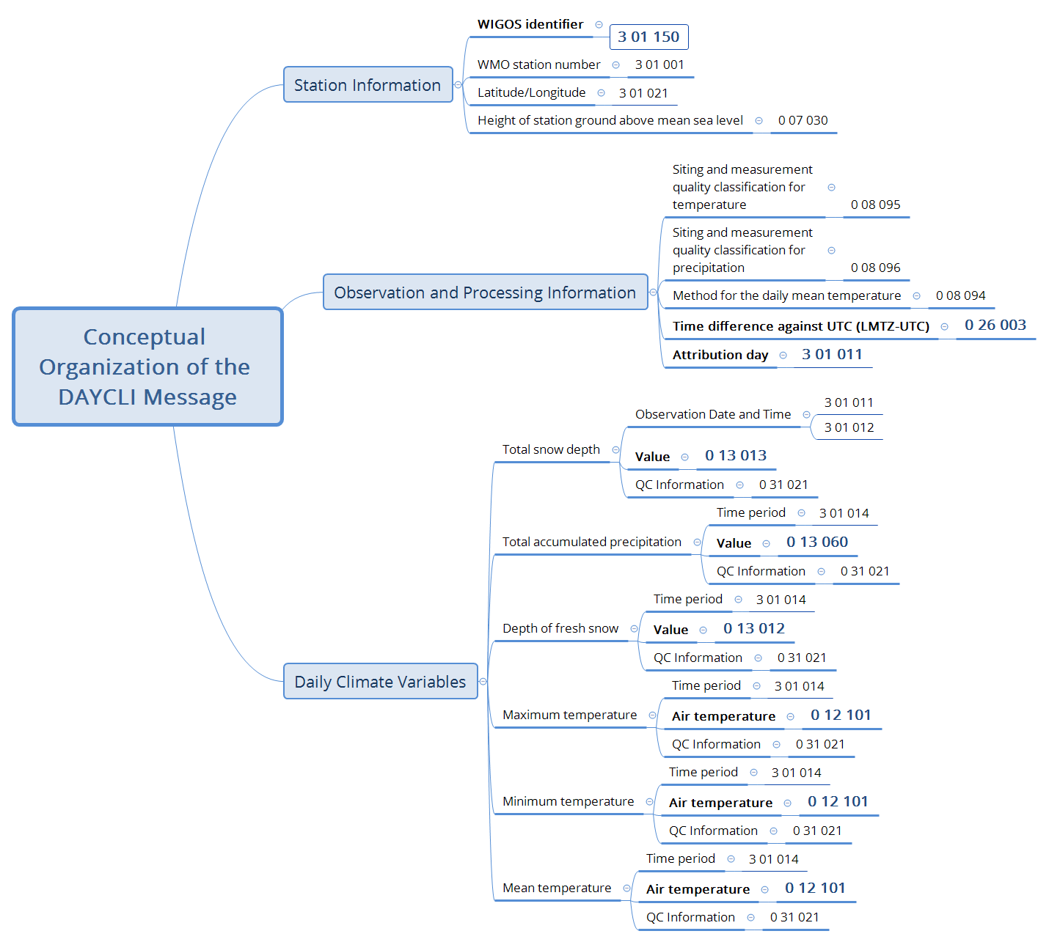
Figure 6-1 Conceptual Organization of the DAYCLI Message

BUFR Descriptor Types
BUFR represents information through standardized descriptors. Every descriptor is identified by the notation F X Y, where the first digit (F) defines the descriptor type, while X and Y identify the descriptor category and the individual descriptor within that category.
- F identifies the descriptor type;
- X identifies the descriptor category;
- Y identifies the descriptor number within that category.
The descriptor type (F) determines the function of the descriptor.
The four descriptor types defined by BUFR are summarized in Table 6-1,Erreur ! Source du renvoi introuvable. where Tables B, C and D refer to the corresponding tables in WMO-No. 306.
Table 6-1 BUFR Descriptor Types
F | Descriptor Type | BUFR Table | Description
0 | Element Descriptor | Table B | Represents a single data element.
1 | Replication Descriptor | — | Repeats one or more descriptors.
2 | Operator Descriptor | Table C | Temporarily modifies the interpretation of subsequent descriptors.
3 | Sequence Descriptor | Table D | Represents a predefined sequence of BUFR descriptors.

Examples of each descriptor type as used in DAYCLI are summarized in Table 6-2.
Table 6-2 Examples of BUFR Descriptor Types Used in DAYCLI
F | Descriptor Type | Example from DAYCLI | Explanation
0 | Element Descriptor | 0 07 030 – Height of station ground above mean sea level | Represents a single information element.
1 | Replication Descriptor | 1 06 003 – Replicate the following six descriptors three times | Repeats the same group of descriptors to encode the maximum, minimum and mean temperatures.
2 | Operator Descriptor | 2 04 008 – Add associated field | Activates an associated field that carries the QC information associated with the following data value.
3 | Sequence Descriptor | 3 01 021 – Latitude/Longitude (High Accuracy) | Represents a predefined sequence of BUFR descriptors.
The DAYCLI BUFR sequence makes use of all four descriptor types. While element and sequence descriptors represent information directly, replication and operator descriptors provide the encoding mechanisms required to organize and associate that information efficiently.

BUFR Sequence Descriptors
Many components of the DAYCLI message are represented using BUFR sequence descriptors (F = 3). A sequence descriptor groups together a predefined set of descriptors that logically belong to the same information item.
The sequence descriptor 3 01 021 (Latitude/Longitude (high accuracy)) is composed of the BUFR descriptors listed in Erreur ! Source du renvoi introuvable..
Table 6-3 Sequence Descriptor Latitude/Longitude
BUFR Descriptor | Element Name
0 05 001 | Latitude (high accuracy)
0 06 001 | Longitude (high accuracy)
The two element descriptors above are grouped in the sequence descriptor 3 01 021 (Latitude/Longitude (high Accuracy)), which is used in the DAYCLI sequence.
This approach groups logically related information into reusable building blocks, making BUFR messages easier to construct, interpret and maintain while ensuring consistent data exchange.
Many other components of the DAYCLI message are represented in the same way, including the WIGOS Station Identifier, WMO Block and Station Numbers, Attribution Day, and other observational and climatological context information.

BUFR Encoding Mechanisms
The DAYCLI BUFR sequence makes use of several BUFR encoding mechanisms to represent the DAYCLI information model efficiently while preserving the relationships between observations and their associated metadata. Unlike element and sequence descriptors, which represent information directly, these mechanisms control how information is organized, repeated or associated within the BUFR message.
The following sections introduce the principal encoding mechanisms used in the DAYCLI BUFR sequence together with examples illustrating their application.

Replication descriptors
Replication descriptors (F = 1) allow a group of BUFR descriptors to be repeated without redefining the same structure multiple times. This mechanism reduces redundancy while ensuring that repeated observations share an identical representation.
In the DAYCLI BUFR sequence, replication is used to encode the three daily temperature statistics (maximum, minimum and mean) using the same group of descriptors. Rather than defining three separate structures, a single group of descriptors is repeated three times by the replication descriptor 1 06 003.
Each replicated group contains:
- the time period over which the statistic is computed;
- the first-order statistic identifying whether the value represents the maximum, minimum or mean temperature;
- the associated quality control information; and
- the air temperature value.
This approach ensures that all daily temperature statistics are encoded consistently while avoiding unnecessary duplication of descriptor definitions.
Figure 6-2 illustrates the replication mechanism used for the three daily temperature statistics.
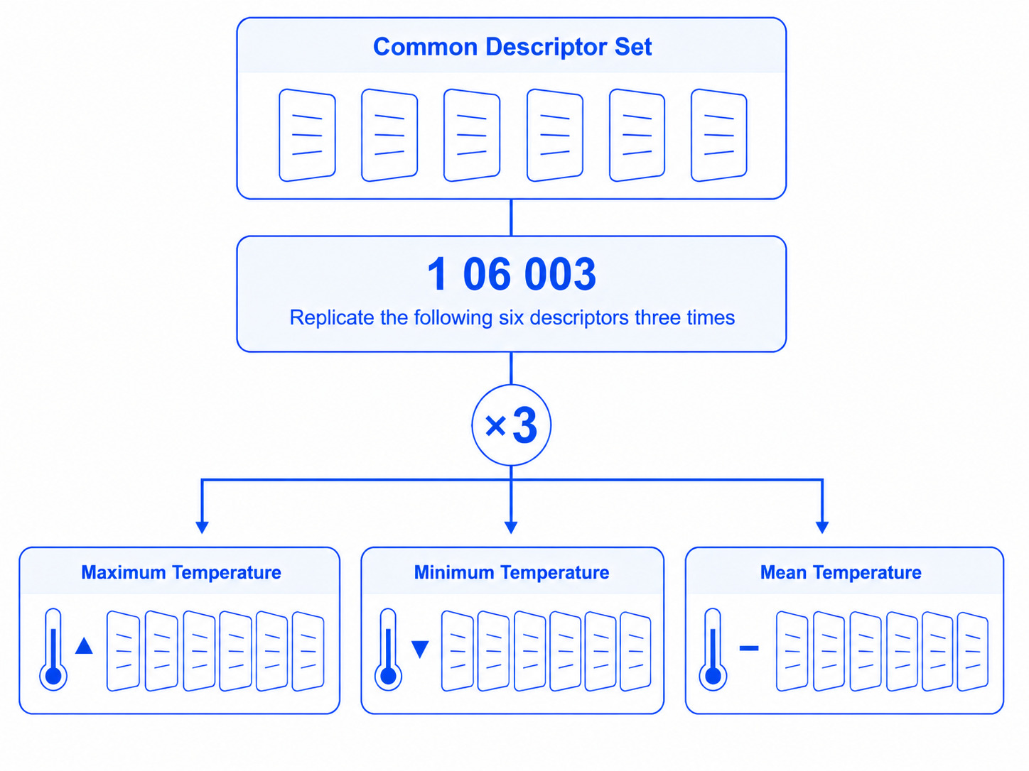
Figure 6-2 Example of the replication mechanism used for the three daily temperature statistics
In DAYCLI, replication is used only for the three daily temperature statistics.

Associated Fields and Operator Descriptors
Associated Fields provide a mechanism for attaching additional information directly to a data value without introducing a separate data element into the BUFR message. In the DAYCLI BUFR sequence, this mechanism is used to represent the quality control (QC) information associated with each reported daily climate value.
An Associated Field is controlled by Operator descriptors (F = 2), which activate and terminate the mechanism. The operator descriptor 2 04 008 (Add Associated Field) activates an 8-bit associated field for subsequent data values, while 2 04 000 (Cancel Associated Field) terminates the mechanism after the corresponding value has been encoded.
The descriptor 0 31 021 (Associated Field Significance) identifies the meaning of the associated field. In the DAYCLI sequence, its value is set to 5, indicating that the associated field contains quality control information associated with each reported daily climate value.
The resulting structure associates the QC information directly with the corresponding daily climate value. The Associated Field mechanism therefore avoids the need to represent the QC information as a separate data element for each reported value.
Figure 6-3 illustrates the use of Operator descriptors to activate and terminate the Associated Field mechanism for a daily climate value.

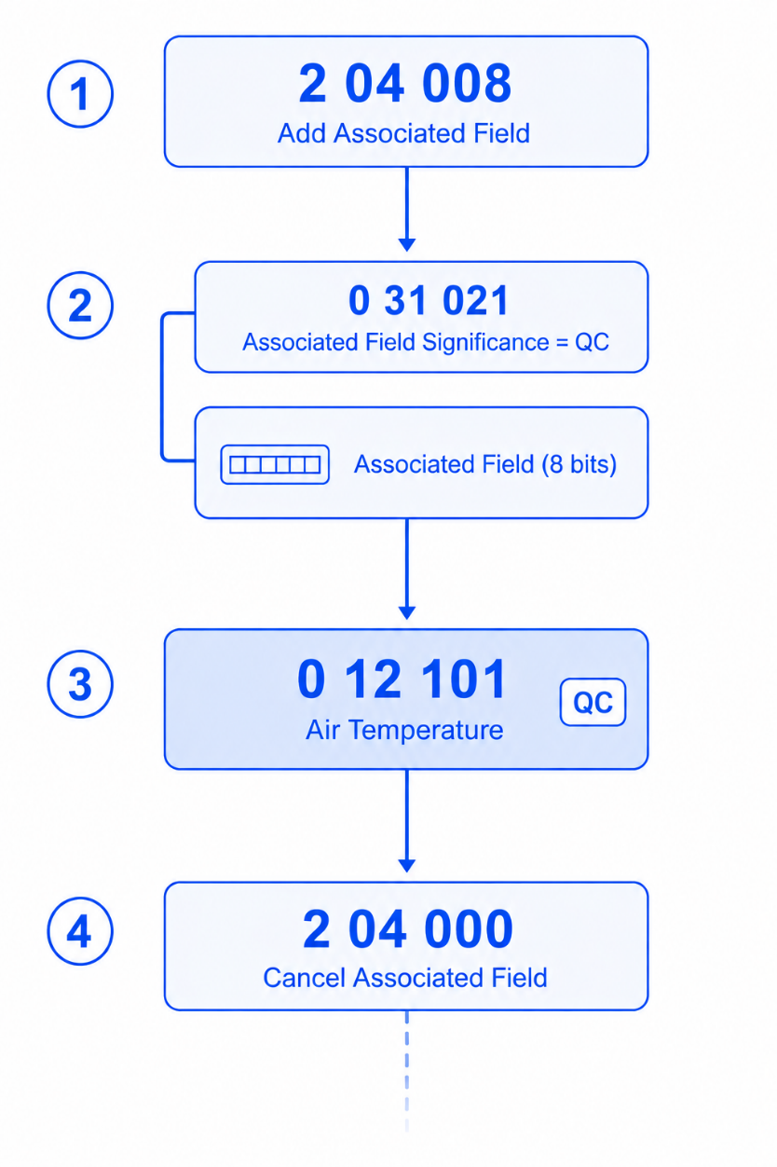
Figure 6-3 Use of Operator Descriptors to control the Associated Field mechanism
The following section describes how each component of the DAYCLI information model is represented within the DAYCLI BUFR sequence. For each information item, the corresponding BUFR descriptors, tables and encoding rules are presented together with explanatory notes and implementation examples.

BUFR Representation of DAYCLI Information
This chapter describes how each component of the DAYCLI information model is represented within the DAYCLI BUFR sequence (3 07 095). Readers may refer to the complete sequence in Annex E to see how these elements fit within the overall DAYCLI structure.
This section follows the order of the BUFR sequence (see Annex E). For each information element, the corresponding BUFR and sequence descriptors are described. Where applicable, the associated encoding mechanisms are described together with explanatory notes to facilitate implementation and interpretation.
Examples throughout this section are based on existing WIGOS stations selected to illustrate the particular concepts being described.

Station Information
Station information forms the first part of the DAYCLI BUFR sequence. It identifies the observing station and provides the information required to locate it unambiguously. This information establishes the geographical and institutional context for the daily climate observations that follow.
The DAYCLI BUFR sequence represents station information using a combination of sequence descriptors and elementary descriptors corresponding to the WIGOS Station Identifier, WMO block and station number, geographical location and station elevation.

Summary of BUFR Descriptor Characteristics
The numerical representation of each information element is defined by the corresponding BUFR descriptor contained in Table B of the Manual on Codes (WMO-No 306, Vol I.2). Each descriptor specifies the unit, scale, reference value and data width used to encode the reported value.
The following Table 7-1 summarizes the characteristics of the BUFR descriptors used in this sub-section.
Table 7-1 Summary of BUFR Descriptor for Station Information
FXY | Element Name | Unit | Scale | Reference Value | Data Width (bits)
0 01 001 | WMO Block Number | Numeric | 0 | 0 | 7
0 01 002 | WMO Station Number | Numeric | 0 | 0 | 10
0 01 125 | WIGOS Identifier Series | Numeric | 0 | 0 | 4
0 01 126 | WIGOS Issuer of Identifier | Numeric | 0 | 0 | 16
0 01 127 | WIGOS Issue Number | Numeric | 0 | 0 | 16
0 01 128 | WIGOS Local Identifier Character | CCITT IA5 | 0 | 0 | 128
0 05 001 | Latitude (high accuracy) | ° | 5 | -9000000 | 25
0 06 001 | Longitude (high accuracy) | ° | 5 | -18000000 | 26
0 07 030 | Height of Station | m | 1 | -4000 | 17

The BUFR characteristics presented in this table are provided for convenience. The definition of each descriptor remains the corresponding entry in BUFR / CREX Table B of the Manual on Codes (WMO-No. 306, Volume I.2).

WIGOS Station Identifier
The WIGOS Station Identifier (WSI) provides the primary and globally unique identification of the observing station. As described in Part III, the WSI ensures the unambiguous identification of stations participating in the international exchange of meteorological and climatological observations.
In the DAYCLI BUFR sequence, the WSI is represented by the BUFR sequence descriptor 3 01 150 (WIGOS Identifier), which groups together the four components defined by the WIGOS framework.
The sequence descriptor comprises the following element descriptors, as detailed in Table 7-2.
Table 7-2 BUFR Representation of the WIGOS Station Identifier
BUFR Descriptor | Element Name | Example | Remarks
0 01 125 | WIGOS Identifier Series | 0 | Fixed value defined by the WIGOS framework.
0 01 126 | WIGOS Issuer of Identifier | 20000 | Assigned to the Mauritius Meteorological Services.
0 01 127 | WIGOS Issue Number | 0 | Initial issue number.
0 01 128 | WIGOS Local Identifier Character | 61995 | Assigned by the issuing authority.
Example: The four element descriptors shown above together form the WIGOS Station Identifier 0-20000-0-61995 assigned to VACOAS (MAURITIUS).
Together, these four descriptors uniquely identify the observing station and provide a persistent station identifier that remains independent of national station numbering systems.
Every DAYCLI message shall include a WIGOS Station Identifier. National station identifiers, such as the WMO Block and Station Number, may be provided in addition where available.

WMO Block Number and Station Number
The WMO Block Number and Station Number provide the traditional identification of an observing station within the WMO station numbering system. Although the WIGOS Station Identifier (WSI) is the mandatory station identifier for the international exchange of DAYCLI messages, the WMO Block Number and Station Number may be included to facilitate interoperability with existing observing systems, archives and applications.
In the DAYCLI BUFR sequence, the WMO Block Number and Station Number are represented by the following BUFR element descriptors:
BUFR Descriptor | Element Name | Example | Remarks
0 01 001 | WMO Block Number | 61 | Identifies the WMO geographical block.
0 01 002 | WMO Station Number | 995 | Station number assigned within the block.
Example: For the observing station VACOAS (MAURITIUS), the WMO station identifier is 61-995.

Latitude/Longitude (High Accuracy)
The geographical location of the observing station is represented in the DAYCLI BUFR sequence by the BUFR sequence descriptor 3 01 021 (Latitude/Longitude (High Accuracy)).
This sequence descriptor comprises the following BUFR element descriptors:
BUFR Descriptor | Element Name | Example | Remarks
0 05 001 | Latitude (high accuracy) | 20.29750° S
0 06 001 | Longitude (high accuracy) | 57.49470° E
The geographical reference system and coordinate precision are described in Section 5.
Example: The geographical location of the observing station VACOAS (MAURITIUS) is represented by the coordinates 20.29750° S, 57.49470° E, which correspond respectively to −2 029 750 and 5 749 470 when encoded in BUFR in units of 10⁻⁵ degrees.
Implementation Note: In BUFR, latitude (descriptor 0 05 001) and longitude (descriptor 0 06 001) are encoded as signed integer values expressed in units of 10⁻⁵ degrees. Latitude is positive north of the Equator and negative south of the Equator. Longitude is positive east of the Greenwich meridian and negative west of the Greenwich meridian.

Station Elevation
The elevation of the observing station is represented in the DAYCLI BUFR sequence by the BUFR element descriptor 0 07 030 (Height of Station).
The station elevation is represented by the following BUFR element descriptor:
BUFR Descriptor | Element Name | Example | Remarks
0 07 030 | Height of Station | 423 m | Height above mean sea level.
The definition of station elevation is provided in Section 5.
Example: The elevation of the observing station VACOAS (MAURITIUS) is represented by the value 423 m.
Implementation Note: The station elevation is expressed in metres above mean sea level (MSL) in accordance with the BUFR definition of descriptor 0 07 030.

Observation and Processing Information
Observation and processing information complements the reported daily climate variables by describing the observing conditions, processing methods and temporal reference used to produce them. This information is essential for the scientific interpretation and comparability of exchanged climate data.

Summary of BUFR Descriptor Characteristics
The numerical representation of each information element is defined by the corresponding BUFR descriptor contained in BUFR / CREX Table B of the Manual on Codes. Each descriptor specifies the unit, scale, reference value and data width used to encode the reported value.
The characteristics of the BUFR descriptors used to represent Observation and Processing Information are summarized in Table 7-3 Descriptor Characteristics for Observation and Processing Information

Table 7-3 Descriptor Characteristics for Observation and Processing Information

FXY | Element Name | Unit | Scale | Reference Value | Data Width (bits)
0 04 001 | Year | a | 0 | 0 | 12
0 04 002 | Month | mon | 0 | 0 | 4
0 04 003 | Day | d | 0 | 0 | 6
0 04 004 | Hour | h | 0 | 0 | 5
0 08 094 | Method used to calculate the average daily temperature | Code Table | 0 | 0 | 8
0 08 095 | Siting and Measurement Quality Classification for Temperature | Code Table | 0 | 0 | 8
0 08 096 | Siting and Measurement Quality Classification for Precipitation | Code Table | 0 | 0 | 8
0 26 003 | Time difference (see Note) | min | 0 | -1440 | 12
Note: Descriptor 0 26 003 is to be used with 0 08 025 (time difference qualifier).
The BUFR characteristics presented in this table are provided for convenience. The definition of each descriptor remains the corresponding entry in Table B of the Manual on Codes (WMO-No. 306, Volume I.2).

Siting and Measurement Quality Classification for Temperature
The siting and measurement quality of temperature observations are represented in the DAYCLI BUFR sequence by the BUFR element descriptor 0 08 095 (Siting and Measurement Quality Classification for Temperature).
This descriptor uses a combined code table in which the numeric character represents the Siting Classification and the alphabetic character represents the Measurement Quality Classification.
BUFR Descriptor | Element Name | Example | Remarks
0 08 095 | Siting and Measurement Quality Classification for Temperature | 1A | Combined code representing the siting classification (1–5) and the measurement quality classification (A–D) for temperature observations.
The definitions of the siting classification and the measurement quality classification are provided in Section 5. The corresponding BUFR code table used by the DAYCLI sequence is reproduced in Annex C.
Example: A value of 1A indicates that the temperature observation was performed at a Class 1 site with Measurement Quality Class A, i.e. well sited and high-quality measurement standards.
Implementation Note: The descriptor value shall be selected from the associated BUFR code table. The numeric and alphabetic components shall not be encoded separately. However, if either the siting classification or the measurement quality classification is missing, code figures 26 to 34 may be used.

Siting and Measurement Quality Classification for Precipitation
The siting and measurement quality of precipitation observations are represented in the DAYCLI BUFR sequence by the BUFR element descriptor 0 08 096 (Siting and Measurement Quality Classification for Precipitation).
This descriptor uses a combined code table in which the numeric character represents the Siting Classification and the alphabetic character represents the Measurement Quality Classification.
BUFR Descriptor | Element Name | Example | Remarks
0 08 096 | Siting and Measurement Quality Classification for Precipitation | 1A | Combined code representing the siting classification (1–5) and the measurement quality classification (A–D) for precipitation observations.
The definitions of the siting classification and the measurement quality classification are provided in Section 5. The corresponding BUFR code table used by the DAYCLI sequence is reproduced in Annex D.
Example: A value of 1A indicates that the precipitation observation was performed at a Class 1 site with Measurement Quality Class A.
Implementation Note: The descriptor value shall be selected from the associated BUFR code table. The numeric and alphabetic components shall not be encoded separately. However, if either the siting classification or the measurement quality classification is missing, code figures 26 to 34 may be used.

Method Used to Calculate the Average Daily Temperature
The method used to calculate the average daily temperature is represented in the DAYCLI BUFR sequence by the BUFR element descriptor 0 08 094 (Method Used to Calculate the Average Daily Temperature).
This descriptor identifies the procedure used by the NMHS to derive the reported average daily temperature from the available temperature observations.
BUFR Descriptor | Element Name | Example | Remarks
0 08 094 | Method used to calculate the average  daily temperature | 2 - Average of the 24-hourly observations | Indicates the method used to derive the daily climate value.
The principles and methodologies governing the calculation of the average daily temperature are described in Section 5. The corresponding BUFR code table used by the DAYCLI sequence is reproduced in sub-section 5.7.8. Mean Temperature Calculation Method.
Example: A value of 2 indicates that the reported average daily temperature was calculated as the average of the 24-hourly observations.
Implementation Note: The descriptor value shall be selected from the associated BUFR code table according to the operational method used by the NMHS to calculate the reported average daily temperature.

Time Difference against UTC (LMTZ–UTC)
The time difference between the Local Meteorological Time Zone (LMTZ) and Coordinated Universal Time (UTC) is represented in the DAYCLI BUFR sequence by the BUFR element descriptor 0 26 003 (Time Difference against UTC (LMTZ–UTC)).
This descriptor specifies the time offset, expressed in minutes, between the LMTZ used to define the Climatological Day and UTC. It enables the Climatological Day and the associated observation period to be unambiguously referenced to the standard UTC.
BUFR Descriptor | Element Name | Example | Remarks
0 26 003 | Time Difference against UTC (LMTZ–UTC) | +240 min | Time difference between the LMTZ and UTC, expressed in minutes.
The definition and role of the LMTZ in determining the Climatological Day are described in Section 5.
Example: For a Climatological Day defined using UTC+4, the descriptor value is +240 minutes (4*60 minutes).
Implementation Note: Positive values indicate that the LMTZ is ahead of UTC, while negative values indicate that it is behind UTC. The value is expressed in minutes and shall be encoded accordingly.

Attribution Day
The Attribution Day is represented in the DAYCLI BUFR sequence by the BUFR sequence descriptor 3 01 011 (Date), which contains the year, month and day of the Attribution Day.
This sequence identifies the calendar day to which the reported daily climate value is attributed. It ensures that when the observation period extends across two calendar days, or when the Climatological Day does not coincide with the UTC day, the value is assigned to the correct calendar day according to NMHS conventions.
BUFR Descriptor | Element Name | Example | Remarks
0 04 001 | Year | 2026 | Year of the Attribution Day.
0 04 002 | Month | 07 | Month of the Attribution Day.
0 04 003 | Day | 28 | Day of the Attribution Day.
The definition and role of the Attribution Day are described in Section 5.
Example: A daily precipitation total measured over an observation period ending at 08:00 LMTZ on 29 July 2026 may be attributed to 28 July 2026, depending on the national definition of the climatological and Attribution Day. In this case, the sequence 3 01 011 would contain the values 2026, 07, and 28.
Implementation Note: The Attribution Day shall correspond to the calendar day assigned by the reporting NMHS according to its climatological practices and shall be encoded using the BUFR sequence 3 01 011 (Date), comprising the descriptors Year (0 04 001), Month (0 04 002) and Day (0 04 003).

Example of the BUFR Representation of Observation and Processing Information
The following example illustrates how the observation and processing information described in this section is represented in a DAYCLI message. The values are provided for illustration purposes only and correspond to a hypothetical daily climate report.
BUFR Descriptor | Element Name | Example | Remarks
0 08 095 | Siting and Measurement Quality Classification for Temperature | 1A |  | Siting classification =1 & Quality classification =A
0 08 096 | Siting and Measurement Quality Classification for Precipitation | 2B |  | Siting classification =2 & Quality classification =B
0 08 094 | Method Used to Calculate the Average Daily Temperature | 2 |  | Average of the 24-hourly observations
0 08 025 | Time Difference Qualifier | 3 |  | Select LMTZ-UTC
0 26 003 | Time Difference against UTC (LMTZ–UTC) | +240 min |  | LMTZ-UTC=240
3 01 011 | Attribution Day | 2026-07-28 |  | Attribution Day = 2026-07-28
This example illustrates how the descriptors describing observation conditions, processing methods and temporal attribution complement the reported daily climate values, ensuring their correct interpretation by users.

Climate Variables
This section describes how the daily climate variables introduced in Part II are represented within the DAYCLI BUFR sequence. Although each variable has its own BUFR descriptor, several common encoding mechanisms are shared by all or part of the variables. These common mechanisms are presented first before describing the representation of each climate variable.

Summary of BUFR Descriptor Characteristics
The numerical representation of each information element is defined by the corresponding BUFR descriptor contained in Table B of the Manual on Codes. Each descriptor specifies the unit, scale, reference value and data width used to encode the reported value.
The following table summarizes the characteristics of the BUFR descriptors used in this sub-section.
FXY | Element Name | Unit | Scale |  | Reference Value |  | Data Width (bits)
0 04 001 | Year | a |  | 0 |  | 0 |  | 12
0 04 002 | Month | mon |  | 0 |  | 0 |  | 4
0 04 003 | Day | d |  | 0 |  | 0 |  | 6
0 04 004 | Hour | h |  | 0 |  | 0 |  | 5
0 04 005 | Minute | min |  | 0 |  | 0 |  | 6
0 12 101 | Maximum daily temperature | K | 2 |  | 0 |  | 16
0 12 102 | Minimum daily temperature | K | 2 |  | 0 |  | 16
0 12 103 | Average daily temperature | K | 2 |  | 0 |  | 16
0 13 060 | Total accumulated precipitation | kg m⁻² | 1 |  | -1 |  | 17
0 13 012 | Depth of fresh snow | m | 2 |  | -2 |  | 12
0 13 013 | Total snow depth | m | 2 |  | -2 |  | 16
The BUFR characteristics presented in this table are provided for convenience. The formal definition of each descriptor remains the corresponding entry in Table B of the Manual on Codes (WMO-No. 306, Volume I.2).
Note that 1 kg m-2 of precipitation is equivalent to 1 mm of precipitation.

Total Snow Depth (Instantaneous Measurement)
The Total Snow Depth is the only DAYCLI variable represented as an instantaneous measurement rather than an accumulated, extreme or derived daily value.
Unlike the other elements, the Total Snow Depth corresponds to the snow depth observed at a specified date and time. Consequently, both the date and time of the measurement are included in the DAYCLI message to ensure its correct interpretation.
BUFR Descriptor | Element Name | Example | Remarks
0 08 028 | Extended Time Significance | 42 | Indicates that the following date and time correspond to the specific measurement time of the Total Snow Depth (instantaneous measurement).
3 01 011 | Date | 2026-01-15 | Date of the Total Snow Depth measurement.
3 01 012 | Time | 06:00 | Time of the Total Snow Depth measurement.
2 04 008 | Add Associated Field |  | See the Associated Field mechanism described in Section 6.3.2
0 31 021 | Associated Field significance | 5 | The Associated Field contains the DAYCLI Quality Control (QC) flag
0 13 013 | Total Snow Depth | 18 cm | Measured snow depth.
 |  | 0 | Associated QC Flag = 0
2 04 000 | Cancel Associated Field |  | See the Associated Field mechanism described in Section 6.3.2

The example above shows the BUFR representation of the Total Snow Depth reported by Toulouse-Blagnac (WSI 0-20000-0-03779). The measurement is performed every day at 06:00 LMTZ (UTC+0). On 15 January 2026, the total snow depth was 18 cm, with a QC flag equal to 0: “Data checked and declared good”.
Implementation Note
In accordance with the Manual on Codes (WMO-No. 306), a snow depth value supports two special values:
–0.01 m (encoded value –1 after scaling) indicates a small amount of snow (less than 0.005 m).
–0.02 m (encoded value –2 after scaling) indicates that the snow cover is not continuous.

BUFR Representation of the Time Period
Most DAYCLI variables represent a value calculated or observed over a defined observation period rather than at a single point in time. For these variables, the beginning and end of the observation period are explicitly represented in the DAYCLI BUFR message. This ensures that the daily value can be interpreted in relation to the Climatological Day and the Local Meteorological Time Zone (LMTZ) defined by the reporting NMHS.
In BUFR, this observation period is represented using the Extended Time Significance mechanism, together with descriptor 0 08 028 and the sequence descriptor 3 01 014 (Time Period).
In the DAYCLI BUFR representation:
- the Extended Time Significance setting 41 indicates that the information period is for an observation period;
- the Extended Time Significance descriptor 0 08 028, indicating that the fields that follow specify the start and end date/time of an observation period; and
- the sequence descriptor 3 01 014 (Time Period) provides the two consecutive Date and Time groups representing the beginning and end of the observation period, expressed to the nearest minute.
The sequence descriptor 3 01 014 (Time Period) is composed of two consecutive Date (3 01 011) and Time (3 01 012) groups, which represent the beginning and end of the observation period associated with the Climatological Day, as expressed in the LMTZ.
BUFR Descriptor | Element Name | Example | Remarks
1 02 002 | Replicate 2 descriptors 2 times | _ | Creates two consecutive Date–Time groups.
3 01 011 | Date | 2026-01-15 | Beginning of the observation period.
3 01 012 | Time | 00:01 | Beginning of the observation period.
3 01 011 | Date | 2026-01-16 | End of the observation period.
3 01 012 | Time | 00:00 | End of the observation period.
The example column above represents the Time Period or the Climatological Day for the mean temperature beginning at 00 hour and 1 minute of the current day and ending at 00 hour and 0 minute the following day.
Implementation Note 1
The observation period shall be consistent with the climatological observing practices of the reporting NMHS. Different national conventions may be used to define the Climatological Day. In climatological practice, these conventions are often referred to simply by their nominal observation hours (e.g. 06–06, 00–00 or 12–12). This shorthand is widely understood by climatologists without explicitly defining the period to the nearest minute.
When a Time Period is explicitly represented in DAYCLI with minute-level precision, both the beginning and end times are included in the period representation. The two Date–Time pairs therefore identify the first and last minutes of the observation period.
For example, a 24-hour period commonly described as 00:00 to 00:00 may be represented as 00:00 to 23:59 when the period begins at 00:00, or as 00:01 to 00:00 on the following day when the period begins one minute after 00:00. Similarly, a period commonly described as 06:00 to 06:00 may be represented as 06:00 to 05:59 on the following day, or as 06:01 to 06:00 on the following day.
These examples illustrate national observing practices and are not prescribed by DAYCLI. The purpose of the explicit minute-level representation is to ensure that the observation period is exchanged unambiguous at the one-minute resolution supported by DAYCLI and that each observation is assigned to one, and only one, Climatological Day.
Implementation Note 2
Ideally, the reference time for observations should remain stable throughout the year (e.g. 09:00 local time), regardless of whether Daylight Saving Time is in effect. However, some NMHSs take a different approach.
Because the DAYCLI information model does not impose a particular observing convention, it supports NMHSs that define their Climatological Day using a fixed (invariant) local observation time throughout the year, even when applying Daylight Saving Time. This is the case at the Melbourne station in Australia, for instance. When and where Daylight Saving Time applies in such an NMHS, the corresponding UTC offset changes by one hour, while the LMTZ reference and the local observation time remain unchanged. The beginning and end of the observation period are explicitly provided in each DAYCLI Record, allowing the observation period to be unambiguously interpreted under the applicable LMTZ.
In the descriptions given under the next sub-sections, the following applies to the auxiliary information communicated for each variable:
- The Time Period corresponds to the Climatological Day defined by the reporting NMHS and described in Section 5;
- Has an Associated Field that is its associated QC flag value.

Total Accumulated Precipitation
The Total Accumulated Precipitation represents the total amount of precipitation accumulated over the observation period associated with the Climatological Day. Unlike variables corresponding to a single observation, this parameter is derived from measurements aggregated continuously throughout the defined observation period.
The method used to derive the daily precipitation total is determined by the observing practices of the reporting NMHS. DAYCLI represents the resulting accumulated value together with the observation period over which it was measured and the quality flag assigned to the observation for that calendar day.
BUFR Representation
The Total Accumulated Precipitation is represented using the following descriptors:
BUFR Descriptor | Element Name | Example | Remarks
0 08 028 | Extended Time Significance | 41 | Indicates that the following information refers to an observation period.
3 01 014 | Time Period | 2026-01-14 06:01  2026-01-15 06:00 | Defines the observation period (see Section 7.3.3).
2 04 008 | Add Associated Field |  | See the Associated Field mechanism described in Section 6.3.2
0 31 021 | Associated Field Significance | 5 | Indicates that the Associated Field contains the DAYCLI Quality Control (QC) flag
0 13 060 | Total Accumulated Precipitation | 12.8 mm | Total precipitation accumulated during the observation period.
 |  | 0 | Associated QC Flag = 0
2 04 000 | Cancel Associated Field |  | Ends the associated field.
QC Flag = 0 means that “Data checked and declared good”.
Implementation Note
In accordance with the Manual on Codes (WMO-No. 306), a value of –0.1 kg m⁻² before scaling (encoded as –1 after scaling) indicates a trace amount of precipitation, corresponding to a non-measurable quantity of less than 0.05 kg m⁻² (equivalent to 0.05mm).

Depth of Fresh Snow
The Depth of Fresh Snow represents the depth of newly fallen snow accumulated during the observation period associated with the Climatological Day. Unlike Total Snow Depth, which corresponds to the snow cover present at a specific observation time, this variable represents the accumulation of fresh snowfall over the observation period.
BUFR Representation
The Depth of Fresh Snow is represented using the following descriptors:
BUFR Descriptor | Element Name | Example | Remarks
0 08 028 | Extended Time Significance | 41 | Indicates that the following information refers to an observation period.
3 01 014 | Time Period | 2026-01-15 08:01  2026-01-16 08:00 | Defines the observation period (see Section 7.3.3).
2 04 008 | Add Associated Field |  | See the Associated Field mechanism described in Section 6.3.2
0 31 021 | Associated Field Significance | 5 | Indicates that the Associated Field contains the DAYCLI Quality Control (QC) flag.
0 13 012 | Depth of Fresh Snow | 0.18 m | Depth of fresh snow accumulated during the observation period.
 |  | 0 | Associated QC Flag = 0
2 04 000 | Cancel Associated Field |  | Ends the associated field.
QC Flag = 0 means that “Data checked and declared good”.
Implementation Note
In accordance with the Manual on Codes (WMO-No. 306), a snow depth value supports two special values:
–0.01 m (encoded value –1 after scaling) indicates a small amount of snow (less than 0.005 m).
–0.02 m (encoded value –2 after scaling) indicates that the snow cover is not continuous.

Maximum Daily Temperature
The Maximum Daily Temperature represents the highest air temperature occurring during the observation period associated with the Climatological Day. It corresponds to the maximum air temperature recorded during the observation period.
BUFR Representation
The Maximum Daily Temperature is represented using the following descriptors:
BUFR Descriptor | Element Name | Example | Remarks
0 08 028 | Extended Time Significance | 41 | Indicates that the following information refers to an observation period.
3 01 014 | Time Period | 2026-01-15 08:01  2026-01-16 08:00 | Defines the observation period (see Section 7.3.3).
2 04 008 | Add Associated Field |  | See the Associated Field mechanism described in Section 6.3.2
0 31 021 | Associated Field Significance | 5 | Indicates that the Associated Field contains the DAYCLI Quality Control (QC) flag
0 12 101 | Maximum Daily Temperature | 298.65 K | Highest air temperature occurring during the observation period.
 |  | 0 | Associated QC Flag = 0 (Table 5-3)
2 04 000 | Cancel Associated Field |  | See the Associated Field mechanism described in Section 6.3.2

Minimum Daily Temperature
The Minimum Daily Temperature represents the lowest air temperature occurring during the observation period associated with the NMHS-defined Climatological Day.
BUFR Representation
The Minimum Daily Temperature is represented using the following descriptors:
BUFR Descriptor | Element Name | Example | Remarks
0 08 028 | Extended Time Significance | 41 | Indicates that the following information refers to an observation period.
3 01 014 | Time Period | 2026-01-15 08:01 → 2026-01-16 08:00 | Defines the observation period (see Section 7.3.3).
2 04 008 | Add Associated Field |  | See the Associated Field mechanism described in Section 6.3.2
0 31 021 | Associated Field Significance | 5 | Indicates that the Associated Field contains the DAYCLI Quality Control (QC) flag
0 12 102 | Minimum Daily Temperature | 267.35 K | Lowest air temperature occurring during the observation period.
 |  | 0 | Associated QC Flag = 0 (Table 5-3)
2 04 000 | Cancel Associated Field |  | See the Associated Field mechanism described in Section 6.3.2

Average Daily Temperature
The Average Daily Temperature is a derived daily climate variable representing the average air temperature over the observation period associated with the Climatological Day. Unlike the maximum and minimum daily temperatures, which correspond to the highest and lowest temperatures occurring during the observation period, the daily average temperature is calculated using a method defined by the reporting NMHS.
BUFR Representation
The Average Daily Temperature is represented using the following descriptors:
BUFR Descriptor | Element Name | Example | Remarks
0 08 028 | Extended Time Significance | 41 | Indicates that the following information refers to an observation period.
3 01 014 | Time Period | 2026-01-15 08:01 → 2026-01-16 08:00 | Defines the observation period (see Section 7.3.3).
2 04 008 | Add Associated Field |  | See the Associated Field mechanism described in Section 6.3.2
0 31 021 | Associated Field Significance | 5 | Indicates that the Associated Field contains the DAYCLI Quality Control (QC)
0 12 103 | Average Daily Temperature | 289.75 K | Average air temperature for the observation period.
 |  | 0 | Associated QC Flag = 0 (Table 5-3)
2 04 000 | Cancel Associated Field |  | See the Associated Field mechanism described in Section 6.3.2
The method used to calculate the average daily temperature shall be identified using the Method Used to Derive Average Daily Temperature descriptor described in Section 5 and is included earlier in the message (BUFR descriptor 0 08 094).
Implementation Note: DAYCLI does not prescribe a particular calculation method for mean temperature; it standardizes the representation of the resulting daily value and provides the information needed to identify how it was derived.
The preceding sections have described how the principal DAYCLI information elements are represented within the BUFR sequence. Together, these elements provide the complete BUFR representation required to exchange a DAYCLI message.
The following Part moves from the representation of DAYCLI data to the practical considerations for implementing DAYCLI within NMHSs.

Part V - Implementation
This Part provides practical guidance to support the implementation of DAYCLI by NMHSs. Successful implementation begins with a thorough understanding of national climatological practices, national operational workflows and existing national systems. Once this understanding has been established, the information required for international exchange can be identified, compiled and mapped to the DAYCLI exchange model and progressively integrated into operational data flows.

Preparing for DAYCLI Implementation

Understanding National Climatological Practices
One of the fundamental principles of DAYCLI is that implementing the international exchange of daily climate data does not require NMHSs to change their established climatological practices. National definitions, observing practices and operational procedures remain under the responsibility of each NMHS and continue to provide the scientific basis for the production of official national climate datasets.
Experience gained from the implementation of Climate Data Management System (CDMS) in many NMHSs has shown that one of the most important preparatory steps for DAYCLI implementation is to develop a comprehensive understanding of these existing national practices. Although they form the foundation of national climate datasets, they are not always documented in a single location or described in a consistent manner. Information may be distributed across operational manuals, technical procedures, software documentation, database configurations or embedded directly within operational processing systems. In some cases, important elements of this knowledge may rely primarily on long-established operational experience. Developing this understanding often requires discussions with climatologists, observing network specialists, CDMS managers, software developers and other operational experts in order to reconstruct how daily climate values are actually produced throughout the operational data flow.
Particular attention should be given to identifying the national definitions and operational rules used to produce daily climate values. These include, for example, the national observation hours adopted for climatological purposes, the observation schedules used by conventional and AWSs, the actual observation or accumulation periods on which each reported daily climate variable is based (i.e. the Climatological Day(s)), the calculation methods applied to derived variables, and the quality control and validation procedures used before daily values become part of the official national climate record. Together, these elements define the scientific context required for the correct interpretation and meaningful international exchange of daily climate data.
DAYCLI implementation therefore offers an opportunity not only to prepare data for international exchange, but also to consolidate and document national climatological practices. This process will strengthen institutional knowledge, facilitate future system developments and contribute to the long-term preservation of climatological expertise within NMHSs. Consequently, many of the activities described in this section are consistent with the principles promoted in WMO guidance on climate data management and quality assurance, as well as internationally recognized quality management systems such as ISO 9001.

Understanding the National Operational Workflow
In addition to understanding national climatological practices, successful DAYCLI implementation requires a clear understanding of the operational workflow through which official daily climate datasets are produced. These datasets result from a sequence of operational processes extending from the observation network to the publication of the official national climate record. Understanding how these operational procedures interact is an essential prerequisite for integrating DAYCLI into existing operational environments.
A typical operational workflow may include the collection of observations from conventional and automatic weather stations (AWSs), operational data acquisition and processing, ingestion into a CDMS or an equivalent climate data management environment, completeness checks, climate-specific QC procedures, computation and archiving of daily climate values as the official national climate dataset, and the production of relevant climate-related products, including CLIMAT and DAYCLI messages. These functions may be distributed across several operational systems rather than being implemented within a single application.
Particular attention should be given to identifying where the information required by DAYCLI is created, validated and maintained throughout this workflow. Some information originates directly from the observing systems, while other elements are generated during operational processing or derived during climate-specific validation and computation. Understanding these relationships helps facilitate the efficient integration of DAYCLI into the national operational environment while preserving the integrity of the official national climate record.
A generic operational workflow commonly found within NMHSs is illustrated in Figure 8-1.
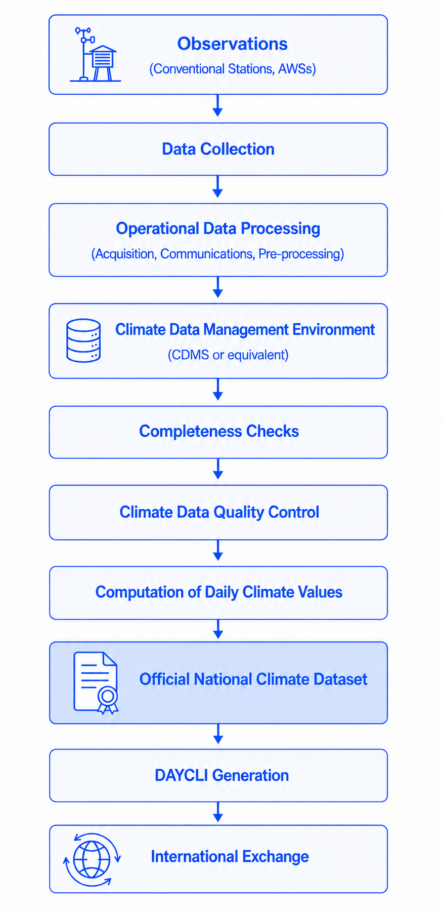
Figure 8-1 Generic Operational Workflow

Identifying Existing Documentation and Information Sources
A successful DAYCLI implementation relies on the ability to identify and review the documentation and information sources that describe how official daily climate data are produced and managed. In many NMHSs, this information has accumulated over many years and may be distributed across numerous documents, information systems and operational resources.
Ideally, this information is documented, but may be spread across observing manuals, climatological procedures, metadata repositories, CDMS documentation, database descriptions, software specifications, operational instructions, technical reports or historical project documentation. Some information may also be embedded directly within software applications, database configurations or automated processing routines rather than being explicitly documented.
The objective of this review is to identify the sources that describe the origin, processing, validation and management of the information required for DAYCLI. This review also helps identify documentation gaps, inconsistencies or undocumented operational practices that may require clarification before implementation begins.
Where documentation is incomplete or outdated, discussions with operational experts and experienced staff may be necessary to reconstruct important aspects of the production process. These exchanges frequently reveal operational knowledge that has never been formally documented but remains essential for understanding how official national daily climate datasets are produced.
This review may also provide an opportunity for NMHSs to verify that station metadata maintained in their CDMSs or in the WMO Observing Systems Capability Analysis and Review (OSCAR) database remain complete and up to date. Since OSCAR implements the WIGOS Metadata Standard (WMO-No. 1192), maintaining consistent and up-to-date station metadata supports not only the implementation of DAYCLI but also the broader interoperability of WMO observing and climate data systems.

Identifying Knowledge Holders and Operational Expertise
Although many aspects of climate data production are documented, important operational knowledge often resides with experienced staff rather than within formal documentation. Successful DAYCLI implementation therefore requires NMHSs to identify the individuals and organizational units responsible for the various stages of the national climate data production process.
Staff responsible for managing the DAYCLI implementation should consult widely with relevant personnel within their organization.
Particular attention should be given to operational knowledge that has accumulated over many years but has not been formally documented. Historical observing practices, software behaviour, data processing rules, exceptions procedures and national conventions are sometimes known only by a limited number of experienced staff. Identifying this expertise at an early stage reduces the risk of losing valuable institutional knowledge and facilitates the clarification of undocumented operational practices.
Preparing for DAYCLI implementation therefore provides an opportunity not only to identify the expertise required for implementation, but also to preserve institutional knowledge and strengthen collaboration between the different organizational units involved in the production, management and exchange of official national climate datasets.

Documenting and Preserving National Climatological Knowledge
The activities described in the previous sections frequently reveal valuable operational knowledge that is dispersed across documentation, information systems and the experience of operational staff. Consolidating this knowledge in a structured and accessible manner is an important step towards ensuring efficient access to the information required to prepare DAYCLI, regardless of the technical approach ultimately adopted for implementation.
Documenting national climatological practices, operational workflows, metadata definitions and processing procedures helps preserve institutional knowledge, improves traceability and facilitates future maintenance and development of national climate data management systems. It also reduces dependence on individual expertise and helps ensure the continuity of operational practices as staff responsibilities evolve over time.
Although the primary objective of this work is to support the implementation of DAYCLI, the resulting documentation often provides broader benefits for NMHSs. It can facilitate staff training, improve communication between organizational units, support future modernization projects and contribute to the long-term stewardship of national climate datasets.
The activities described in this chapter are also consistent with broader WMO guidance on climate data management, quality management and climate services implementation. In particular, the Guidelines on Quality Management in Climate Services (WMO-No. 1221) provide complementary guidance on the application of quality management principles to climate services, including climate data management. As part of this process, NMHSs may also wish to review the consistency of their metadata against what appears in OSCAR, and consult the relevant WMO publications referenced in Annex A.
Once these preparatory activities have been completed, NMHSs are in a much better position to identify how the information required by DAYCLI can be integrated into their existing operational environment. The following section describes how DAYCLI information can be integrated into the national operational environment and prepared for operational exchange.

Integrating DAYCLI into Existing Operational Environments
Rather than requiring changes to existing climatological practices or operational procedures, DAYCLI should be integrated into existing operational environments by identifying where the required information is produced, how it is managed and how it can be represented within the DAYCLI message. The implementation process therefore focuses on understanding and mapping existing information rather than redesigning operational systems.
NMHSs may implement DAYCLI progressively, starting with a limited number of stations, variables or metadata elements. This phased approach allows services to gain operational experience, refine workflows and expand coverage over time without disrupting existing national operations.
The following sections describe a generic approach that can be adapted to different national environments while preserving the flexibility needed to accommodate a wide variety of operational practices and technical solutions.

General Integration Principles
A DAYCLI message represents a tailored summary of information that has already been produced, quality controlled and officially accepted within the national operational environment and should be based on existing operational processes whenever possible. Official daily climate values, together with their associated metadata, should be extracted from the systems in which they are already managed rather than generated through parallel processing chains developed specifically for international exchange. This approach promotes consistency between national and international datasets, reduces duplication of effort and facilitates the long-term maintenance of the implementation.
Because operational environments differ significantly between NMHSs, no single architectural solution can be recommended. Regardless of the technical architecture adopted, the objective remains the same: to ensure that the DAYCLI message faithfully represents the official national climate record.
Implementing DAYCLI should therefore be viewed primarily as an information integration exercise rather than as the deployment of a new operational system. Once the required information has been identified, mapped and validated, it can be encoded using the DAYCLI BUFR sequence for international exchange.

Identifying Sources of DAYCLI Information
Once the general integration principles have been established, the next step is to identify where the information required by DAYCLI is maintained within the national operational environment. This activity focuses on locating existing information rather than creating new datasets or modifying operational procedures.
The information required to populate a DAYCLI message may originate from a variety of sources depending on the architecture adopted by each NMHS. Daily climate values may be maintained within a CDMS, an operational database, a data warehouse or another climate data management environment. Associated metadata may be stored in dedicated metadata repositories, station management systems, WIGOS metadata records, CDMSs or other operational information systems. In some cases, the required information may be distributed across several independent systems that together support the production of official national climate datasets.
In many NMHSs, the information required by DAYCLI is also maintained by different organizational units with distinct operational responsibilities. For example, daily climate datasets may be managed by climatological services, while observing metadata, station classifications or WIGOS information may be maintained by observing network or metadata management teams. Successful implementation therefore requires effective coordination between these different areas of expertise to ensure that the information exchanged through DAYCLI remains consistent with the official national climate record.
For each element of the DAYCLI message, NMHSs should identify the authoritative source of information from which the value or metadata will be obtained. This includes not only the daily climate values themselves, but also the associated metadata, quality information and other descriptive elements required by the DAYCLI specification.

Mapping National Information to the DAYCLI Specification
The next step is information mapping. The objective of information mapping is to determine how existing national information corresponds to the variables, metadata and descriptive elements required to formulate the DAYCLI message, while preserving nationally established definitions and operational procedures without requiring changes to national practices.
In many cases, the required information can be transferred directly to the corresponding DAYCLI element. In other situations, transformation rules may be required. These may include the conversion of data formats, the translation of national classification schemes such as QC flagging schemes to DAYCLI flags, the derivation of additional information from existing data or the association of metadata maintained in separate operational systems. Such transformations should be fully documented to ensure transparency, reproducibility and long-term maintenance of the implementation.
Particular attention should be given to the mapping of quality information. National QC schemes are generally designed to support the complete management and traceability of climate observations throughout their operational lifecycle and may therefore contain a much richer set of quality codes and status indicators than those required by the DAYCLI specification. On the other hand, DAYCLI QC flags may require information that is not routinely recorded in NMHS quality assessments: for instance, the DAYCLI flag for “Out of instrument range” may not be routinely incorporated into NMHS QC procedures and flagging. Such information may nevertheless be valuable for extremes analysis and downstream applications, including engineering applications. Finally, the quality information exchanged through DAYCLI is intended to communicate the status of the data for international exchange, rather than to reproduce the full operational history maintained by the NMHS.
As a consequence, a one-to-one correspondence between national quality codes and DAYCLI quality indicators will not always be possible. In some cases, several national quality codes may need to be mapped to a single DAYCLI flag, while in others, information maintained within national systems may not be represented in the exchanged message. For instance, for DAYCLI purposes it is immaterial whether data has been flagged via a fully automated process only, versus automated flagging of suspects that are then subject to additional, usually manual, follow-up, whereas this distinction may be important at the national level. Similarly, some observations retained within national databases for traceability purposes may not be suitable for international exchange. Such mapping decisions should be clearly documented by the NMHS to ensure transparency, consistency and reproducibility over time.
The mapping process may also identify information that is not currently available or that cannot yet be represented consistently within the existing operational environment. The above example of Out of Instrument Range is an example. Rather than delaying implementation, NMHSs should document these situations and consider progressive implementation strategies that allow additional information to be incorporated as national systems continue to evolve.

Managing Missing or Unavailable Information
During the mapping process, NMHSs may identify information required by the DAYCLI specification that is not currently available within their operational environment or cannot yet be extracted automatically. Such situations are common, particularly during the initial implementation of DAYCLI.
The absence of certain metadata or descriptive information does not necessarily prevent NMHSs from sharing DAYCLI. Where permitted by the specification, DAYCLI messages may initially be generated using the information that is available, while plans are developed to incorporate additional elements progressively as national systems evolve. This incremental approach allows operational implementation to begin without waiting for every optional or recommended information element to become available.
Where information is unavailable, NMHSs should document the reason for its absence and identify whether the limitation arises from operational practices, historical data availability, metadata management or technical constraints. This documentation provides a basis for future improvements and helps maintain transparency regarding the completeness of the exchanged information.
Similarly, where national information cannot be represented directly within the current DAYCLI specification, NMHSs should preserve this information within their national systems while exchanging the information that is supported by the international standard. The purpose of DAYCLI specification is not to replace national information models, but to provide a standardized mechanism for exchanging the information required to support international climate data exchange.
As operational systems, metadata repositories and climate data management practices continue to evolve, previously unavailable information may progressively become available for inclusion in future DAYCLI exchanges. DAYCLI implementation should therefore be viewed as an evolutionary process that can mature over time rather than as a one-time implementation project.
This progressive implementation approach should, however, be understood in relation to the distinction between Core Information and Rich Information described in Section 10. Core Information represents the minimum information required for routine operational international exchange of daily climate observations, while Rich Information comprises additional metadata and contextual information that may be progressively incorporated as national capabilities evolve.
NMHSs may therefore progressively enrich their DAYCLI messages with Rich Information and other available information without delaying implementation, while ensuring that the required Core Information is provided.

Implementing DAYCLI Encoding and Decoding
Before exchanging DAYCLI messages operationally, Members need the capability to generate and decode the DAYCLI BUFR sequence (3 07 095). Several implementation approaches may be adopted depending on national technical resources, existing software infrastructure and operational requirements.
Members may choose to:
- Develop a dedicated DAYCLI encoder and decoder based on the BUFR specification described in these Guidelines;
- Adapt an existing BUFR software library or application to support the DAYCLI BUFR sequence;
- Use an existing DAYCLI implementation or software solution where available.
The choice of implementation approach remains the responsibility of each NMHS. Regardless of the approach adopted, the resulting implementation should generate and interpret DAYCLI messages in full conformity with the DAYCLI BUFR specification.
General BUFR software libraries and implementation resources are listed in Annex A (Section 12.2). An illustrative example showing how a DAYCLI BUFR message may be produced using an existing software solution is provided in Annex B. These resources are provided for information only and do not constitute an endorsement of any particular software package or implementation.
WIS2Box provides an existing WMO community-based environment for the dissemination and exchange of WMO data and has previously supported the encoding and decoding of earlier DAYCLI BUFR sequences. Support for the current DAYCLI BUFR sequence is expected to be incorporated into WIS2Box. NMHSs already using WIS2Box may therefore consider this environment as a natural option for the operational production and exchange of DAYCLI messages as the required functionality becomes available.

Validation Before Operational Exchange
Before DAYCLI messages are exchanged operationally, NMHSs should verify that the implemented solution correctly represents the official national climate record and complies with the DAYCLI specification. Validation should confirm not only the technical correctness of the exchanged messages but also the consistency of the information extracted from the national operational environment.
Validation should include verification that the information mapping has been implemented correctly, that the authoritative sources of information are used consistently and that any transformation rules applied during message generation do not lead to unintended distortions or information loss. Particular attention should be given to quality information, metadata and derived elements whose values may depend on national operational practices.
Validation should also confirm that all Core information required by the DAYCLI specification is present before operational exchange begins. Any optional or recommended information not yet available should be documented as part of the implementation process and incorporated progressively as national capabilities evolve.
Operational testing should include, where practicable, the generation and review of representative DAYCLI messages covering a range of situations, including different observing stations, climate variables and data quality conditions. Such testing provides confidence that the implementation behaves consistently under normal operational conditions.
Validation should not be limited to the technical generation of DAYCLI messages within the NMHS. Whenever possible, NMHSs are encouraged to verify that their messages are correctly interpreted by external partners, including other NMHSs and designated international data collection centres. Such interoperability testing provides additional confidence that the exchanged information is interpreted consistently across different operational environments and software implementations.
NMHSs should also take advantage of international validation and monitoring mechanisms as they become available. For instance, future services developed within the WMO WIGOS Data Quality Monitoring System may provide valuable feedback on the quality, consistency and interoperability of exchanged DAYCLI messages, thereby supporting continuous improvement of national implementations. Global, regional or national monitoring and data centres may also contribute to the validation and monitoring of DAYCLI messages as appropriate. Successful DAYCLI implementation is achieved not simply by producing technically valid exchange messages, but by ensuring that these messages faithfully represent the official national climate record and can be interpreted consistently throughout the international climate data exchange community.

Information Requirements for International Exchange
A technically valid DAYCLI message is a prerequisite for international exchange. Such a message complies with the BUFR encoding rules and can be successfully transmitted, decoded and processed by receiving systems. The validation of BUFR encoding is, however, outside the scope of these Guidelines.
For the purpose of these Guidelines, the information contained in a DAYCLI message can be organized into two complementary categories.
Core Information represents the minimum information required for routine operational international exchange of daily climate observations. It enables receiving systems to correctly identify, interpret and integrate the exchanged observations.
Rich Information comprises additional metadata and contextual information that progressively enhance the scientific value of exchanged observations by improving their interpretation, traceability and long-term reuse.
The Core and Rich Information associated with each DAYCLI Information Family are summarized in Table 10-1.
Information Family | Core Information | Rich Information
Station Identification | - WIGOS Station Identifier | - WMO Block and Station Number  - Station Location  - Station Elevation
Observation and Processing Information | - Attribution Day  - Time Difference against UTC | - Siting and Measurement Quality Classification for Temperature  - Siting and Measurement Quality Classification for Precipitation  - Method Used to Calculate the Average Daily Temperature
Climate Variables | - Identification of each reported climate variable, together with either its observed value or an explicit indication that the value is unavailable. | - Date and Time for the Total Snow Depth observation  - Time Period (or Climatological Day) associated with each of the other reported climate variables  - QC Flag for each reported climate variable
Table 10-1 Core and Rich Information Associated with the DAYCLI Information Families
One important principle of DAYCLI is that the explicit indication that an expected observation is unavailable is itself valuable climate information. Reporting that a value is unavailable provides a clearer and more complete description of the climate record than omitting the observation altogether, as it distinguishes unavailable observations from missing or incomplete message transmission.
As national climate data management systems evolve, NMHSs are encouraged to progressively enrich their DAYCLI messages with additional metadata and contextual information. While Core Information supports routine operational exchange, Rich Information increases the scientific value of internationally exchanged climate observations and promotes their consistent interpretation and long-term reuse.

International Exchange and Use of DAYCLI Data

International Exchange of DAYCLI Messages
DAYCLI messages are defined exclusively in BUFR format and are intended for the international exchange of daily climate observations together with their associated metadata. Messages cannot be exchanged using Traditional Alphanumeric Code (TAC) or Character form for the Representation and EXchange of meteorological data (CREX) representation of DAYCLI.
DAYCLI messages may be exchanged through the communication infrastructure provided by the WMO Information System (WIS). Since the introduction of WIS 2.0, the WMO Information System has provided the operational framework for the discovery, access and exchange of meteorological, hydrological and climate information. During the transition from the legacy Global Telecommunication System (GTS), Members may continue to exchange DAYCLI messages using either infrastructure, according to their operational capabilities and the WMO transition arrangements.
Regardless of the communication infrastructure employed, DAYCLI messages remain fully interoperable through their common BUFR representation. The communication mechanism does not alter the content of the exchanged climate information or the principles described in these Guidelines.

Collection by Regional and Global Centres
DAYCLI messages may be collected, archived and disseminated by regional and global climate data centres in support of climate monitoring, climate assessments and climate services. Such centres may include WMO Regional Climate Centres (RCCs), Global Producing Centres (GPCs), Global Data Centres or other designated entities.
The collection and dissemination of DAYCLI messages by regional or global centres does not alter the national responsibility of NMHSs for the content, validation and interpretation of the observations they provide.
Regional and global centres may organise DAYCLI data within databases or information systems to facilitate regional and global access, integration and analysis. Preserving the original nationally provided DAYCLI information facilitates subsequent international exchange and ensures that authoritative national observations remain clearly distinguishable from any subsequently derived datasets, analyses or products.
As a reminder, when integrating and interpreting DAYCLI observations originating from multiple Members, the nationally defined temporal references associated with the observations should be considered. In particular, the Attribution Day and the Time Difference against UTC provide essential information for the consistent interpretation of daily climate observations, especially where national observing practices differ or where seasonal changes in local civil time are applied.
Regional and global centres may derive additional datasets, analyses and climate products by combining observations from multiple Members or by applying additional processing for specific applications. Such value-added information contributes to a wide range of regional and global climate products and services while remaining clearly distinguishable from the original nationally provided DAYCLI observations.

Supporting Climate Services
The international exchange of DAYCLI messages enables nationally validated daily climate observations to be combined at regional and global scales. By integrating observations contributed by multiple Members, regional and global centres are able to produce a wide range of datasets, analyses and products that complement national climate information and support climate monitoring, climate assessments, the detection and analysis of climate extremes, and other climate applications.
They also provide authoritative observational datasets for climate prediction and projection activities, including model evaluation, bias assessment and long-term climate analyses. By combining observations from many countries, these products provide information that would not be available from national datasets alone.
The resulting climate information supports decision-making in sectors such as agriculture, water resources, energy, public health, disaster risk reduction, infrastructure planning and urban resilience. Through this collaborative approach, NMHSs not only contribute nationally authoritative climate observations to the international community but also benefit from regional and global climate products enriched by observations from other Members. DAYCLI therefore supports both the exchange of authoritative national climate data and the development of interoperable climate services for the benefit of all WMO Members.
The climate information value chain enabled by DAYCLI is illustrated in Figure 11-1.

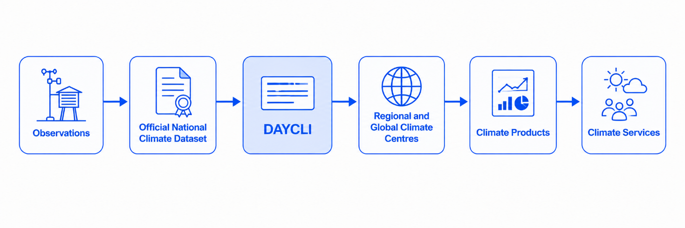
Figure 11-1 Climate Information Value Chain Enabled by DAYCLI

Annex A - References
This annex lists the principal regulatory documents, technical publications and implementation resources relevant to the implementation and use of the DAYCLI BUFR message.

WMO regulatory and technical documents
- Manual on Codes (WMO-No. 306, Volume I.2, Edition 2026).
- Manual on the WMO Integrated Global Observing System (WMO-No. 1160, Edition 2024).
- Manual on the High-Quality Global Data Management Framework for Climate (WMO-No. 1238, Edition 2023).
- Guide to Instruments and Methods of Observation (WMO-No. 8, Volume I, Edition 2024).
- Guide to Climatological Practices (WMO-No. 100, Fourth Edition, 2023).
- Guide to the WMO Integrated Global Observing System (WMO-No. 1165, Edition 2024).
- Climate Data Management System Specifications (WMO-No. 1131, Edition 2025).
- WIGOS Metadata Standard (WMO-No. 1192, Edition 2019).
- Guidelines on Quality Management in Climate Services (WMO-No. 1221, Edition 2018).
- WMO Guidelines on Surface Station Climate Data Quality Control and Quality Assurance for Climate Applications (WMO-No. 1269, Edition 2021).
- Jones, P.D., Lister, D.H., Osborn, T.J., Harpham, C., Salmon, M. and Morice, C.P., 2012: Hemispheric and large-scale land-surface air temperature variations: An extensive revision and an update to 2010. Journal of Geophysical Research, 117, D05127. https://doi.org/10.1029/2011JD017139.
- Van den Besselaar, E.J.M., Klein Tank, A.M.G., van der Schrier, G. and Jones, P.D., 2012: Synoptic messages to extend climate data records. Journal of Geophysical Research, 117, D07101. https://doi.org/10.1029/2011JD016687.

BUFR software and implementation resources
This subsection provides examples of BUFR software, libraries and implementation resources that may assist Members in developing, adapting or integrating DAYCLI encoding and decoding capabilities. The list is provided for information only and is not intended to be exhaustive or to constitute an endorsement of any particular software solution.
World Meteorological Organization
A command-line interface (CLI) and an Application Programming Interface (API) to convert data stored in a CSV file to the WMO BUFR data format.
All information available at: https://csv2bufr.readthedocs.io

World Meteorological Organization
WIS2 in a Box (WIS2Box) is a reference Implementation of a WIS2 Node including the DAYCLI template.
WIS2Box: https://docs.wis2box.wis.wmo.int/
WIS2Box training: https://training.wis2box.wis.wmo.int/csv2bufr-templates/daycli-template

Environment and Climate Change Canada (ECCC)
BUFR encoding and decoding library supporting climatological applications: https://github.com/ECCC-MSC/libecbufr
European Centre for Medium-Range Weather Forecasts (ECMWF)
Reference software library for encoding and decoding BUFR and GRIB messages, supporting C, Fortran and Python interfaces.
GitHub ecCodes: https://github.com/ecmwf/eccodes
Documentation and download: https://confluence.ecmwf.int/display/ECC/ecCodes+Home
National Institute for Space Research in Brazil (INPE)
Example implementation supporting DAYCLI BUFR encoding and decoding, provided as an open reference for NMHSs: http://mtc-m12e.sid.inpe.br/ibi/8JMKD2USNRW34T/4FTJ6U2
National Oceanic and Atmospheric Administration (NOAA)
BUFR processing library used operationally within NOAA environments: https://github.com/NOAA-EMC/NCEPLIBS-bufr

Annex B - Example Implementation of DAYCLI Production Using Existing Software (INPE, Brazil)
This annex provides an illustrative example of how DAYCLI BUFR messages may be produced using existing software solutions. The example is intended to support understanding and experimentation and does not imply endorsement of any specific implementation, software package or operational approach.
Further information on this software is available via the National Institute for Space Research in Brazil (INPE) distribution link: http://mtc-m12e.sid.inpe.br/ibi/8JMKD2USNRW34T/4FTJ6U2 or the following link: https://github.com/sergioh-pessoal/daycli_toolkit.

Context and objectives
The example implementation is based on software developed by the Brazilian National Institute for Space Research (INPE) to support the encoding and decoding of DAYCLI BUFR messages. The example software is designed to operate within typical NMHS climatological workflows and to interface with data produced and validated by a CDMS.
The objective of this example is to demonstrate how nationally validated daily climate data can be transformed into DAYCLI BUFR messages without modifying national climatological practices, definitions or quality control procedures.

Position within NMHS workflows
Daily climate values are computed, quality controlled and validated within the CDMS in accordance with national climatological practices. Once validated, the daily values are archived as the authoritative national daily climate datasets.
The DAYCLI software operates as a technical encoding layer, converting these daily climate data and associated metadata into DAYCLI BUFR messages for international exchange. The software does not perform climatological calculations or quality control (QC) decisions.

Input data formats and handling of observation time practices
The example implementation supports two alternative input data formats, reflecting different observing time practices encountered in national and historical datasets.
The first input format is intended for stations whose observations are performed at fixed and consistent times throughout the year, in line with standard WMO observing practices. This format is well suited to operational surface stations where observation schedules do not vary seasonally.
The second input format is designed to accommodate stations for which observation times may vary during the year, for example due to changes between summer and winter time.
By supporting both input formats, the example implementation facilitates the integration and preservation of diverse national and historical datasets, while allowing the resulting DAYCLI BUFR messages to clearly document Attribution Day and associated measurement time periods. This flexibility supports data continuity and transparency while preserving the national climatological values and practices from which the data originate.

Examples of input files for DAYCLI BUFR production
The input data formats are based on a Fortran Name list structure, in which groups of information are defined using blocks starting with a group name (e.g. $GroupName) and ending with a slash (/).
The initial groups contain fixed metadata, such as:
- generating centre and sub-centre identifiers;
- station location information;
- fixed measurement periods associated with each parameter.
The final group, $DATA_SECTION, contains the actual daily climate values and associated quality flags, separated by semicolons (;).

Format 1 – Fixed observation times
In Format 1, the measurement periods are defined in separate groups and are not included in the data section. For example, for maximum temperature:
&STIME_TX
HOUR=06
MINUTE=01
DT=0
/
In this example:
HOUR and MINUTE define the observation time;
DT = 0 indicates that the measurement period starts on the current Attribution Day (LMTZ);
DT = -1 indicates that the measurement period starts on the previous day (LMTZ).
The data section then contains only the reference date and the sequence of values and quality flags:
&DATA_SECTION
!date ;rr(mm); qrr; ds;qds;tsd;qtsd;tn(c);qtn; tx(c); qtx;tm(c);qtm
20220101 ;2.9; 0; ; 5 ; ; 5 ; 23.0; 0; 31.9; 0;25.9; 0
20220102 ;7,4; 0; ; 5 ; ; 5 ; 23,4; 0; 32.3; 0;26.3; 0
20220103 ;6.0; 0; ; 5 ; ; 5 ; 22.8; 0; 28.4; 0;24.7; 0
20220104 ;3.3; 0; ; 5 ; ; 5 ; 21.7; 0; 32.1; 0;25.8; 0
20220105 ;1.4; 0; ; 5 ; ; 5 ; 22.8; 0; 31.5; 0;26.4; 0
20220106 ;0.2; 0; ; 5 ; ; 5 ; 22.9; 0; 31.9; 0;26.3; 0
20220107 ;0.1; 0; ; 5 ; ; 5 ; 23.3; 0; 31.7; 0;26.9; 0
20220108 ;7.4; 0; ; 5 ; ; 5 ; 22.5; 0; 31.1; 0;25.9; 0
/
Where:
- rr = total accumulated precipitation in mm.
- ds = fresh snow
- tsd = total snow depth
- tn = minimum temperature
- tx = maximum temperature
- tm = mean temperature
Quality flags are indicated using the prefix q (e.g. qrr, qtn, etc.).
The software uses the fixed observation times and the reference date to compute the start and end times required for DAYCLI BUFR encoding.

Format 2 -Explicit measurement intervals
In Format 2, the measurement periods are explicitly defined within the data section. Each parameter is associated with its own time interval, value and quality flag.
&DATA_SECTION !!date;interval;tsd;qtsd;interval;rr;qrr;interval;fsd;qfsd;interval;tx;qtx;interval;tn;qtn;interval;tm;qtm
20220401;20220401T0601;0;7;20220401T0601-20220402T0600;15.5;0;20220401T0601-20220402T0600;0;7;20220401T0601-20220402T0600;278.95;0;20220331T1801-20220401T1800;273.35;0;20220401T0001-20220402T0000;275.05;0
20220402;20220402T0601;0;7;20220402T0601-20220403T0600;1.9;0;20220402T0601-20220403T0600;1;7;20220402T0601-20220403T0600;277.65;0;20220401T1801-20220402T1800;274.05;0;20220402T0001-20220403T0000;275.85;0
/
In this case, the software directly encodes the provided time intervals into the DAYCLI BUFR message without performing additional calculations.

Additional information
Further information, software updates and implementation examples are available through the software repository referenced above.

Annex C - Siting and Measurement Quality Classification for Temperature
Code Table 0 08 095
Code table 0 08 095
Code figure

0 | Reserved
1 | 1A
2 | 1B
3 | 1C
4 | 1D
5 | Reserved
6 | 2A
7 | 2B
8 | 2C
9 | 2D
10 | Reserved
11 | 3A
12 | 3B
13 | 3C
14 | 3D
15 | Reserved
16 | 4A
17 | 4B
18 | 4C
19 | 4D
20 | Reserved
21 | 5A
22 | 5B
23 | 5C
24 | 5D
25 | Reserved
26 | 1
27 | 2
28 | 3
29 | 4
30 | 5
31 | A
32 | B
33 | C
34 | D
35–254 | Reserved

Notes:
- Code figures 1–24 are siting classifications according to the Guide to Instruments and Methods of Observation (WMO-No. 8), Volume I, Chapter 1, Annex 1.D and Annex 1.G.
- Code figures 26–30 are siting classifications according to the Guide to Instruments and Methods of Observation (WMO-No. 8), Volume I, Chapter 1, Annex 1.D.
- Code figures 31–34 are measurement quality classifications according to the Guide to Instruments and Methods of Observation (WMO-No. 8), Volume I, Chapter 1, Annex 1.G.

Annex D - Siting and Measurement Quality Classification for Precipitation
Code Table 0 08 096

Code table 0 08 096
Code figure
0 | Reserved
1 | 1A
2 | 1B
3 | 1C
4 | 1D
5 | Reserved
6 | 2A
7 | 2B
8 | 2C
9 | 2D
10 | Reserved
11 | 3A
12 | 3B
13 | 3C
14 | 3D
15 | Reserved
16 | 4A
17 | 4B
18 | 4C
19 | 4D
20 | Reserved
21 | 5A
22 | 5B
23 | 5C
24 | 5D
25 | Reserved
26 | 1
27 | 2
28 | 3
29 | 4
30 | 5
31 | A
32 | B
33 | C
34 | D
35–254 | Reserved
Notes:
- Code figures 1–24 are siting classifications and measurement quality classifications according to the Guide to Instruments and Methods of Observation (WMO-No. 8), Volume I, Chapter 1, Annex 1.D and Annex 1.G.
- Code figures 26–30 are siting classifications according to the Guide to Instruments and Methods of Observation (WMO-No. 8), Volume I, Chapter 1, Annex 1.D.
- Code figures 31–34 are measurement quality classifications according to the Guide to Instruments and Methods of Observation (WMO-No. 8), Volume I, Chapter 1, Annex 1.G.

Annex E - BUFR DAYCLI Template
This annex reproduces the official DAYCLI BUFR sequence (3 07 095) as published in the Manual on Codes (WMO-No. 306, Volume I.2). It is recommended to use sequence 3 07 095 in preference to the earlier DAYCLI sequences 3 07 074 and 3 07 075.

3 07 095 (Daily temperatures and precipitations including snow for climate report (DAYCLI))
Table references | Element name | Element description
3 01 150 | WIGOS identifier
3 01 001 | WMO block and station number
3 01 021 | Latitude/longitude (high accuracy)
0 07 030 | Height of station ground above mean sea level
0 08 095 | Siting and measurement quality classification for temperature
0 08 096 | Siting and measurement quality classification for precipitation
0 08 094 | Method used to calculate the average daily temperature
0 08 028 | Extended time significance | = 40 Attribution date (in LMTZ)
0 08 025 | Time difference qualifier | = 3 (LMTZ-UTC)
0 26 003 | Time difference
3 01 011 | Year, month, day | Attribution date (LMTZ)
 | Total snow depth (see Note 14)
0 08 028 | Extended time significance | = 42 Time at which the daily and instantaneous measurement is made (in LMTZ)
3 01 011 | Year, month, day
3 01 012 | Hour, minute
2 04 008 | Add associated field | 8 bits long
0 31 021 | Associated field significance | = 5
0 13 013 | Total snow depth
2 04 000 | Add associated field | Cancel
 | Total accumulated precipitation (see Note 15)
0 08 028 | Extended time significance | = 41 Time period over which the daily measurement is made (in LMTZ)
3 01 014 | Time period
2 04 008 | Add associated ﬁeld | 8 bits long
0 31 021 | Associated ﬁeld significance | = 5
0 13 060 | Total accumulated precipitation
2 04 000 | Add associated ﬁeld | Cancel
 | Depth of fresh snow (see Note 15)
3 01 014 | Time period

3 07 095 (Daily temperatures and precipitations including snow for climate report (DAYCLI))
Table references | Element name | Element description
2 04 008 | Add associated ﬁeld
0 31 021 | Associated ﬁeld significance
0 13 012 | Depth of fresh snow
2 04 000 | Add associated ﬁeld | Cancel
 | Max, min, mean temperature (see Note 16)
0 07 032 | Height of sensor above local ground (or deck of marine platform)
1 06 003 | Replicate 6 descriptors 3 times
3 01 014 | Time period
0 08 023 | First-order statistics | 2 - maximum; 3 - minimum; 4 - mean
2 04 008 | Add associated ﬁeld | 8 bits long
0 31 021 | Associated ﬁeld significance | = 5
0 12 101 | Temperature/air temperature
2 04 000 | Add associated ﬁeld | Cancel
0 08 023 | First-order statistics | Cancel

