Consultation structure on climate data series homogenization

DRAFT no.1 for WMO CONSULTATIONS on homogenization

ET-DDS March 2025

Content

[1 Objectives 2](#_Toc193967346)

[2 how to reach these objectives 2](#_Toc193967347)

[2.1 Speakers 3](#_Toc193967348)

[2.2 Structure of the consultation 3](#_Toc193967349)

[3 Stewardship 4](#_Toc193967350)

[3.1 Consultation sessions 4](#_Toc193967351)

[3.2 Attendees and contacts 5](#_Toc193967352)

[3.2.1 List of Data Managers 5](#_Toc193967353)

[3.2.2 List of RCCS contacts 5](#_Toc193967354)

[3.2.3 List of homogenization experts 5](#_Toc193967355)

[3.2.4 People to contact at NCEI (NOAA), C3S? Canada? Others? 5](#_Toc193967356)

[3.2.5 List of National Climate Services Information Systems (CSIS) Focal Points 5](#_Toc193967357)

[3.2.6 List of NMHS with international datasets: UK Met Office, Météo-France, JMA, DWD, BoM 5](#_Toc193967358)

[3.2.7 Other organizations: Agrhymet, ACMAD, Universities (Delaware, CHIRPS, …) 5](#_Toc193967359)

[3.2.8 HMEI: HydroMeteorological and Environmental Industry 6](#_Toc193967360)

[3.3 Survey to prepare 6](#_Toc193967361)

[4 First Talk: Why homogenization 6](#_Toc193967362)

[5 Second Talk: Which products and climate services are directly linked to homogenized data? 7](#_Toc193967363)

[6 Third Talk: How to implement homogenization process in a department? 7](#_Toc193967364)

# Objectives

The aim of the series of consultations is to be close to the concerns of WMO Members and to plan appropriate assistance accordingly. These consultations are first and foremost an opportunity to listen to Members, and in particular to the meteorologists and climatologists who routinely manage climate data.

One of the objectives is to provide decision makers in National Meteorological and Hydrological Services (NMHS) with arguments to start/continue to homogenize their climate data. The consultation should therefore focus on answering these questions:

* Why is it important and beneficial to homogenize climate data?
* Which products and climate services are directly linked to homogenized data?

Eventually to also answer:

* How can homogenization processes be implemented in a NMHS?

The consultation is not a technical consultation on homogenization processes. Such information/expertise/training could be provided in a second phase as training/workshop sessions if requested/needed. [If too technical questions on statistics and software are asked during the consultations these questions could be forwarded to the right person outside the consultations and the answer given later.]

With this objective in mind, the homogenization consultation will briefly recall the importance of the data chain: data preservation, metadata, data rescue, enrichment of data series, data sharing and data products and services.

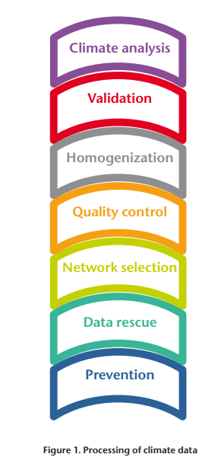

The consultation is also a mean to exchange, gather and update our knowledge on certain topics before, during and after the date on the consultations.

# how to reach these objectives

Based on:

* ET-DDS support;
* Homogenization experts and community;
* NMHSs, and other national, regional and global centers.

For these consultations the contributions of Regional Climate Centers are essential. Use cases of developing countries are desirable (status, difficulties, etc.)

## Speakers

Suggestion to invite for each consultation on homogenization people for very short talk (5 to 10 minutes):

* Representative of ET-DDS
* **Representative(s) of a Regional Climate Center that will present its status, capacity, plan to assist NMHSs in data homogenization**
* Representative(s) of a NMHS who has implemented or is (not) implementing data homogenization in its department. To have a developing country and a developed country...
* Representative of Global Centers (World Meteorological Centers, NOAA, C3S, …)

Speakers have to be contacted in advance. Presentations be ready also in advance [to reduce time consuming in technical matters during the consultation].

## Structure of the consultation

Talks defined by ET-DDS:

* First talk: Why it is important and beneficial to homogenize climate data?
* Second talk: List (1 slide) of products and climate services using homogenized data
* Third talk: How to implement homogenization processes in a NMHS

Review of the talks by experts in homogenization could be a good point to participate to a global acceptance of these consultations.

Included also interventions of RCCs, NMHSs and global, regional, national centers.

All presentations received before the consultation and tested especially for time duration.

*Agenda suggestion (so far, not to take for granted)*

|  |  |  |
| --- | --- | --- |
| **Title** | **Time duration mn (90 mn)** | **Who** |
| ***Technical duration in case of problem*** | 5 |  |
| **First talk**: Why homogenization? | 15 |  |
| NMHS use case | 9 |  |
| RCC or Regional or Global center use case | 9 |  |
| **Second talk**: Which products and climate services are directly linked to homogenized data? (1 slide) | 8 |  |
| **Third talk**: How to implement homogenization process in a department? (1 slide) | 8 |  |
| Survey request | 3 |  |
| Discussion | 20 |  |
| Thanks, and next steps | 2 |  |
| Total | 79 |  |

# Stewardship

## Consultation sessions

Be able to have talks with easy local time and languages organizations.

2 or 3 consultations for homogenization, e.g. Consultations for Normals/CLINO data.

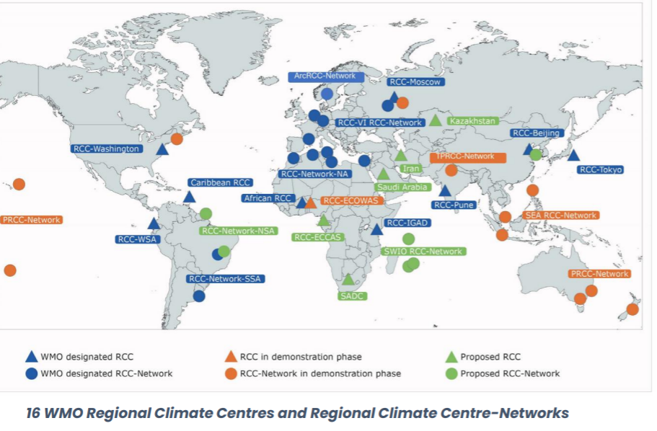

## Attendees and contacts

Contact to NMHSs, RCCs, Global Centers and people from SERCOM e.g. ET-CIDS. List of potential participants:

### List of Data Managers

+- 300 email addresses

### List of RCCS contacts

|  |  |  |  |
| --- | --- | --- | --- |
| **WMO RA** | **RCC name** | **Status** | **Name** |
| 1 | African RCC | designated | Pierre Kamsu Tamo |
| 1 | RCC-Network-NA | designated | Rachid Sebbari |
| 1 | RCC-IGAD | designated | Guleid Artan; Zewdu Segele; Zachary Atheru |
| 2 | RCC-Beijing | designated | Peiqun Zhang; Song Lianchun |
| 2 | RCC-Tokyo | designated | Kiyotoshi Takahashi |
| 2 | RCC-Pune | designated | Sreejith Op |
| 2 | RCC-Moscow | designated | Valentina Khan |
| 3 | RCC-WSA | designated | Felipe Costa do Carmo |
| 3 | RCC-Network-SSA | designated | María de los Milagros Skansi |
| 4 | RCC-Washington | designated | Wassila Thiaw |
| 4 | Caribbean RCC | designated | Adrian Trotman; Cedric Meerbeeck |
| 6 | RA VI RCC-Network | designated | Stefan Roesner |
| 1 | RCC-ECOWAS | in demonstration | Seydou Traore |
| 5 | PRCC-Network | in demonstration | Simon McGree; Nihmei Salesa |
| 5 | SEA RCC-Network | in demonstration | Thea Turkington |
|  | ArcRCC-Network | in demonstration | Helge Tangen |
| 1 | RCC-ECCAS | in demonstration | Pascal Moudi |
| 1 | RCC-SADC | in demonstration | Surekha Ramessur |
| 2 | TP-RCC | in demonstration | Lijuan Ma |

### List of homogenization experts

mailing list of Monika Lakatos from Hungary: [homogenisation@met.hu](mailto:homogenisation@met.hu), with 180 members

### People to contact at NCEI (NOAA), C3S? Canada? Others?

GHCN data base uses homogenized data. <ftp://ftp.ncdc.noaa.gov/pub/data/ghcn/v3/software/>

Berkeley Earth et DCENT.

### List of National Climate Services Information Systems (CSIS) Focal Points

<https://community.wmo.int/en/governance/commission-membership/national-climate-services-information-systems-csis-focal-points>

### List of NMHS with international datasets: UK Met Office, Météo-France, JMA, DWD, BoM

### Other organizations: Agrhymet, ACMAD, Universities (Delaware, CHIRPS, …)

### HMEI: HydroMeteorological and Environmental Industry

<https://www.hmei.org/>

# Use cases Contributions

Positive answers

? (done by)

|  |  |  |  |
| --- | --- | --- | --- |
|  | RCC | OK |  |
| Argentina | Yes | Yes | "Maria de los Milagros Skansi" [mms@smn.gob.ar](mailto:mms@smn.gob.ar), "Hernan Veiga" <hernan.veiga@smn.gob.ar> |
| Australia BoM | Yes | Yes | "simon mcgree" [simon.mcgree@bom.gov.au](mailto:simon.mcgree@bom.gov.au) "Blair Trewin" <blair.trewin@bom.gov.au> |
| Hungaria |  | Yes | "Mónika Lakatos" <lakatos.m@met.hu> |
| India (IMD) |  |  | "A D Tathe" [adtathe.imd@gmail.com](mailto:adtathe.imd@gmail.com), "kripan ghosh" <kripanghosh@yahoo.co.in> |
|  |  |  |  |
| Madagascar |  | Yes | "Luc Randriamarolaza" <luc.randriamarolaza@gmail.com> |
| SADEC | Yes | ? | mail the 19/03/2025 to "Surekha Ramessur" <sramessur@sadc.int> |
|  |  |  |  |

2 consultations for homogenization

1. Australia (RCC) + Madagascar -> French-English
2. Argentina (RCC) + India (?) -> Spanish-English

# Survey to prepare

A survey will be addressed to all attendees (link and QR-Code given during the consultation). The survey will have to be filled in in 1- or 2-week time after the assigned consultation.

It should be friendly, easy and short, and should include:

* Name
* Country
* Organization: NMHS, RCC, Universities, companies…
* e-mail
* Is your organization doing data homogenization? Is-it an on-going work?
* If not
  + Why? No need, not a priority, no knowledge, no expertise, no budget, no human resource?
  + Do you plan to launch homogenization process in the future?
* Free text for comment

## UN Countries development status and UN Map official map

Need a list of all NMHSs with official country names, Region, Developing countries, LDC, Landlocked countries, SIDS.

Need the official UN Map to transcribe feedback to world map.

**Reinaldo** to concentrate of the list of NMHSs (Spreadsheet) and UN Map for the basement of the future survey with all the countries and their development UN status.

WMO contact: Veronica Grasso ("Veronica Grasso" [VGrasso@wmo.int)](mailto:VGrasso@wmo.int%29).

"Nakiete Msemo" <NMsemo@wmo.int> who sent the list of countries and also:

|  |
| --- |
| <https://www.un.org/ohrlls/content/list-sids> |
| <https://unctad.org/topic/least-developed-countries/list> |
| <https://blogs.worldbank.org/en/opendata/world-bank-country-classifications-by-income-level-for-2024-2025> |

In charge of the UN Map in WMO: "Timo Proescholdt" [tproescholdt@wmo.int](mailto:tproescholdt@wmo.int), mail sent by Reinaldo the 21 march 2025

GIS Geographic Information System? QGIS ?

**Denis** to check the possibility for quick and easy survey with smartphone and PC.

**Urip:** “*To answer the survey, it needs to be explained what the definition of doing data homogenization. Because, the respondents have a different understanding of doing homogenization.* “

**Sohyun Na from WMO (WMO Conference) :**

18/03/2025:

*« At WMO Conferences, we normally use Microsoft Forms for our post-meeting surveys on meeting logistics, while I know that some other departments use Mentimeter for this purpose. You also have the option to decide whether the survey results should be anonymous or not.*

*Separately, for registration and tracking the list of participants, I suggest enabling our usual Zoom registration page to collect their names, emails, and affiliated organizations. Since we will be using Zoom for this meeting, this would be the easiest.*

*This is my suggestion, but let me know your thoughts.*

*Best regards,So* »

# First Talk: Why homogenization?

Lead: Jose

See:

<https://wmoomm.sharepoint.com/sites/wmocpdb/eve_activityarea/Forms/AllItems.aspx?ga=1&id=%2Fsites%2Fwmocpdb%2Feve%5Factivityarea%2FClimate%20Services%2FSERCOM%2D3%2Fet%2Ddds%2FConsultations%2FHomogenization&viewid=e07d9046%2D993e%2D4365%2D901c%2D919a3acaa1bd>

# Second Talk: Which products and climate services are directly linked to homogenized data?

1. Data homogenization, fill in data gap, data rescue);
2. Data access portal;
3. Trend / Indices / Diagnostic/ on historical and present data on climate change (including Normals data);
4. Model verification/calibration (climate model, reanalysis, seasonal forecasting, etc.);
5. Other Specific climate services (health, energy, agriculture, etc.), Analysis, Research;

|  |  |  |  |
| --- | --- | --- | --- |
|  |  |  | Contact point |
| () | 2 | [Homogenised daily and monthly dataset for the Pacific Islands](file:///C:\Users\stuberd\Documents\Documents\mission_projet\Pays_Organisations\OMM\CCl-Next\SERCOM\SERCOM%202024-2028\ET-DDS\Task\Consultations\Homogenization\Structure\Homogenised%20daily%20and%20monthly)%20dataset%20for%20the%20Pacific%20Islands) | "simon mcgree" <simon.mcgree@bom.gov.au> |
| Latvia Latvian Environment, Geology and Meteorology Centre | 1 |  | [**klimats@lvgmc.lv**](mailto:klimats@lvgmc.lv), dace.zandersone@lvgmc.lv |
| Latvia Latvian Environment, Geology and Meteorology Centre | 3 |  | [**klimats@lvgmc.lv**](mailto:klimats@lvgmc.lv), dace.zandersone@lvgmc.lv |
| Latvia Latvian Environment, Geology and Meteorology Centre | 4 |  | [**klimats@lvgmc.lv**](mailto:klimats@lvgmc.lv), dace.zandersone@lvgmc.lv |
| France Météo-France | 2 | [Public access for long-term homogenized series](https://www.data.gouv.fr/fr/datasets/donnees-changement-climatique-lsh-longues-series-homogeneisees/) | denis.stuber@meteo.fr |
| France Météo-France | 3 | [CLIMAT HD](https://meteofrance.com/climathd) | denis.stuber@meteo.fR |
| France Météo-France | 4 | Evaluation of the CNRM-AROME evaluation model forced by ERA5 over the period 1959-2024 and check that the model reproduces temperature trends close to those observed (in progress). | "CAILLAUD Cécile" <cecile.caillaud@meteo.fr> |
|  |  |  |  |
| Spain (AEMET) | 1 | [Link-1](https://www.aemet.es/documentos/es/serviciosclimaticos/vigilancia_clima/resumenes_climat/mensuales/2024/res_mens_clim_2024_02.pdf), [Link-2](https://www.aemet.es/documentos/es/serviciosclimaticos/vigilancia_clima/resumenes_climat/mensuales/2024/res_mens_clim_2024_02.pdf) | "Jose Guijarro" <jaguijarro21@gmail.com>; |
| Spain (Universidad de Zaragosa) | 1 | <https://clices.unizar.es/es/>  [Data information](https://urldefense.com/v3/__https:/digital.csic.es/handle/10261/354840__;!!D9dNQwwGXtA!WHRdiA1pYVal-CURvCpYJiT776TVtpUqdeQyr6zcX4h9zk5qY0yMrb1csAV38LPv5lrf8WMS8c4XH8KP_FKHm_0pxA$) | "Beguería Portugués, Santiago" <sbegueria@eead.csic.es>; "Carlos Gonzalez" <jcgh@unizar.es>; |
| Ukrainia Ukrainian Hydrometeorological Institute | 2 | <https://doi.org/10.1002/gdj3.70000> | "Oleg Skrynyk" <oleg.skrynyk@urv.cat>; |
| USA NOAA/NCEI | 1 | Global Historical Climatology Network monthly ([GHCNm](https://www.ncei.noaa.gov/products/land-based-station/global-historical-climatology-network-monthly" \t "_blank)) |  |

# Third Talk: How to implement homogenization process in a department?