Table of Contents

1. Purpose 2

1.1. Intended Audience 2

1.2. Intended Use 2

1.3. Scope 2

1.4. Definitions and Acronyms 2

2. Overall System Description 3

2.1. Use Case Diagrams 3

2.2. System Architecture 4

2.3. Functional Requirements 4

2.3.1. Start Up and Main Menu 4

2.3.2. Dispense Black Coffee 5

2.3.3. Dispense Hot Water 6

2.3.4. Remote Access 7

2.3.5. Authentication Services 8

2.4. Non-Functional Requirements 9

2.4.1. Power Management 9

3. Software Architecture 10

3.1. Static Software Architecture 10

# Purpose

## Intended Audience

This SRS document describes the System Requirements and Software Design for an IoT Coffee maker and the target audience are System and Software Engineers working on the development of this project.

## Intended Use

The SRS defines the overall System Architecture and Requirements as well as the Software Architecture and Design. This document is also contains the definition of the System Requirements which shall be used as the input for System Test cases and Software Unit Test cases.

## Scope

## Definitions and Acronyms

|  |  |
| --- | --- |
| **Acronym** | **Description** |
| IR | Infra Red |
| LED | Light Emitting Diode |
| NFC | Near Field Communication |
| SW | Software |
| HW | Hardware |

# Overall System Description

## Use Case Diagrams

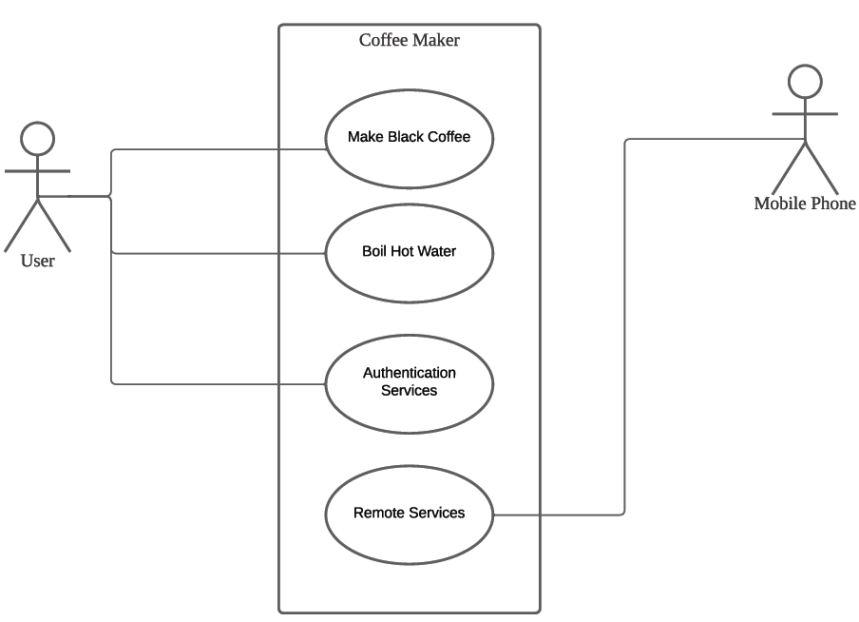

## System Architecture

The System Architecture



DC Motor

Servo Motor

Heater

Water Temperature Sensor

SPI_ADC_CH01

LCD

I2C

**Raspberry Pi Development Board**

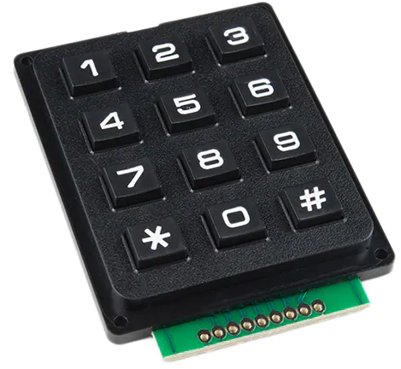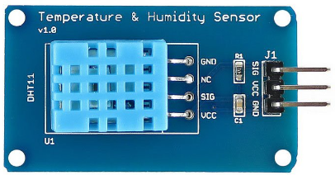

Water Temperature Sensor

## Functional Requirements

### Start Up and Main Menu

|  |  |
| --- | --- |
| **REQ_ID** | **Requirement** |
| REQ-01 | When the Coffee Maker is first powered ON, the main menu with the text below shall be displayed on the LCD scree  Line 1 = “1.Prepare Coffee”  Line 2 = “2. Power Off” |
| REQ-02 | In the main menu defined in REQ-01, if the option “1. Prepare Coffee” is selected on the keypad, then the following menu shall be displayed on the LCD screen  Line 1 = “Black Coffee”  Line 2 = “Hot Water” |
| REQ-03 | In the main menu defined in REQ-01, if the option “2. Power Off” is selected, the LCD should display the following text for 2 seconds and then turn off the LCD display and back light and enter into the Low Power Mode state defined in the State Machine in REQ-xx  Line 1 = “Thank you”  Line 2 = “Powering Off” |

### Dispense Black Coffee

|  |  |
| --- | --- |
| **REQ_ID** | **Requirement** |
| REQ-04 | From the main menu, if the user selects “1. Prepare Coffee 🡪 1. Black Coffee” then the flowchart defined in Figure 1 shall be implemented. |

Start

Turn ON heating element to boil water

Turn OFF heating element

Water Temperature ≥100

Turn ON motor to grind coffee beans for 5 seconds

Rotate Servo 30° position for 5 seconds to dispense coffee

Rotate Servo back to 0° position

Display “Black Coffee Ready” for 3 seconds

Display the Main Menu on LCD

End

**N**

**Y**

**REQ-05**

**REQ-06**

**REQ-07**

**REQ-08**

**REQ-09**

**REQ-10**

**REQ-11**

**REQ-12**

**Figure 1**

### Dispense Hot Water

|  |  |
| --- | --- |
| **REQ_ID** | **Requirement** |
| REQ-13 | From the main menu, if the user selects “1. Prepare Coffee 🡪 2. Hot Water” then the flowchart defined in Figure 2 shall be implemented. |

Start

Turn ON heating element to boil water

Turn OFF heating element

Water Temperature ≥100

End

Beep Buzzer for 500ms

**N**

**Y**

**REQ-14**

**REQ-15**

**REQ-16**

**REQ-17**

**Figure 2**

### Remote Access

The Coffee Maker supports “Remote Access” to monitor the coffee maker functions, set events and also remote

|  |  |
| --- | --- |
| **REQ_ID** | **Requirement** |
| REQ-18 | The user shall be able to login to the IP address of the IoT Coffee Maker to view a web page |
| REQ-19 | The internal Web Server on the IoT Coffee Maker shall allow the user to monitor the following,   * Water Level using Moisture Sensor * Ambient Room Temperature |
| REQ-20 | The internal Web Server on the IoT Coffee Maker shall allow the user to control the following,   * View the Main Menu defined in REQ-01 * Trigger all functions in the main menu remotely |

### Authentication Services

For commercial variants of the coffee maker, an added feature is to authenticate the user log in to use the coffee maker via an NFC card reader before unlocking the functions on the coffee maker for the user.

|  |  |
| --- | --- |
| **REQ_ID** | **Requirement** |
| REQ-21 | For commercial variants of the IoT Coffer Maker with NFC reader, upon Power On the LCD shall display the following  Line 1 = “Tap card to unlock”  Line 2 = Display time “hh:mm:ss” |
| REQ-22 | If the NFC reader detects a NFC card that has been registered in the internal data base then the coffee maker shall display the main menu defined in REQ-01 |
| REQ-23 | If the NFC reader detects an unregistered NFC card, the following shall be implemented,   * LCD shall display the following. * Buzzer shall be activated based on the timing diagram below   **500ms**  **500ms**  **500ms**  **500ms**  **Buzzer**  **ON**  **OFF** |

## Non-Functional Requirements

### Power Management

The IoT Coffee Maker has 2 Power Modes as defined in the State Machine diagram in Figure xx below. The transitions between the Low Power Mode and High Power Mode are triggered by the events labelled “evEnterLPM” and “evEnterHPM”.

Conditions for trigger the events are defined in the requirements below.

**Figure 3**

High Power Mode

Low Power Mode

evEnterLPM

evEnterHPM

|  |  |
| --- | --- |
| **REQ_ID** | **Requirement** |
| REQ-24 | **“evEnterLPM” Trigger Condition 1**   * When the option “2. Power Off” is selected in the main menu |
| REQ-25 | **“evEnterHPM” Trigger Condition 2**   * When the coffee maker has not dispensed any coffee for at least 1 minute |
| REQ-26 | **“evEnterHPM” Trigger Condition 1**   * When the user presses any button on the key pad |
| REQ-27 | **“evEnterHPM” Trigger Condition 2**   * When the Ultrasonic Distance Sensor detects an object is within 10 cm of the coffee maker |
| REQ-28 | **“evEnterHPM” Trigger Condition 3**   * When the IR sensor detects that the coffee container has been removed |

# Software Architecture

## Static Software Architecture

The Software Architecture defines the various Software Components that are developed to realize the implementation of the system requirements.

**Hmi.py**

**Power_Mgt.py**

**Application Layer**

**Hardware Abstraction Layer (HAL)**

**Hal_adc.py**

**hal_usonic.py**

**NFC**

**hal_servo.py**

**Black_Coffee.py**

**Hot_Water.py**