

Automatic Hydroponics

SRS Document by Group B



Soh Chuan Xun Matthew (2319331)

Ng Ding Xuan Nahilus (2319191)

Gan Yu Heng (2319696)

Khant Si Thu (2330167)

Group members

Table of Contents

1. Purpose 2
   1. Intended Audience 2
   2. Intended Use 2
   3. Definitions and Acronyms 2
2. Overall System Description 3
   1. Use Case Diagrams 3
   2. System Architecture 4
   3. Functional Requirements 5
      1. Monitor Key Parameters 5
      2. Control UV Light Source 5
      3. Control Fan 5
      4. Control Pump 5
      5. Dashboard 6
   4. Non-Functional Requirements 7
3. Software Architecture 8
   1. Static Software Architecture 8

# 1. Purpose

## Intended Audience

This SRS document describes the System Requirements and Software Design for an Automated Gardening System, and the target audience are System and Software Engineers working on the development of this project.

## Intended Use

The SRS defines the overall System Architecture and Requirements as well as the Software. Architecture and Design. This document also contains the definition of the System. Requirements which shall be used as the input for System Test cases and Software Unit Test cases.

## Definitions and Acronyms

|  |  |
| --- | --- |
| **Acronym** | **Description** |
| LED | Light Emitting Diode |
| EC | Electrical Conductivity |
| PH | Potential of Hydrogen |
| AT | Ambient Temperature |
| UV | Ultraviolet |
| SW | Software |
| HW | Hardware |

# 2. Overall System Description

## 2.1. Use Case Diagram

Raspberry Pi 4 Model B Board

## System Architecture

ADC

EC Sensor (Moisture sensor)

AT Sensor (DHT11)

GPIO21

ADC

Humidity Sensor (DHT11)

GPIO21

Light Sensor (LDR)

GPIO04

PH Sensor (Potentiometer)

GPIO24

GPIO26

Pump (Servo motor)

UV light source (LED)

PWM

Fan

(DC Motor)

PWM

GPIO23

LCD Display

GPIO2,3

I2C

## Function Requirements

* + 1. Monitor Key Parameters

|  |  |
| --- | --- |
| REQ-ID | Requirements |
| REQ-01 | The light intensity of the surroundings will be measured in the background. A reading should be taken every 5 seconds. |
| REQ-02 | The ambient temperature will be measured in the background. A reading should be taken every 5 seconds. |
| REQ-03 | The relative humidity will be measured in the background. A reading should be taken every 5 seconds. |
| REQ-04 | The pH level of the solution will be measured in the background. A reading should be taken every 5 seconds. |
| REQ-05 | The electrical conductivity of the solution will be measured in the background. A reading should be taken every 5 seconds. |

* + 1. Control UV Light Source

|  |  |
| --- | --- |
| REQ-ID | Requirements |
| REQ-06 | If the light intensity level of the surroundings is < 1000 lux or about 5pm light level, then the UV light source (LED) will turn on.  While the light source is on, it will only turn off if the light intensity level of the surroundings is > 1100 lux. |

* + 1. Control Fan

|  |  |
| --- | --- |
| REQ-ID | Requirements |
| REQ-07 | Desired ambient temperature (setpoint) = 25°C.  Maximum ambient temperature = 32°C.  The speed of the fan will be controlled with a PID controller to bring the temperature to the desired temperature.  If the average temperature over 1 minute is more than the maximum temperature, an alert will be sent to the dashboard. |

* + 1. Control Pump

|  |  |
| --- | --- |
| REQ-ID | Requirements |
| REQ-08 | Desired EC level should be set by the user.  If the EC level is below the desired EC level, a pump (Servo Motor) turns on once to dispense additional nutrient solution into the hydroponics solution. Then, 30 seconds must have elapsed before the pump can be activated again.  For one activation of the pump, the servo motor moves to the 90° position and back to the 0° position. |

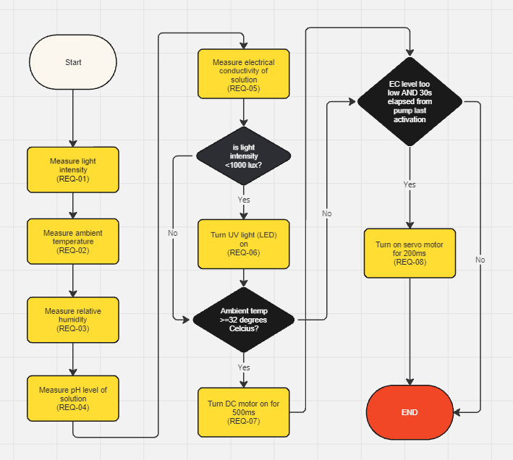

* + 1. Dashboard

|  |  |
| --- | --- |
| REQ-ID | Requirements |
| REQ-09 | The user shall be served a web page (dashboard) when they visit the IP address of the server. |
| REQ-10 | The dashboard shall require user authentication with username and password to be accessed and use a persistent cookie so that the user does not have to sign in again for 30 days. |
| REQ-11 | The dashboard shall allow the user to visualize data in real time from the following sensors:   1. AT sensor 2. PH sensor 3. EC sensor 4. Humidity sensor 5. Light sensor   And display the following parameters of the system:   1. Status of UV light source (ON/OFF, ON duration) 2. Status of fan (speed, ON duration) 3. Status of pump (ON/OFF) |
| REQ-12 | The dashboard shall provide user controls to create, edit or delete configuration profiles with the following parameters:   1. Name of profile 2. Desired EC level to turn on the pump 3. Light intensity level (in lux) to turn on and off the UV light source 4. Ambient temperature setpoint (in °C) 5. Maximum ambient temperature (in °C)   The system will use the configuration profile chosen by the user from a dropdown menu. A default profile shall be created with the parameters defined in earlier requirements. |
| REQ-13 | The dashboard shall allow the user to specify Wi-Fi SSID and password. The Raspberry Pi should try to automatically connect to this Wi-Fi. If connection fails after retrying for 5 minutes, it should automatically create an access point, with the name “Gardening System”. It will switch to Wi-Fi once it is available.  On the LCD screen display the following:  Line 1: [IP address to dashboard]  Line 2: [Port to dashboard] / [AP/Wi-Fi] |

* 1. Non-Function Requirements

|  |  |
| --- | --- |
| REQ-ID | Requirement |
| REQ-14 | The user should be informed that the power rating of the Raspberry Pi 4B is 5.0V and 3.0A. |
| REQ-15 | The type and concentration of nutrient solution is to be determined by the user from the type of plant and nutrient solution. Then, the desired EC level to turn on the pump should be set by the user from the dashboard with a configuration profile. |
| REQ-16 | The system is expected to respond within 5 seconds upon changes that occur towards the perimeter monitored. |
| REQ-17 | Wi-Fi should be available for the system to use Wi-Fi instead of access point.  Otherwise, the system will be in access point mode and the user should connect to the Raspberry Pi’s access point (hotspot) to access the dashboard. |
| REQ-18 | The raspberry pi is expected to be in a cool and dry location to ensure maximum work efficiency and life expectancy (5-10 years) unless overclocked with frequent data read/write. |

1. Software Architecture
   1. Static Software Architecture

The software architecture defines the various software components that are developed to realize the implementation of the system requirements.

|  |  |
| --- | --- |
| **Application Layer** | **Hardware Abstraction Layer (HAL)** |
| PID.py | hal_adc.py |
| dashboard.py | hal_servo.py |
| monitor_parameters.py | hal_led.py |
| control_pump.py | hal_dc_motor.py |
| control_fan.py | hal_temp_humidity_sensor.py |
| control_light_source.py | hal_lcd.py |
| main.py |  |
| control_lcd.py |  |