Table of Contents

Document Version 2

1. Purpose 3

1.1. Intended Audience 3

1.2. Intended Use 3

1.3. Scope 3

1.4. Definitions and Acronyms 3

2. Overall System Description 4

2.1. Use Case Diagrams 4

2.2. System Architecture 5

2.3. Functional Requirements 6

2.3.1. Function xxxx 6

2.3.2. Function yyyy 7

2.3.3. Function zzzz 7

3.1. Non-Functional Requirements 8

3.1.1. Non-Functional Requirement xxxx 8

4. Software Architecture 9

4.1. Static Software Architecture 9

# Document Version

|  |  |  |  |  |
| --- | --- | --- | --- | --- |
| No | Update | Name | Date | Version |
| 1. | Initial version |  |  | 1.0 |

# Purpose

## Intended Audience

This SRS document outlines the System Requirements and Software Design for a Library Book Reservation and Collection System. The intended audience is citizens who wish to borrow or return books to the library.

## Intended Use

The SRS defines the overall System Architecture and Requirements as well as the Software Architecture and Design. This document is also contains the definition of the System Requirements which shall be used as the input for System Test cases and Software Unit Test cases.

## Scope

## Definitions and Acronyms

|  |  |
| --- | --- |
| **Acronym** | **Description** |
| NRIC | National Registration Identity Card |
| SP | Singapore Polytecyhnic |
| RFID | Radio-frequency identification |
| SW | Software |
| HW | Hardware |

# Overall System Description

## Use Case Diagrams

Add Use Case diagrams here ..

Library Book Reservation and Collection System

Dispense and collect books

Reserve books user selected

RFID card reader to collect fines

Mobile devices

user

Scan NRIC or SP Student Card

Automated services

Remote services

## System Architecture



DC Motor

Servo Motor

Heater

Water Temperature Sensor

SPI_ADC_CH01

LCD

I2C

**Raspberry Pi Development Board**

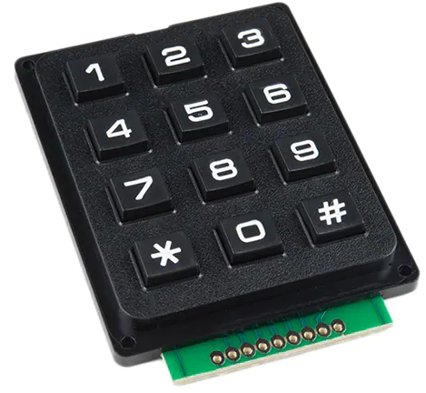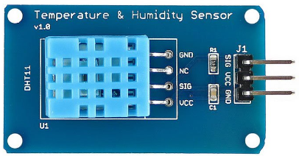

Water Temperature Sensor

## Functional Requirements

### Function Reserving Books

To allow users to reserve books using the system.

|  |  |
| --- | --- |
| **REQ_ID** | **Requirement** |
| REQ-01 | The system will allow the user to reserve books via a website or Mobile app. |
| REQ-02 | If reserved books are not collected within 5 days from reserved date, it is automatically cancelled. |
| REQ-03 | The user can select library branch to reserve books from. |

### Function Collecting Books

To allow users to collect reserved books.

|  |  |
| --- | --- |
| **REQ_ID** | **Requirement** |
| REQ-04 | User can collect books reserved from the system implementing the flowchart defined in Figure 1. |

REQ-05

Start

Scan SP student card or NRIC at RFID scanner

REQ-06

Is the card valid?

No

REQ-08

Yes

REQ-07

Does user have outstanding fines?

Pay fine

No

REQ-09

Dispense Book

End

**Figure 1**

### Function Borrowing Books

1. Allows user to borrow books

|  |  |
| --- | --- |
| **REQ_ID** | **Requirement** |
| REQ-10 | They system will allow user to borrow a maximum of 10 books. |

### Function collecting fines

1. Allows user to borrow books

|  |  |
| --- | --- |
| **REQ_ID** | **Requirement** |
| REQ-11 | Users must pay any outstanding fines at the machine using the RFID card reader before being allowed to collect their book reservations |
| REQ-12 | A fine of $0.15 per book each day after return date |

### Function Loan Periods

1. The time loaned to users per book

|  |  |
| --- | --- |
| **REQ_ID** | **Requirement** |
| REQ-11 | Each book has a loan period of 18 days |
| REQ-12 | Each book can be renewed only once for an additional 7 days. |

### Function Returning Books

1. Allows users to return books

|  |  |
| --- | --- |
| **REQ_ID** | **Requirement** |
| REQ-13 | The system will allow the user to return books implementing the flow chart in Figure 2. |

Start

REQ-15

REQ-14

User pays fine of $0.15 for each day after the return date

Is book overdue?

Yes

No

Accept book return

REQ-16

End

## Non-Functional Requirements

### Non-Functional Requirement xxxx

Add short description here …

|  |  |
| --- | --- |
| **REQ_ID** | **Requirement** |
| REQ-xx |  |
| REQ-xx |  |

# Software Architecture

## Static Software Architecture

The Software Architecture defines the various Software Components that are developed to realize the implementation of the system requirements.

**PowerMgt**

**HMI**

**Application Layer**

**Hardware Abstraction Layer (HAL)**

**ADC**

**USonic**

**NFC**

**Servo**

**RainSens**

**BlackCoffee**

**HotWater**