Table of Contents

Document Version 2

1. Purpose 3

1.1. Intended Audience 3

1.2. Intended Use 3

1.3. Scope 3

1.4. Definitions and Acronyms 3

2. Overall System Description 4

2.1. Use Case Diagrams 4

2.2. System Architecture 5

2.3. Functional Requirements 6

2.3.1. Function-Monitoring 6

2.3.2. Function-Adjustment 7

2.3.3. Function Dashboard 7

3.1. Non-Functional Requirements 8

3.1.1. Non-Functional Requirement xxxx 8

4. Software Architecture 9

4.1. Static Software Architecture 9

# Document Version

|  |  |  |  |  |
| --- | --- | --- | --- | --- |
| No | Update | Name | Date | Version |
| 1. | Initial version | Dennis  Yan Tiong  Reynard  Heng Jeang | 17/6/2024 | 1.0 |
| 2. | Updated Adjustment Function Requirements | Dennis | 23/6/2024 | 1.1 |
| 2. | Updated Dashboard Function Requirements | Heng Jeang | 23/6/2024 | 1.1 |
| 2. | Added in Monitoring Function Requirements | Yan Tiong | 23/6/2024 | 1.1 |
| 2. | Added in Dashboard Function Requirements | Reynard | 23/6/2024 | 1.1 |
| 3. | Added in Flowcharts for Adjustment Functions  Added in Use Case Diagram | Dennis | 24/6/2024 | 1.2 |
| 3. | Added in Flowcharts for Dashboard Functions | Reynard | 24/6/2024 | 1.2 |
| 3. | Added in Application Layer | Heng Jeang | 24/6/2024 | 1.2 |
| 4. | Added in System Architecture | Yan Tiong | 25/6/2024 | 1.3 |
| 5. | Added in Static Software Architecture HAL | Dennis | 26/6/2024 | 1.4 |
| 6. | Updated the requirements and flowchart to reflect base release of the project. | Dennis  Reynard | 8/8/2024 | 1.5 |

# Purpose

## Intended Audience

This SRS document describes the System Requirements and Software Design for an Automated Gardening System, and the target audience are System and Software Engineers working on the development of this project.

## Intended Use

The SRS defines the overall System Architecture and Requirements as well as the Software Architecture and Design. This document also contains the definition of the System Requirements which shall be used as the input for System Test cases and Software Unit Test cases.

## Scope

The automatic gardening system aims to support the monitoring and control of a hydroponic system, allowing for the best plant growth in a limited area. This is achieved through the continuous monitoring of the key parameters (pH level of the solution, Ambient temperature, Relative humidity, Ambient lighting intensity, EC (Electrical Conductivity) level).  
The data collected from these sensors will be displayed on graphs/charts on a dashboard implemented on the web browser. This system will contribute to Singapore's goal of increasing local food production by providing an efficient and automated solution for hydroponic farming

## Definitions and Acronyms

|  |  |
| --- | --- |
| **Acronym** | **Description** |
| IR | Infra Red |
| LED | Light Emitting Diode |
| NFC | Near Field Communication |
| SW | Software |
| HW | Hardware |
| EC | Electrical Conductivity |
| LDR | Light Dependent Resistor |

# Overall System Description

## Use Case Diagrams

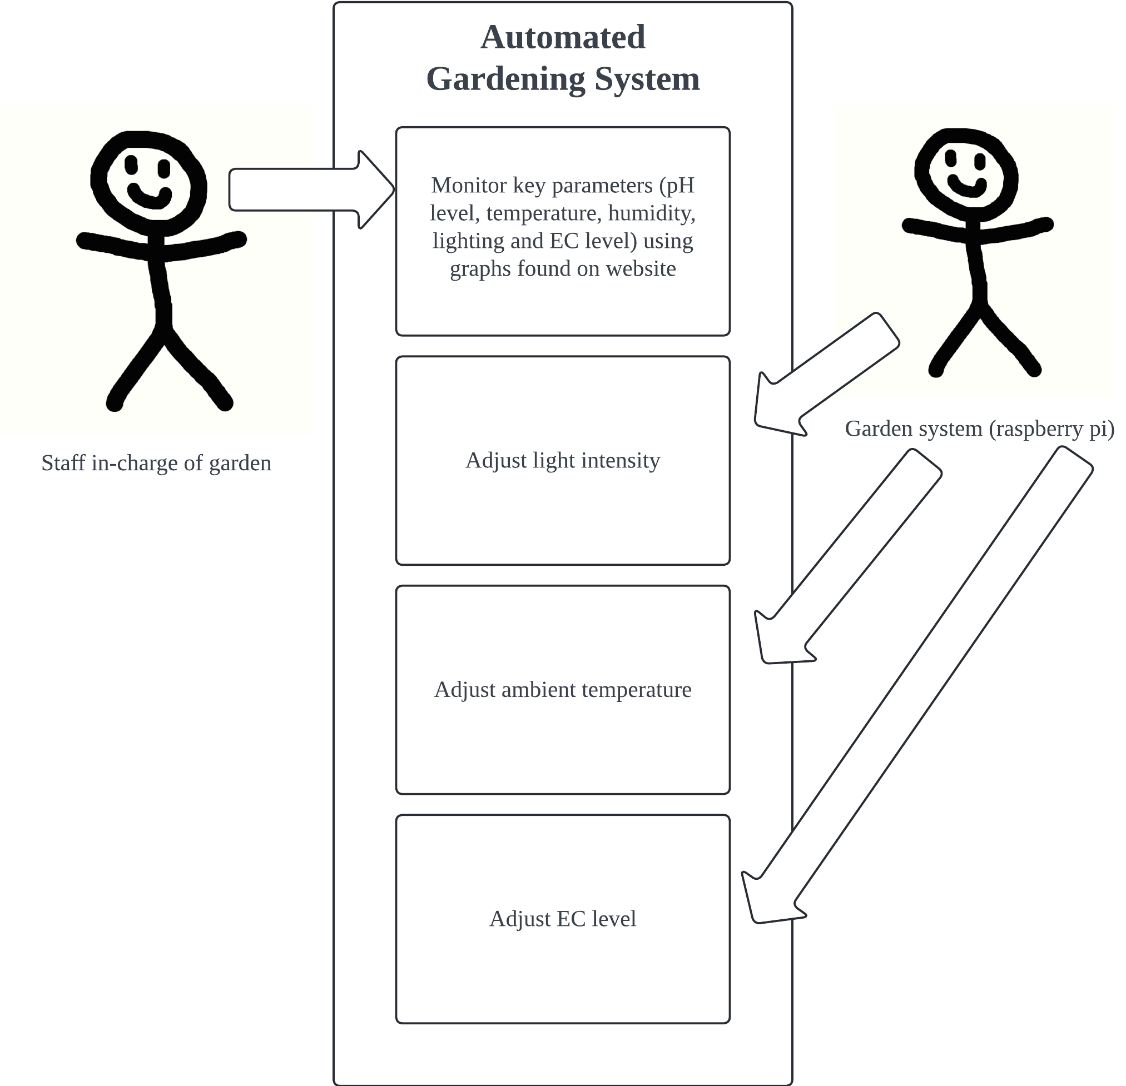

after evaluating reading of light

after evaluating reading of ambient temperature

after evaluating reading of EC level

## System Architecture

## Functional Requirements

### Function - Monitoring

The monitoring functions are used to monitor 5 different factors continuously, this allows the solution to adjust any of the factors accordingly.

|  |  |
| --- | --- |
| **REQ_ID** | **Requirement** |
| REQ-01 | The system shall monitor the pH level of the hydroponic solution continuously. In this case, we are using the IR sensor to imitate the pH level as we are unable to measure pH level with the sensors we have.The system shall return the data when prompted. |
| REQ-02 | The system shall monitor the ambient temperature continuously using the DHT temperature and humidity sensor. The system shall return the data when prompted. |
| REQ-03 | The system shall monitor the relative humidity continuously using the DHT temperature and humidity sensor. The system shall return the data when prompted. |
| REQ-04 | The system shall monitor the ambient lighting intensity continuously using an LDR. The system shall return the data when prompted. |
| REQ-05 | The system shall monitor the EC level continuously using a potentiometer. The system shall return the data when prompted. |

### Function - Adjustment

Based on the data from the monitoring, the solution shall make the necessary adjustments.

| **REQ_ID** | **Requirement** |
| --- | --- |
| REQ-06 | The system shall request for the EC level data and analyze it. If the EC level drops below its minimum level, the system shall automatically activate a pump based on a servo motor to dispense nutrient solution. The servo shall dispense the nutrient solution until the EC level returns back to normal.  The flowchart below illustrates REQ-06. |
| REQ-07 | The system shall request for the ambient temperature data and analyze it. If the ambient temperature goes above its maximum level,the system shall activate the fan (dc motor) to reduce ambient temperature until it returns to normal  The flowchart below illustrates REQ-08. |
| REQ-08 | The system shall request for the ambient light level data and analyze it. If the ambient light level drops below its minimum level, the system shall control the ambient lighting intensity by turning on the UV light (LED) until the light level returns to normal.  The flowchart below illustrates REQ-07. |

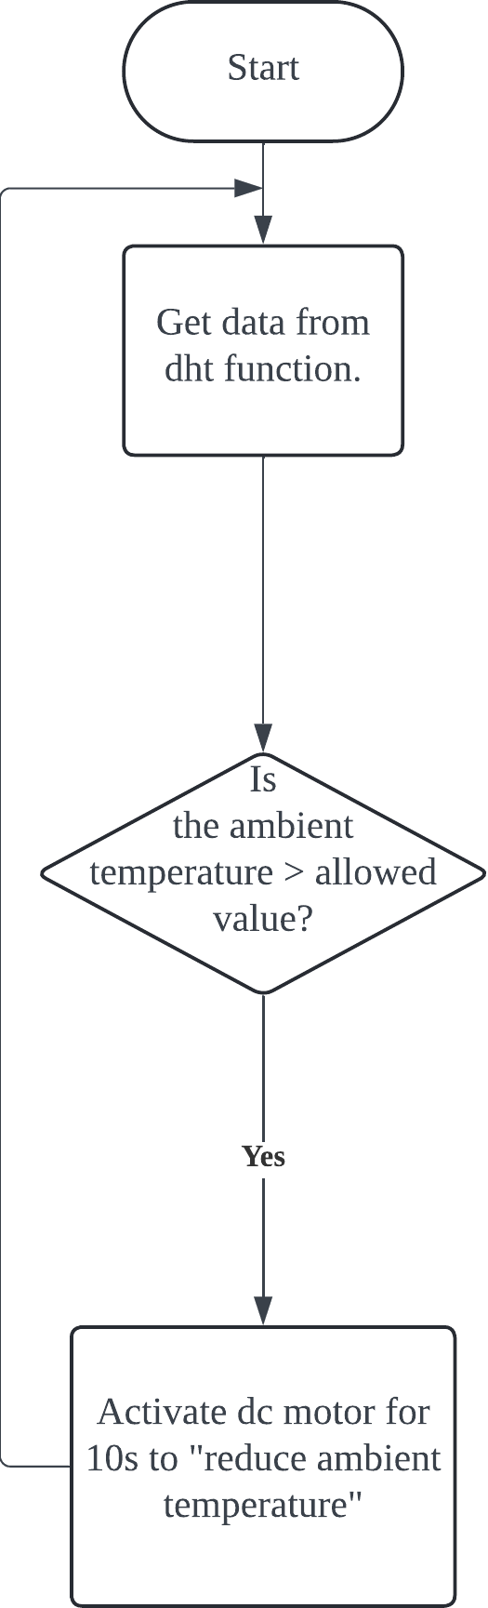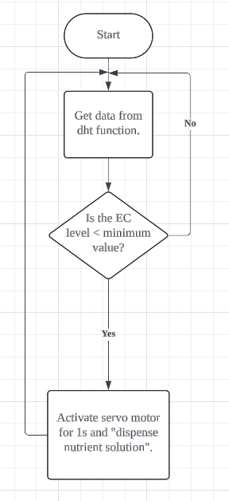

Flowchart for REQ-06 Flowchart for REQ-07

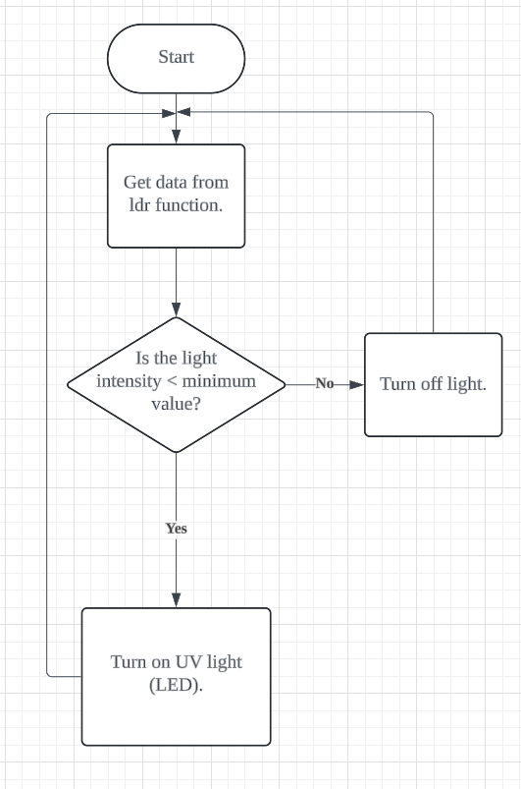

Flowchart for REQ-08

### Function - Dashboard

Based on the data obtained from monitoring, the website will display a dashboard to visualize the data from the different sensors via a web page/mobile application.

|  |  |
| --- | --- |
| **REQ_ID** | **Requirement** |
| REQ-9 | The system shall provide a webpage dashboard for visualizing sensor data. |
| REQ-10 | On the right of the web page, there will be a navigation bar that displays different icons, allowing users to choose between different options, Home, Dashboard, and About.  e.g. When the user clicks on the Dashboard icon, the user will be redirected to the Dashboard page. |
| REQ-11 | When ‘Home’ is chosen, the webpage will display the homepage that welcomes users to the website. |
| REQ-12 | When ‘About’ is chosen, the webpage shall display an introduction and information about the project. |
| REQ-13 | When ‘Dashboard’ is chosen, the webpage will display the dashboard that visualizes the data obtained from the sensors. |
| REQ-14 | The dashboard shall update data from all connected sensors continuously. |
| REQ-15 | The dashboard shall include graphs and charts to visualize trends and patterns in sensor data over time(e.g. pH level of the solution, Ambient temperature, Relative humidity, Ambient lighting intensity, EC (Electrical Conductivity) level). |
| REQ-16 | The dashboard shall display alerts for any sensor readings that fall outside the pre-set optimal level for the EC level, light intensity, and temperature.  When sensor readings exceed the optimal level, the text displaying the levels will turn red. |
| REQ-17 | There shall be a node showing the live current time in the Dashboard webpage. |
| REQ-18 | When the cursor hovers over the navigation bar, it will extend out and display page options with names. |
| REQ-19 | There should be a footer that credits team members and provides a link to the Github project repository and Youtube Video. |
| REQ-20 | When the cursor hovers over graph data, a popup showing the exact value will appear. (Tooltip) |

### 

### Below are diagrams and flowcharts demonstrating the requirements specified for the web page.

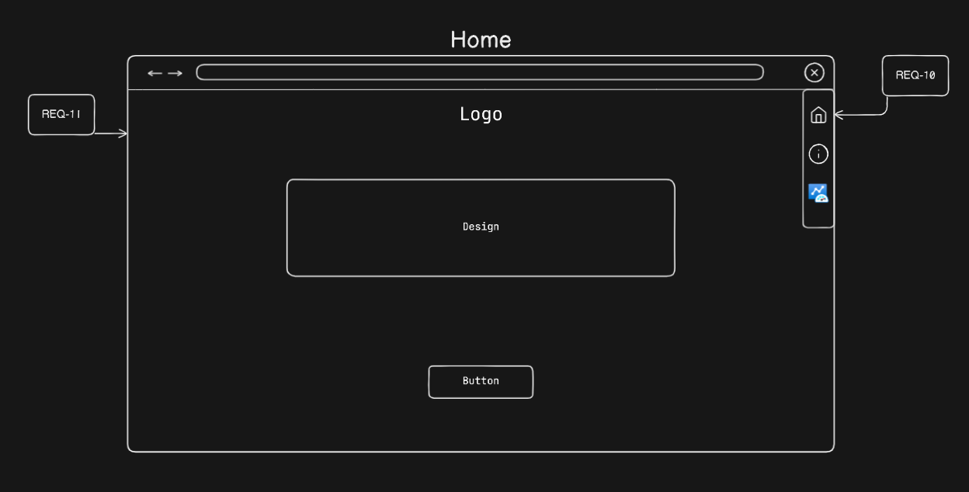

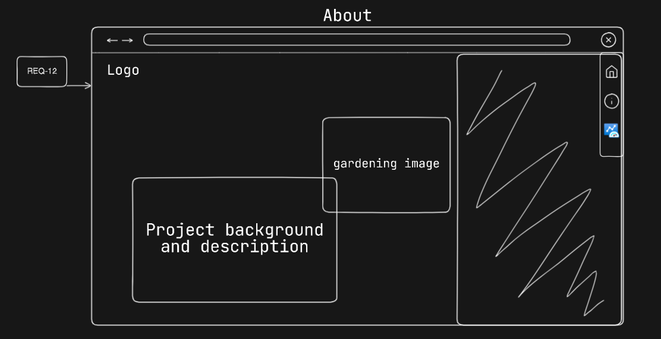

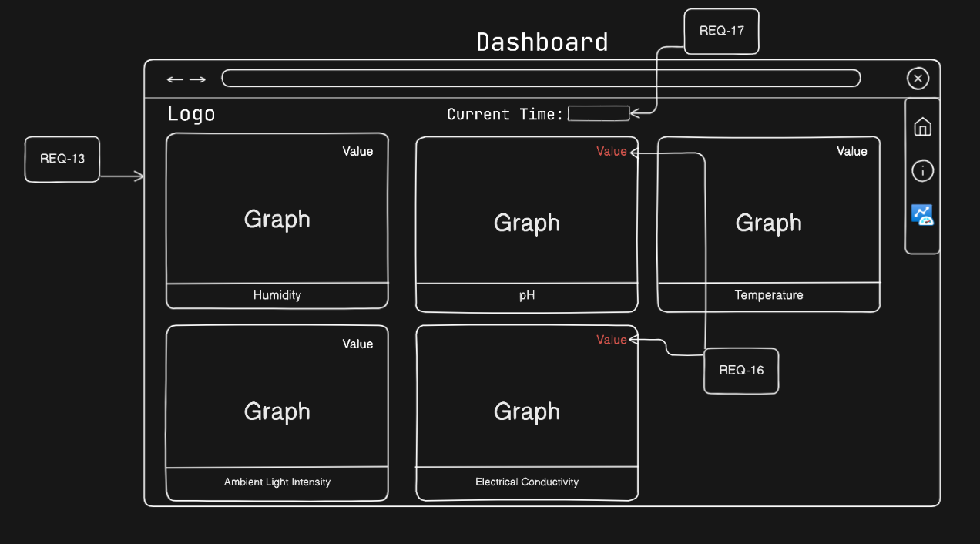

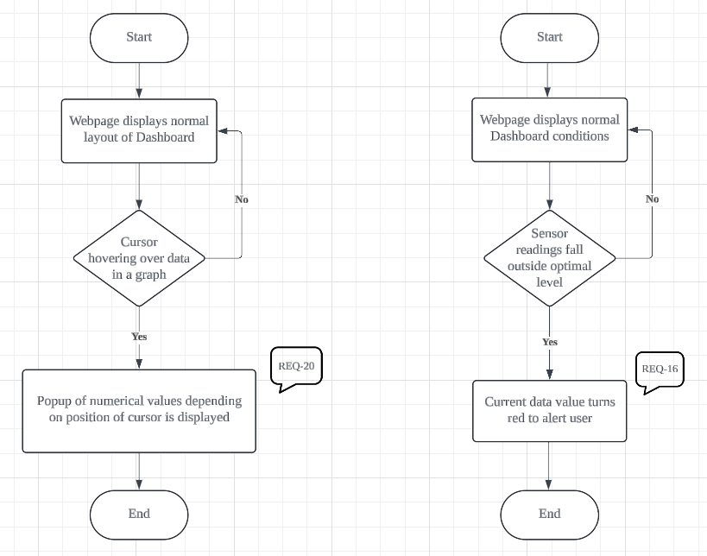

### Function - Login

|  |  |
| --- | --- |
| **REQ_ID** | **Requirement** |
| Req-21 | LCD shall display login method(“1” for keypad login, “2” for RFID login)for user to input |
| Req-22 | pass_login() shall be called if “1” is chosen, prompting user to enter password |
| Req-23 | LCD shall display “Access Granted” if password entered into the keypad is correct |
| Req-24 | LCD shall display “Access Denied” If the password entered into the keypad is wrong |
| Req-25 | LCD shall wait for 2 seconds before prompting user to enter password again |
| Req-26 | rfid_login() shall be called if “2” is chosen,, prompting user to use rfid |
| Req-27 | LCD shall display “Login Success” if rfid is equal to id |
| Req-28 | input password shall be cleared, and the prompt resetted when “*” is keyed |
| Req-29 | The function shall check if the password is correct when “#” is keyed |

## Non-Functional Requirements

### Non-Functional Requirement

|  |  |
| --- | --- |
| **REQ_ID** | **Requirement** |
| REQ-30 | The dashboard shall be compatible with all major web browsers, including Chrome, Firefox, Safari, and Edge. |

### Non-Functional Requirement

|  |  |
| --- | --- |
| REQ-31 | “test_update_pH” function shall check if pH level drops below the defined threshold and assert whether output is “red”. |
| REQ-32 | “test_update_temperature” function shall check if temperature drops below the defined threshold and assert whether output is “black”. |
| REQ-33 | “test_update_humidity” function shall check if humidity level drops below the defined threshold and assert whether output is “black”. |
| REQ-34 | “test_update_light” function shall check if the light value drops below the defined threshold and assert whether the output is “red”. |
| REQ-35 | “test_update_ec” function shall check if ec level drops below the defined threshold, and assert whether output is “red”. |
| REQ-36 | “test_update_chart” function shall check if the number of data points displayed on the graphs is less than or equal to 8 and assert if it's true. |

# Software Architecture

## Static Software Architecture

The Software Architecture defines the various Software Components that are developed to realize the implementation of the system requirements.

**Application Layer**

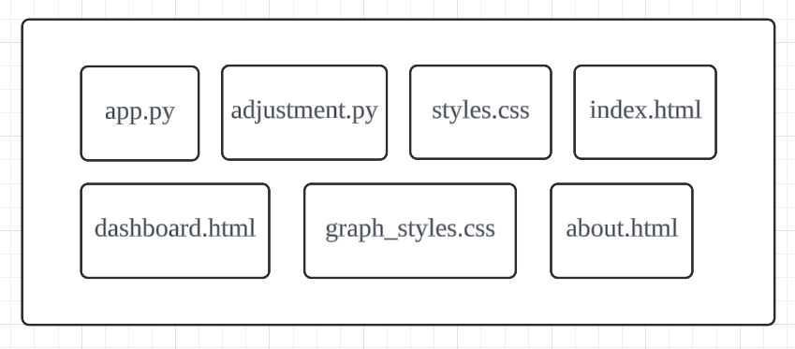

**Hardware Abstraction Layer (HAL)**

