SRS Document for Supermarket system

Developed by:

Ming Feng

Jerick

Paven

Chandan

Table of contents

**1. Purpose 2**

1.1. Intended audience 2

1.2. Intended Use 2

1.3. Scope 2

1.4. Definition and Acronyms 2

**2. Overall System Description 4**

2.1. Use Case Diagrams 4

2.2. System Architecture 5

2.3. Functional Requirements 6

2.3.1. Database 6

2.3.2. Kiosk 7

2.3.3. Website 9

**3. Software Architecture 10**

3.1. Static Software Architecture 10

Application Layer 10

Hardware Abstraction Layer 10

# 

# Purpose

## Intended audience

This SRS document describes the system requirements and software design for a Supermarket self-checkout system, with the target audience being system and software engineers working on the development of this project

## Intended Use

The SRS defines the overall system architecture and requirements, as well as the software architecture and design. The document also contains the definition of the system requirements which shall be used ad the input for the system test cases and software unit tests.

## Scope

This document encompasses all specifications relating to the minimum viable product of the Supermarket self-checkout system, and does not include quality-of-life features and other features that will benefit the system but are not necessary to the delivery of the product.

## Definition and Acronyms

| Acronym | Description |
| --- | --- |
| RFID | Radio frequency identification |
| QR code | Quick response code |
| LCD | Liquid crystal display |
| INT | Integer |
| API | Application programming interface |

# 

# Overall System Description

* 1. Use case diagrams

## 

Figure 2.1.1 Use case diagram of Online Purchases

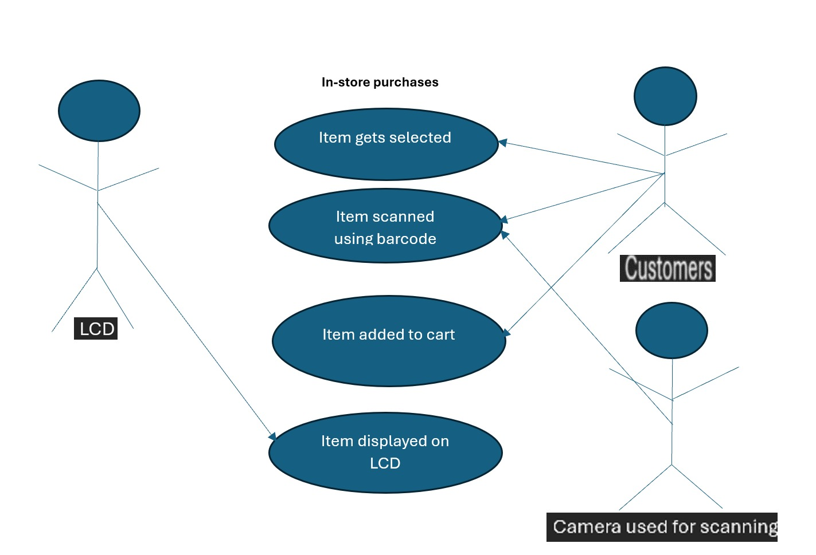

**Figure 2.1.2 Use case diagram of In-Store purchases**

## 

## System Architecture

Figure 2.2 System architecture of RPI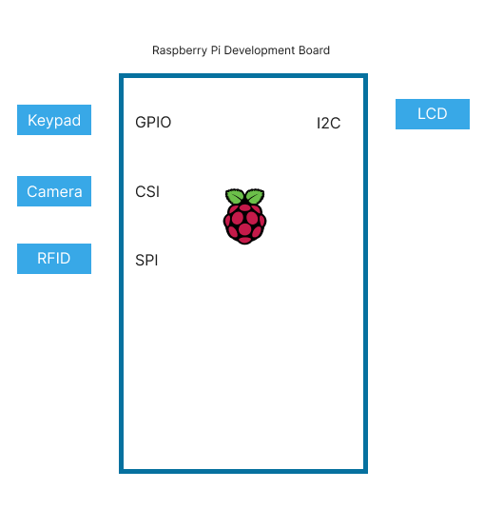

## Functional Requirements

### Database

| REQ_ID | Requirement |
| --- | --- |
| REQ-01 | Create a database called “Products” with the following structure:  {  “id”: (Int),  “name”: (String),  “quantity”: (Float)  } |
| REQ-02 | API for to communicate with the products database defined in REQ-01 they should include the following functionality:   1. Get entire list of products from the database in REQ-01 2. Add product or edit fields of items from database in REQ-01 |
| REQ-03 | Create a database called “Orders” with the following structure:  {  “id”: (int),  “products”:(array of product ID(string) that person has ordered)  “deliver”: (boolean whether it is delivery or collect in-store),  “paid”: (boolean whether it has been paid for)  “collected”: (bool if user has collected item, leave as TRUE)  } Id is auto generated every time a new order is made |
| REQ-04 | API to communicate with the Orders database as defined in REQ-03 and should include the following functionality:   1. Create order, filling up all fields and appending it to the database  Edit “paid” and “collected” fields to reflect if they have paid or collected it. |

### 

### Kiosk

| REQ_ID | Requirement |
| --- | --- |
| REQ-05 | When the kiosk is powered on, some text should display on the LCD:  Line 1=’Welcome!’  Line 2=’Scan anything to start’ |
| REQ-06 | Able to scan barcode with camera and store it as a variable in code |
| REQ-07 | When Barcode is scanned, Retrieve Product name and and price of product using REQ-02 and display product name and price of item on first line of LCD. if the product name is too long for the screen to display, replace name with the first letter of each word separated by a “.”. For example, if the name is “Pokemon Go”, it should use “P.G” to show on the screen. |
| REQ-08 | If multiple barcodes are scanned, display running total on the bottom line of the LCD. |
| REQ-09 | When “*” is pressed on the keypad, this indicates that the customer has finished scanning all barcodes. Display on the LCD:  Line 1=’Total cost: ’+ total amount  Line 2=’1: card, 2: atm’  Pressing ‘1’ on the keypad would use the “paywave” method of payment  And pressing ‘2’ on the keypad would use the pin code method of payment |
| REQ-10 | If ‘1’ pressed, display on the LCD:  Line 1: “Please tap your card”  Wait for card to be tapped and if the card is valid in a list of numbers, authorise the payment |
| REQ-11 | If ‘2’ pressed, display on the LCD:  Line 1: “Please enter your pin”  Wait for the correct pin to enter to authorise payment |
| REQ-12 | After payment has been made show the following message on the LCD:  Line 1: ”Payment success”  Line 2: “Remember your things” |
| REQ-13 | If payment is not successful, beep the buzzer once and display the following message:  Line 1:“Payment unsuccessful”  Line 2=’1: card, 2: atm’  Pressing ‘1’ on the keypad would use the “paywave” method of payment  And pressing ‘2’ on the keypad would use the pin code method of payment |
| REQ-14 | If no barcodes are scanned within 15 minutes, clear the LCD. (Save power)  Barcodes can still be scanned while the LCD is cleared. |
| REQ-15 | If barcodes are scanned after 15 minutes, display the LCD using REQ-07 and continue running each requirement. |

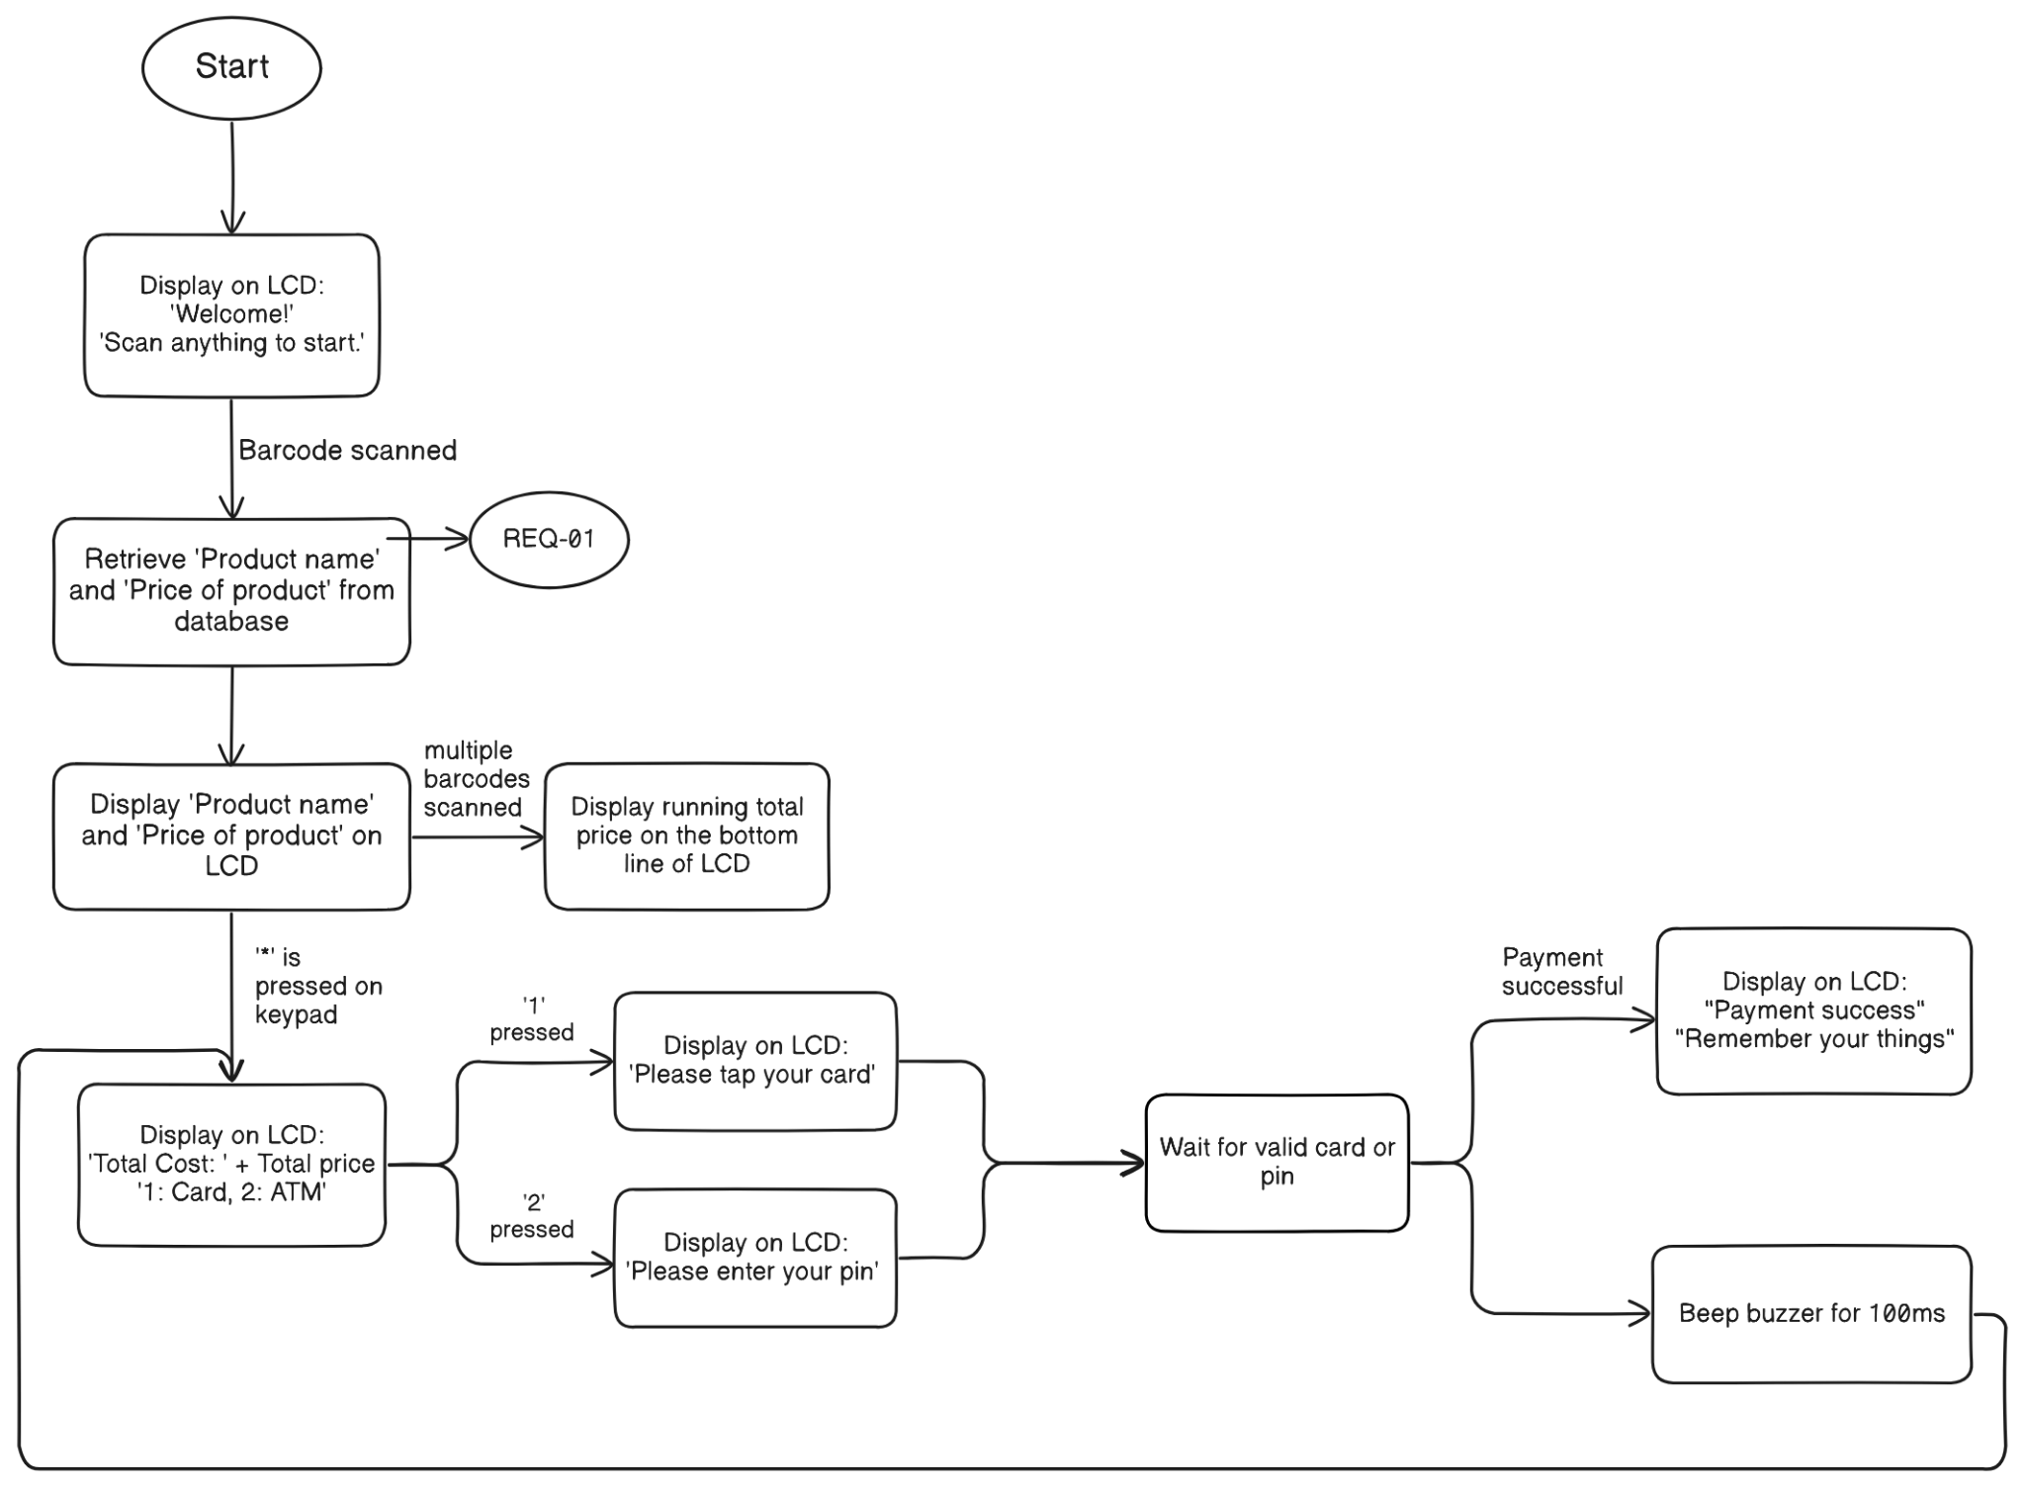

### 

### Website

| REQ_ID | Requirement |
| --- | --- |
| REQ-16 | Using REQ-02, display all items available in the supermarket |
| REQ-17 | Users can add items to a cart |
| REQ-18 | Using REQ-04, users can order items, and specify 2 option, delivery or self checkout |
| REQ-19 | If delivery is selected, 4 dollars is added to the total. After that, users will be asked to enter their pin to pay for it. |
| REQ-20 | If self checkout is selected, collected will be set to false, and a qr code will be generated with the order id for the admin to reference and update the collected field when scanned by the admin at the shop. |

# 

# Software Architecture

## Static Software Architecture

**The Software architecture defines the various Software components that are developed to realise the implementation of the system requirements.**

#### Application Layer

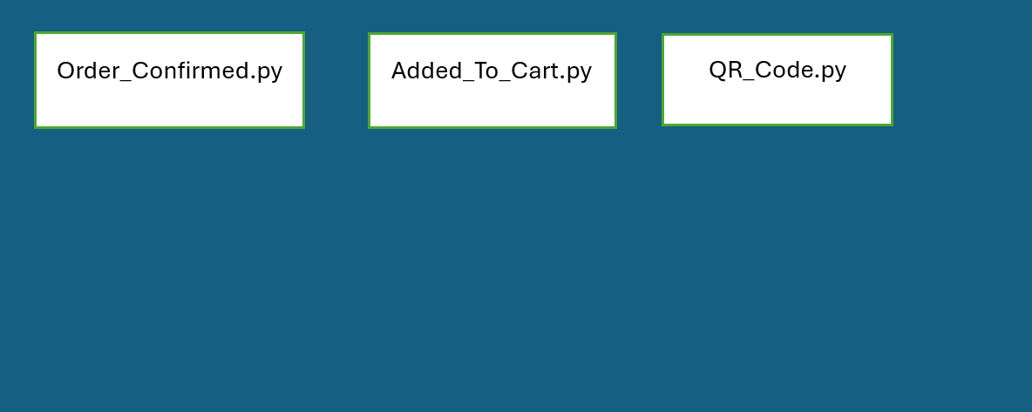

**Figure 3.1.1 Software architecture of the application layer**

#### Hardware Abstraction Layer (HAL)



**Figure 3.1.2 Software Architecture of the Hardware Abstraction Layer**