Table of Contents

Document Version 3

1. Purpose 4

1.1. Intended Audience 4

1.2. Intended Use 4

1.3. Scope 4

1.4. Definitions and Acronyms 4

2. Overall System Description 5

2.1. Use Case Diagrams 5

2.2. System Architecture 6

2.3. Functional Requirements 7

2.3.1. Start Up, Main Menu & Function Drink Selection 7

2.3.2. Function Payment Options & Purchase Methods 8

2.3.3. Remote/Online Order System 9

2.3.4. Drinks Preparation System 9

2.3.5. Drinks Collection System 10

2.3.6. Function Theft Prevention & Security Features 10

2.3.7. Function Environment Monitoring & Technician Access 11

2.4. Non-Functional Requirements 12

**2.4.1.** **Performance** 12

**2.4.2.** **Security** 12

**2.4.3.** **Reliability** 12

**2.4.4.** **Usability** 13

**2.4.5.** **Energy Efficiency** 13

**2.4.6.** **Maintainability** 13

**2.4.7.** **Monitoring and Environmental Control** 13

**2.4.8.** **Safety** 13

3. Software Architecture 14

3.1. Static Software Architecture 14

# Document Version

|  |  |  |  |  |
| --- | --- | --- | --- | --- |
| No | Update | Name | Date | Version |
| 1. | Initial version |  | 05/01/2025 | 1.0 |

# Purpose

## Intended Audience

This SRS document describes the System Requirements and Software Design for a Smart Drink Vending Machine.  
This document is intended for:

* **System Engineers**: For understanding the integration of hardware and software components.
* **Software Developers**: To guide the coding and implementation process.
* **Test Engineers**: For creating and executing test cases.
* **Stakeholders**: To provide an overview of the project goals and deliverables.

## Intended Use

The SRS defines the overall System Architecture and Requirements as well as the Software Architecture and Design. This document is also contains the definition of the System Requirements which shall be used as the input for System Test cases and Software Unit Test cases.

## Scope

The **Smart Drinks Vending Machine** is an automated system that allows users to:

* Interact with an intuitive LCD and keypad interface.
* Order drinks remotely using a Telegram bot.
* Monitor environmental conditions for optimal storage.
* Ensure security with theft prevention mechanisms.
* Perform maintenance and diagnostics efficiently.

This system enhances the user experience by offering intelligent, reliable, and energy-efficient vending operations.

## Definitions and Acronyms

|  |  |
| --- | --- |
| **Acronym** | **Description** |
| IR | Infra-Red |
| LED | Light Emitting Diode |
| NFC | Near Field Communication |
| SW | Software |
| HW | Hardware |
| HMI | Human Machine Interface |
| USonic | Ultra Sonic |
| ADC | Analog to Digital Converter |
| picam | Camera Module of Raspberry Pi |
| AES-256 | Advanced Encryption Standard 256-bit |

# Overall System Description

## Use Case Diagrams

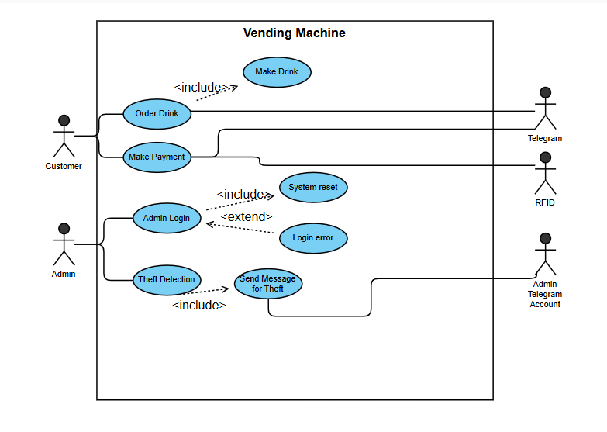

Figure

## System Architecture



DC Motor

Servo Motor

Camera

Ultrasonic sensor

GPIO 25,27

LCD

I2C

**Raspberry Pi Development Board**

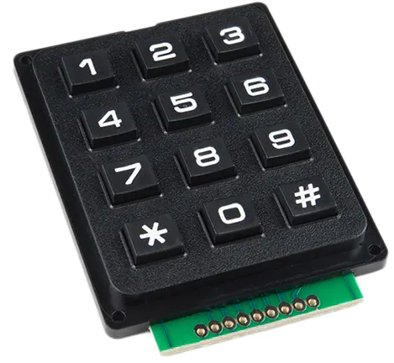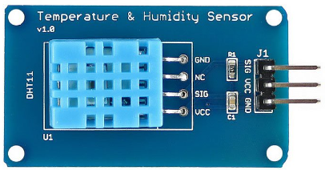

SPI_ADC_CH01

GPIO 23

GPIO 26

GPIO

GPIO 21

IR sensor

GPIO

GPIO 17

Moisture sensor

GPIO 04

RFID Reader

GPIO

LED

Buzzer

GPIO 24

GPIO 18

Figure

## Functional Requirements

### Start Up, Main Menu & Function Drink Selection

|  |  |
| --- | --- |
| **REQ_ID** | **Requirement** |
| REQ-01 | When the vending machine is operating, the LCD will display the main menu below for customer and admin access.  Line 1 = “1. Customer”  Line 2 = “2. Admin” |
| REQ-02 | If the option 1 defined in REQ-01 is selected on main menu, the following text will display.  Line 1 = “1. Order drinks”  Line 2 = “2. Collect drinks” |
| REQ-03 | If option 1 defined in REQ-02, is selected, the vending machine shall allow customers to select their drinks using a numeric keypad and display options on an LCD screen.  Line 1 = “1. Sample drink 1”  Line 2 = “2. Sample drink 2” |
| REQ-04 | The customer can browse through the drinks menu by pressing “*” on keypad to move up and “#” to move down for more drink’s options. If ‘#” is pressed, the following texts will be displayed on LCD.  Line 1 = “1. Sample drink 3”  Line 2 = “2. Sample drink 4” |

### Function Payment Options & Purchase Methods

If the customer selected a drink from one of the options from REQ-04, the following flowchart from figure 3 (next page) will be implemented.

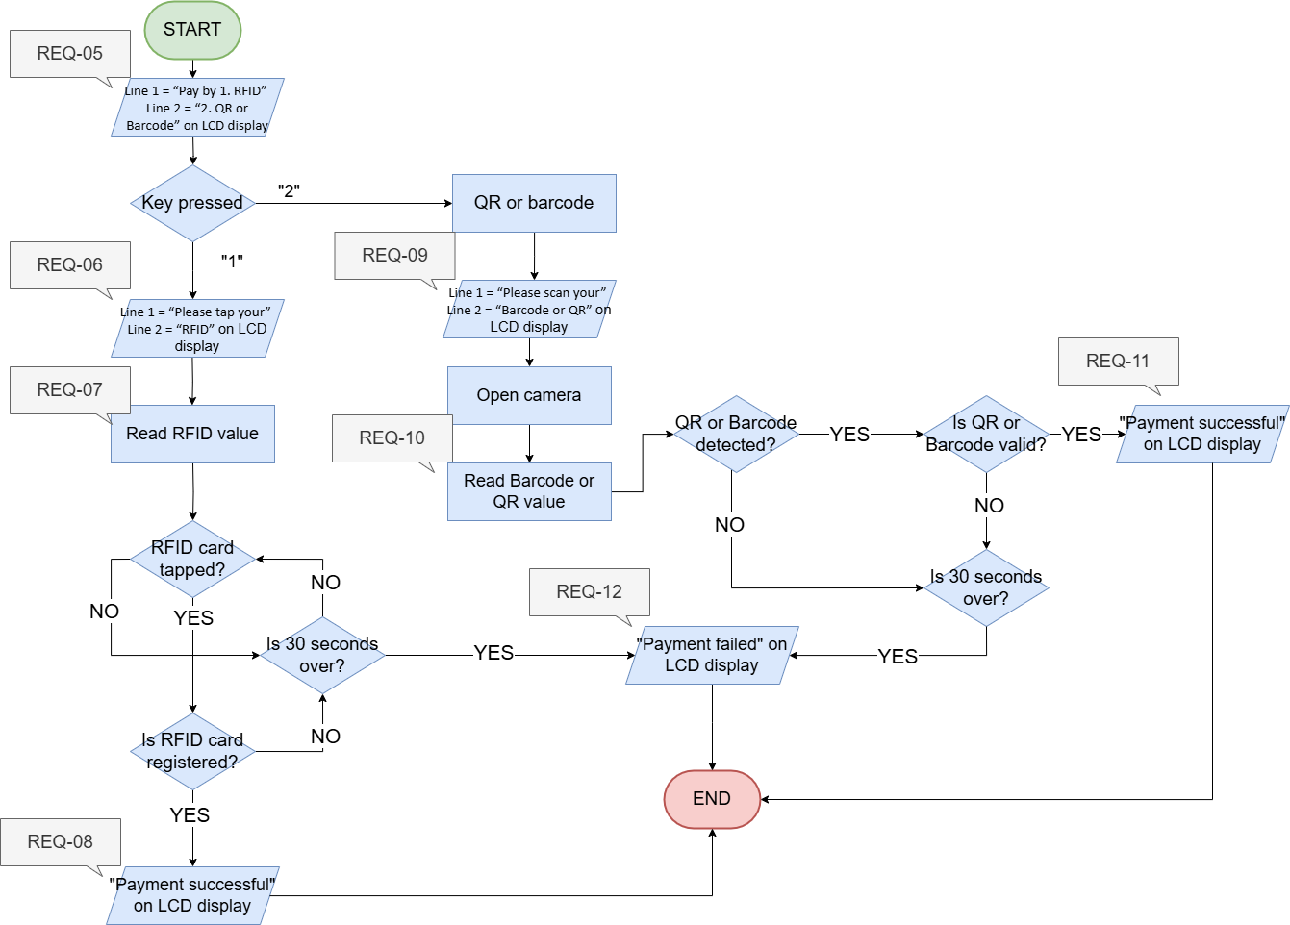

Figure

|  |  |
| --- | --- |
| **REQ_ID** | **Requirement** |
| REQ-13 | After the payment has been done, the following text will be displayed on LCD and a countdown will start  Line1 = “Preparing Drink!”  Line2 = “**:** min” |

### Remote/Online Order System

The vending machine supports a unique “Remote/Online Order System” to enable remote drink purchases a telegram bot.

|  |  |
| --- | --- |
| **REQ_ID** | **Requirement** |
| REQ-14 | The customer will be able to access online order system after sending “/start” to the telegram bot. After the first time, the customer will be able to start ordering drinks straight away without sending “/start”. |
| REQ-15 | The telegram bot will be able to provide customer with   * Drinks menu * Online payment options * Remote order system |
| REQ-16 | After the customer have gone through the procedures from REQ-10, the telegram bot will issue a unique token, QR code or barcode for remote collection when the drink is ready at the vending machine. |
| REQ-17 | Telegram bot will make use of ChatGPT API to provide customers with human like responses and will be able to suggest drinks based on customer’s input text message. |
| REQ-18 | If the drink is ready to be collected at the vending machine, telegram bot will notify the user with an alert message. |

### Drinks Preparation System

|  |  |
| --- | --- |
| **REQ_ID** | **Requirement** |
| REQ-19 | The vending machine start preparing the drinks upon receiving the signal from REQ-14 or REQ-17. The following flowchart will be implemented for drinks preparation system |

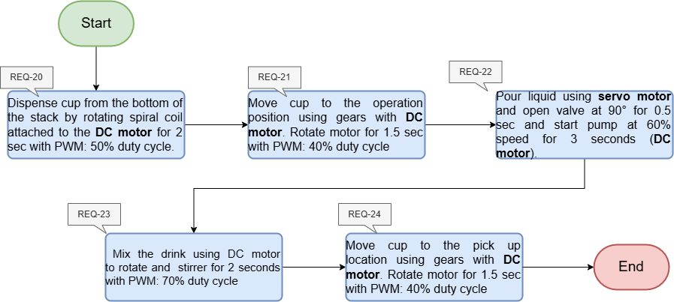

Figure

### Drinks Collection System

### 

|  |  |
| --- | --- |
| **REQ_ID** | **Requirement** |
| REQ-25 | When the drink is ready the door attached to servo motor will open and allow the customer to collect the drink. |
| REQ-26 | For remote collection system, when the customer select option 2 from REQ-02, the following text will be displayed on LCD.  Line 1 = “1. Enter token”  Line 2 = “2. Scan QR”  Depends on the user selection, the authentication process will begin, and the door will open for collection. |

### Function Theft Prevention & Security Features

|  |  |
| --- | --- |
| **REQ_ID** | **Requirement** |
| REQ-27 | The vending machine shall implement a burglar detection system that detects if the machine’s door is forcefully opened. There will be IR sensor placed near the door handle to check whether the door handle is being touched. The door handle will be implemented with potentiometer and servomotor. The following flowchart from figure 5 will be used to implement for the security features of the vending machine. |

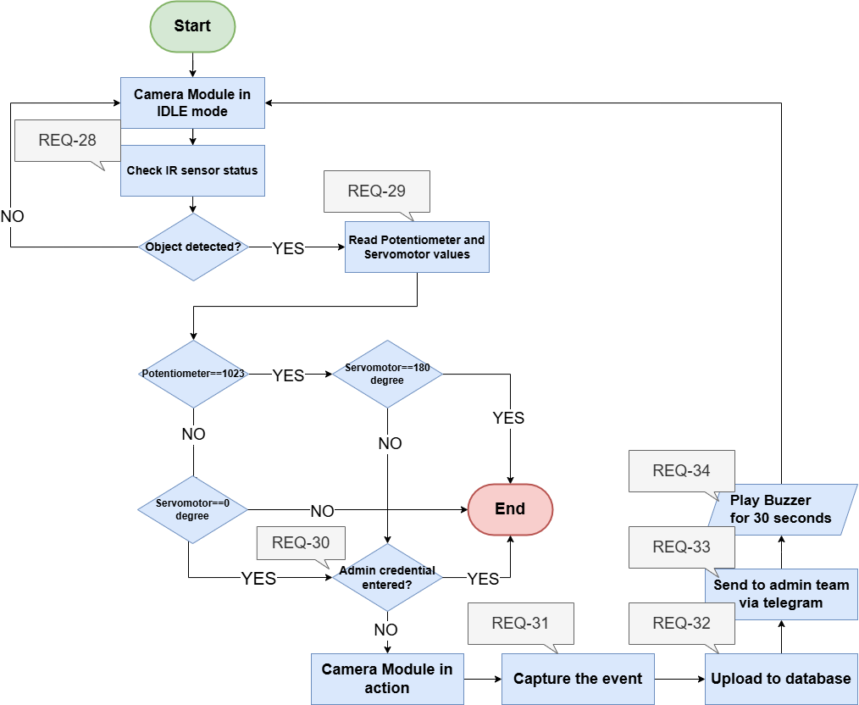

Figure

### Function Environment Monitoring & Technician Access

|  |  |
| --- | --- |
| **REQ_ID** | **Requirement** |
| REQ-35 | The vending machine shall maintain optimal storage conditions for drinks.   * Storage Temperature using temperature sensor * Humidity level using the humidity sensor * Water level using ultrasonic sensor * Water Leakage using moisture sensor   If environment controls fail, then the flowchart defined in figure 6 will be implemented. |

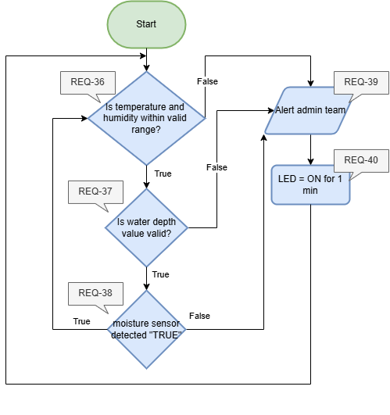

Figure

|  |  |
| --- | --- |
| **REQ_ID** | **Requirement** |
| REQ-41 | The vending machine also allow the technicians and admin to access inventory and hardware maintenance. To access the system, the user can select option 2 from REQ-01 and the following flowchart from the figure will be deployed. |

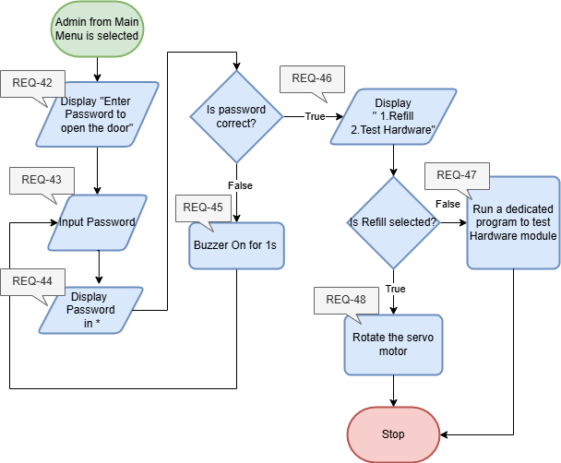

Figure

## Non-Functional Requirements

### **Performance**

|  |  |
| --- | --- |
| **REQ_ID** | **Requirement** |
| NFR-01 | The vending machine shall process drink selection and payment transactions within **5 seconds**. |
| NFR-02 | The machine shall detect environmental parameter changes (e.g., temperature or humidity) and respond within **2 seconds**. |
| NFR-03 | The RFID reader shall authenticate a user within **1 second** after scanning |

### **Security**

|  |  |
| --- | --- |
| **REQ_ID** | **Requirement** |
| NFR-05 | Unauthorized attempts to access the machine shall trigger the **buzzer** and log the incident with a timestamp and captured image from the **camera module**. |
| NFR-06 | Technicians shall be automatically logged out after **5 minutes** of inactivity. |

### **Reliability**

|  |  |
| --- | --- |
| **REQ_ID** | **Requirement** |
| NFR-07 | The vending machine shall achieve an uptime of **99.9%**, including during Docker container updates. |
| NFR-08 | All sensors (e.g., **moisture**, **temperature**, **IR**) and actuators (e.g., **servo**, **DC motor**) shall operate reliably for at least **10,000 cycles** without maintenance. |
| NFR-09 | Alerts generated due to failures or security breaches shall reach the technician within **10 seconds**. |
| NFR-10 | The system shall include a battery backup to support critical functions during power outages. |

### **Usability**

|  |  |
| --- | --- |
| **REQ_ID** | **Requirement** |
| NFR-11 | The machine shall use the **LED** and **buzzer** for visual and auditory feedback during the interaction process. |

### **Energy Efficiency**

|  |  |
| --- | --- |
| **REQ_ID** | **Requirement** |
| NFR-12 | The vending machine shall enter a **low-power mode** if idle for more than **2 minutes**, using only essential sensors (e.g., **IR sensor** for object detection). |
| NFR-13 | The **LDR** module shall adjust the LCD brightness based on ambient light to reduce power consumption. |

### **Maintainability**

|  |  |
| --- | --- |
| **REQ_ID** | **Requirement** |
| NFR-14 | The system shall generate detailed logs (e.g., drink dispensing, environmental data, security incidents) that are retained for at least **30 days**. |
| NFR-15 | The machine shall allow remote diagnostics and software updates to minimize on-site maintenance. |

### **Monitoring and Environmental Control**

|  |  |
| --- | --- |
| **REQ_ID** | **Requirement** |
| NFR-16 | The system shall allow technicians to test individual components (e.g., **buzzer**, **servo motor**) through a diagnostic mode accessed via the keypad. |
| NFR-17 | The system shall continuously monitor internal temperature and humidity to ensure optimal operating conditions. |

### **Safety**

|  |  |
| --- | --- |
| **REQ_ID** | **Requirement** |
| NFR-18 | The vending machine shall detect vibrations or tilting using the **accelerometer**, triggering an alert for potential tampering. |
| NFR-19 | The **slide switch** shall act as an emergency power cutoff for technicians during maintenance |

# Software Architecture

## Static Software Architecture

The Software Architecture defines the various Software Components that are developed to realize the implementation of the system requirements.

**NFC**

**HMI**

**Drink Preparation Manager**

**Verification**

**Application Layer**

**Hardware Abstraction Layer (HAL)**

**ADC**

**USonic**

**IR sensor**

**Servo**

**Moisture sensor**

**Payment System**

**DC motor**

**Buzzer**

**Keypad**

**Temp Humidity Sensor**

**LCD**

**picam**

**Security features**

**Remote Order System**