Table of Contents
Document Version 2
1. Purpose 3
1.1. Intended Audience 3
1.2. Intended Use 3
1.3. Scope 3
1.4. Definitions and Acronyms 3
2. Overall System Description 4
2.1. Use Case Diagrams 4
2.2. System Architecture 5
2.3. Functional Requirements 6
2.3.1. Function xxxx 6
2.3.2. Function yyyy 7
2.3.3. Function zzzz 7
3.1. Non-Functional Requirements 8
3.1.1. Non-Functional Requirement xxxx 8
4. Software Architecture 9
4.1. Static Software Architecture 9

Document Version
No | Update | Name | Date | Version
1. | Initial version | N.A | N.A. | 1.0
2. | Added Scope | Srikar | 12/11/2025 | 1.1
3. | Added Use case diagram | Thiha | 13/11/2025 | 1.2
4. | Added Rpi Flowcharts | Por Yu | 15/11/2025 | 1.3
5. | Added system architecture | Vrishank | 18/11/2025 | 1.4
6. | Finished Functional/non functional requirements | Por Yu | 18/11/2025 | 1.5

Purpose

Intended Audience
This SRS document describes the System Requirements and Software Design for a Library Book Reservation and Collection System and the target audience are System and Software Engineers working on the development of this project.

Intended Use
The SRS defines the overall System Architecture and Requirements as well as the Software Architecture and Design. This document is also contains the definition of the System Requirements which shall be used as the input for System Test cases and Software Unit Test cases.

Scope
Our Library Book Reservation and Collection System aims to provide greater convenience to the general public when reserving books from their local public library. The system aims to provide a user-friendly interface and to provide convenience to the user when it comes to reserving and picking up books. Below are the Scopes of this project.
- User Registration and Database Authentication system
  - Implement a way for User to sign up on the App, website
  - Enable a way for Users to sign in to their account using a password on the App and website
- Online Reservations:
  - Implement a way for Users to choose a library and view all the books available for reservation at that location.
  - Implement a way for Users to select a book and reserve it online
  - Set a limit to the number of books a user can have reserved/borrowed at any point in time.
  - Display to user the list of books they have borrowed or reserved on the account
  - Implement a way for users to extend their loan period on the App once
- Penalties:
  - Implement a system that checks for reserved/ borrowed books for late returns and cancels reservations that are not picked up
  - Implement a system to calculate the fee and block users from borrowing more books if they have late returns until money is deducted from a RFID card
- Physical Book Borrowing:
  - Implement a Kiosk using the raspberry pi that lets a user log in by scanning their NRIC/SP student Card
  - Check if the user will exceed their 10 books limit and block the loan if necessary
  - If all requirements are met dispense the book using the Motor
- Returns Process:
  - To return their books, a user must scan the barcode on the book using the Kiosk’s Camera Module

Definitions and Acronyms

Acronym | Description
IR | Infra Red
LED | Light Emitting Diode
RFID | Radio-Frequency IDentification
NRIC | National Registration Identity Card
SP | Singapore Polytechnic

Overall System Description

Use Case Diagrams

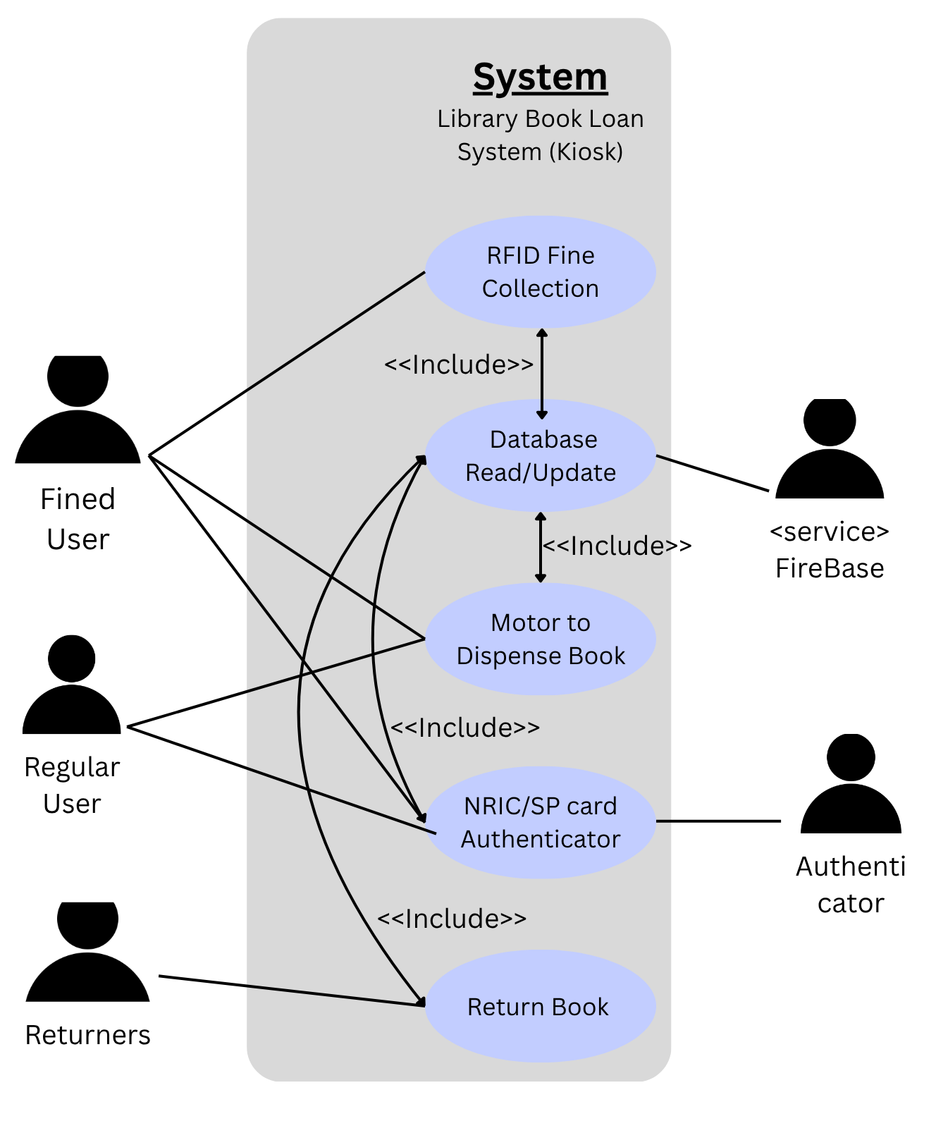

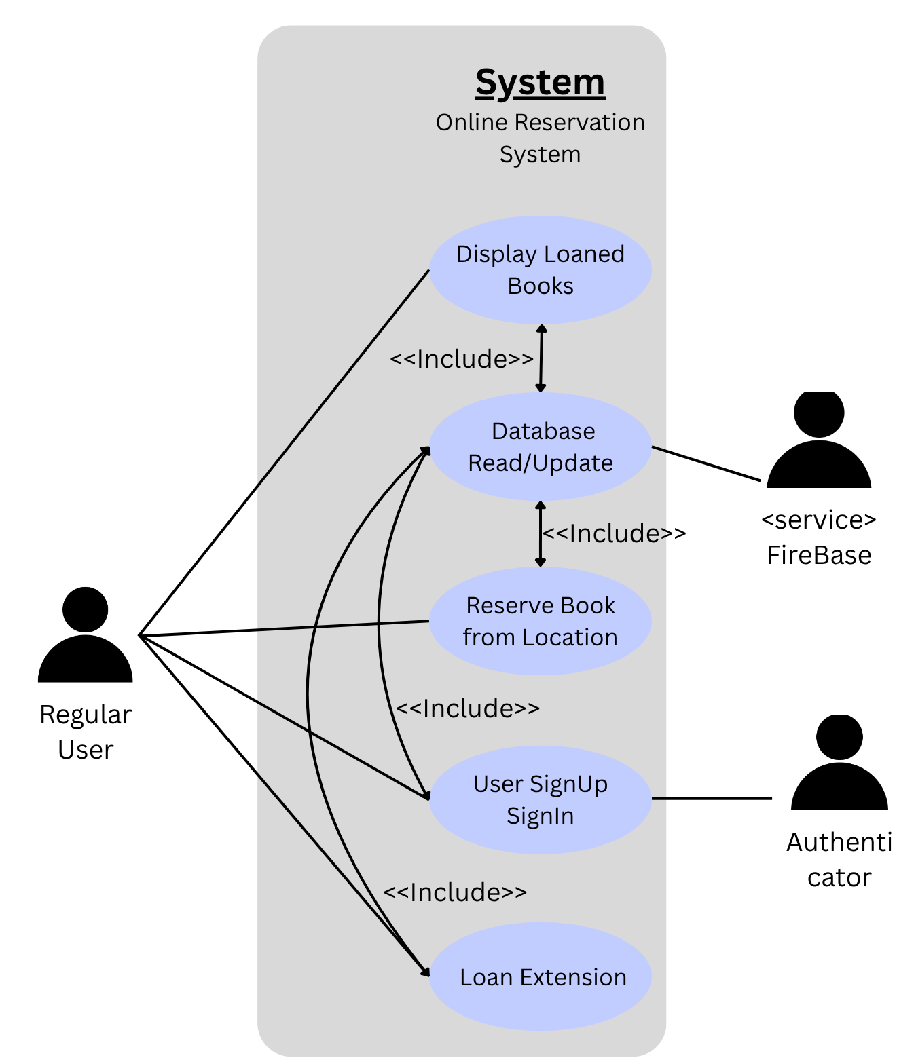

Sequence Diagram

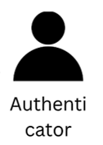

Update Fine cleared
Has Fine?
Request fine payment
Fine paid
Dispense book
Confirm
Update
Book dispensed
Database
Fine collection
Motor
Status check
Read
Send ID
Tap card
System

System Architecture
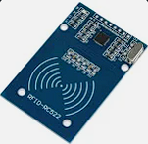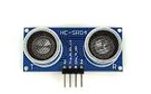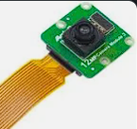

DC Motor
Servo Motor
LCD
I2C
Raspberry Pi Development Board
Slide switch
Buzzer
GPI022
GPIO7,11,9,10
PWM
PWM
GPIO18
GPIO6 / GPIO20 / GPIO19 / GPIO13 (Rows)
GPIO12 / GPIO5 / GPIO16 (Columns)
PWM

Functional Requirements

Kiosk Startup
What should be done by the Raspberry Pi when the user is there to collect their reservation

REQ_ID | Requirement
REQ-01 | When the Raspberry pi is started the following should be shown on the LCD  “Please scan your Identity card”
REQ-02 | Once the user has scan their card the Raspberry Pi has to scan the database for Profiles that match the ID.
REQ-03 | If no match is found in REQ-02 the LCD should Display  “No account found”
REQ-04 | If there is a match in REQ-02 the LCD should Display  “1 –Collect Books 2- Return Books”

Function Collect Books

When the user wants to collect their books from the kiosk the following should take place

REQ_ID | Requirement
REQ-05 | In REQ-04 if option 1 is selected on the matrix keypad, the following flowchart should be implemented

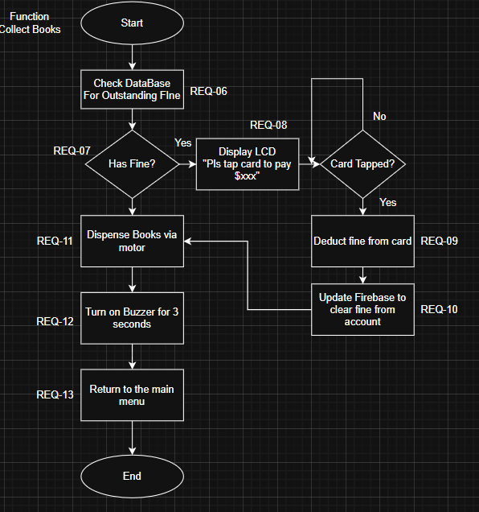

Function Return Books
What should be done on the Kiosk when the user chooses to return books
REQ_ID | Requirement
REQ-14 | In REQ-04 if option 2 is selected on the matrix keypad, the following flowchart should be implemented

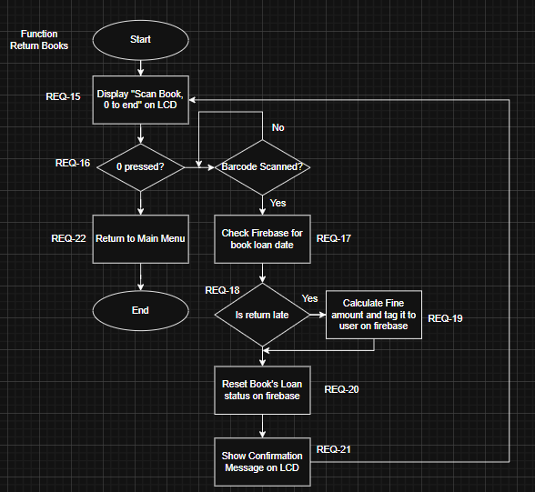

Function Reserve Book Online
What should be implemented on an App for users to be able to reserve their books online.

REQ_ID | Requirement
REQ-22 | App shall prompt user to input id and password or create an account if they haven’t
REQ-23 | If user enter password in REQ-22 App shall check firebase for matching id and password
REQ-24 | If match found in REQ-23 App shall let user into app
REQ-25 | If No match is found in REQ-23 App shall show a notification to user for wrong password
REQ-26 | From req-24, user should be prompted by 2 buttons 1 to reserve book and 1 to view borrowed books
REQ-27 | If user selects to view borrowed books, A list of reserved books and their loaned dates, title and location should be shown to user
REQ-28 | If user chooses to reserve book, a map of Singapore with all available libraries show up.
REQ-29 | Once user picks a location, App shall display a list of book titles not already reserved or borrowed and is available at that location
REQ-30 | If user picks a book, they shall be prompted to confirm the borrow
REQ-31 | Once user confirms, App should check if the user has borrowed 10 books already
REQ-32 | If the user has borrowed more then 10 books from REQ-31, the app should reject the reservation
REQ-33 | If not flagged by REQ-32, App should update the books firebase entry with the user’s id, the date, and reservation status
REQ-34 | From REQ-27 If a user taps on a book they have borrowed, the app should prompt the user if they want to extend the reservation
REQ-35 | From REQ-34 If the user confirms, the app should check if the book has already been extended
REQ-36 | If the book has already been extended the app should show an error message rejecting the extension
REQ-37 | If the book has not already been extended the app should update the books firebase to indicated that it has been extended and move

Backup

Non-Functional Requirements

Non-Functional Requirement Save Database Cost by reading only when necessary

Instead of reading the database every few seconds with the raspberry pi, we should read from the database only when we need it for the functions

REQ_ID | Requirement
REQ-38 | Only Read firebase for entries before matching profile, checking fines, checking book’s reservation status before dispensing
REQ-xx

Software Architecture

Static Software Architecture

The Software Architecture defines the various Software Components that are developed to realize the implementation of the system requirements.
collectbook.py
HMI
Application Layer
Hardware Abstraction Layer (HAL)
ADC
RFID
Servo
CamModule
returnbook.py
database.py
deductfine.py
scanbarcode.py

