Table of Contents
Document Version 3
1. Purpose 4
1.1. Intended Audience 4
1.2. Intended Use 4
1.3. Scope 4
1.4. Definitions and Acronyms 4
2. Overall System Description 5
2.1. Use Case Diagrams 5
2.2. System Architecture 5
2.3. Functional Requirements 6
2.3.1. Start Up and Main Menu 6
2.3.2. Automatic Fire Detection 6
2.3.3. Manual Alert 7
2.3.4 Sprinkler Control 8
2.3.5 SCDF notification (SMS) 8
2.3.6 Remote Access (Optional / Commercial Variant) 8
2.3.7 Logging and Configuration 9
2.4 Non-Functional Requirements 9
2.4.1 Performance and Reliability 9
2.4.2 Power Management 9
2.4.3 Safety and Security 10
3 Software Architecture 11
3.1 Static Software Architecture 11
4. Appendices 12
4.1 Requirements Traceability Matrix 12
4.2 GPIO Pin Plan 12

Document Version
No | Update: | Name: | Date: | Version:
1. | Initial version | SRS_project_DCPEFT2A03_GroupB | 11/05/26 | 1.0
2. | Updated Version | SRS_project_DCPEFT2A03_GroupB | 25/05/26 | 1.1
3. |  | SRS_project_DCPEFT2A03_GroupB
4. |  | SRS_project_DCPEFT2A03_GroupB
5.

Purpose
This System / Software Requirements Specification (SRS) describes the system requirements and software design for the Smart Fire Alert System, an IoT-driven fire-detection device built on a Raspberry Pi. It defines what the system shall do so that the requirements can be used as the input for system test cases and software unit test cases

Intended Audience
This document is intended for the system and software engineers (the project group members) developing the Smart Fire Alert System, and for the supervising assessor reviewing the work. The customer is the Singapore Civil Defence Force (SCDF).

Intended Use
The SRS defines the overall system architecture and requirements, as well as the software architecture and design. It serves as the agreed reference for design, implementation on the Raspberry Pi, and verification through test cases derived from each numbered requirement.

Scope
In recent years there have been several fire outbreaks in the rental apartments of elderly residents in Singapore. To detect such fires as early as possible, the Smart Fire Alert System continuously monitors a resident's home for early signs of fire using two sensor types — a temperature sensor and a smoke detector. When at least one sensor detects a possible fire, the system sounds a local audible alarm, notifies SCDF by SMS, and activates a sprinkler valve (driven by a servo motor) in the affected room. A manual alert button lets the resident summon SCDF immediately. The prototype is implemented in Python on a Raspberry Pi, with source code and documentation maintained on GitHub.

Definitions and Acronyms

Acronym | Description
Acronym | Description
SCDF | Singapore Civil Defence Force
IoT | Internet of Things
GPIO | General-Purpose Input/Output
PWM | Pulse-Width Modulation (used to drive the servo)
ADC | Analogue-to-Digital Converter
SPI / I2C | Serial Peripheral Interface / Inter-Integrated Circuit (sensor & LCD buses)
GSM | Global System for Mobile communication (SMS module)
SMS | Short Message Service
LCD | Liquid Crystal Display
HAL | Hardware Abstraction Layer
SW / HW | Software / Hardware

Overall System Description

Use Case Diagrams
The diagram below shows the main actors — the elderly resident and SCDF — and the use cases the Smart Fire Alert System provides.
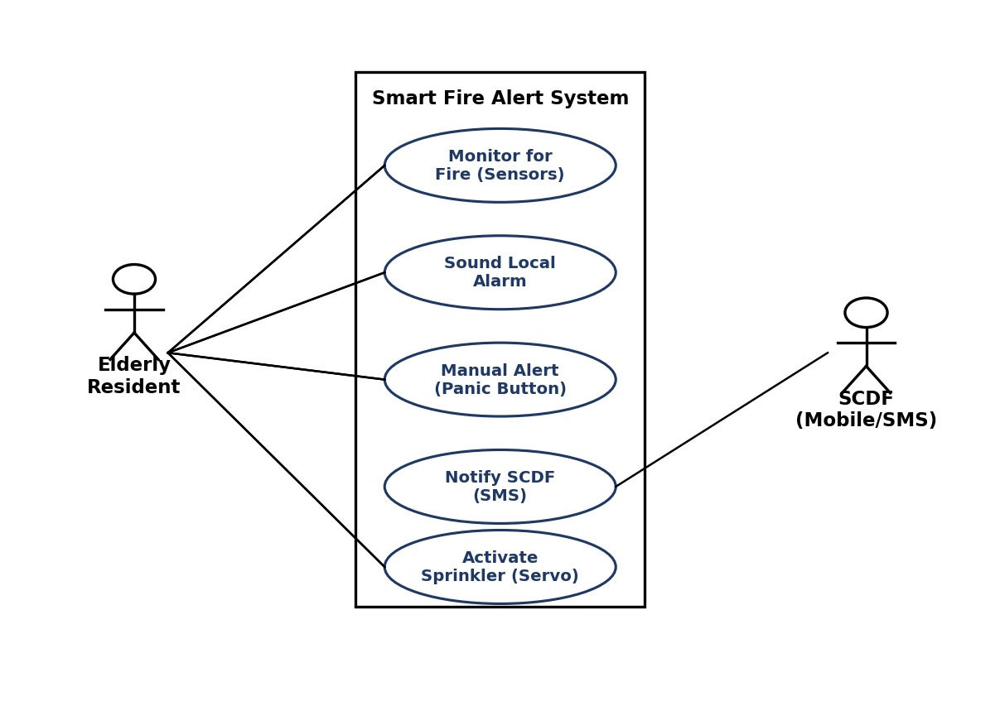

System Architecture
The Raspberry Pi development board is the central controller. It reads the temperature sensor (via an SPI ADC channel), the smoke detector, and the manual alert button on its GPIO, and drives the buzzer, the servo motor controlling the sprinkler valve, the GSM module for SMS, and an I2C LCD for status display.
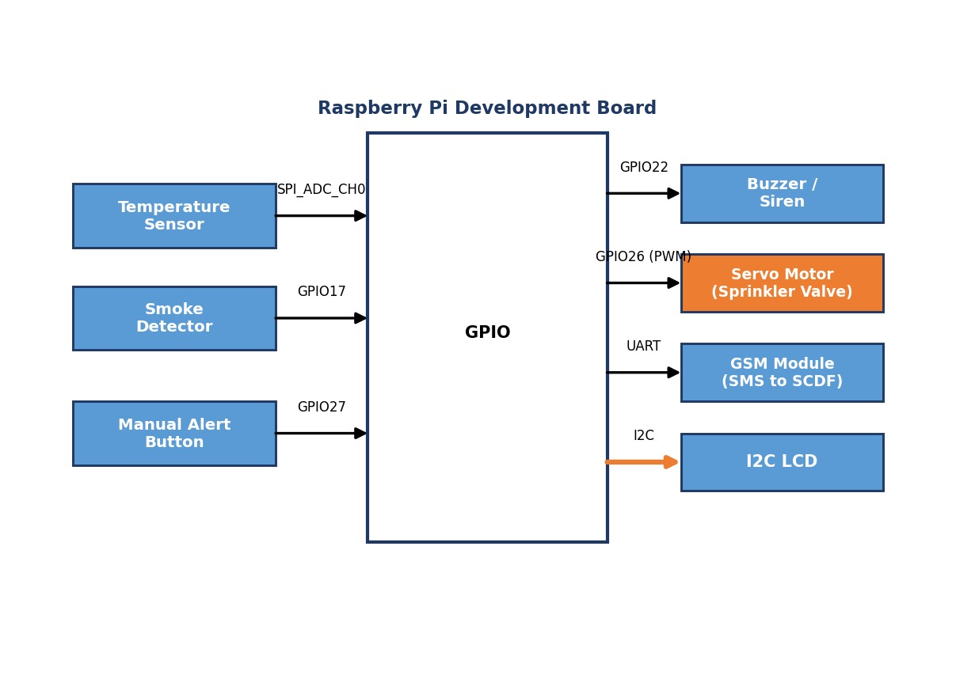
Figure 2 — System Architecture

Functional Requirements

Start Up and Main Menu
REQ_ID | Requirement
REQ-01 | When the Smart Fire Alert System is first powered ON, the main menu below shall be displayed on the LCD:  Line 1 = "1. Monitoring ON"  Line 2 = "2. System Off"
REQ-02 | In the main menu (REQ-01), if "1. Monitoring ON" is selected on the keypad, the system shall enter the Monitoring State and display:  Line 1 = "Monitoring..."  Line 2 = "Temp:__C Smoke:__"
REQ-03 | In the main menu (REQ-01), if "2. System Off" is selected, the LCD shall display the text below for 2 seconds, then turn off the display and backlight and enter the Low Power Mode defined in the State Machine in REQ-29:  Line 1 = "Shutting down"  Line 2 = "Stay safe"

Automatic Fire Detection
REQ_ID | Requirement
REQ-04 | From the Monitoring State, the system shall continuously execute the fire-detection flowchart defined in Figure 3.

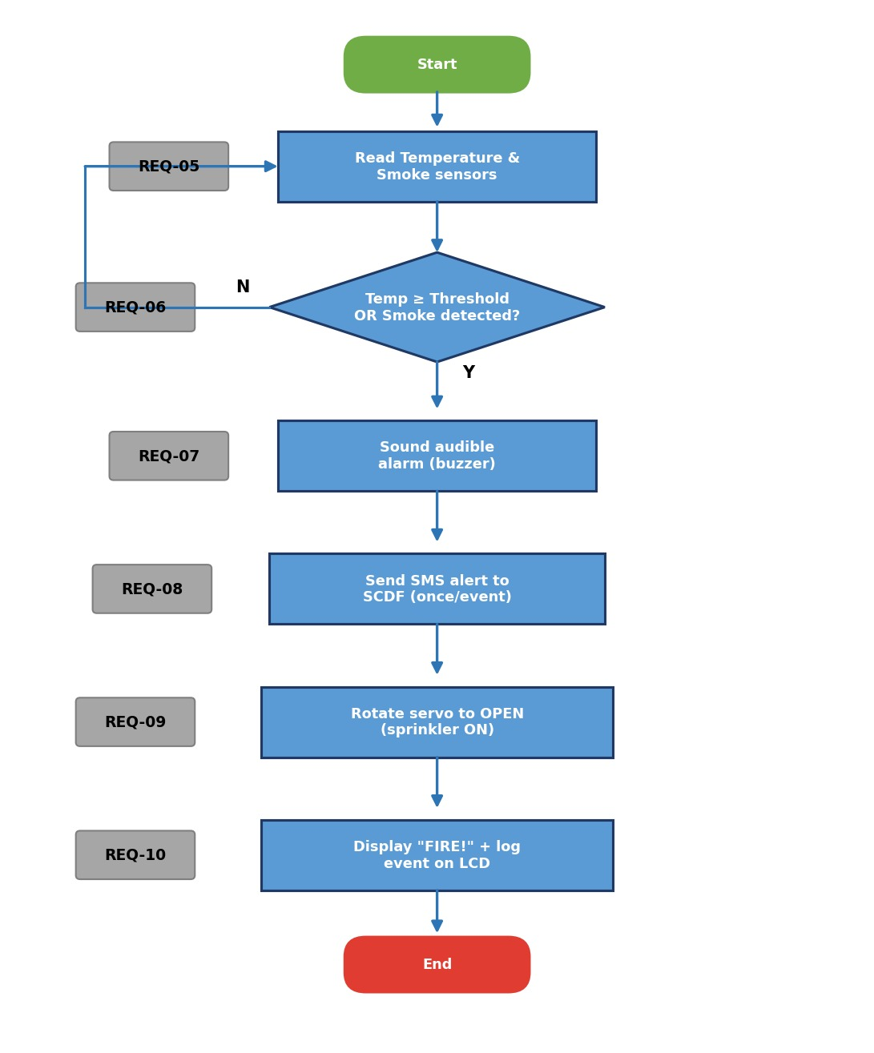
Figure 3 — Automatic Fire Detection
The individual steps of Figure 3 are specified by the following requirements:
REQ_ID | Requirement
REQ-05 | The system shall read the Temperature sensor and the Smoke detector at a sampling interval no greater than 2 seconds.
REQ-06 | The system shall raise a fire-detected condition if the temperature is ≥ the configured threshold OR the smoke detector indicates smoke (logical OR — at least one sensor is sufficient). Otherwise it shall continue monitoring.
REQ-07 | On a fire-detected condition, the system shall sound the audible alarm (buzzer/siren) loud enough to alert a resident in another room.
REQ-08 | The system shall send an SMS alert to SCDF, once per fire event, including the triggering sensor and a timestamp.
REQ-09 | The system shall rotate the servo motor to the OPEN position (e.g., 90°) to activate the sprinkler valve in the affected room.
REQ-10 | The system shall display "FIRE DETECTED" on the LCD and log the event.

Manual Alert
REQ_ID | Requirement
REQ-11 | The system shall provide a manual alert (panic) button. While in the Monitoring State, the system shall continuously execute the manual-alert flowchart defined in Figure 4.

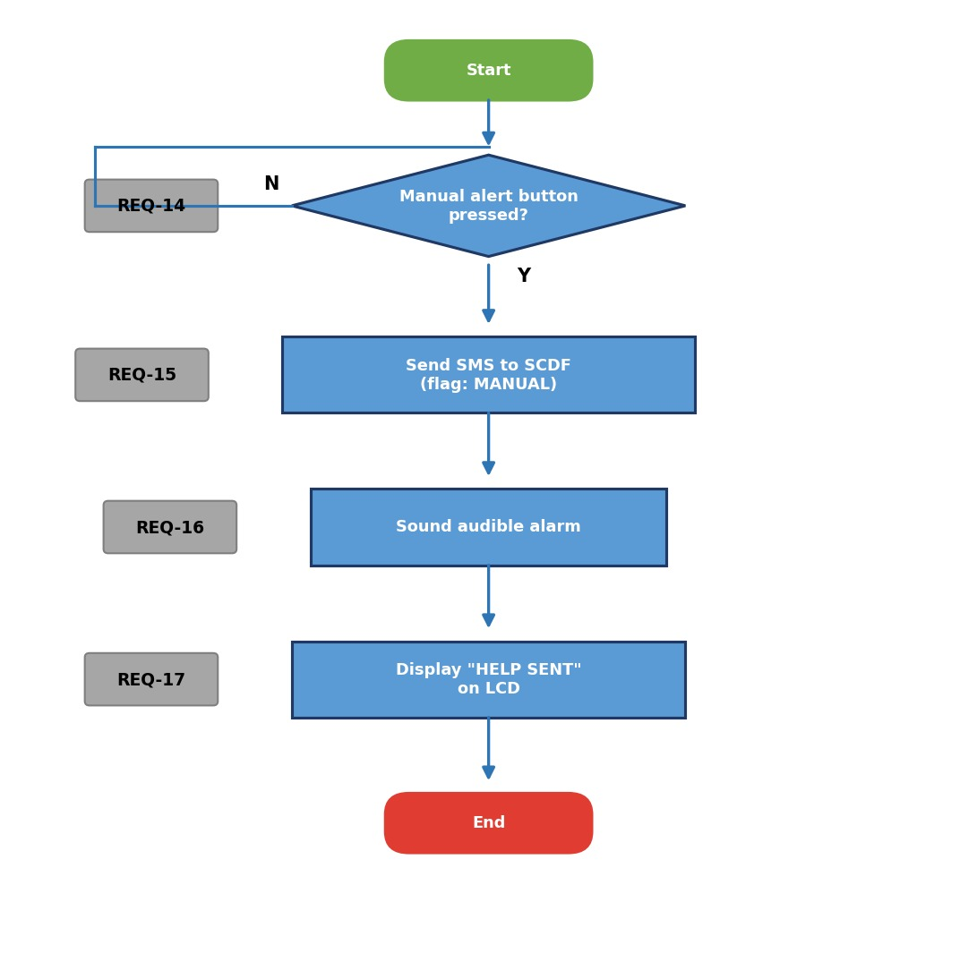
Figure 4 — Manual Alert

2.3.4 Sprinkler Control
REQ_ID | Requirement
REQ-12 | The system shall detect a press of the manual alert button at any time during monitoring, independently of the sensor readings.
REQ-13 | On a manual alert, the system shall send an SMS to SCDF flagged as a MANUAL alert, clearly distinguishable from an automatic fire alert.
REQ-14 | On a manual alert, the system shall sound the audible alarm.
REQ-15 | On a manual alert, the system shall display "HELP REQUESTED" on the LCD.
REQ-16 | As a first line of fire defence, the system shall activate the sprinkler in the room where a fire is detected by any sensor (see REQ-09).
REQ-17 | The sprinkler valve shall be actuated by a servo motor driven from a GPIO PWM output: the servo rotates to the OPEN angle to dispense water and back to the CLOSED angle to stop.
REQ-18 | When the alert is cleared/reset, the system shall return the servo to the CLOSED (safe) position.

2.3.5 SCDF notification (SMS)
REQ_ID | Requirement
REQ-19 | The system shall notify SCDF of an alert by sending an SMS message via the GSM module to a configured emergency number.
REQ-20 | The SMS message shall contain at least the following:  - Alert type (AUTO fire detection or MANUAL)  - Triggering sensor(s), where applicable  A timestamp (hh:mm:ss)
REQ-21 | If sending the SMS fails, the system shall retry and shall log the failure. The local alarm and sprinkler shall operate regardless of SMS success.

2.3.6 Remote Access (Optional / Commercial Variant)
This subsection is an optional enhancement for a connected variant; it is not required for the core prototype
REQ_ID | Requirement
REQ-22 | The user shall be able to connect to the IP address of the Smart Fire Alert System to view a web page.
REQ-23 | The internal web server shall allow the user to monitor the following:  - Current room temperature  - Current smoke-detector status  Current system state and recent alert log
REQ-24 | The internal web server shall allow the user to control the following:  - Arm / disarm monitoring  Silence/reset an active alarm and close the sprinkler valve

2.3.7 Logging and Configuration
REQ_ID | Requirement
REQ-25 | The system shall log all significant events (threshold crossings, alarms, SMS notifications, manual alerts, sprinkler activation, faults) with timestamps.
REQ-26 | Sensor thresholds, sampling interval, the servo OPEN/CLOSED angles, and the SCDF phone number shall be configurable without changing source code (e.g., a configuration file).
REQ-27 | If a sensor returns an invalid reading, the system shall log the fault and continue monitoring using the remaining sensor.

Non-Functional Requirements

Performance and Reliability
REQ_ID | Requirement
REQ-28 | From the moment a sensor crosses its threshold, the system shall trigger the alarm, the SMS notification and the sprinkler within 5 seconds. An exception in one subsystem shall not crash the monitoring loop; faults shall be caught and logged.

Power Management
The Smart Fire Alert System has two power modes as defined in the State Machine in Figure 5. The transitions between Low Power Mode and the active Monitoring State are triggered by the events “evEnterLPM” and “evEnterMonitor”. The trigger conditions are defined in the requirements below.
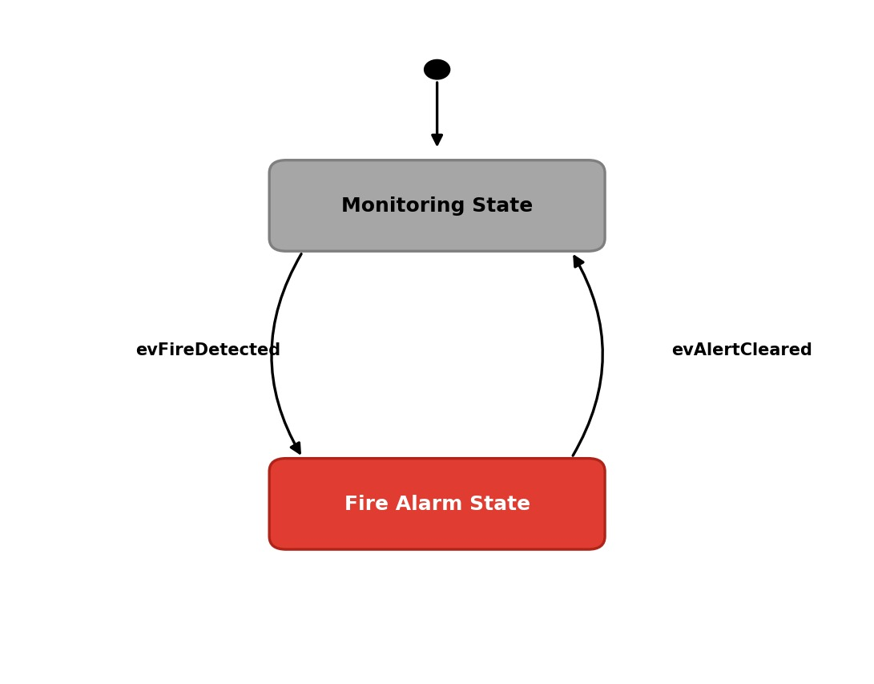
Figure 5 — Power-Mode State Machine

REQ_ID | Requirement
REQ-29 | "evEnterLPM" Trigger Condition  When the option "2. System Off" is selected in the main menu.
REQ-30 | "evEnterMonitor" Trigger Condition 1  When the user presses any button on the keypad.
REQ-31 | "evEnterMonitor" Trigger Condition 2  When the user presses the manual alert button.

Safety and Security
REQ_ID | Requirement
REQ-32 | On power-up and after an alert is cleared, the servo (sprinkler valve) shall default to the CLOSED (safe) position. The system is a supplementary aid and not a certified life-safety device.
REQ-33 | Notification credentials and the SCDF phone number shall not be hard-coded in committed source; they shall be stored in a configuration/secrets file excluded from the GitHub repository.

Software Architecture

Static Software Architecture
The software architecture defines the software components developed to realise the system requirements. It is organised into an Application Layer (system behaviour) and a Hardware Abstraction Layer (HAL) that wraps each hardware peripheral so the application code is independent of wiring details.
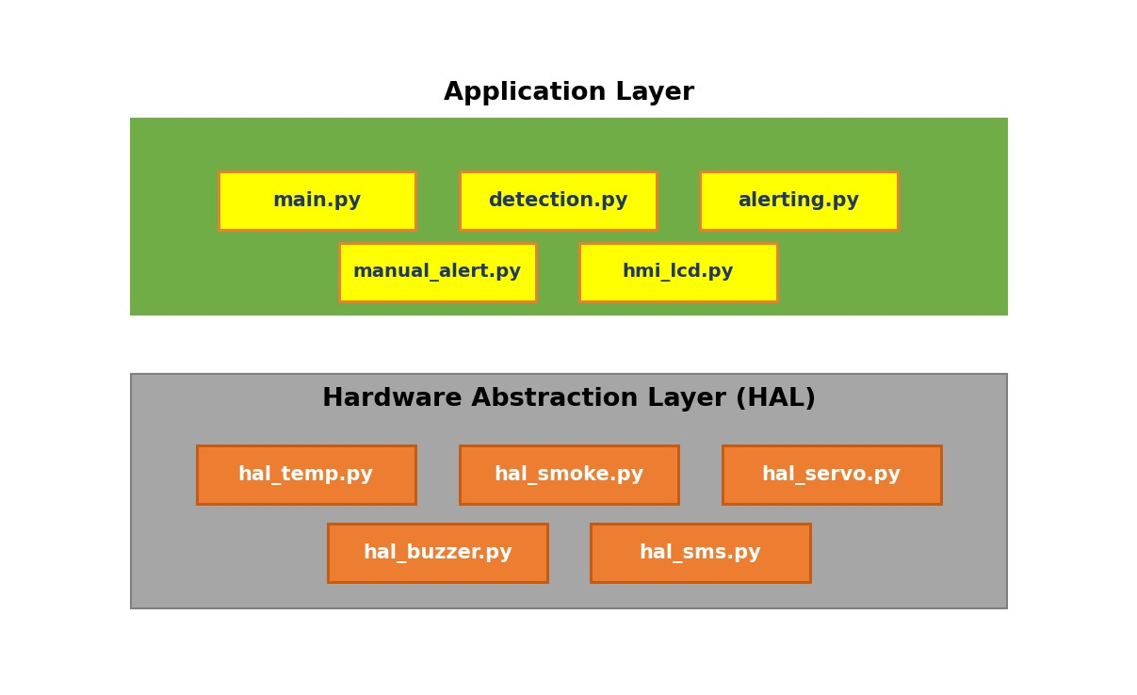
Figure 6 — Static Software Architecture

Module | Responsibility
main.py | Entry point; main menu, state machine, and the monitoring loop.
detection.py | Reads sensors via the HAL and applies the fire-detection logic (REQ-05–REQ-10).
alerting.py | Coordinates buzzer, SMS and LCD messages for an alert.
manual_alert.py | Handles the panic-button input (REQ-11–REQ-15).
hmi_lcd.py | Drives the I2C LCD menus and status text.
hal_temp.py | Reads the temperature sensor (SPI ADC).
hal_smoke.py | Reads the smoke detector (GPIO).
hal_servo.py | Drives the servo (PWM) to OPEN/CLOSE the sprinkler valve.
hal_buzzer.py | Drives the buzzer/siren (GPIO).
hal_sms.py | Sends SMS via the GSM module (UART).

4. Appendices

4.1 Requirements Traceability Matrix
This matrix maps each customer requirement from the brief to the requirement(s) that satisfy it, to demonstrate full coverage.
Customer Requirement (brief) | Satisfied by | Type
Deploy at least 2 sensor types (Temperature + Smoke) | REQ-05, Fig. 2 | Functional
Detect possible fire from sensor parameters | REQ-05, REQ-06 | Functional
Alert resident via audible alarm | REQ-07, REQ-14 | Functional
Inform SCDF (via SMS) | REQ-08, REQ-19, REQ-20 | Functional
Manual alert switch/button for urgent help | REQ-11 to REQ-15 | Functional
Activate sprinkler in the affected room | REQ-09, REQ-16, REQ-17 | Functional
Electrically actuated control valve (servo motor) | REQ-17 | Functional
Respond quickly / run reliably | REQ-28 | Non-functional

4.2 GPIO Pin Plan
Planning reference — confirm the actual BCM pins your team wires.
Device | BCM Pin | Notes
Temperature sensor | SPI ADC CH0 | Analogue via MCP3008 (SPI)
Smoke detector | GPIO17 | Digital input
Manual alert button | GPIO27 | Digital input, internal pull-up
Buzzer / siren | GPIO22 | Digital output
Servo (sprinkler valve) | GPIO26 | PWM output
GSM module (SMS) | UART (TX/RX) | Serial; common ground required
LCD | I2C (SDA/SCL) | Status display
Ensure a common ground between the Pi and any externally powered actuator (servo / GSM module).

