Table of Contents
1. Purpose 3
1.1. Intended Audience 3
1.2. Intended Use 3
1.3. Scope 3
1.4. Definitions and Acronyms 3
2. Overall System Description 4
2.1. Use Case Diagrams 4
2.2. System Architecture 5
2.3. Functional Requirements 6
2.3.1. Fire Detection – Temperature Sensor (DHT11) 6
2.3.2. Fire Detection – Light Sensor (LDR) 7
2.3.3. Fire Configuration & Alarm (Trigger Logic) 8
2.3.4. Local Alert (Buzzer/LCD/LED) 8
2.3.5 SCDF Notification (Telegram) 9
2.3.6 Manual Emergency Alert 10
2.3.7 Automatic Fire Suppression (Sprinkler Control) 10
2.3.8 System Override (Keypad, Password) 11
2.3.9 System Override (RFID) 11
2.3.10 Event Logging 11
2.4 Non-Functional Requirements 12
2.4.1 Performance Requirements 12
2.4.2 Reliability Requirements 12
2.4.3 Security Requirements 12
2.4.4 Usability Requirements 12
2.4.5 Maintainability Requirements 13
3 Software Architecture 14
3.1 Static Software Architecture 14
4. Appendices 15
4.1 Requirements Traceability Matrix 15
4.2 GPIO Pin Plan 15

Document Version
No | Update: | Name: | Date: | Version:
1. | Initial version | SRS_project_DCPEFT2A03_GroupB | 11/05/26 | 1.0
2. | Updated Version | SRS_project_DCPEFT2A03_GroupB | 25/05/26 | 1.1
3. | Updated Version | SRS_project_DCPEFT2A03_GroupB | 25/07/26 | 1.2
4. | Updated Version | SRS_project_DCPEFT2A03_GroupB | 17/08/26 | 1.3
5. | Updated Version | SRS_project_DCPEFT2A03_GroupB | 20/8/2026 | 1.4

Purpose
This System / Software Requirements Specification (SRS) describes the system requirements and software design for the Smart Fire Alert System, an IoT-driven fire-detection device built on a Raspberry Pi. It defines what the system shall do so that the requirements can be used as the input for system test cases and software unit test cases

Intended Audience
This document is intended for the system and software engineers (the project group members) developing the Smart Fire Alert System, and for the supervising assessor reviewing the work. The customer is the Singapore Civil Defence Force (SCDF).

Intended Use
The SRS defines the overall system architecture and requirements, as well as the software architecture and design. It serves as the agreed reference for design, implementation on the Raspberry Pi, and verification through test cases derived from each numbered requirement.

Scope
In recent years, there have been several fire outbreaks in the rental apartments of elderly residents in Singapore. To detect such fires as soon as possible, the Smart Fire Alert System continuously monitors a resident’s home for early signs of fire using 2 sensors, a temperature sensor and smoke detector. When at least one sensor detects a possible fire, the system sounds a local alarm which notifies SCDF via SMS and activates a sprinkler valve (driven by a servo motor) in the affected room. A manual alert button lets the resident summon SCDF immediately. The prototype is implemented in Python on a Raspberry Pi, with source code and documentation maintained on GitHub.

Definitions and Acronyms

Acronym | Description
Acronym | Description
SCDF | Singapore Civil Defence Force
IoT | Internet of Things
GPIO | General-Purpose Input/Output
PWM | Pulse-Width Modulation (used to drive the servo)
ADC | Analogue-to-Digital Converter
SPI / I2C | Serial Peripheral Interface / Inter-Integrated Circuit (sensor & LCD buses)
GSM | Global System for Mobile communication (SMS module)
SMS | Short Message Service
LCD | Liquid Crystal Display
HAL | Hardware Abstraction Layer
SW / HW | Software / Hardware
DHT11 | Digital Temperature and Humidity Sensor
LED | Light Emitting Diode
LCD | Liquid Crystal Display
DHT11 | Digital Temperature and Humidity Sensor
LDR | Light Dependent Resistor
RTC | Real-Time Clock
RFID | Radio Frequency Identification

Overall System Description

Use Case Diagrams
The diagram below shows the main actors, the elderly resident and SCDF, and the use cases the Smart Fire Alert System provides.

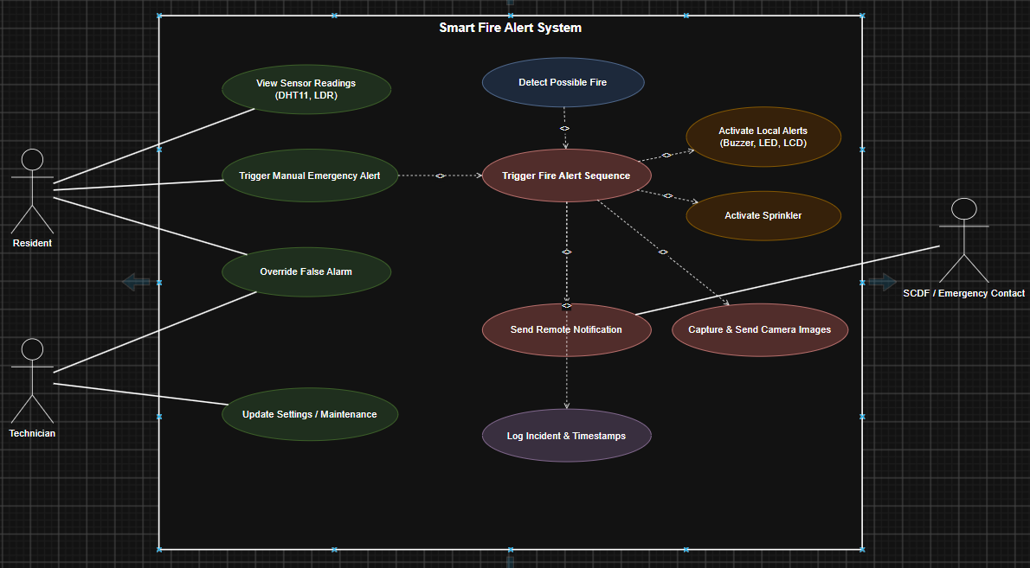
Figure 2.1: Smart Fire Alert System (Overall System)

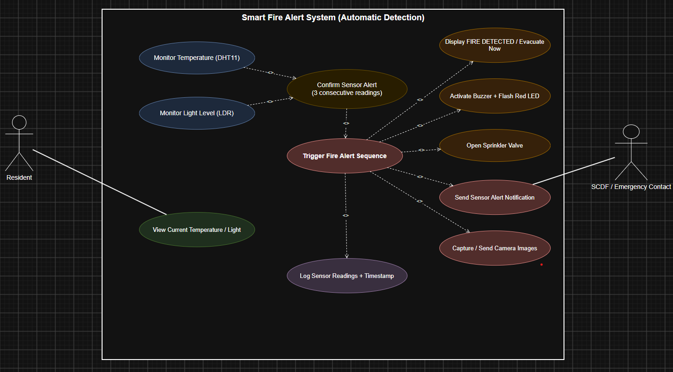
Figure 2.2: Smart Fire Alert System (Automatic Detection)

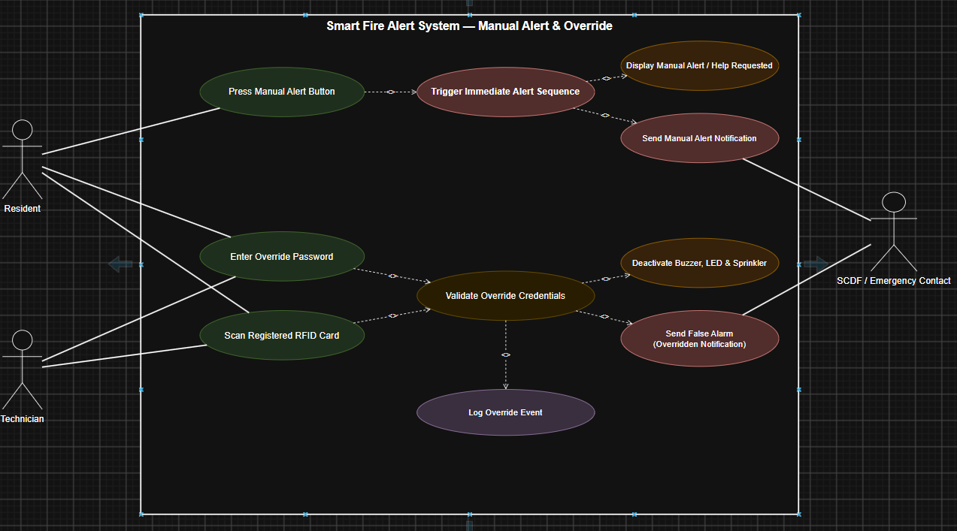
Figure 2.3: Smart Fire Alert System (Manual Alert & Override)

System Architecture
The Raspberry Pi development board is the central controller. It reads the temperature sensor (via an SPI ADC channel), the smoke detector, and the manual alert button on its GPIO, and drives the buzzer, the servo motor controlling the sprinkler valve, the GSM module for SMS, and an I2C LCD for status display.
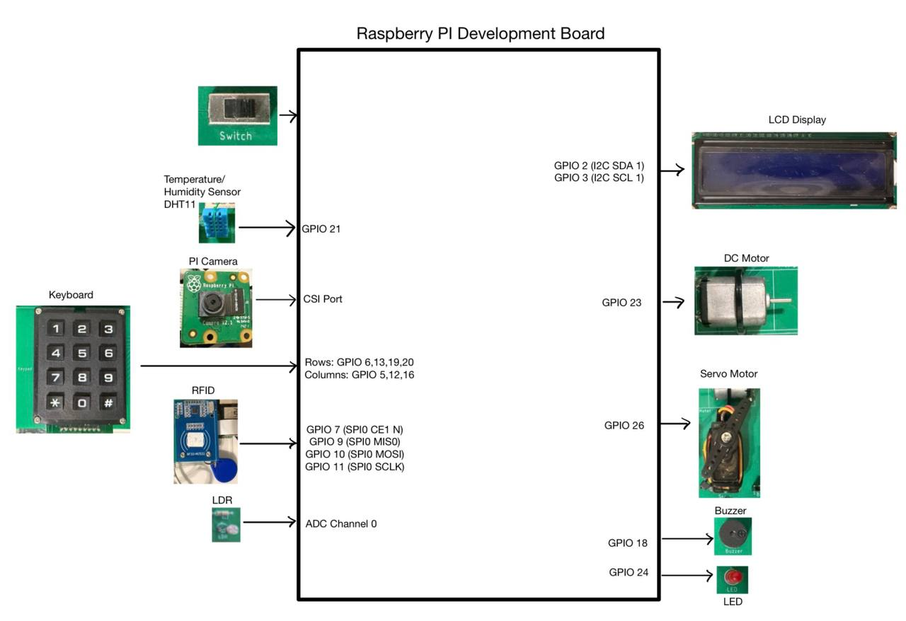
Figure 2 — System Architecture

Functional Requirements

Fire Detection – Temperature Sensor (DHT11)
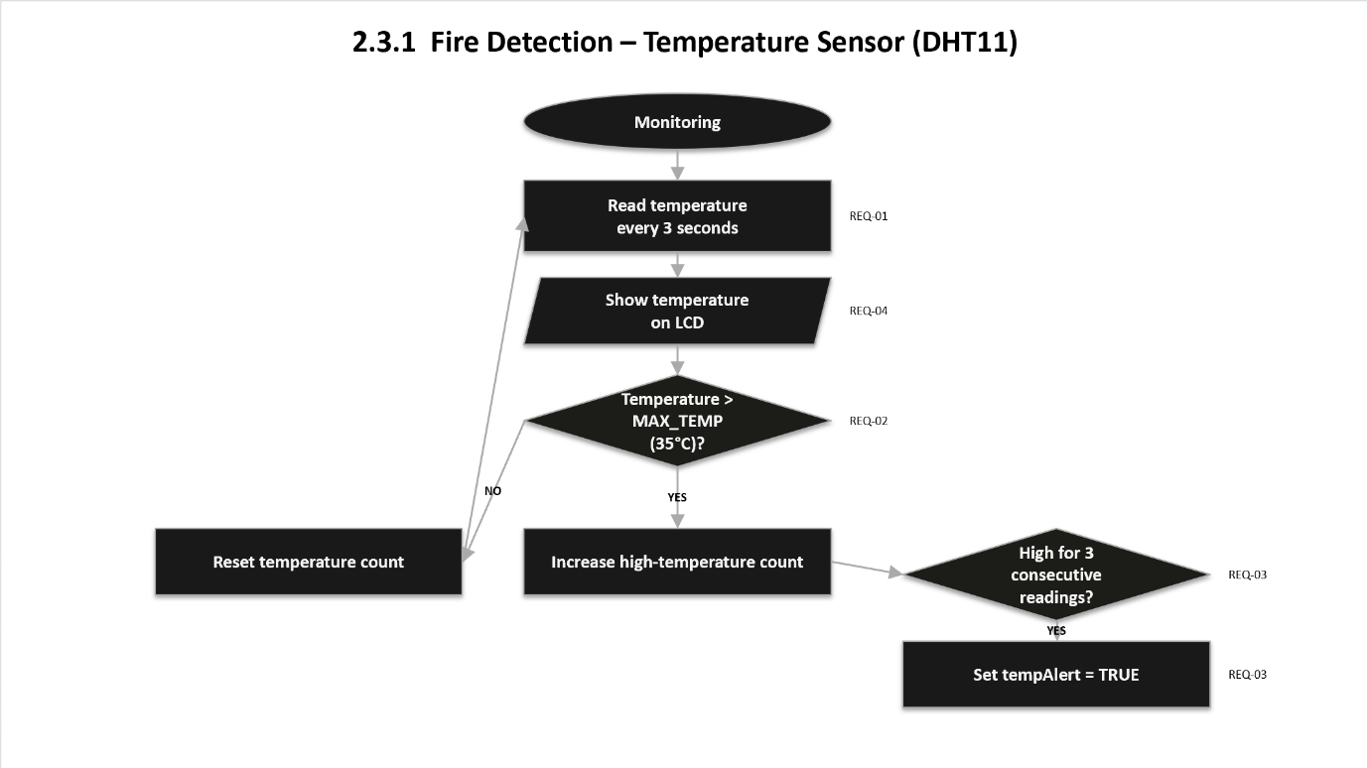
REQ_ID | Requirement
REQ-01 | The system shall continuously read the ambient room Temperature from the DHT11 sensor at an interval of 3 second.
REQ-02 | The system shall define a temperature threshold, MAX_TEMP, defaulted to 35°C.  If ambient Temperature > 35°C, a possible fire condition is flagged.
REQ-03 | If the ambient Temperature > 35°C, from REQ-02 is met, for 3 consecutive readings, the system shall set the tempAlert flag to True.  To filter false positives from brief spikes.
REQ-04 | The system shall display the current temperature reading on the LCD when in monitoring/idle mode. Eg:  Line 1 – “Temp: XX.X C”

Fire Detection – Light Sensor (LDR)
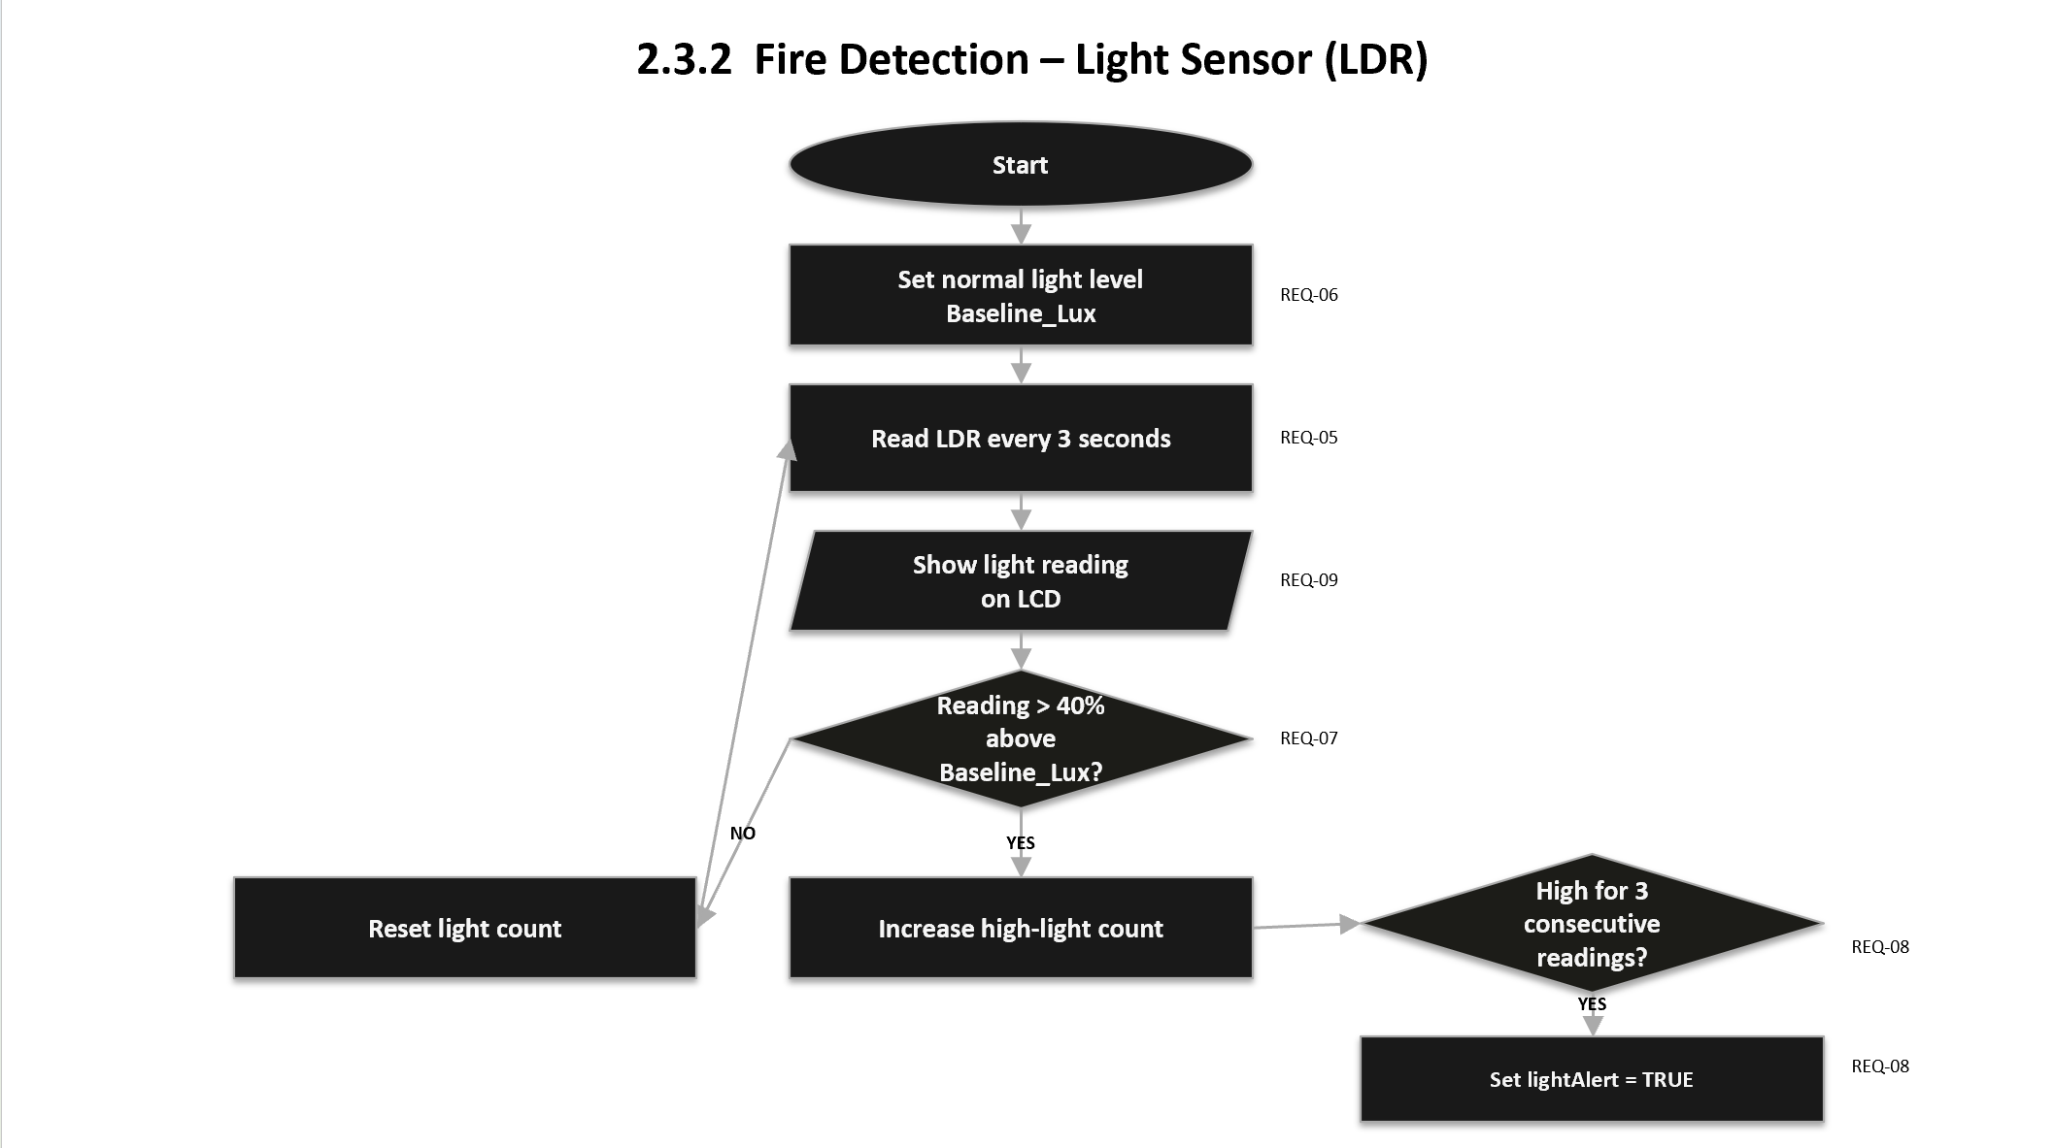

REQ_ID | Requirement
REQ-05 | The system shall continuously read the ambient light intensity from the LDR sensor via ADC Channel 0 at an interval of 3 second.
REQ-06 | The system shall establish a baseline ambient reading, Baseline_Lux, during system startup/calibration.
REQ-07 | The system shall define a brightness threshold, Max_Lux, such that if the LDR reading increases by more than the threshold (e.g. 40%) above Baseline_Lux, it is flagged as a possible flame/fire flicker.
REQ-08 | If the sudden brightness increase condition in REQ-07 is met for 3 consecutive readings (3 seconds), the system shall set the lightAlert flag to TRUE.  To filter false positive spikes.
REQ-09 | The system shall display the current light sensor reading on the LCD when in monitoring/idle mode. Eg:  Line 2: “Light: XXXX”

Fire Configuration & Alarm (Trigger Logic)
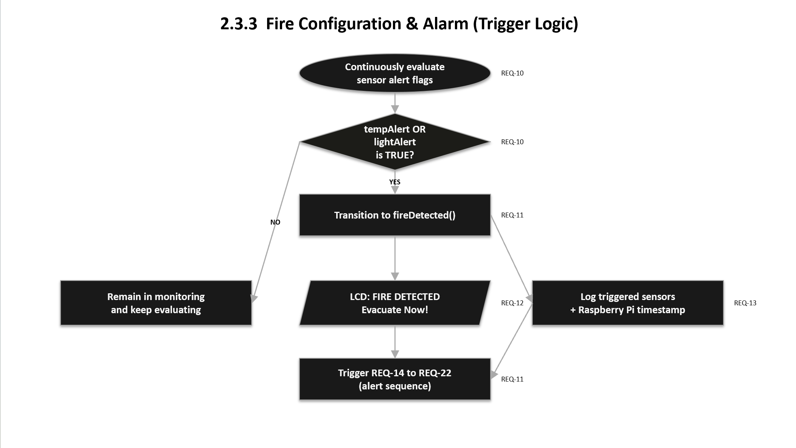
REQ_ID | Requirement
REQ-10 | The system shall evaluate tempAlert AND lightAlert continuously (fire is confirmed if at least one sensor detects an anomaly, per SCDF requirements).
REQ-11 | If either tempAlert or lightAlert Is TRUE, the system shall immediately transition to fireDetected() state and trigger REQ-12 to REQ-22.
REQ-12 | Upon entering the fireDetected() state, the LCD shall display:  Line 1 = “FIRE DETECTED”  Line 2 = “Evacuate Now!”
REQ-13 | The system shall log the sensors together with a timestamp obtained from the Raspberry Pi System Clock.

2.3.4. Local Alert (Buzzer/LCD/LED)
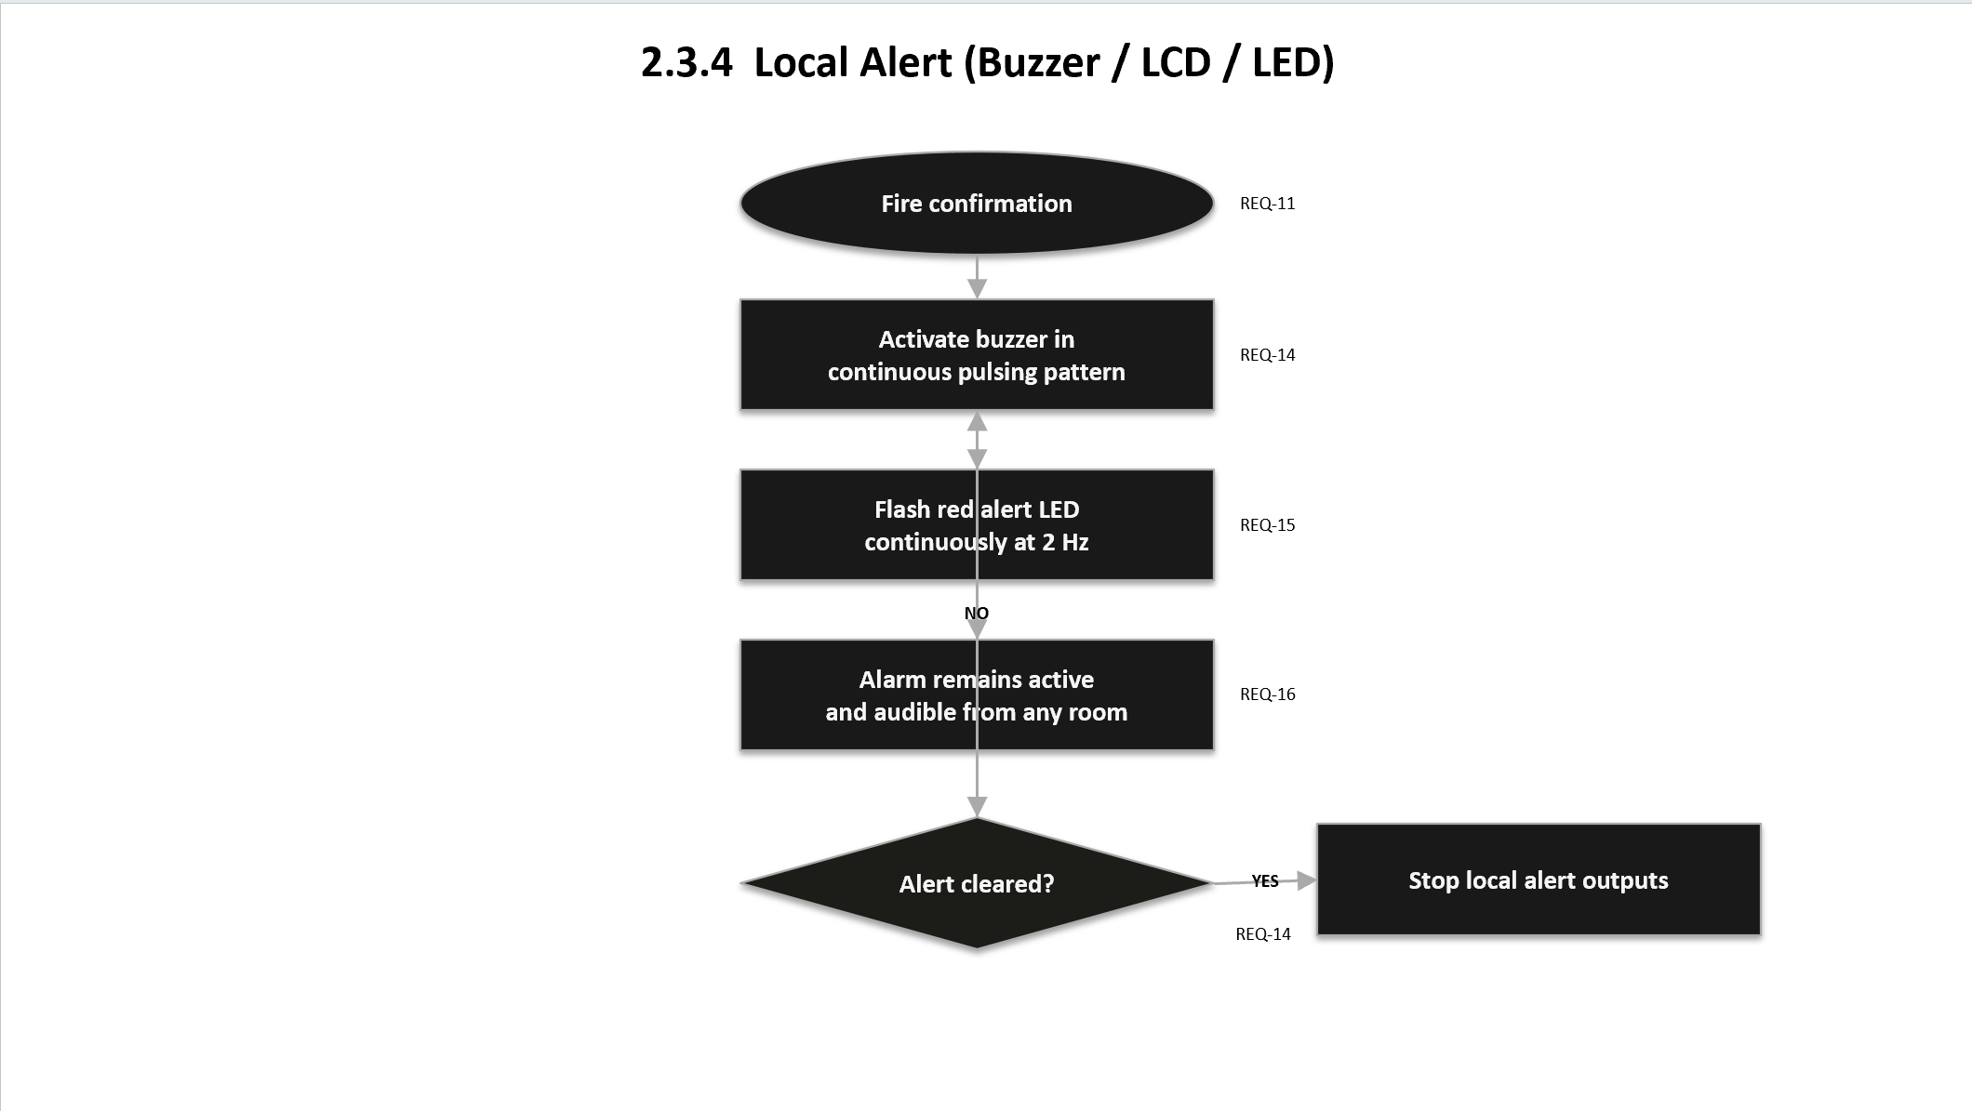
REQ_ID | Requirement
REQ-14 | Upon fire confirmation (REQ-11), the system shall immediately activate the buzzer in a continuous pulsing pattern of:  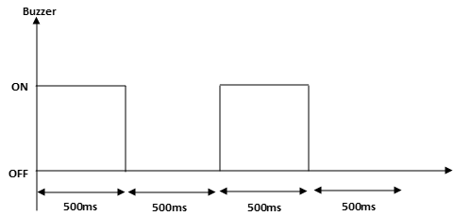  The buzzer will be activated until the alert is manually cleared or an authorised override is performed in accordance with REQ-31 to REQ-35.
REQ-15 | Upon fire confirmation, the system shall activate the red alert LED to flash continuously at 2 Hz to provide a visual cue for hearing-impaired residents.
REQ-16 | The audible alarm volume/pattern shall be designed to be audible from any room in a typical HDB Flat, so residents in another room are alerted.

2.3.5 SCDF Notification (Telegram)
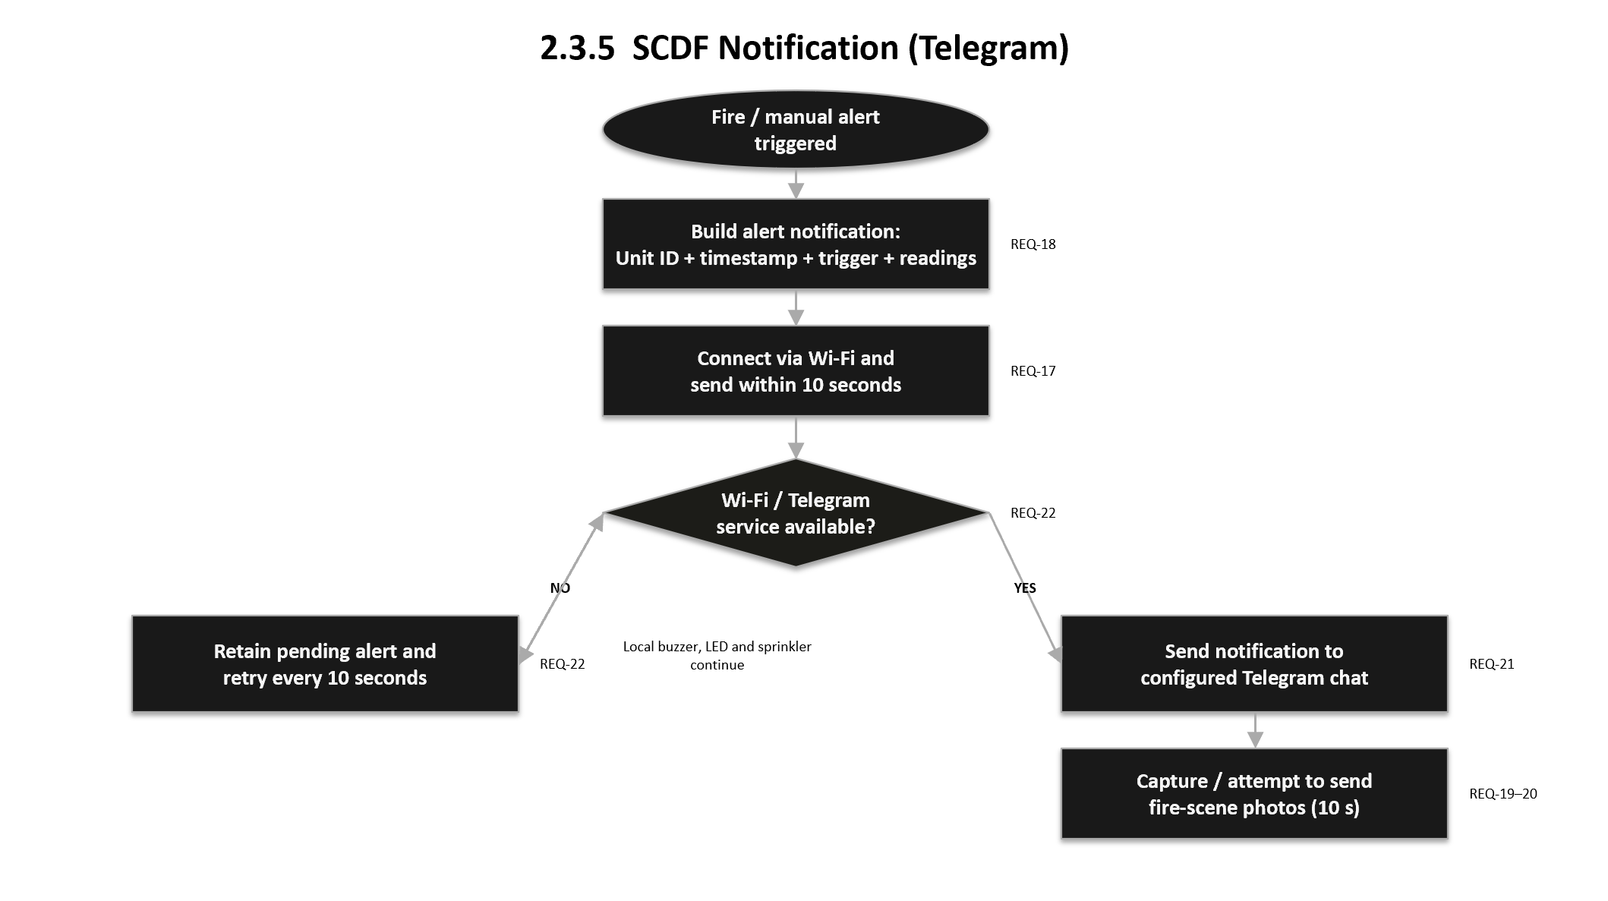
REQ_ID | Requirement
REQ-17 | Upon fire confirmation, the system shall connect via the onboard WIFI module and transmit an alert notification to SCDF’s monitoring endpoint within 10 seconds.
REQ-18 | The notification shall include:  - Unit/Address ID  - Timestamp (from Raspberry Pi’s System Clock)  - Triggered Sensor  - Current temperature/light readings  Lastly, it will include a tag where:  If triggered by Sensor (REQ-10 & 11):  tag = “Sensor Alert”  else if triggered Manually (REQ-23):  tag = “Manual Alert”
REQ-19 | While an alert is active, the system shall capture fire-scene photos at approximately 10-second intervals and save each captured photo locally with a timestamped filename.
REQ-20 | The system shall attempt to transmit each captured fire-scene photo to the configured Telegram chat when a network connection is available.
REQ-21 | The system shall send each alert notification to the configured Telegram chat and include the unit ID, alert type, timestamp, and triggered sensor or manual input.
REQ-22 | If the Wi-Fi connection or Telegram service is unavailable when an alert notification is triggered, the system shall retain the pending alert notification and retry transmission every 10 seconds until successful. Local alert functions, including the buzzer, LED, and sprinkler, shall continue operating without interruption during the retry process.

2.3.6 Manual Emergency Alert
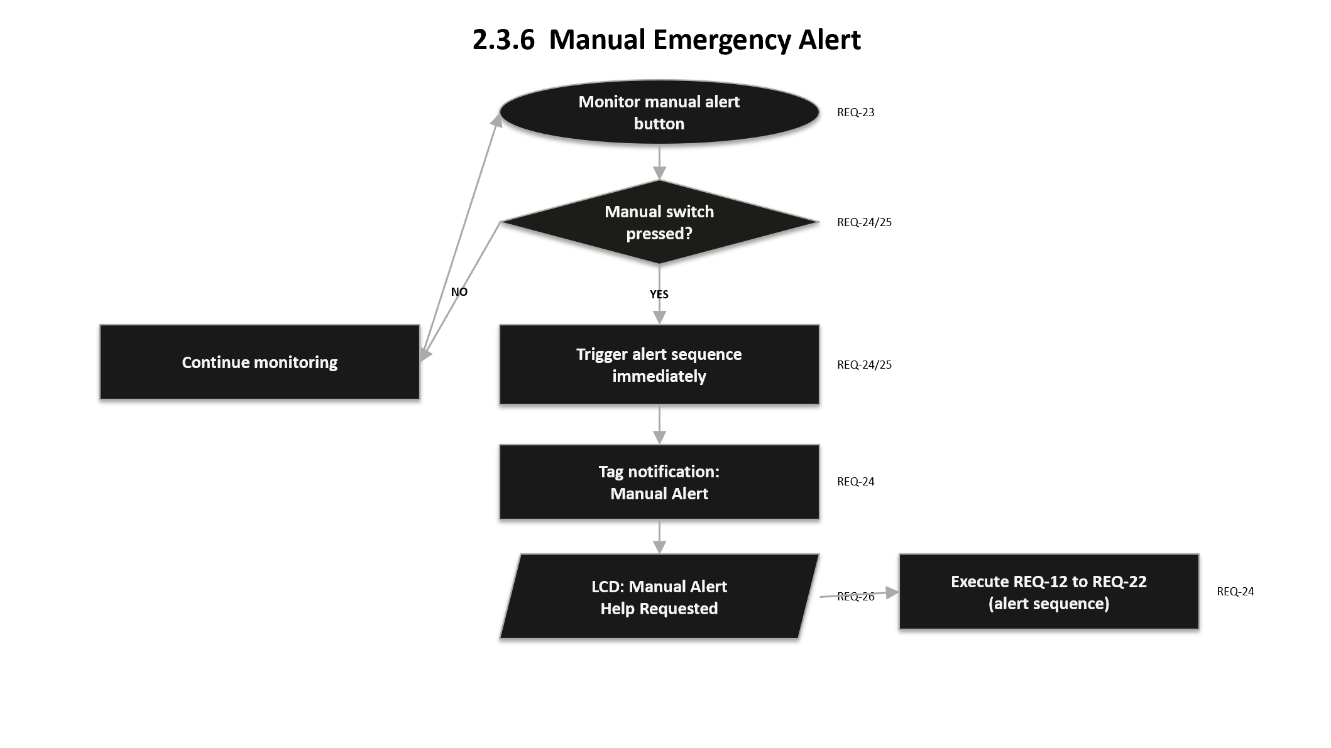
REQ_ID | Requirement
REQ-23 | The system shall always provide a physical manual alert switch/button accessible to the residents.
REQ-24 | When the manual switch is pressed, the system shall immediately trigger the same alert sequence as automatic fire detection, REQ-12 to REQ-22.  It will be tagged as “Manual Alert” instead of “Sensor Alert” in the notification payload.
REQ-25 | The manual alert shall bypass the 3-consecutive reading confirmation logic for either Temperature in REQ-03 or Light in REQ-08, triggering instantly on a single button press, since it represents a direct request for urgent help rather than a sensor inference.
REQ-26 | The LCD shall display the following text when a manual alert is triggered:  Line 1: “Manual Alert”  Line 2: “Help Requested”

2.3.7 Automatic Fire Suppression (Sprinkler Control)
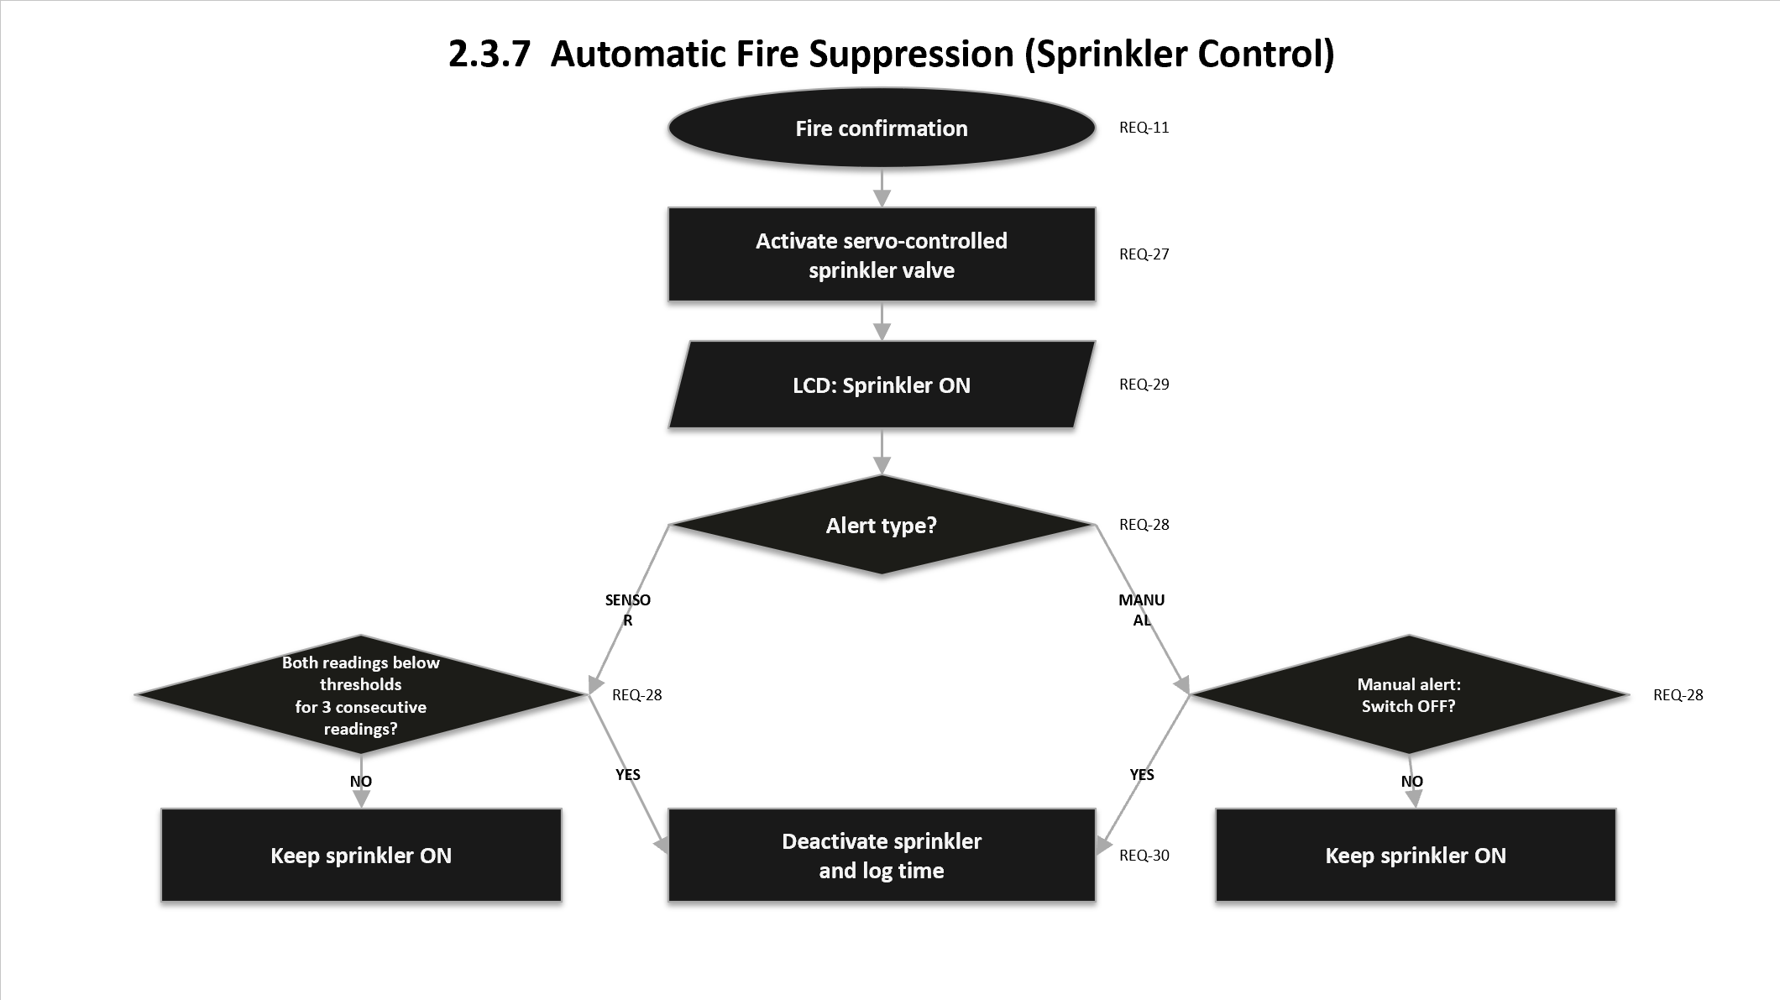
REQ_ID | Requirement
REQ-27 | Upon fire confirmation (REQ-11), the system shall activate the sprinkler control valve via the servo motor to release water in the affected room.
REQ-28 | For sensor-triggered alerts, the system shall clear the alert when both temperature and light readings return below their respective thresholds for 3 consecutive readings. When an authorised keypad or RFID override is entered, the local alert and sprinkler shall be temporarily deactivated for 10 seconds as a fault-alert period. For a manual alert, this 10-second period shall provide the user with time to turn off the manual switch; if the switch remains on after 10 seconds, the manual alert shall resume.
REQ-29 | The LCD shall display sprinkler status during activation:  Line 1: “Sprinkler ON”
REQ-30 | The system shall log the sprinkler status during activation and deactivation times (via Raspberry Pi’s System Clock) for post-incident review.

2.3.8 System Override (Keypad, Password)
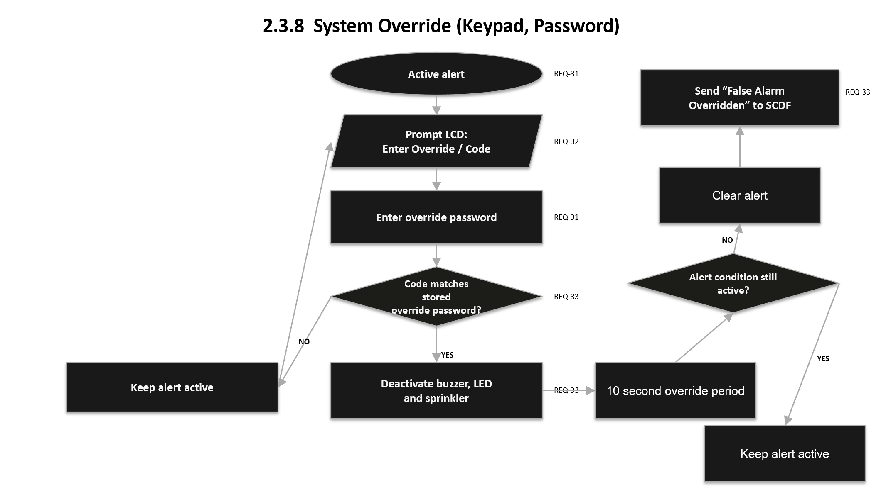
REQ_ID | Requirement
REQ-31 | The system shall provide a keypad interface allowing an authorised user to enter a password to override a false alert.
REQ-32 | Upon override activation, the system shall prompt:  Line 1: “Enter Override”  Line 2: “Code”
REQ-33 | If the entered code matches the stored override password, the system shall deactivate the buzzer, LED, and sprinkler, and send a “False Alarm Overridden” notification to SCDF.

2.3.9 System Override (RFID)
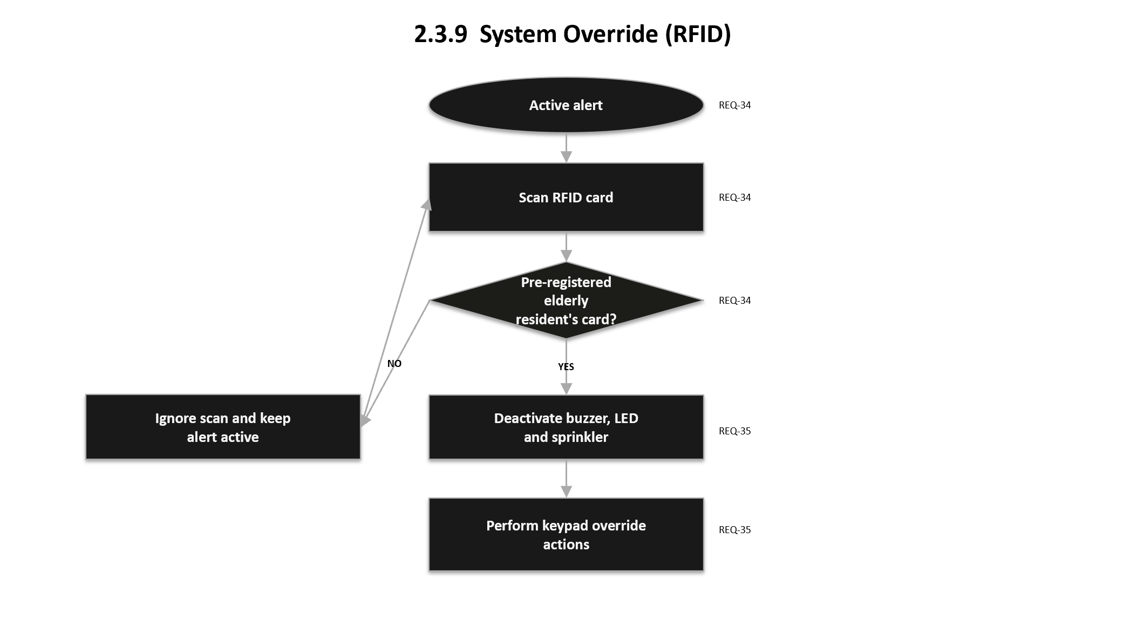
REQ_ID | Requirement
REQ-34 | The system shall provide an RFID reader allowing override via a pre-registered elderly resident’s RFID card, as an accessibility-friendly alternative to keypad entry.
REQ-35 | Upon a valid RFID card scan during an active alert, the system shall perform the same override actions as REQ-34.

2.3.10 Event Logging
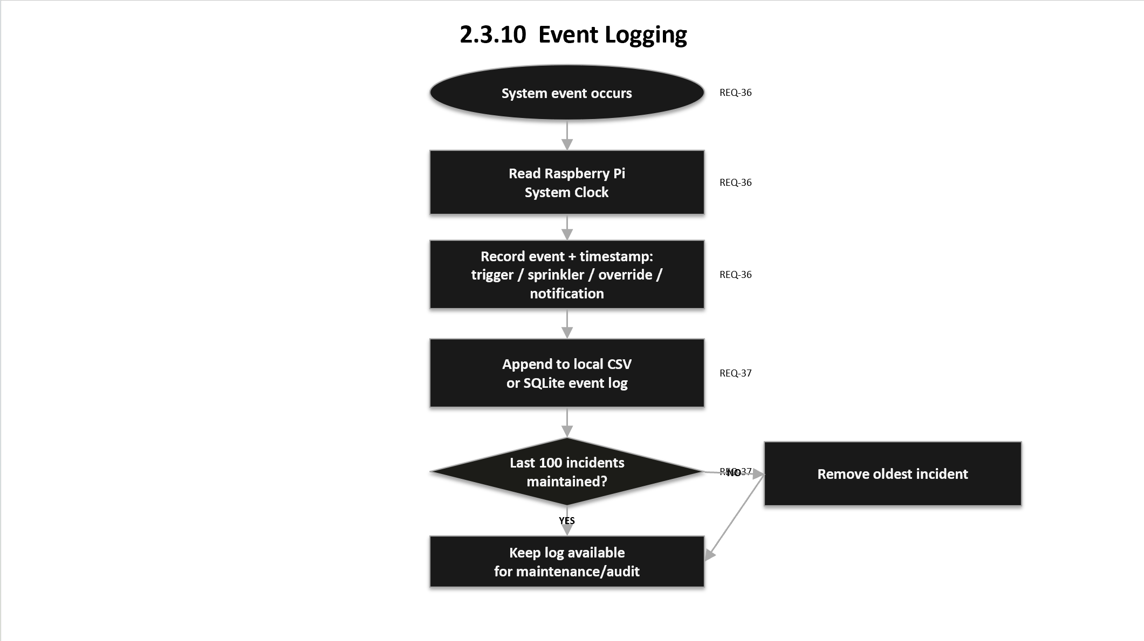
REQ_ID | Requirement
REQ-36 | The system shall use the Raspberry Pi’ System Clock to timestamp all events: alert triggers, sprinkler activation/deactivation, overrides, and notification transmissions.
REQ-37 | The system shall maintain a local event log (e.g. CSV or SQLite) of the last 100 incidents for maintenance/audit purposes.

Non-Functional Requirements

Performance Requirements
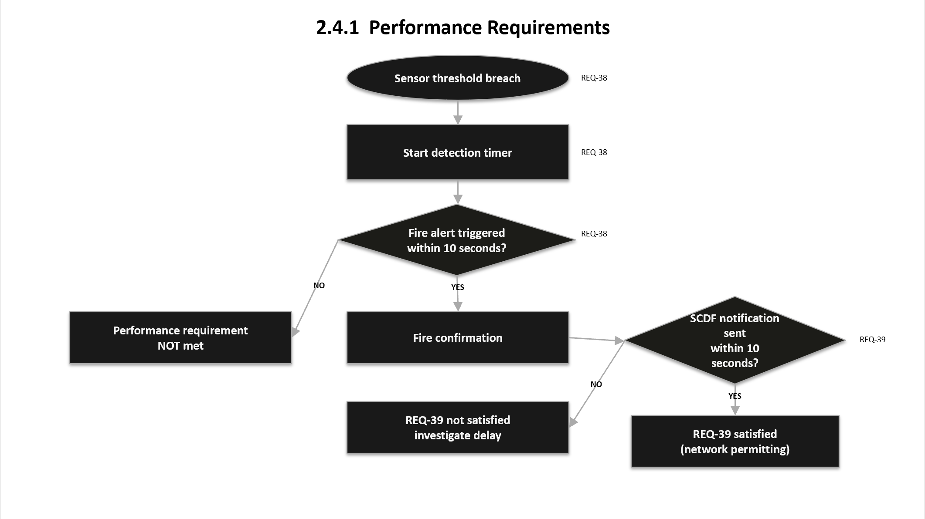
REQ_ID | Requirement
REQ-38 | The system shall detect and trigger an alert within 10 seconds of a sensor threshold breach.
REQ-39 | The system shall transmit the SCDF notification within 10 seconds of fire confirmation, network conditions permitting.

Reliability Requirements
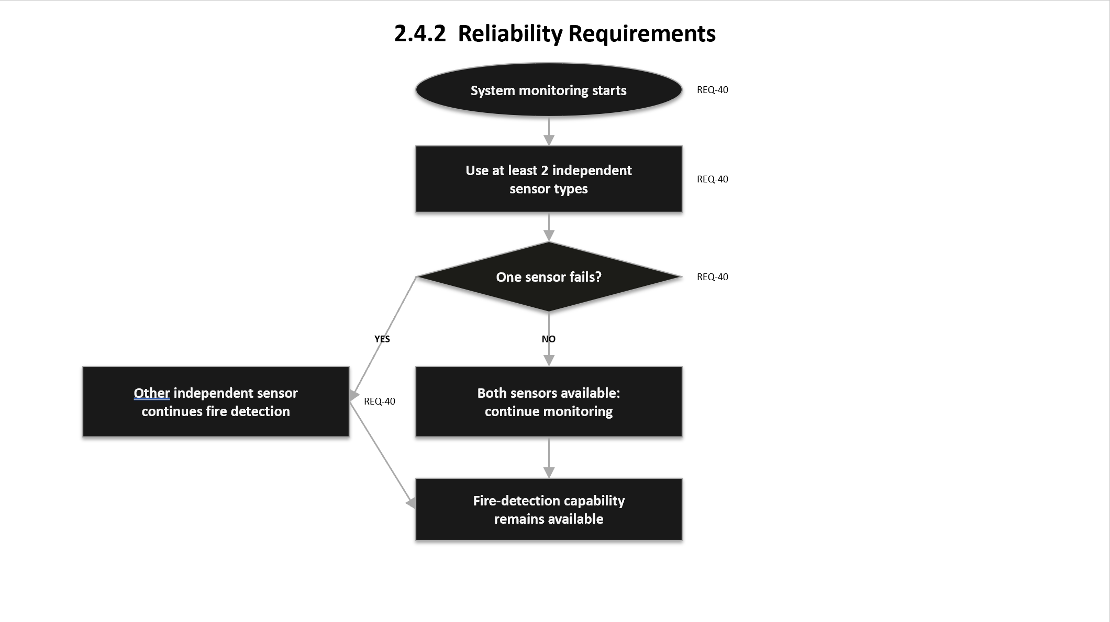
REQ_ID | Requirement
REQ-40 | The system shall use at least 2 independent sensor types (per SCDF requirement) so that failure of a single sensor does not eliminate fire-detection capability.

Security Requirements
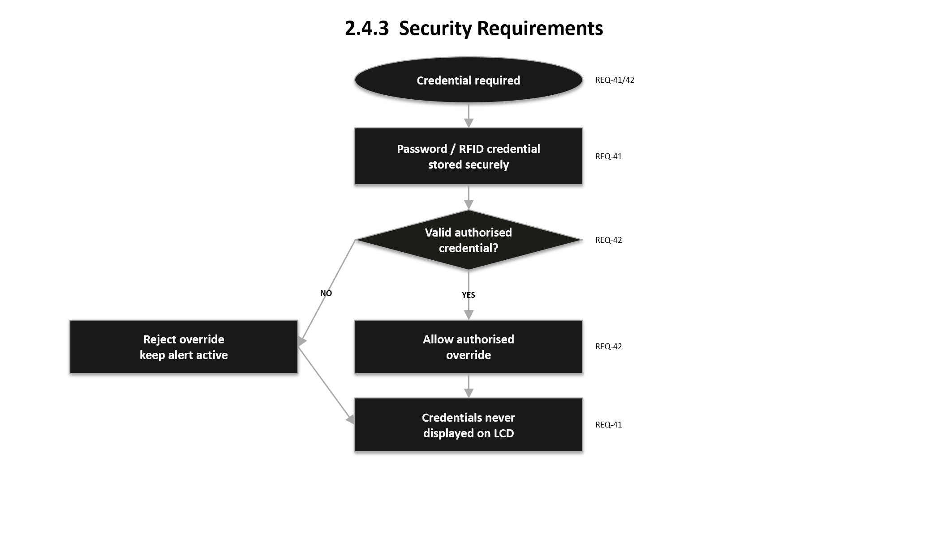
REQ_ID | Requirement
REQ-41 | Override passwords and RFID credentials shall be stored securely and never displayed on the LCD. (****)
REQ-42 | Only authorised residents/technicians with valid credentials shall be able to override an active alert.

Usability Requirements
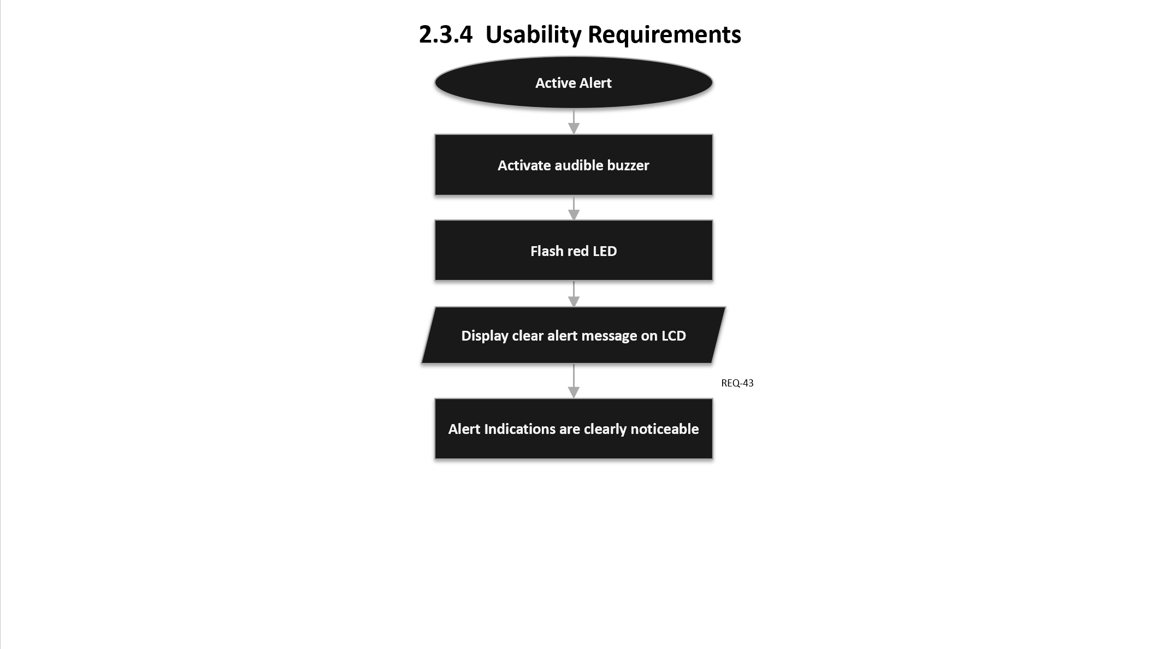
REQ_ID | Requirement
REQ-43 | The system shall provide clear and easily noticeable alert indications to support elderly residents, using an audible buzzer, a flashing LED, and a clear LCD alert message during an active alert.

Maintainability Requirements
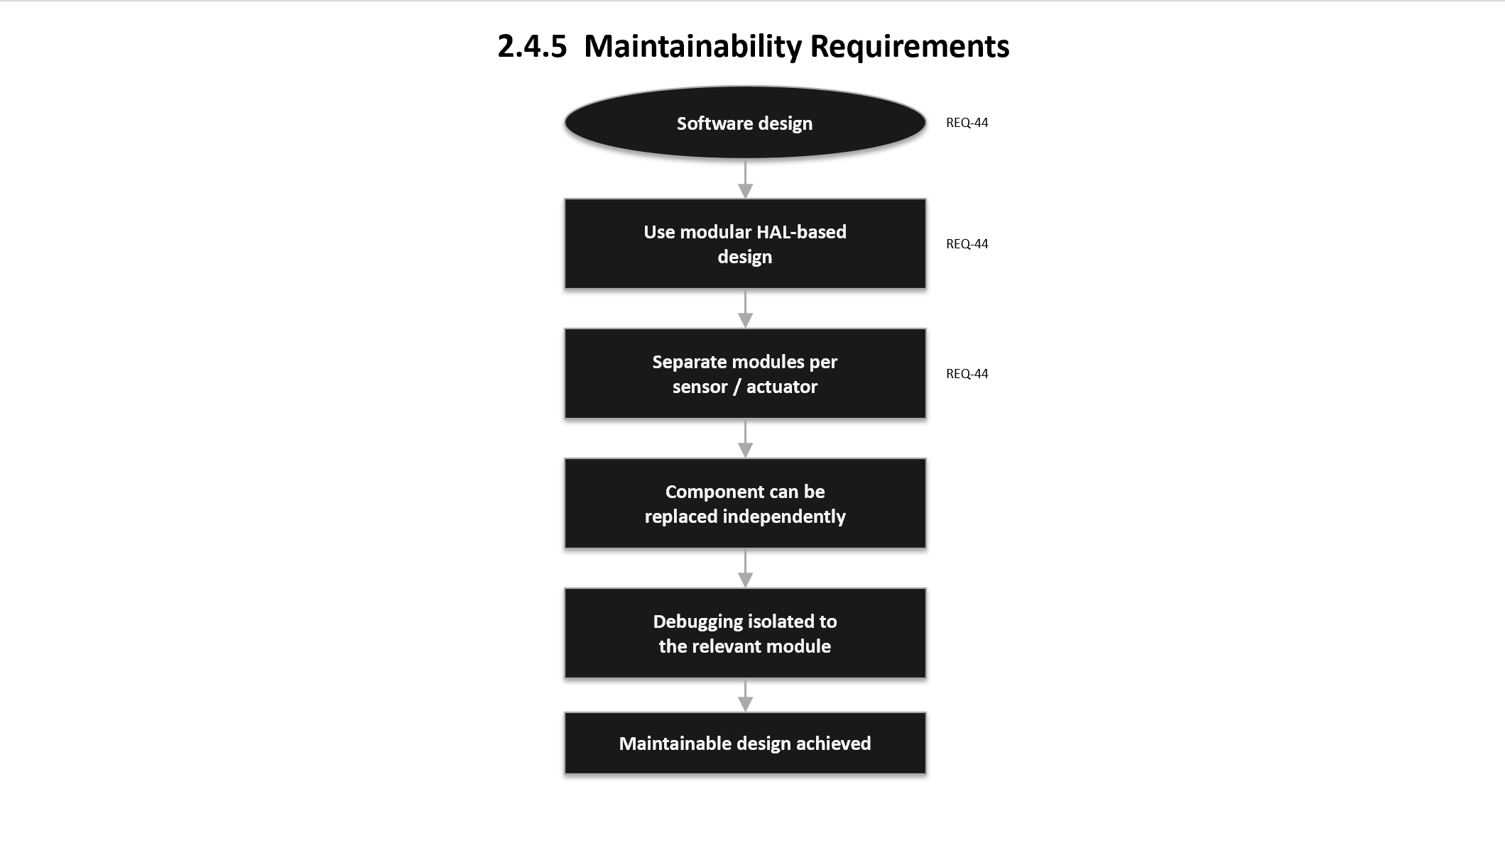
REQ_ID | Requirement
REQ-44 | The software shall follow a modular HAL-based design (separate modules per sensor/actuator) to simplify component replacement and debugging.

Software Architecture

Static Software Architecture
The software architecture defines the software components developed to realise the system requirements. It is organised into an Application Layer (system behaviour) and a Hardware Abstraction Layer (HAL) that wraps each hardware peripheral so the application code is independent of wiring details.
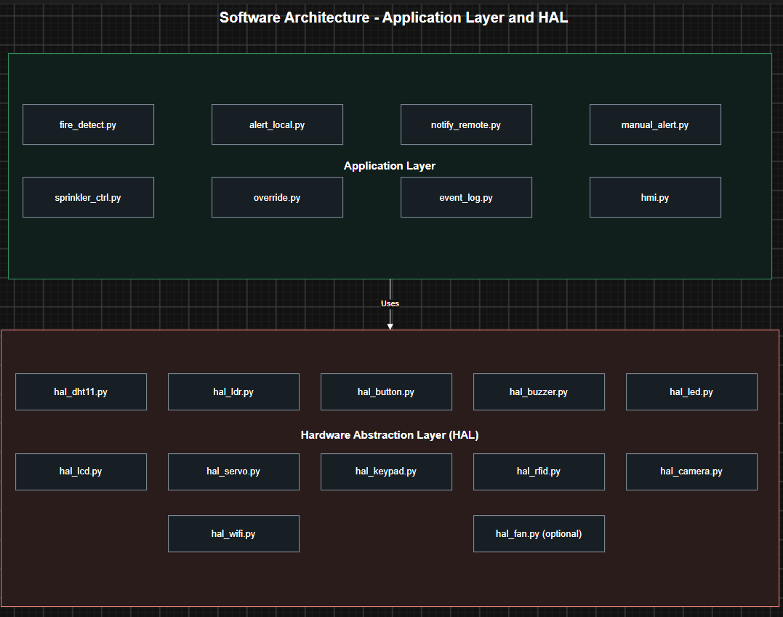
Figure 3.1: Static Software Architecture

Module | Responsibility
main.py | Entry point; main menu, state machine, and the monitoring loop.
detection.py | Reads sensors via the HAL and applies the fire-detection logic (REQ-05–REQ-10).
alerting.py | Coordinates buzzer, SMS and LCD messages for an alert.
manual_alert.py | Handles the panic-button input (REQ-11–REQ-15).
hmi_lcd.py | Drives the I2C LCD menus and status text.
hal_temp.py | Reads the temperature sensor (SPI ADC).
hal_smoke.py | Reads the smoke detector (GPIO).
hal_servo.py | Drives the servo (PWM) to OPEN/CLOSE the sprinkler valve.
hal_buzzer.py | Drives the buzzer/siren (GPIO).
hal_sms.py | Sends SMS via the GSM module (UART).

4. Appendices

4.1 Requirements Traceability Matrix
This matrix maps each customer requirement from the brief to the requirement(s) that satisfy it, to demonstrate full coverage.
Customer Requirement (brief) | Satisfied by | Type
Deploy at least 2 sensor types (Temperature + Smoke) | REQ-05, Fig. 2 | Functional
Detect possible fire from sensor parameters | REQ-05, REQ-06 | Functional
Alert resident via audible alarm | REQ-07, REQ-14 | Functional
Inform SCDF (via SMS) | REQ-08, REQ-19, REQ-20 | Functional
Manual alert switch/button for urgent help | REQ-11 to REQ-15 | Functional
Activate sprinkler in the affected room | REQ-09, REQ-16, REQ-17 | Functional
Electrically actuated control valve (servo motor) | REQ-17 | Functional
Respond quickly / run reliably | REQ-28 | Non-functional

4.2 GPIO Pin Plan
Planning reference — confirm the actual BCM pins your team wires.
Device | BCM Pin | Notes
Temperature sensor | SPI ADC CH0 | Analogue via MCP3008 (SPI)
Smoke detector | GPIO17 | Digital input
Manual alert button | GPIO27 | Digital input, internal pull-up
Buzzer / siren | GPIO22 | Digital output
Servo (sprinkler valve) | GPIO26 | PWM output
GSM module (SMS) | UART (TX/RX) | Serial; common ground required
LCD | I2C (SDA/SCL) | Status display
Ensure a common ground between the Pi and any externally powered actuator (servo / GSM module).

