

GETTING STARTED WITH FLAME



Prepared by,

Mesude Bicak, Mariam Kiran

Last Update: March 16, 2009

Abstract

This is a short report for installing and using FLAME.

TABLE OF CONTENTS

1. HOW DOES FLAME WORK

2. HOW TO SETUP FLAME
2.1 MinGW
2.2 Extra Installations
2.2.1 GDB
2.2.2 Dotty
2.3 Libmboard

3. HOW TO RUN A MODEL

1. HOW DOES FLAME WORK

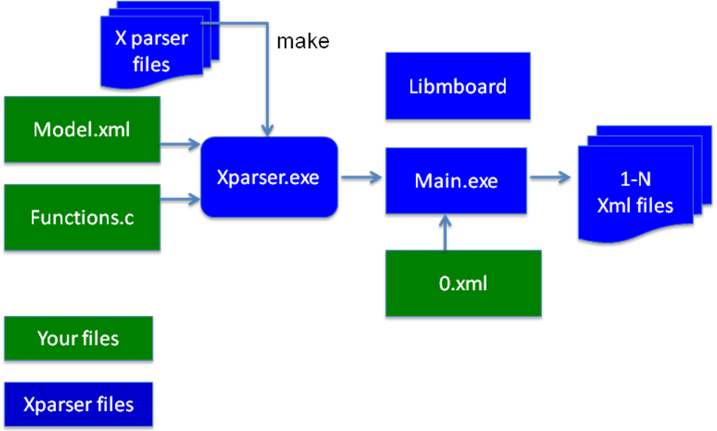

- Model.xml – should contain the whole structure of your model
i.e Agent descriptions, memory variables, functions, messages

- Functions.c – should contain the implementations of the functions specified in Model.xml

- 0.xml – should contain the initial states of the memory variables of the agents
i.e Initializations of all parameters

The number of the resulting XML files depends on the number of iterations you specify to run your model (through Main.exe).

2. HOW TO SETUP FLAME

What is required:

- Latest version of the framework (Xparser)
- C compiler
- Libmboard

2.1 MinGW:

Recommended C compiler is MinGW, which is built-in in Unix. Windows users can download a copy from the following link:
http://sourceforge.net/project/showfiles.php?group_id=2435&package_id=240780

Configuring MiNGW for Windows users:

Computer -> Properties -> Advanced settings -> Environment variables -> System variables

Select “Path” and edit it as follows:
- Add the path of the MinGW
- i.e “C:\MinGW\bin” after “;”
- Rename “C:\MinGW\bin\mingw32-make.exe” to “make.exe”

2.2 Extra Installations

2.2.1 GDB

For debugging, GDB GNU Debugger is recommended. It is freely available with many tutorials on how to use on web. You can get your free copy from the following link:
http://sourceforge.net/project/showfiles.php?group_id=2435&package_id=20507

Note: Windows users are recommended to use the version 5.2.1 (available in the above link)

2.2.2 Dotty
The parser creates diagrams about the flow of your model. These are created in .dot format. To access these files download Graphviz from www.graphviz.org. You can view and include these pictures in your model description and convert the image to other formats life pdf.
2.3 Libmboard

For Windows:
Download the libmboard for windows and unzip and place the folder where your model is. This is an already precompiled version for windows platforms.

For Linux/Mac systems:
1. Download the latest version of libmboard from ccpforge. Place this anywhere because we will compile this and put it to a specific place on the operating system to be used with FLAME.

2. Go to the Folder where you want to place libmboard.
For example if placing on “\Volumes”
- mkdir libmboard
This make a directory for libmboard

3. Go to the downloaded libmboard. Unzip this and go into the folder.
>./configure --prefix =/Volumes/libmboard --disable –tests
>make
If no complaints, go into the folder /Volumes/libmboard
>make install
This will compile the libmboard on your system.

Now, you are ready to get your hands on FLAME!
3. HOW TO RUN A MODEL

Go into the Xparser folder:

- Compile Xparser using “make” (MinGW)
>cd xparser
>make

These commands will compile the Xparser and generate “xparser.exe”.

- Point the Xparser to your “Model.xml”
>xparser ..\model\model.xml

“Xparser.exe” will parse your “model.xml”.

- Compile your model

>cd ..\model
>make

These commands will compile your model and generate “main.exe”.

For Mac/ Linux users:
You have to point the make to the compiled libmboard folder. So you write following to point it where your libmboard is:

> make LIBMBOARD_DIR=/Volumes/libmboard

- Run your model. Give the number of iterations and point it to the 0.xml file.
>main.exe 100 xml\0.xml

This command will run your model over 100 iterations using the initial states specified in your 0.xml and generate 100 XML files.

It is then up to you to create a program to view the output ;-)

