**Flask App Deployment  
GitHub → ECR → EC2  
Using Docker on AWS**

Contents

**1.Create Dockerfile** 3

**2.GitHub Workflow** 3

**3.Push Changes to GitHub** 3

**4.Create an IAM user in AWS** 3

**5.Create ECR Repository** 5

**6.Create EC2 Instance** 5

**7.Create Runner in GitHub and download and configure the same runner in EC2** 6

**8.Create GitHub secrets and variables** 6

**9.To check the deployment** 6

**10.To check the working of the app** 7

**11.To avoid AWS from charging your credit/debit card** 8

### **1.Create Dockerfile**

<https://raw.githubusercontent.com/ETAMILSELVAN47/AWS_CI_CD_Project/refs/heads/main/Dockerfile>

### **2.GitHub Workflow**

**Folder structure:**  
.github/workflows  
 main.yaml  
Download the main.yaml file from:  
<https://raw.githubusercontent.com/ETAMILSELVAN47/AWS_CI_CD_Project/refs/heads/main/.github/workflows/main.yaml>

### **3.Push Changes to GitHub**

git add .

git commit -m "commit"

git push origin main

### **4.Create an IAM user in AWS**

Navigation: IAM → Users  
 a) Add users  
 Username: Tamilselvan  
 Click on Next  
 b) Attach policies directly  
 AmazonEC2FullAccess  
 AmazonEC2ContainerRegistryFullAccess  
 Click on Next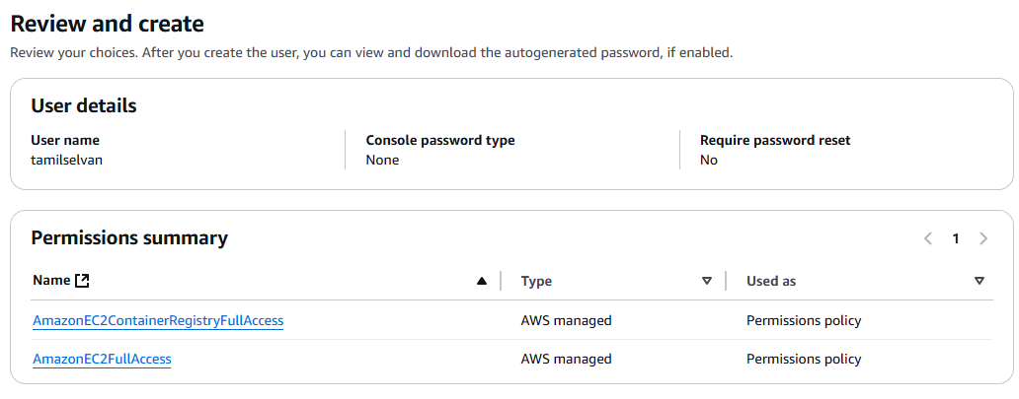

Click on Create user

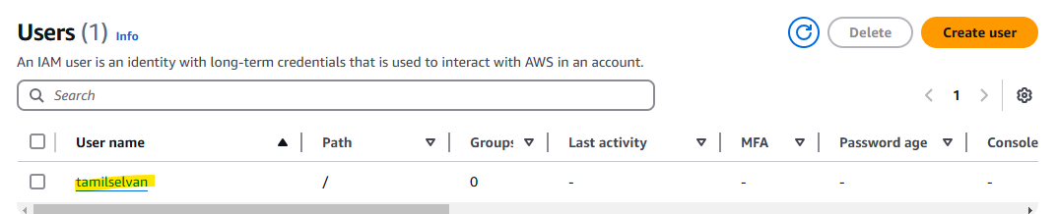

Click on username

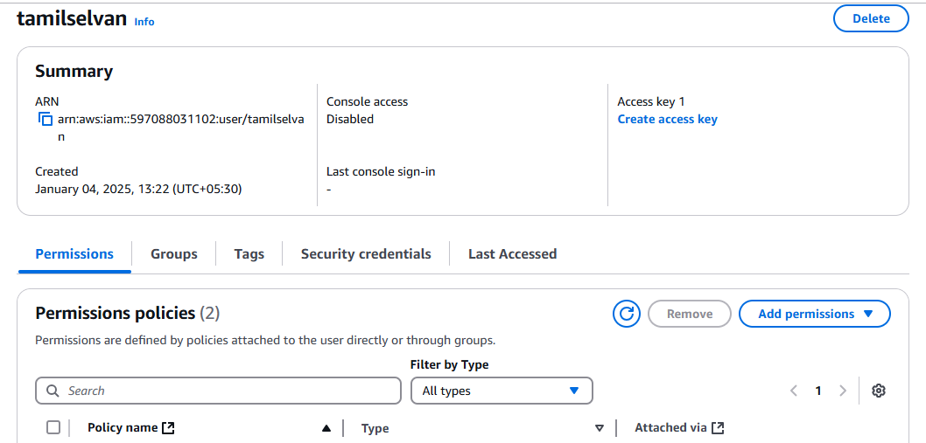

Click on **Security credentials** tab  
Create access key  
Enable the checkbox: **Command Line Interface (CLI)**  
Enable the checkbox: **Terms and conditions**  
Click on **Next**  
Click on **Create Access Key**  
Note down the **Access key**(**Access Key ID)** and **Secret Access Key**  
Download the .csv file  
Click on **Done**

### **5.Create ECR Repository**

**Navigation:** Elastic Container Repository → Repositories  
a) Click on **Create Repository**  
b) Visibility settings: Private  
c) Repository name: **url / {studentperformance}**  
**597088031102.dkr.ecr.us-east-1.amazonaws.com/studentperformance**  
**AWS_ECR_LOGIN_URI/ECR_REPOSITORY_NAME**  
d) Click on **Create**  
e) Note down the repository name and URI

### **6.Create EC2 Instance**

Navigation: EC2

1. Click on launch instance
2. Name: studentperformance
3. Select ubuntu
4. Instance type: t2.medium
5. Keypairlogin
6. Enable the checkbox

Allow HTTPS traffic from the internet

Allow HTTP traffic from the internet

1. Click on Launch Instance
2. Click on instances (EC2🡪Instances)
3. Check the status

Wait for the status: Running

1. Click on Instance ID
2. Click on Connect
3. EC2 Instance Connect
4. Click on connect
5. Docker setup and Github Runner Setup in EC2

#optinal

sudo apt-get update -y

sudo apt-get upgrade

#required

curl -fsSL https://get.docker.com -o get-docker.sh

sudo sh get-docker.sh

sudo usermod -aG docker ubuntu

newgrp docker

Github 🡪 ECR Repository 🡪 EC2 Instance

### **7.Create Runner in GitHub and download and configure the same runner in EC2**

Navigation: Settings → Actions → Runners

a) Click on **New self-hosted runner**  
b) Select **Linux**  
c) Execute all the commands (Download, Configure)  
d) Check **Settings → Actions → Runners** and verify the runner name and status  
(It is basically called an app runner, and if the status is **Idle (green)**, it means it is waiting for the commit to happen)  
Runner: **self-hosted**  
Status: **Idle**

**Note:**  
Whenever a commit happens in GitHub, the runner will push the code to the ECR repository, and deployment will occur.

* Name of the runner group: **Press Enter**
* Name of the runner: **self-hosted** (give this name because it is used in workflows/main.yaml)
* Name of the work folder: **Press Enter**

### **8.Create GitHub secrets and variables**

Navigation: **Settings → Secrets and Variables → Actions**  
Click on **New repository secret**

|  |  |
| --- | --- |
| Name | Secret |
| AWS_ACCESS_KEY_ID | Access key in .csv file |
| AWS_SECRET_ACCESS_KEY | secret access key in .csv file |
| AWS_REGION |  |
| AWS_ECR_LOGIN_URI |  |
| ECR_REPOSITORY_NAME |  |

### **9.To check the deployment**

a) Made some changes in app.py by adding some space  
b) **GitHub Actions → Workflows**  
Check the workflow:

* **CI** – Continuous Integration
* **CD** – Continuous Delivery
* **CD** – Continuous Deployment

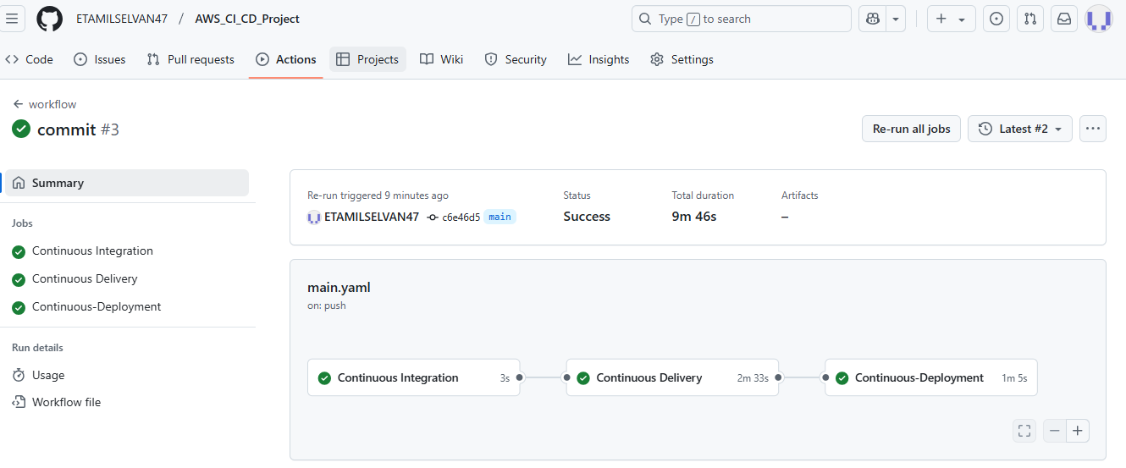

### **10.To check the working of the app**

Navigation: **EC2 → Instances**  
 a) Click on **Instance ID**  
 b) Click on **Security** tab  
 c) Click on **Security Groups**  
 d) Click on **Edit inbound rules**  
 e) Click on **Add rule**  
 f) Select **Custom TCP** and set **Port = 8080** (because we have mentioned port 8080 in the app.py file)  
 Click on **Save rules**

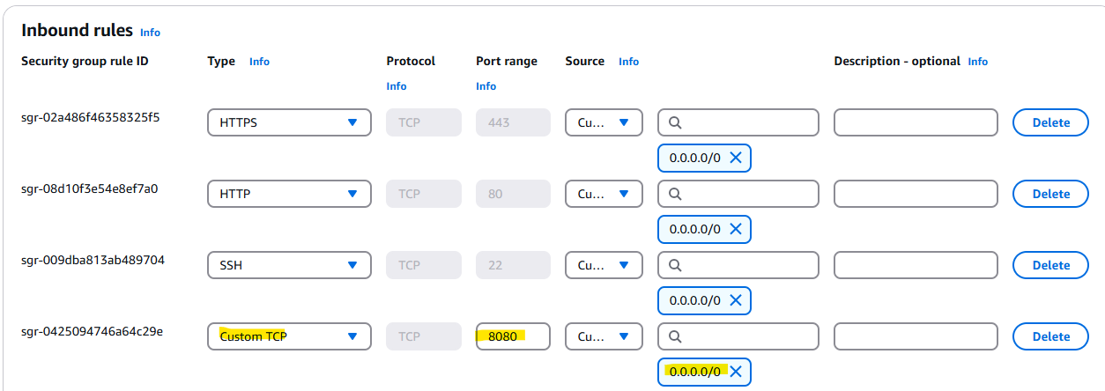

g) Copy the **Public IPv4 address**: 54.234.219.68  
h) Check the app in any web browser

<http://54.234.219.68:8080/>

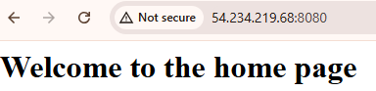

<http://54.234.219.68:8080/predict>

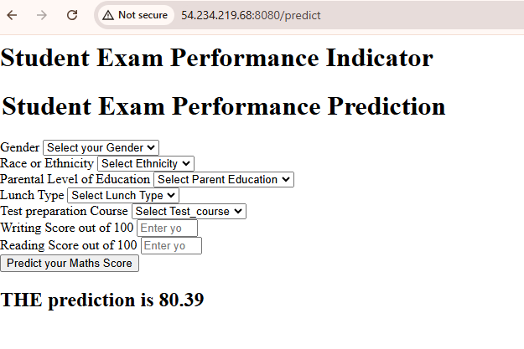

### **11.To avoid AWS from charging your credit/debit card**

a) Terminate the instance (EC2 🡪 Instances 🡪 Instance State 🡪 Terminate (Instance)  
b) Delete the repository (Elastic Container Repository🡪Repositories 🡪 Delete)  
c) Delete the user (IAM 🡪 Users 🡪 Delete User)