1. **Convenient and Effortless 3D Printing of Everyday Life Repair Spare Part**

|  |  |
| --- | --- |
| Type | Master Thesis (may be combined with a prior Master Project (MP)) or Research Track (RT) |
| Credits | 30 |
| Start | 01.11.2023 |

# Description

* 1. This thesis topic is motivated by a personal real-world problem: When we moved into a new flat, I damaged a small plastic part (picture below) of an already installed wall lamp. The broken plastic leg caused the lid to fall off. I searched the Internet for spare parts – no luck. According to the manufacturer, the only option is to repurchase the same lamp. Not very sustainable.

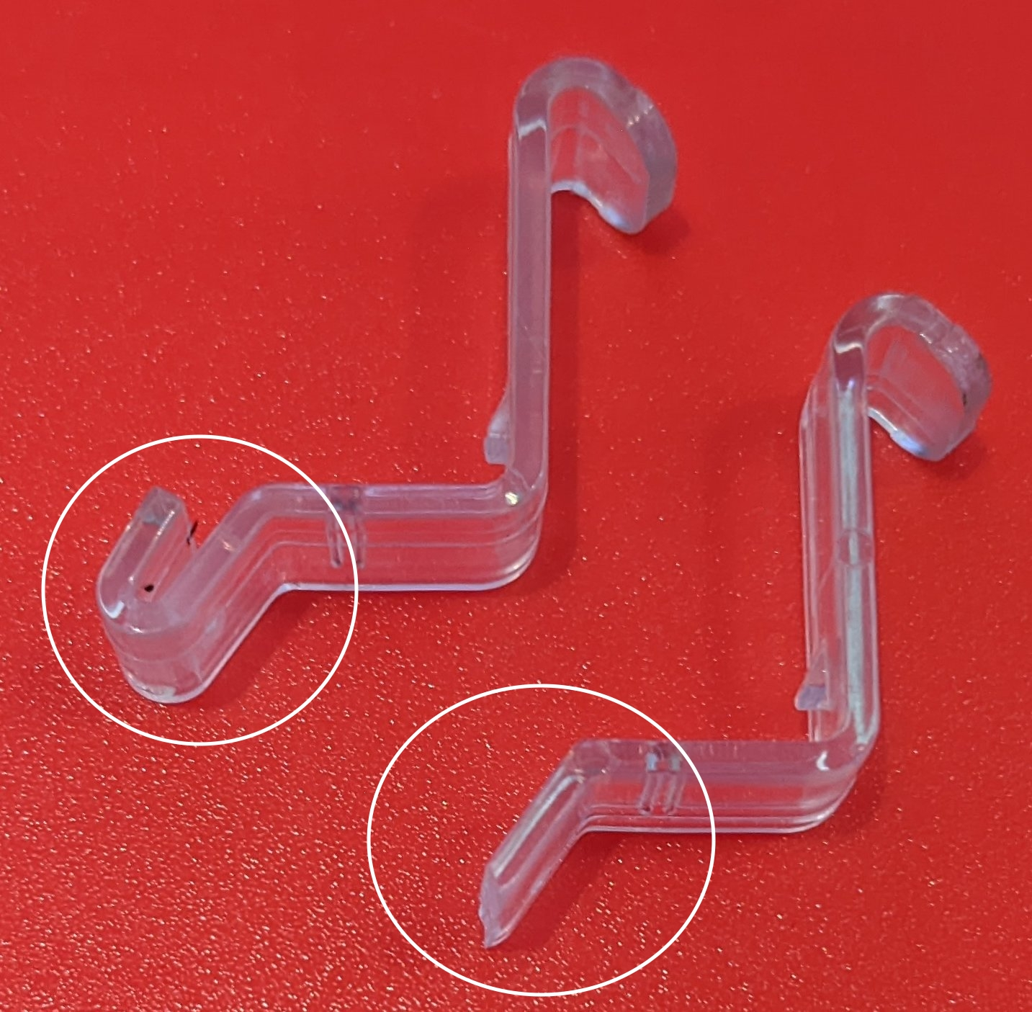

I found a website that claimed to provide a 3D model of the plastic part that could be printed using a 3D printer – but the website was not working and thus not providing the file. Printing simple plastic spare parts would have solved the issue. Problem: Like most people, I do not have a background in 3D printing and do not have the time to learn how to construct the corresponding models. A less sophisticated solution is required, requiring neither special hardware nor special knowledge.

**The goal of this master thesis is** to develop a method to conveniently and effortlessly print 3D spare parts for everyday life repairs (such as the wall lamp above). The overall thesis is separated into three sub-tasks:

1. Taking the broken component or another (not broken) spare part (if available) and capturing its dimensions using a suitable digitization method (e.g., taking pictures, videos, etc.).
2. Processing the captured information, producing a 3D printable model of the component.
3. Printing the component.

The thesis focuses on simple geometric components such as the broken plastic part in the picture above. Subsequent research may tackle more complex structures.

With the results of the master thesis, we aim to make the provision of 3D printed spare parts more accessible to everyone, reduce the complexity of the process and automate as many steps as possible along the way. This way, the master thesis also aims to generate tangible contributions to a more sustainable future.

# Prerequisites

1. Background in 3D printing and creating corresponding models.
2. Python coding skills
3. Git
4. Android app development

# Tasks

1. Research and analyze existing solutions that tackle similar issues.
2. Identify suitable approaches to each of the three steps described above.
3. Prototype a process pipeline that allows printing a spare part of the broken plastic component of my wall lamp.

# Contact

Benjamin Leiding<benjamin.leiding@tu-clausthal.de>

[Anant Sujatanagarjuna<anant.sujatanagarjuna@tu-clausthal.de>](mailto:Anant Sujatanagarjuna<anant.sujatanagarjuna@tu-clausthal.de>?subject=Research Project Inquiry: M2X Lifecycle Modelling Comparison)