1. 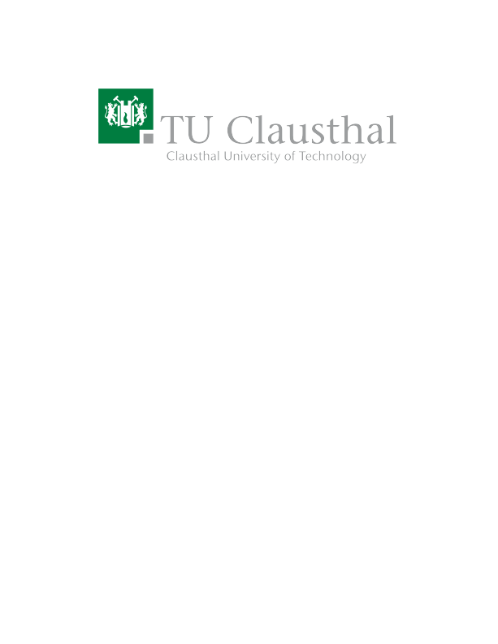**Practical and Secure Over-the-Air (OTA) Updates for an Aquatic Autonomous Smart Sensor Array**

|  |  |
| --- | --- |
| Type | Master Thesis (may be combined with a prior Master Project (MP)) |
| Credits | 30 |

# Description

*Hydroguard-IoT* – a startup founded in 2022 by students from TU Clausthal and the Ostfalia – develops an autonomous water quality monitoring and Harmful Algae Bloom (HAB) prediction system. HABs caused by toxic cyanobacteria pose considerable health risks to the population through ingestion or contact. The system provides timely and well-targeted preventive and mitigation measures to protect drinking and bathing water bodies and water bodies for recreational and commercial use.

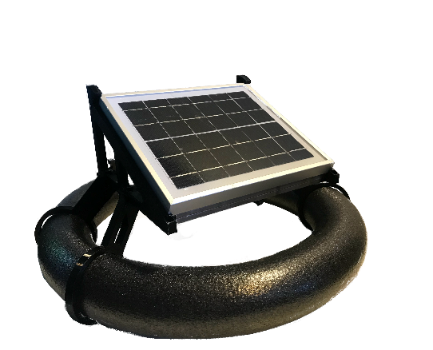

The prototypes (pictured above) are currently tested in real-world conditions, i.e., being placed on a lake for long periods. However, software development continues in parallel, and upgrades need to be rolled out and installed on a regular base. Thus far, updates can only be installed by retrieving the prototype from the lake, connecting it to a computer, upgrading the software and bringing it back to the lake. Retrieving the prototype from the lake via a boat is time-consuming and cumbersome.

**The goal of this master thesis is** to conceptualize, implement and test a practical/convenient and secure over-the-air (OTA) update mechanism for the devices that allows for software upgrades without retrieving them from the lake.

# Prerequisites

1. Raspberry Pi / Arduino and IoT experience
2. Python coding skills
3. Git
4. Background in IoT communication protocols and IT/network security

# Tasks

1. Research and analyze existing solutions that tackle similar issues.
2. Identify suitable approaches and conceptualize a suitable OTA mechanism.
3. Implement, test and evaluate the OTA mechanism with the Hydroguard team under real-world conditions.

# Contact

Benjamin Leiding<benjamin.leiding@tu-clausthal.de>

[Anant Sujatanagarjuna<](mailto:Anant Sujatanagarjuna<anant.sujatanagarjuna@tu-clausthal.de>?subject=Research Project Inquiry: M2X Lifecycle Modelling Comparison)[anant.sujatanagarjuna@tu-clausthal.de](mailto:anant.sujatanagarjuna@tu-clausthal.de)[>](mailto:Anant Sujatanagarjuna<anant.sujatanagarjuna@tu-clausthal.de>?subject=Research Project Inquiry: M2X Lifecycle Modelling Comparison)

[info@Hydroguard-iot.de](mailto:Info@Hydroguard-iot.de)