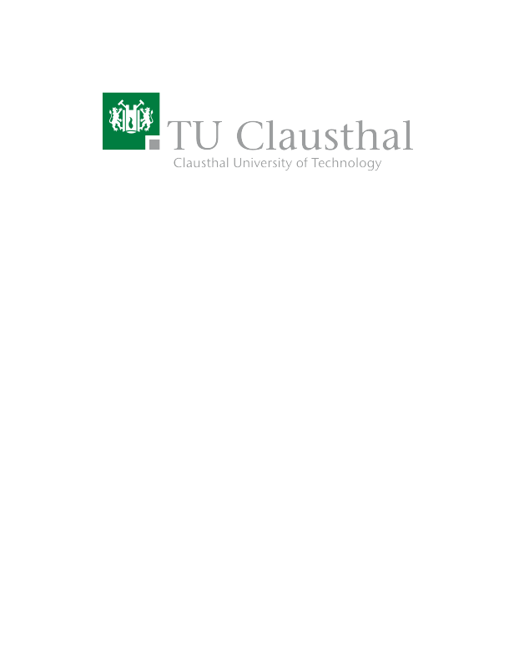
Literature Review: Comparison of Vertical and Traditional Farming Solutions
Type | Bachelor/Master Project
Credits | 8CP
Start date | 01.02.2023 / 01.03.2023

Description
Climate change and environmental pollution are decreasing the availability of farmland used to supply us with reliable food sources. Rising temperatures, extreme weather events – e.g., too much/little rain – and global political instabilities such as the war in Ukraine are further pushing our existing food supply chains to the brink of failure. Vertical Farming [1] and its various flavours (hydroponics [2], aeroponics [3], etc.) offer an interesting set of solutions for a resilient, climate changed-adapted food production that requires less space than traditional farming and promises increased yields per m² as well as more efficient utilization of scarce resources like water.

However, despite its benefits, vertical farming solutions still lack widespread adoption. It is not clear how much vertical farming solutions could contribute to a future resilient, localized and climate change-adapted food production. Thus, the task is to review existing literature and projects and explore the landscape of vertical farming solutions in the context of climate change, environmental pollution and the resilience of food production. The comparison of traditional and vertical farming is supposed to focus on Germany in particular – thus, German language skills are required.

Prerequisites
- German (at least C1) → You will need to read/understand German papers focusing on the specifics of German agriculture.
- Background in life-cycle assessments (LCAs)
- Background in sustainability, e.g., participating in the “Limits to Growth: Sustainability and the Circular Economy” or the “Emerging Technologies for the Circular Economy” courses of our research group or equivalent knowledge from other sources.

Tasks
- Familiarize yourself with the various types of vertical farming setups.
- Learn how to conduct a literature review.
- Research and review the existing literature on vertical farming solutions as well as related projects.
- Compare pre-defined indicators of vertical farming and traditional farming with respect to resilience, environmental pollution, climate change and sustainability with a particular focus on Germany, e.g., how much space is required to supply an average person with enough food for a year? How much water is required?, etc.

Resources
- Banerjee, Chirantan, and Lucie Adenaeuer. "Up, up and away! The economics of vertical farming." Journal of Agricultural Studies 2.1 (2014): 40-60 – Link.
- Jensen, Merle H. "Hydroponics." HortScience 32.6 (1997): 1018-1021 – Link.
- Lakhiar, Imran Ali, et al. "Modern plant cultivation technologies in agriculture under controlled environment: A review on aeroponics." Journal of plant interactions 13.1 (2018): 338-352 – Link.
- Kalantari, F., Tahir, O. M., Joni, R. A., & Fatemi, E. (2018). Opportunities and challenges in sustainability of vertical farming: A review. Journal of Landscape Ecology, 11(1), 35-60 – Link.

Contact
Benjamin Leiding<benjamin.leiding@tu-clausthal.de>

