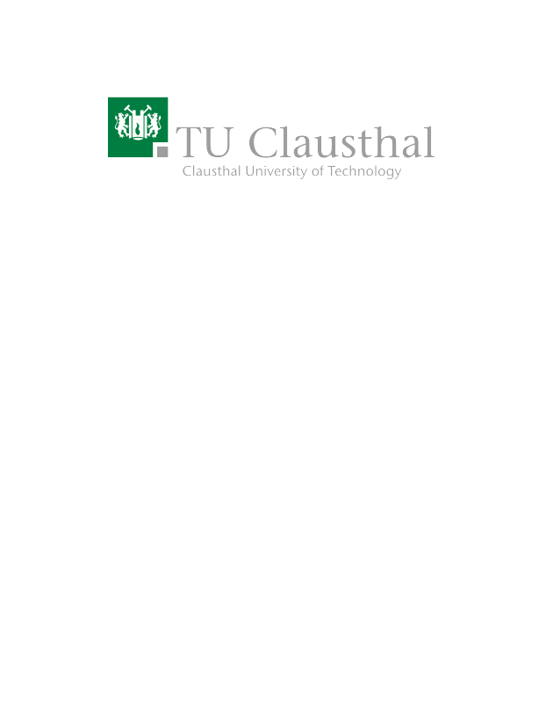
Trashy – A General-Purpose Household Trash Sorting Appliance
Type | Research Project, Master Thesis
Credits | 30CPs
Start date | 01.05.2023 / 01.06.2023

Description
Every person in Germany produces about 632kg of waste per year. Most of it is – more or less accurately – disposed of using the yellow, blue, green and black trash bins provided by the local waste disposal company. However, most people either do not care to properly pre-sort their waste or lack the knowledge to do so. As a result, a labour-intensive manual pre-sorting at the waste disposal company is required before further processing, e.g., recycling the input materials. Additionally, pre-sorting the waste in the first place is a pretty tedious task.
Therefore, we propose prototyping “Trashy”, a general-purpose trash sorting appliance for private households. The idea is to have just one trash bin that accepts all trash except biodegradable food waste and automatically sorts it based on pre-defined characteristics that facilitate more efficient recycling processes and minimise missorting waste in private households. The goal is to build a prototype demonstrator in our lab in Goslar and offer the construction details and the corresponding software under an open-source license.

Prerequisites
- Background in machine learning and image recognition
- Raspberry Pi and IoT experience
- Python or Rust coding skills
- Git
- Some crafting skills to design and build the physical components of “Trashy”

Tasks
- Review existing projects and publications on general-purpose trash-sorting appliances. What are their strength/weaknesses?
- Design and construct a “Trashy” demonstrator/prototype in our lab in Goslar.
- Develop and implement an image recognition-based trash sorting machine learning tool that guides “Trashy” to sort trash into various pre-defined categories.
- Evaluate the accuracy of “Trashy”.
- Write a report.

Resources
- C. Ching (2019). How to build an image classifier for waste sorting – Link.
- Flores, Myra G., and Jose B. Tan Jr. "Literature review of automated waste segregation system using machine learning: A comprehensive analysis." International journal of simulation: systems, science and technology (2019) – Link.
- These Robots Are Using Artificial Intelligence To Sort Your Recycling | Forbes (2020) – Link.

Contact
Benjamin Leiding<benjamin.leiding@tu-clausthal.de>

https://opensource.org/licenses

