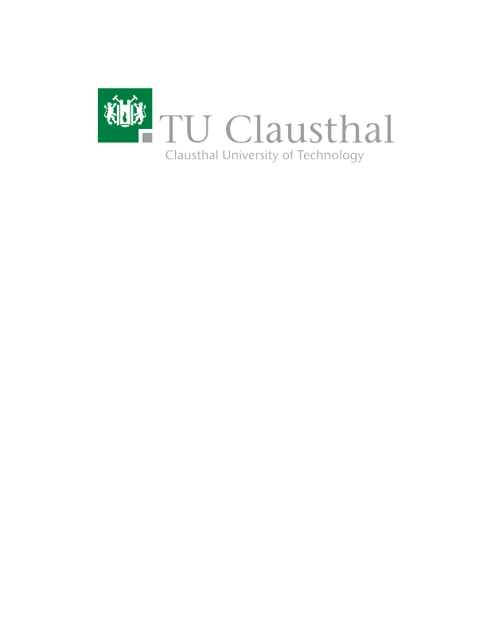
Comparison of Home Heating Methods With a Web Calculator on GitHub Pages
Type | Bachelor Thesis
Credits | 12 CP
Start date | 01.02.2023 / 01.03.2023

Description
Recent geopolitical developments caused a surge in electricity and heating prices. While most houses rely on fossil fuels for heating, other alternatives exist. But which choice is the most sustainable and applicable form of heating based on a multitude of input parameters?

Your task is to create a web-based comparison tool that accepts a multitude of input parameters (e.g., size of your home, heating costs per square meter and year, etc.) and provides a comparison as well as a visual illustration of different home heating approaches (e.g. natural gas, oil, wood, solar, etc.) – including their advantages, disadvantages and related challenges.

Prerequisites
- Coding experience, preferably Python, as well as web development (HTML, CSS, JS)
- Experience with GitHub projects and FOSS software development

Tasks
- Conceptualize and design a web-based comparison tool for various types of home heating using GitHub pages.
- Successfully implement and test the selected features.
- Maintain the implementation on a GitHub repository with detailed documentation of the project (Licensed under a FOSS license like GPLv3).
- Write a report, i.e., thesis.

Resources
-

Contact
Benjamin Leiding<benjamin.leiding@tu-clausthal.de> (Main Contact)

