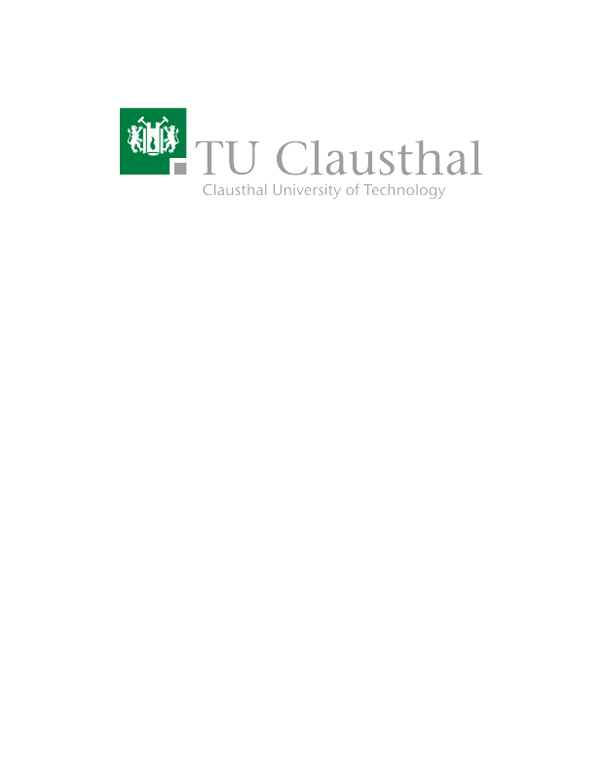
Water-level Management and Prediction for Smart Farming
Type | Bachelor Thesis
Credits | 12 CP
Start date | 01.02.2023 / 01.03.2023

Description
As part of our indoor and outdoor farming research projects (e.g., MushR (Link)), we regularly face tedious maintenance-related challenges. One of them is refilling tanks (e.g., water, nutrient solutions, etc.) before they are empty, disrupting our experiment processes. In addition, maintenance tasks such as tank refills need to take place on work days. Therefore, it is mandatory to not only measure the current (water) level of the tanks but also predict when they will be empty based on historic data recordings.

Your task is to conceptualize, design, implement and test an IoT-based sensor system that i) measures how much water (or any other liquid substance) is left in our tanks, ii) dispatches an alarm if a critical level is reached and iii) predicts when the tank will be empty and notify relevant persons in case this might occur on a weekend or any other day when no qualified person is available at the lab.

Prerequisites
- Coding experience, preferably Python
- IoT basics (e.g., Raspberry Pi)
- Experience with GitHub projects and FOSS software development

Tasks

- Conceptualize and design a tank refill system using IoT sensors and a Raspberry Pi.
- Successfully implement and test the selected features.
- Maintain the implementation on a GitHub repository with detailed documentation of the project (Licensed under a FOSS license like GPLv3).
- Write a report, i.e., thesis.

Resources
- ETCE Lab Website – MushR Project (Link)

Contact
Benjamin Leiding<benjamin.leiding@tu-clausthal.de> (Main Contact)

