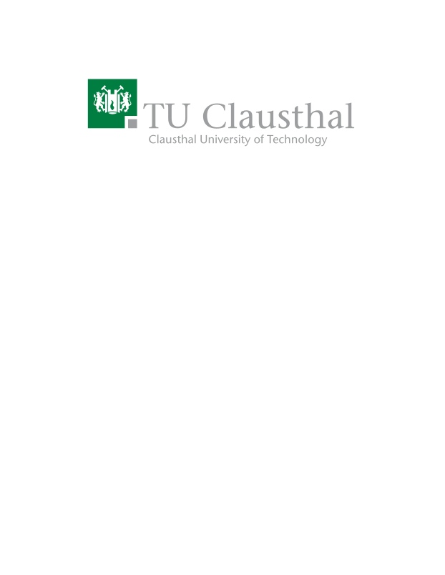
A Modern Reimplementation of CPNTools
Type | Research Project, Master Thesis
Credits | 30CP
Start date | 01.10.2023

Description
Coloured Petri Nets (CPNs) are a graphical language for constructing models of concurrent systems and analysing their properties. CPN models have been used for formal verification and modelling
of various protocols and applications, e.g., [1], [2], [3], [4], [5]. The current state-of-the-art solution for their development, simulation and analysis is CPNTools [6]. While this tool is functionally suitable for these purposes, there are numerous reasons why using CPNTools can be incredibly difficult:
- The Graphical User Interface (GUI) is quite dated and many simple actions like editing code is unnecessarily tedious.
- CPNTools only works on MS Windows systems. Although CPNTools is open-source, it cannot be run natively on GNU/Linux distributions.
- Simulation of CPNs and generation of state-space graphs is single-threaded and takes arbitrarily long amounts of time.

Thus, a comprehensive re-implementation of the features of CPNTools is necessary.

Prerequisites
- Background in formal methods
- CPNs
- Python or Rust
- Experience with GitHub projects and FOSS software development

Tasks

- Review and select features of CPN Tools that are sufficient for a Minimum Viable Product (MVP) re-implementation.
- Review existing “petri net compatible” simulation backends to reduce redundant development.
- Plan and document various aspects of the proposed implementation (such as system architecture) using UML.
- Successfully implement and test the selected features.
- Maintain the implementation on a GitHub repository with detailed documentation of the project (Licensed under a FOSS license like GPLv3).
- Write a report.

Resources
- R. R. Igorevich, Daekyo Shin, and D. Min. CPN Based Analysis of In–Vehicle Secure Communication Protocol. In International Conference on Heterogeneous Networking for Quality, Reliability, Security and Robustness, 2016. URL https://doi.org/10.1007/978-3-319-60717-7_2
- R. Amoah, S. Çamtepe, and E. Foo. Formal Modelling and Analysis of DNP3 Secure
Authentication. Journal of Network and Computer Applications, 59:345–360, 2016. URL
https://doi.org/10.1016/j.jnca.2015.05.015.
- Yi Ning Sun, Y. Liu, and Shi Shi Liang. Modeling and Analyzing of RRC Protocol Process
Based on CPN. Applied Mechanics and Materials, 599–601:1562–1565, 2014. URL https://doi.org/10.4028/www.scientific.net/AMM.599-601.1562.
- Benjamin Leiding and A. Norta. Mapping Requirements Specifications into a Formalized
Blockchain–Enabled Authentication Protocol for Secured Personal Identity Assurance. In International Conference on Future Data and Security Engineering, 2017. URL https://doi.org/10.1007/978-3-319-70004-5_13.
- A. Sujatanagarjuna, A. Bochem and B. Leiding. Formalizing the Blockchain-Based BlockVoke Protocol for Fast Certificate Revocation Using Colored Petri Nets. Information. 2021; 12(7):277. https://doi.org/10.3390/info12070277.
- CPNTools: A tool for editing, simulating, and analyzing Colored Petri nets https://cpntools.org

Contact
Anant Sujatanagarjuna<anant.sujatanagarjuna@tu-clausthal.de> (Main Contact)
Benjamin Leiding<benjamin.leiding@tu-clausthal.de>

