Exercise – 2

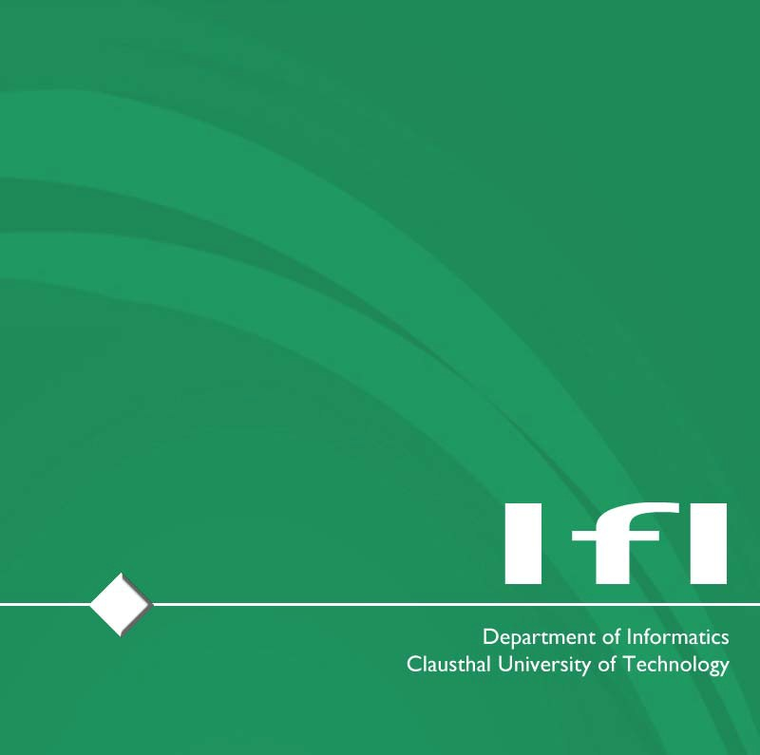

**Published on:** 22.04.2024

**Deadline:** 29.04.2024 – 1:59pm

**Task(s):**

Task 1 – Multiple-Choice Test (Circular Economy)

* You should at least answer half the questions correctly. If not, you might lack the vital knowledge to pass the course.
* The quiz is anonymous – we do not track your answers, how many points you get, etc. It is supposed to give you an understanding of the prior knowledge we expect from course participants.
* The quiz is available online: [Link](https://etce.etce-lab.de/)
* You will receive immediate feedback

**Questions?:** [**etce-iot@tu-clausthal.de**](mailto:etce-etce@tu-clausthal.de?subject=ETCE Exercise Query)