Limits to Growth WS24/25

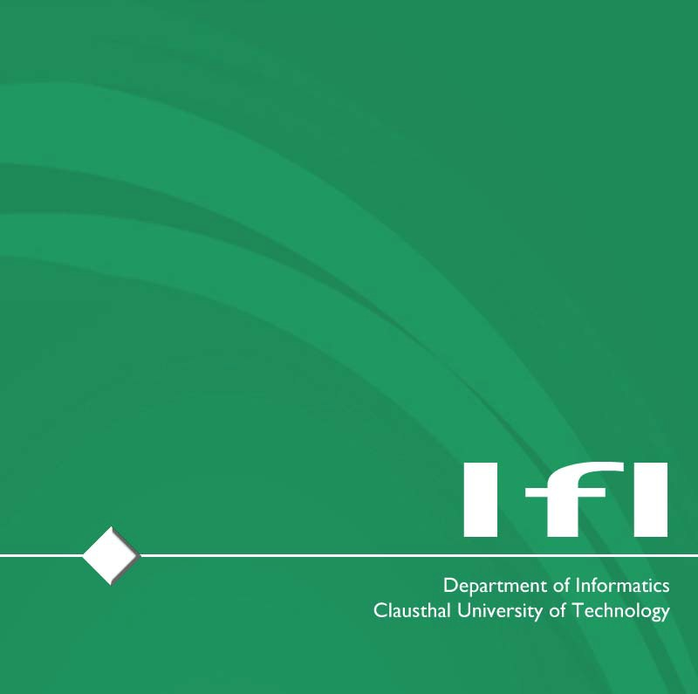

Exercise – 6

**Published on:** 08.01.2025

**Deadline:** 15.01.2025 – 2:00 pm

**Do you have any questions?** Contact us via email [etce-ltg@tu-clausthal.de](mailto:etce-ltg@tu-clausthal.de) or write a message in the Matrix channel!

**Task(s):**

Task 1: In the lecture, we presented a typology of the circular economy vs. circular society discourse (CE vs. CS – Typology). Which of the four categories (*Reformist Circular Society, Transformational Circular Society, Techcentric Circular Economy, Fortress Circular Economy*) do you prefer and/or deem to be more likely and why?

* Explain your choice.

Submission instructions

Upload your submission to https://tucloud.tu-clausthal.de/index.php/s/KGQqI0R6VoPwtNY, using the password “LTG2425” as a PDF file with your name; e.g.: “E06-<firstname.lastname>.pdf”.