Exercise – 4

Published on: 06.07.2026
Deadline: 13.07.2026 – 1:59pm
Mining Operations

Task(s):
- Select one operation process from the following graphic and list inputs and outputs of the selected process (5 each).
- Select one of the inputs and outputs (from Task 1.) and propose a way to integrate them into the circular economy.
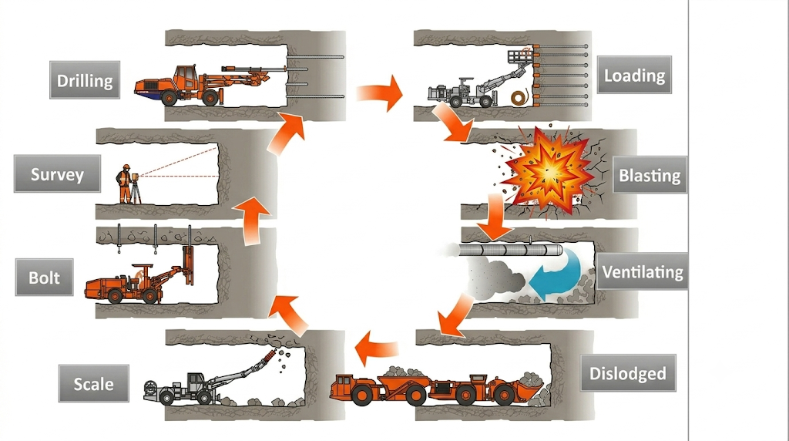
- Provide one related industrial example.

Send your solutions as a PDF file to : etce-iot@tu-clausthal.de

Questions?: etce-iot@tu-clausthal.de

