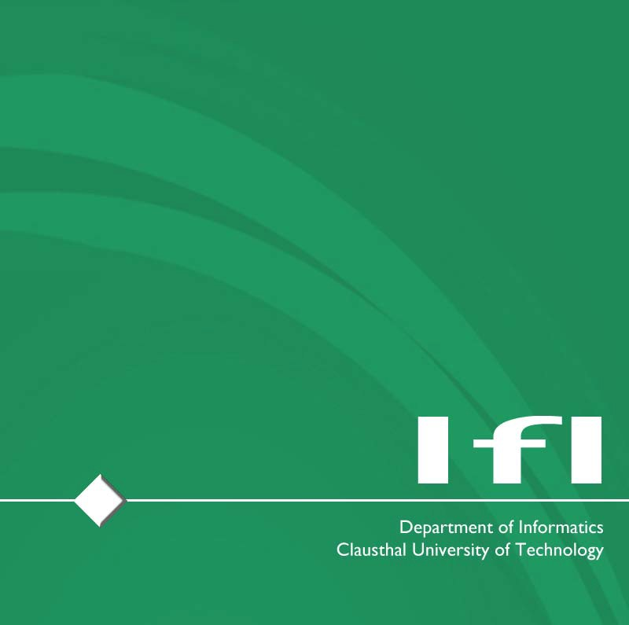
Exercise – 1

Published on: 11.05.2026
Deadline: 18.05.2026 – 1:59pm
Task(s):

Task 1 – Multiple-Choice Test (Circular Economy)
- You should at least answer half the questions correctly. If not, you might lack the vital knowledge to pass the course.
- The quiz is anonymous – we do not track your answers, how many points you get, etc. It is supposed to give you an understanding of the prior knowledge we expect from course participants.
- The quiz is available online: Link
- You will receive immediate feedback

Questions?: etce-iot@tu-clausthal.de

