Software Requirements Specification
for
Electronic Tracking Collar
[ET-Collar]
Version 1.0 approved
Prepared by: Gurpreet Singh, Simarjeet Brar
Organization: Humber College
Date: 01/23/2019
Table of Contents
Table of Contents ii
Revision History ii
1. Introduction 1
1.1 Purpose 1
1.2 Document Conventions 1
1.3 Intended Audience and Reading Suggestions 1
1.4 Product Scope 1
1.5 References 1
2. Overall Description 2
2.1 Product Perspective 2
2.2 Product Functions 2
2.3 User Classes and Characteristics 2
2.4 Operating Environment 2
2.5 Design and Implementation Constraints 2
2.6 User Documentation 2
2.7 Assumptions and Dependencies 3
3. External Interface Requirements 3
3.1 User Interfaces 3
3.2 Hardware Interfaces 3
3.3 Software Interfaces 3
3.4 Communications Interfaces 3
4. System Features 4
4.1 System Feature 1 4
4.2 System Feature 2 (and so on) 4
5. Other Nonfunctional Requirements 4
5.1 Performance Requirements 4
5.2 Safety Requirements 5
5.3 Security Requirements 5
5.4 Software Quality Attributes 5
5.5 Business Rules 5
6. Other Requirements 5
Appendix A: Glossary 5
Appendix B: Analysis Models 5
Appendix C: To Be Determined List 6

Revision History
Name | Date | Reason For Changes | Version
SRS 1.0 | 01/23/2019 |  | 1.0

Introduction

Purpose
The motivation behind this SRS record is to give a point by point diagram of our product item, its functions and objectives. This record portrays the buyer’s intended interest group and its UI, equipment and programming necessities. It characterizes how our client, team and audience see the item functionality of the product and its usefulness. To be specific, this document is going to describe functionality, external interfaces, performance, attributes and the design constraints of the system which is going to be developed.

Document Conventions
This document uses Times 12 in general all the main headings are in Times size 18 Bold all the subheadings uses Times size 14 Bold as well. Anything that requires highlighting is underlined and is in Italic fonts. This following abbreviations:

DB Database
App Reference to android app we developed for this project
GPS Global Positioning System

Intended Audience and Reading Suggestions
This document is to be used as a reference/guideline by developers. This document is also intended for project managers as it specifies our project’s lifecycle and its requirements. Also this documents provide information about all the functionality it designed for the user/buyers to understand its features and working. This project is designed as a GPS device to keep track of our pets. This has been implemented under the guidance of college professors and will be tested by professor. For ease there is table of contents at the first page if someone needs specific information, but I do recommend to read functionality carefully for user to become familiar with functionality.

Product Scope
This project is intended for making use of today’s popular technology cloud computing to help with our daily life concern about our pet’s safety when we’re away. ET-Collar will get data from various sensor used in this project and store that on cloud then later used by designed software that will display that data on user’s cell phone, so that even we are not with our pet’s we will know where and how they are doing. Although there are already couple of products in the market already there is going to be a little competition on business levels but project has a pretty good chance to being recognizable because we using an extra feature using light sensor that will inform user weather or not pet likes to out in sun or inside.

References
https://krazytech.com/projects
http://user.ceng.metu.edu.tr/~e1679216/documents/SRS.pdf

Overall Description

Product Perspective
Project will use hardware and an android app to help user to display pet’s exact location and various other factors using which user can see their pets activity on their cell phones, app is also designed to alert user if anything goes wrong.
However, this app will be only a part of a larger system. There will be cloud server where all the user data is kept and all the execution is done. App will only be the interface for the user data and the execution of provided functionalities.
To use product, users are required to register through the application interface. Whenever a new user registered, all the required data will be created in the database and a predefined workspace will be assigned for the user. Later, user will be able to login and logout the system anytime he wants. Since every operation that user perform reflected to our database, user will find his workspace and can then refer their data on screen that will stored by sensor directly using a microcontroller.
Each user will be provided with device (Hardware) and will be assigned unique ID to it.
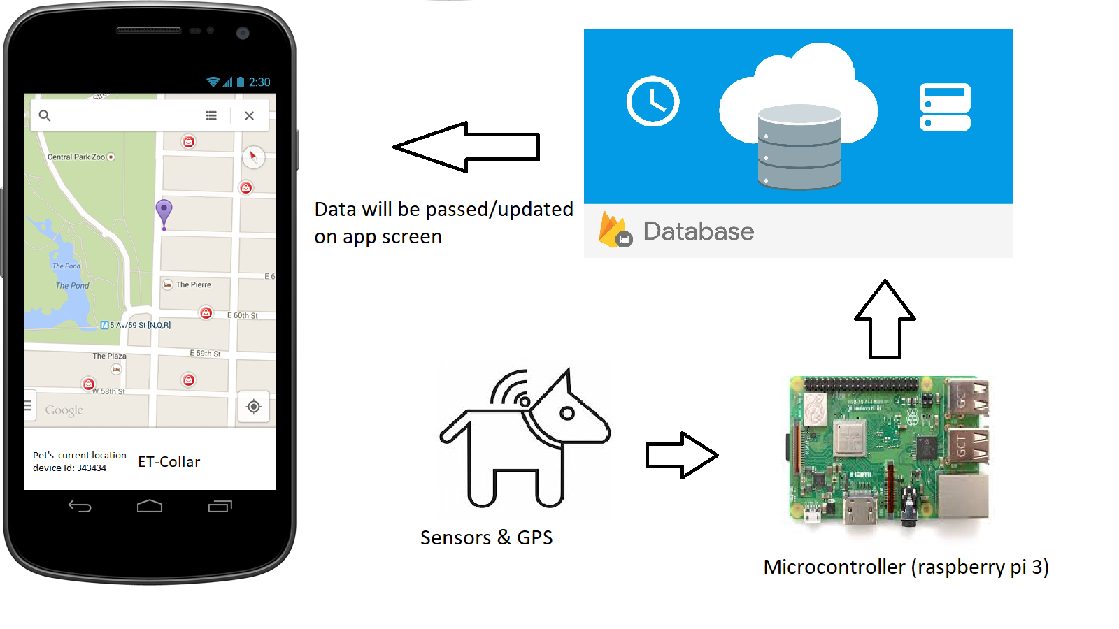

Product Functions
- Hardware sensor update readings every minute
- On cloud readings will be stored.
- Application get data in correct order/field
- App display data to user
- App assign new user
- Sign up and conform login credentials

User Classes and Characteristics
<Identify the various user classes that you anticipate will use this product. User classes may be differentiated based on frequency of use, subset of product functions used, technical expertise, security or privilege levels, educational level, or experience. Describe the pertinent characteristics of each user class. Certain requirements may pertain only to certain user classes. Distinguish the most important user classes for this product from those who are less important to satisfy.>

Operating Environment
Since this project will be used to track pets this will be used by every single person who has pet and is concern about their health and safety. We assume most of the people already know how to use android device but if they have any problem placing hardware and how to use our app we will provide a clear documentation and tutorials about the product features and uasage.

Design and Implementation Constraints
Since this project revels pet’s location hence some personal information your address (possibly) it is a great concern not to share information with others.
Developers should also be careful about the privacy of users. Since product will be cloud application, all user data will be kept on cloud server and necessary precautions should be taken to protect user data. So don’t give your login information to others.
Since product will be cloud application and all user programs will be executed on cloud server, developers should limit the privileges of the users so that they cannot harm other users’ data and system server
Also application is provided only in English and French.

User Documentation
There is no specific user manuals available for users. However, a specific section in the app is available to reach out the customer service for any kind of help or to address any concern regarding the usage of the application. The UI is designed to be intuitive and easy to use.

Assumptions and Dependencies

Assumption comprehend the database, which will be Firebase. We are assuming that we will be able to translate our classes in the database and store data efficiently. If this does not reveals to be true, another DB would have to be designed and deployed.
Also couple of other devices in the market are using similar kind of devices are in the market for e.g. Paw tracker, Telemetry Solutions that might be using similar kind of hardware, GPS systems.
Moreover, we assume that the main user of the app will be using Lollipop and above as otherwise the application will not be functioning properly.

External Interface Requirements

User Interfaces
The main user interface for the application will be the status page where all the data will be displayed that includes distance, light sensor readings location coordinates that will be displayed on map screen as well that uses google maps to display the exact location of the animal there is option to show path to the location using google maps again.
We used android studio version 3.2 as a front-end software to design the app where user will interact with data. Back-end software is firebase database that stores all the user data as well as the sensor that is to be displayed.

Hardware Interfaces

The app is designed to run on all android devices with minimum --------software requirements------
Device must be connected to internet as application reads data from online every minute or so it device required an internet connection all the time to get current the updated and current data.

Software Interfaces
App is designed using android studio version 3.2 is used to deigned the various layouts and screens where the data will be displayed. Firebase data is the platform used to store all the app data including user data user credentials login info and device ID’s as well as the sensor data that is the data from sensor to be sent to the app. Apart from that app uses google maps to give you direction you see the location of the animal somewhere it wasn’t supposed to be.

Communications Interfaces
The main communication is the one that connects app to DB. Where, HTTP protocol is used to exchange data. Other inner communications are managed by the app and OS.

System Features
ET-Collar keeps track of pet as well wild animals location to keep them save and preserve wildlife and keep your pet safe. I think it has a high priority as animals are important part of our ecosystem.

System Feature 1
<Don’t really say “System Feature 1.” State the feature name in just a few words.>
4.1.1 Description and Priority
<Provide a short description of the feature and indicate whether it is of High, Medium, or Low priority. You could also include specific priority component ratings, such as benefit, penalty, cost, and risk (each rated on a relative scale from a low of 1 to a high of 9).>
4.1.2 Stimulus/Response Sequences
<List the sequences of user actions and system responses that stimulate the behavior defined for this feature. These will correspond to the dialog elements associated with use cases.>
4.1.3 Functional Requirements
<Itemize the detailed functional requirements associated with this feature. These are the software capabilities that must be present in order for the user to carry out the services provided by the feature, or to execute the use case. Include how the product should respond to anticipated error conditions or invalid inputs. Requirements should be concise, complete, unambiguous, verifiable, and necessary. Use “TBD” as a placeholder to indicate when necessary information is not yet available.>

<Each requirement should be uniquely identified with a sequence number or a meaningful tag of some kind.>

REQ-1:
REQ-2:

Distributed Database
Distributed database implies that a single application should be recognize device and its data from the database that is app is only connected to one device and should have only one user for data to be displayed.

Other Nonfunctional Requirements

Performance Requirements
Application should be connected to database all the time get readings there must be an internet connection. Sensor should update data continuously.

Safety Requirements
User data should safe and only be accessed by the owner the password must be strong. Device can be attached to pet’s collar but make sure that sensors are away from his paws or mouth so that there won’t be any harm to hardware.
If there is extensive damage to a wide portion of the database due to catastrophic failure, such as a disk crash, the recovery method restores a past copy of the database that was backed up to archival storage (typically tape) and reconstructs a more current state by reapplying or redoing the operations of committed transactions from the backed up log, up to the time of failure

Security Requirements
Each user need to register in order to use software as well as when buying the hardware we take some fair personal information of the buyer. App is designed in a way that there is only and only one account that is linked using unique email.

Software Quality Attributes
Application must be easy to use as it will be used by all age groups that had different technology experiences

Business Rules
<List any operating principles about the product, such as which individuals or roles can perform which functions under specific circumstances. These are not functional requirements in themselves, but they may imply certain functional requirements to enforce the rules.>

Other Requirements
<Define any other requirements not covered elsewhere in the SRS. This might include database requirements, internationalization requirements, legal requirements, reuse objectives for the project, and so on. Add any new sections that are pertinent to the project.>
Appendix A: Glossary
<Define all the terms necessary to properly interpret the SRS, including acronyms and abbreviations. You may wish to build a separate glossary that spans multiple projects or the entire organization, and just include terms specific to a single project in each SRS.>
Appendix B: Analysis Models
<Optionally, include any pertinent analysis models, such as data flow diagrams, class diagrams, state-transition diagrams, or entity-relationship diagrams.>
Appendix C: To Be Determined List
<Collect a numbered list of the TBD (to be determined) references that remain in the SRS so they can be tracked to closure.>

