User Study Guidance
Welcome to our user study! Thank you for participating.

1. Tutorial
Start by viewing the tutorial page, where we’ll use a demo to demonstrate how to use our Explain-Vis system. Feel free to explore the interface and familiarize yourself with the system.

2. Complete Fixed Tasks
After the tutorial, proceed to the Fixed Task pages. You’ll complete two tasks based on provided data scenarios and expected visualizations. After finishing all Fixed Tasks, you’ll be prompted to fill out a feedback form.

Fixed Tasks: Given a written NL query with a failed chart, we display a required chart underneath and you are encouraged to try to fix it to get the required chart.

For data scenario – Hiring, the desired chart is:
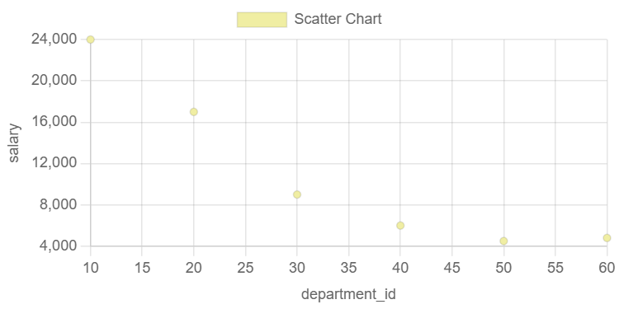
For data scenario – Address, the desired chart is:
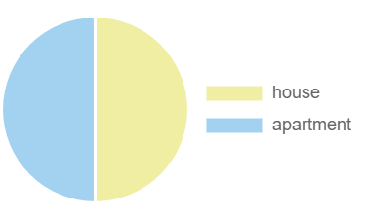

Questionnaire:

3. Complete Open-Ended Tasks
Next, move on to the Open-Ended Task pages. Here, you’ll explore two data scenarios with more freedom to determine the best approach. A Google Sheet is provided for any data manipulation. After completing these tasks, you’ll fill out a final feedback form.

Open-ended Tasks: Given related tables, we display some general questions and you are free to explore and answer these open-ended tasks.

For data scenario – College, general question is:
Can we analyze students' behavior? You are free to use some indicators to compare their academic performance in diverse dimensions.

For data scenario – Cinema, general question is:
Can we better show the schedule? You are free to extend it with detailed information from the cinema and film tables.

Questionnaire:

