MedTwin-IDS: AI-Driven Intrusion Detection and Device Risk Scoring for a Medical IoT Digital Twin
ICT3214 Security Analytics, Coursework 2: Final Report
Group ID: [Group ID]

[Member 1 Full Name]
Student ID: [Student ID]
Singapore Institute of Technology
Singapore
[SIT email]
[Member 4 Full Name]
Student ID: [Student ID]
Singapore Institute of Technology
Singapore
[SIT email]
[Member 2 Full Name]
Student ID: [Student ID]
Singapore Institute of Technology
Singapore
[SIT email]
[Member 5 Full Name]
Student ID: [Student ID]
Singapore Institute of Technology
Singapore
[SIT email]
[Member 3 Full Name]
Student ID: [Student ID]
Singapore Institute of Technology
Singapore
[SIT email]

Abstract—Connected patient monitors, infusion pumps and wearables make hospital wards vulnerable to cyber attacks that can directly harm patients, yet public medical IoT datasets are too small and fixed to test detectors on unseen attacks or in real time. We present MedTwin-IDS, which builds a digital twin of an eight-bed ward to generate exactly labelled packet-level data with realistic clinical and network anomalies and six attack families at three intensities, and uses the twin to derive consistency features such as cross-sensor physiological residuals and message sequence integrity. Random Forest, XGBoost and a multilayer perceptron are compared under a leakage-aware protocol. XGBoost, selected by cross-validation, reaches 99.90% accuracy, a binary F1-score of 0.9966 and a macro F1-score of 0.981 on an independent test run at 2.28 ms per flow, against 0.965 for Random Forest, and is the best model on three further unseen wards. Twin features raise macro F1 from 0.835 to 0.981 and spoofing recall from 28% to 97%. On attack families never seen in training, an Isolation Forest raises mean recall from 0.33 to 0.73, and label-free twin consistency rules raise it to 0.97. In streaming operation, all 30 test campaigns are detected with a median delay of 3.7 s, and per-device risk scores and explanations are shown on an analyst dashboard.
Keywords—medical IoT, digital twin, intrusion detection, XGBoost, explainable AI, real-time detection, risk scoring

Introduction
Hospital wards now run on connected devices. Patient monitors stream vital signs to a nurse station, infusion pumps accept rate changes over the network, and wearable sensors relay data through IoMT gateways. Many of these devices run legacy firmware with weak authentication, and practical attacks on medical devices have been shown for more than a decade [1]. IoMT security surveys stress that data must be protected during collection, transmission and storage [2]. In this setting a cyber attack is a patient-safety event: a spoofed monitor can hide deterioration, altered vitals can trigger the wrong treatment, and an unauthorised pump command can over-infuse a drug.
Machine learning (ML) intrusion detection can learn these threats from data, but IoMT research is held back by its datasets. Public sets such as WUSTL-EHMS-2020 [3] and ECU-IoHT [4] are small and fixed, so they cannot test unseen attacks, varied attack intensity or real-time operation, and ML evaluations in security often suffer from leakage and over-optimism [5], [6]. We therefore ask: can a digital twin of a hospital ward generate realistic labelled data (RQ1); which of three ML models gives the best balance of accuracy and processing time (RQ2); do features that only a twin can compute improve detection of integrity attacks (RQ3); how well do detectors handle attack families never seen in training (RQ4); and can the chosen model run in real time with explainable, device-level risk scores (RQ5)?
We built MedTwin-IDS, which implements Idea 1 of the coursework with per-device risk scoring (Idea 7) and alert explanations (Idea 12). Our contributions are:
- A digital twin of an eight-bed ward that couples patient physiology, 24 medical devices and packet-level network behaviour, with benign clinical and operational anomalies and six attack families at three intensities, giving exactly labelled data (bonus: simulated dataset).
- A parser that turns packets into 55 flow-window features, including 11 twin features that check traffic against the asset registry, message sequence integrity and cross-sensor physiological consistency.
- A leakage-aware comparison of Random Forest, XGBoost and an MLP, checked with bootstrap intervals and three extra test wards, plus an ablation, zero-day, intensity and window-length study and SHAP explanations.
- Label-free twin consistency rules for unseen integrity attacks, and a real-time detector with an Isolation Forest safety net, per-device risk scores, grouped incidents and a Streamlit dashboard (bonus: real-time detection).
On an independent test run, the selected XGBoost model reaches 99.90% accuracy, a binary F1-score of 0.9966 and a macro F1-score of 0.981 over seven classes, while scoring a flow in 2.28 ms. Twin features raise the macro F1-score of XGBoost from 0.835 (network and biometric features only) to 0.981, mainly by exposing spoofing and data alteration. Supervised models detect few attacks from families they never saw (mean recall 0.33 for XGBoost); adding an Isolation Forest raises this to 0.73, and label-free twin consistency rules raise it to 0.97, at the cost of more false positives. In streaming operation every one of 30 test campaigns is detected, with a median time-to-detect of 3.7 s.

Related Work
IoMT datasets. Hady et al. [3] built a healthcare monitoring testbed and released WUSTL-EHMS-2020, about 16,000 records with spoofing and data-alteration attacks, and showed that combining network and biometric features improves detection. ECU-IoHT [4] provides IoHT traffic with ARP spoofing, DoS and scanning and found nearest-neighbour anomaly detectors effective. MQTTset [7] and MQTT-IoT-IDS2020 [8] cover the MQTT protocol used by many IoMT gateways; the latter found flow-level features essential for MQTT attacks. General datasets such as CIC-IDS2017 [9] and UNSW-NB15 [10] have no medical context. All of these are fixed captures, so attack mix, intensity and timing cannot be varied.
Detection methods. Tree ensembles [11], [12] are strong baselines for flow data. N-BaIoT [13] and Kitsune [14] use autoencoders to detect IoT attacks without labels, and Kitsune works online; Isolation Forest [15] is a light alternative for anomaly detection [16]. Sommer and Paxson [5] and Arp et al. [6] warn that closed-world assumptions, data snooping and spurious correlations inflate reported accuracy. Digital twins are well established in industry for design, production and prognostics [17], but we found little work that uses a healthcare twin both to generate security data and to supply detection features.
- Comparison With Related Datasets and Systems
Work | Patient vitals | Controllable attacks | Unseen-attack test | Device risk score
WUSTL-EHMS [3] | Yes | No | No | No
ECU-IoHT [4] | No | No | No | No
MQTT-IoT-IDS [8] | No | No | No | No
Kitsune [14] | No | No | Yes | No
MedTwin-IDS (ours) | Yes | Yes | Yes | Yes
Controllable attacks: attack type, intensity and timing can be set when generating data. Unseen-attack test: detection evaluated on attacks absent from training.

Methods

System Overview
Fig. 1 shows the pipeline. The digital twin (1) produces packet events, which are stored with ground truth and parsed into flow features (2). Three supervised models are trained and one is selected by cross-validation (3); an Isolation Forest and twin consistency rules, both built from normal traffic only, act as safety nets for unseen attacks. The selected model scores the live stream, and a risk engine turns detections into device risk scores, incidents and recommended actions (4) shown on a dashboard (5).

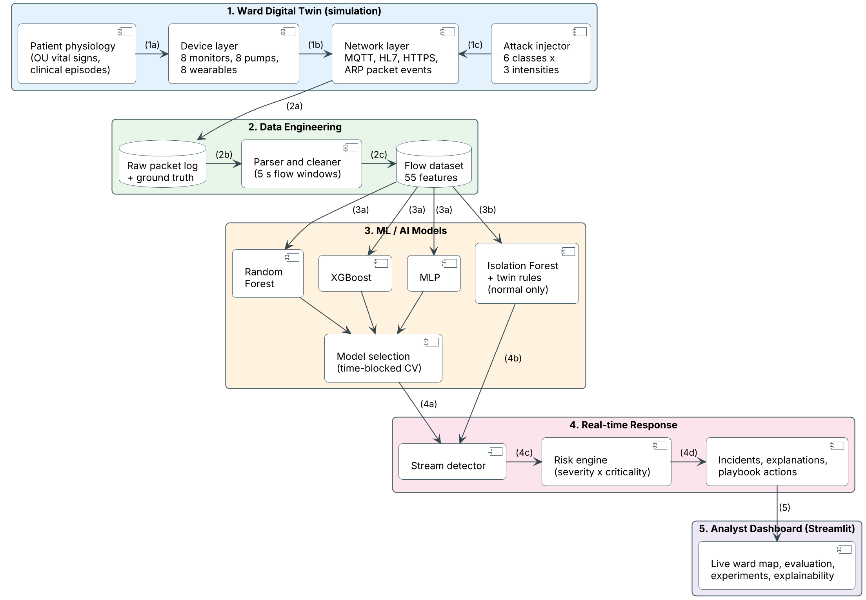
- MedTwin-IDS architecture (PlantUML). Labels (1a) to (5) give the order of processing.

Digital Twin and Data Generation
Ward and devices. The twin models an eight-bed ward. Each bed has a patient monitor publishing vitals at 1 Hz, an infusion pump reporting its rate every 5 s and a wearable sensor publishing every 2 s, all over MQTT (QoS 1) to an IoMT gateway. A nurse station subscribes to all telemetry and sends pump commands, the gateway sends HL7 batches to the EHR server every 30 s, two workstations open HTTPS sessions to the EHR and a vendor portal, and the gateway refreshes ARP entries. The twin's asset registry records each device's IP, MAC, expected TTL and clinical criticality.
Physiology. Each patient's heart rate, SpO₂, temperature, blood pressure, respiration rate and ST segment follow an Ornstein-Uhlenbeck process around a personal baseline with a daily rhythm. Clinical episodes (tachycardia, bradycardia, desaturation, fever, hypertension and ST elevation) ramp in and out over 3 to 15 minutes. Monitors and wearables sample the same patient with different noise, so in normal operation they agree.
Benign confounders. To avoid an easy closed world [5], the twin adds events that look anomalous but are legitimate: network congestion (higher jitter and retransmissions), 2 to 6 MB firmware downloads, device reboots (reconnects and sequence resets), nurse pump changes and pauses, nurse login retries, wearable motion artefacts and large EHR downloads. It also injects capture artefacts (duplicate frames, 65535-style sensor sentinels and truncated records) for the cleaner to handle.
Attacks. Campaigns of 60 to 240 s are placed at random times, cycling through six families (Table II). Each is drawn at low, medium or high intensity and from a rogue host, a compromised workstation or a compromised device, so the same family appears with different footprints. During floods the gateway slows down, which also changes legitimate traffic, and 30 to 90 s after an unauthorised pump command a nurse restores the pump's original rate.
- Attack Families and Intensity Settings
Class | Network and clinical footprint | Low / medium / high
DoS flood | SYN or MQTT PUBLISH flood on the gateway from 1 to 3 sources | 25 / 80 / 250 pkt/s
Spoofing | MQTT client-ID takeover, or IP (and optionally MAC) clone; false or masked vitals | 1x / 2x / 4x rate
Data alteration | ARP poisoning (two forged replies per victim per round); vitals offset in transit; extra delay, TTL may drop by one | 0.2 / 1 / 3 rounds/s
Unauth. access | MQTT credential guessing, then rogue infusion-rate command | 0.5 / 2 / 8 tries/s
Reconnaissance | Host and port scan of the ward subnet | 0.5 / 4 / 20 probes/s
Exfiltration | EHR records staged, then uploaded to an external host | 15 / 120 / 400 kB/s

Datasets
We generated two independent runs (Table III). The training run covers 6 h from 08:00 with seed 7; the test run covers 3 h from 20:00 with seed 2026, so patients, device ports, attack timing and attack sources all differ. Ground truth comes from the generator, so every packet is labelled exactly. Normal traffic dominates, as it does in practice.
- Generated Datasets
 | Training run | Test run
Packets | 1,504,111 | 650,522
Attack campaigns | 60 | 30
Flow windows | 126,857 | 64,488
Normal | 109,776 | 55,041
DoS flood | 542 | 274
Spoofing | 483 | 269
Data alteration | 979 | 433
Unauth. access | 222 | 99
Reconnaissance | 14,520 | 8,210
Exfiltration | 335 | 162

Realism checks (RQ1). In normal training traffic the monitors report heart rates of 67 to 93 bpm (5th to 95th percentile), SpO₂ of 95.2 to 98.5% and temperatures of 36.4 to 37.0 °C, which are typical adult ward values. The median telemetry interval is 1.00 s, 0.15% of packets are retransmissions, and the monitor and wearable on the same patient agree within 3.5 bpm in 95% of normal windows. The training run contains 22 clinical episodes, 6 congestion periods, 4 firmware updates, 5 reboots and 27 nurse pump commands, so benign anomalies are common rather than exceptional.
Training and detecting data. The initial training data is the training run's 126,857 flow windows: about its first three quarters fit and the rest validates the hyperparameter search, and all of it is used for cross-validation and the final fit. The detecting data never touches training: the independent test run (64,488 flows) for the one-time evaluation, three further 1 h runs (seeds 3001 to 3003) for robustness, and live streams (the test log replayed window by window and a new twin, seed 99) for real-time detection.

Pre-processing and Feature Engineering
Cleaning. The cleaner drops records missing essential fields (76 in the training run), duplicate capture frames that are not TCP retransmissions (1,490), and nulls vital-sign values outside the sensors' measurement range (134). Clinically extreme but measurable values are kept, because deleting them would erase evidence of tampering.
Flow windows. Packets are grouped into 5 s service-level bidirectional flows keyed by initiator, responder, service port and protocol. The initiator is the sender of the TCP SYN where it is visible, otherwise the endpoint with the higher (ephemeral) port. Each flow window carries 55 features:
- Network (34): duration, packets, bytes, loads and rates per direction; packet-size extremes; mean inter-arrival time and jitter; SYN, RST, FIN and ARP counts; retransmissions; MQTT CONNECT, refused CONNACK, PUBLISH and command counts; host fan-out and port spread; service indicators.
- Biometric (10): mean temperature, SpO₂, pulse, blood pressure, heart rate, respiration and ST from the flow's telemetry, infusion rate and a telemetry indicator, as in WUSTL-EHMS-2020 [3].
- Twin (11): unknown source; MAC mismatch and TTL deviation against the registry; external destination; duplicated and missing sequence numbers per device; heart-rate and SpO₂ residuals between a patient's monitor and wearable; change of vitals since the last window; within-window heart-rate spread; and the relative pump-rate change, including the change requested by a command.
Identifiers (addresses, ports, MACs, device names and time stamps) are never used as features, so models must learn behaviour rather than memorise hosts or schedules [6].

Detection Models and Rationale
We compare three supervised models that represent different learning families, all built with scikit-learn [18] and xgboost:
- Random Forest (RF) [11]: bagged, decorrelated decision trees. It is robust to scale and noise, needs little tuning and is a standard IDS baseline. Class weights handle imbalance.
- XGBoost [12]: gradient-boosted trees that add each tree to correct the residual errors of the ensemble, with regularisation and histogram-based splits. Boosting suits rare, hard classes, which we weight by the square root of inverse class frequency.
- Multilayer perceptron (MLP): a deep feed-forward network with three ReLU hidden layers (256-128-64 units after tuning), Adam and early stopping, on log-scaled, standardised features. Rare classes are randomly oversampled.
An Isolation Forest [15] is trained on normal training traffic only. It needs no attack labels, so it can flag behaviour that no supervised model has seen. Its thresholds are set at the 1st (standard) and 0.1st (strict, live) percentiles of normal anomaly scores.

Training and Evaluation Protocol
Following Arp et al. [6], we prevent leakage at every stage. (i) Hyperparameters are tuned on a temporal hold-out: the first three quarters of the training run fit and the rest validates, with the cut moved past any campaign it would split (20 settings in total). (ii) Five-fold cross-validation groups windows into 30-minute time blocks and assigns every window of a campaign to the block in which the campaign starts, so no campaign sits on both sides of a split. (iii) The deployed model is chosen on cross-validation macro F1-score alone, with near-ties (below 0.002) broken by latency. (iv) Only then is each model tested once on the independent test run.
We report accuracy, precision, recall, F1-score, false positive rate (FPR) and ROC AUC for attack versus normal, and macro F1-score over the seven classes, which weights rare attacks equally. Cost is measured as training time, batch inference time per flow and single-flow latency (median of 100 calls on one thread).

Real-time Detection and Risk Scoring
The live detector steps the twin (or replays a log) one 5 s window at a time, applies the same cleaner and feature extractor, and scores each flow with the deployed model. A flow is an alert when P(attack) = 1 − P(normal) ≥ 0.5. Each flow's threat is T = P(attack)·s(c), where s(c) is the severity of the most likely attack class c (0.5 for reconnaissance up to 1.0 for data alteration and unauthorised access). Every device involved in the flow is updated as
R_{t} = min(100, max(100·T·w, λ·R_{t−1})) (1)
where w = 0.6 + 0.4k, k is the device's criticality in the registry (1.0 for pumps and the gateway, 0.6 for wearables) and λ = 0.9 per window, so risk jumps at once and decays with a half-life of about 33 s. Two rules from the twin keep blame accurate: when a frame's MAC does not match the registry, the device whose address is claimed is treated as a victim, and an unregistered host becomes its own tracked entity. Alerts for the same device and class within 30 s are grouped into one incident, labelled with its three most abnormal features (z-scores against normal traffic, weighted by model importance; a feature that never varies in normal traffic, such as the sender's registry status or TTL, gets a fixed high score when it deviates) and a playbook action. Flows that the supervised model passes but the strict Isolation Forest flags become “unknown anomaly” alerts; with the optional twin rules (E3), a passed flow that breaks a rule becomes a “twin rule” alert first.

Implementation and Testing
The system is a Python 3 package of 13 modules (twin, attacks, simulator, parser, models, training, experiments, rules, risk engine, real-time detector, figures, benchmark and configuration) plus a Streamlit dashboard. We used pandas and NumPy for data handling, scikit-learn [18] for RF, the MLP, the Isolation Forest and cross-validation, xgboost [12], SHAP [19] for explanations, Plotly for the dashboard and PlantUML for the system diagram. Every run is seeded, so datasets and results are reproducible. An automated suite of 28 pytest tests passes. It checks that the twin is deterministic and labels every packet, that the cleaner removes capture artefacts but keeps extreme vital signs, that flows are oriented by the SYN, that no identifier is used as a feature, that rogue pump commands raise the pump-rate feature, that the twin rules and risk attribution behave as designed, that models train on any subset of classes, that saved models load on any platform, that cross-validation never splits a campaign, that forged frames match benign sizes, that attacked pumps are restored, that explanations cite identity evidence, that the benchmark loader matches the WUSTL-EHMS-2020 schema, and that the real-time detector runs end to end. One test confirms a key property: extracting features window by window, as the live detector does, gives exactly the same values for all 55 features as offline extraction, so the live model sees the inputs it was trained on.

Results and Insight

E1: Model Comparison
- Detection Quality and Processing Time on the Independent Test Run
Metric | RF | XGBoost | MLP
Accuracy (%) | 99.82 | 99.90 | 99.80
Precision (%) | 99.89 | 99.71 | 98.96
Recall (%) | 98.87 | 99.60 | 99.70
F1-score (%) | 99.38 | 99.66 | 99.33
False positive rate (%) | 0.02 | 0.05 | 0.18
ROC AUC | 0.9999 | 0.9999 | 0.9999
Macro F1, 7 classes | 0.965 | 0.981 | 0.973
95% bootstrap interval | 0.947–0.978 | 0.970–0.987 | 0.960–0.982
Macro F1, 5-fold CV | 0.953 ± 0.006 | 0.974 ± 0.009 | 0.947 ± 0.011
Macro F1, 3 extra runs | 0.979 ± 0.005 | 0.993 ± 0.002 | 0.982 ± 0.001
Training time (s) | 15.9 | 32.0 | 123.2
Batch inference (µs / flow) | 12.8 | 6.1 | 2.3
Single-flow latency (ms) | 24.04 | 2.28 | 0.32
Model size (MB) | 6.4 | 1.2 | 0.6
Accuracy to ROC AUC: attack versus normal. Latency: median time to score one flow on one CPU thread. Extra runs: three new 1 h wards (seeds 3001 to 3003, starting 02:00, 11:00 and 17:00).
Table IV shows that all three models separate attacks from normal traffic almost perfectly: binary F1-scores are 0.9938 (RF), 0.9966 (XGBoost) and 0.9933 (MLP), with precision of at least 0.990, recall of at least 0.989, false positive rates of at most 0.18% and ROC AUC of at least 0.9999. Binary accuracy alone would therefore hide the real differences. The macro F1-score, which gives each attack class equal weight, does not: XGBoost reaches 0.981, the MLP 0.973 and RF only 0.965.
- Per-class F1-score on the Test Run
Class | RF | XGBoost | MLP | Flows
Normal | 0.999 | 0.999 | 0.999 | 55,041
DoS flood | 0.993 | 0.994 | 0.994 | 274
Spoofing | 0.912 | 0.981 | 0.981 | 269
Data alteration | 0.931 | 0.951 | 0.892 | 433
Unauth. access | 0.948 | 0.940 | 0.947 | 99
Reconnaissance | 1.000 | 1.000 | 1.000 | 8,210
Exfiltration | 0.975 | 1.000 | 1.000 | 162

Table V locates the gap. DoS, reconnaissance, exfiltration and unauthorised access are recognised by every model (F1 of 0.94 or more), because their footprints are loud: fan-out, volume or refused logins. The two integrity attacks are harder: F1-scores are 0.912, 0.981, 0.981 on spoofing and 0.931, 0.951, 0.892 on data alteration (RF, XGBoost, MLP). A closer look at spoofing shows why RF lags there: it labels 10% of the impostor's flows (the attacker publishing under a victim's identity) as normal, whereas XGBoost and the MLP catch 98% and 99% of them. These flows look like ordinary telemetry; the only evidence is a handful of twin features (duplicated or missing sequence numbers, a heart rate that disagrees with the patient's wearable, and an unregistered or unexpected sender). RF considers a random subset of about seven features at each split and averages independently grown trees, so these few weak signals are often outvoted. Boosting fits each new tree to the errors of the previous ones, so XGBoost concentrates on exactly these hard flows; the MLP combines all features in every unit and also captures them.

Why XGBoost Was Selected
The selection rule uses cross-validation only. XGBoost has the highest cross-validation macro F1-score (0.974 ± 0.009), ahead of RF (0.953 ± 0.006) and the MLP (0.947 ± 0.011). On the test run, a paired cluster bootstrap (resampling whole campaigns) shows that its lead over RF is real (95% interval of the macro-F1 difference 0.004 to 0.031) but that it is statistically tied with the MLP (0.000 to 0.018). To separate them we ran the saved models on three further unseen wards: XGBoost was best in 3 of 3 (mean 0.993, against 0.982 for the MLP and 0.979 for RF). In processing time XGBoost is also a good fit: it trains in 32.0 s (RF 15.9 s, MLP 123.2 s), scores one flow in 2.28 ms and is 1.2 MB on disk. The MLP is faster per flow (0.32 ms) but less stable and needs scaling and oversampling; RF is 11 times slower per flow and 5 times larger. With about 30 flows per 5 s window, XGBoost needs well under 0.1 s of model time per window, so accuracy and stability, not speed, decided the choice.

E2: Do Twin Features Help?
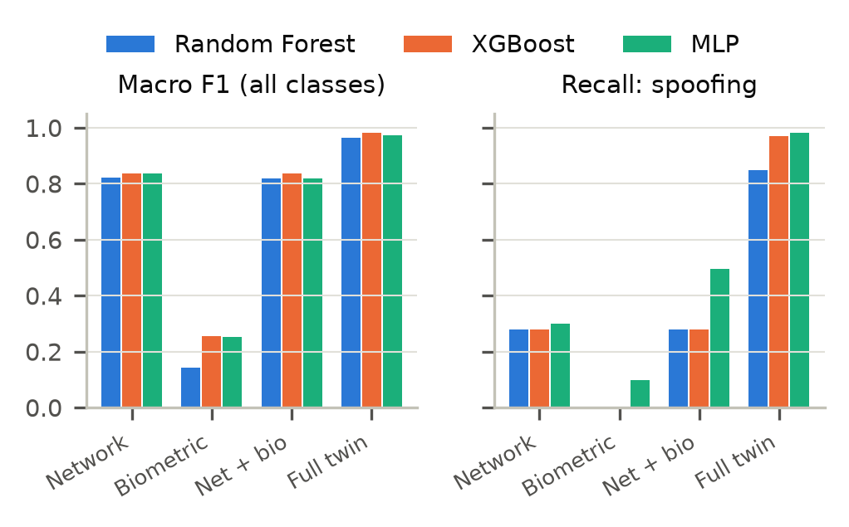
- Ablation on the test run: macro F1-score and spoofing recall for each feature set and model.
Fig. 2 removes feature groups and retrains every model. Biometric features alone are of little use (macro F1 at most 0.25), because the falsified vitals in our attacks are plausible values. Network features alone give 0.835 for XGBoost but recall only 28% of spoofing flows. Adding the biometric features, which is the WUSTL-EHMS-2020 design, changes little (0.835). Adding the 11 twin features lifts XGBoost to 0.981, spoofing recall to 97% and data-alteration recall from 67% to 95%, while the false positive rate falls from 0.81% to 0.05%. The insight is that the value of patient data lies less in the vital signs themselves than in whether they are consistent: with the patient's other sensor, with the device's message sequence and with what the registry expects. That consistency check is exactly what a digital twin can provide (RQ3).

E3: Unseen (Zero-day) Attacks
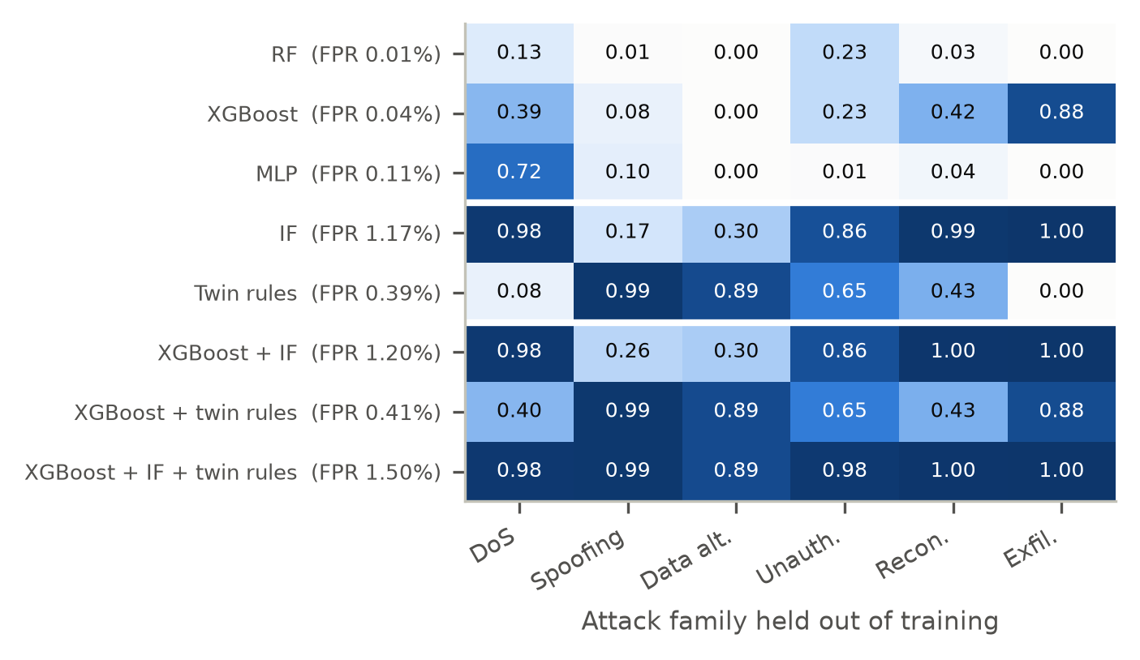
- Recall on an attack family removed from training, per detector. FPR: mean false positive rate on normal test traffic.
Fig. 3 removes one attack family from training at a time; the supervised models use default hyperparameters here, because the tuned ones were chosen with every family present. They largely fail on families they have never seen: mean recall is 0.07 for RF, 0.33 for XGBoost and 0.15 for the MLP, because a closed-world classifier assigns the unknown flows to the nearest class it knows, usually normal [5]. XGBoost's best case is exfiltration (0.88), whose volume resembles other known attacks. The Isolation Forest, trained on normal traffic only, reaches 0.72 on its own and is strong on loud attacks (DoS 0.98, exfiltration 1.00, reconnaissance 0.99, unauthorised access 0.86) but weak on the integrity attacks (data alteration 0.30, spoofing 0.17), whose flows look normal in volume and timing. The hybrid of the two reaches 0.73, but its false positive rate rises from 0.04% to 1.20%. Two lessons follow: an unsupervised safety net is essential for unknown attacks, and unknown integrity attacks need explicit twin consistency checks rather than generic anomaly scores. The live detector therefore uses a stricter Isolation Forest threshold and groups alerts (RQ4).
A designed fix: twin consistency rules. These lessons point to five invariants that the twin knows for every device: (R1) the sender must be registered; (R2) its MAC address and TTL must match the registry; (R3) its sequence numbers must be neither duplicated nor missing; (R4) a patient's monitor and wearable must agree; and (R5) a pump's rate must not change unexpectedly. We implemented them as label-free rules whose thresholds are the 99.9th percentile of each signal in normal training traffic, so they need no attack examples and are the same whichever family is held out. On their own they catch 99% of unseen spoofing and 89% of unseen data alteration, exactly the integrity attacks on which the Isolation Forest is weakest, at a false positive rate of 0.39%. Away from any attack the rate is 0.19%; most of the remaining false positives fall inside attack windows on the honest bed partner of a spoofed or altered device, which R4 flags because it cannot tell which sensor is lying. Combined with XGBoost and the Isolation Forest, mean recall on held-out families rises from 0.73 to 0.97, with every family at 0.89 or above, for a false positive rate of 1.50%. The threshold sets the trade-off: at the 99.99th percentile the rules' false positive rate falls to 0.12% but unseen-spoofing recall drops to 84%. In the live run every family is known, so the rules cannot add detections (12 of 12 either way) and show only their cost: false alerts rise from 36 to 91 and incidents from 34 to 59. Of the 55 rule alerts on normal flows, 23 are R5 firing on legitimate nurse pump commands (pump-rate changes are so rare that its threshold is zero) and 29 are R4 on wearables that briefly disagree with their monitor. We therefore ship the rules as an option (--twin-rules) for wards that prioritise integrity attacks (RQ4).

E4 and E5: Attack Intensity and Window Length
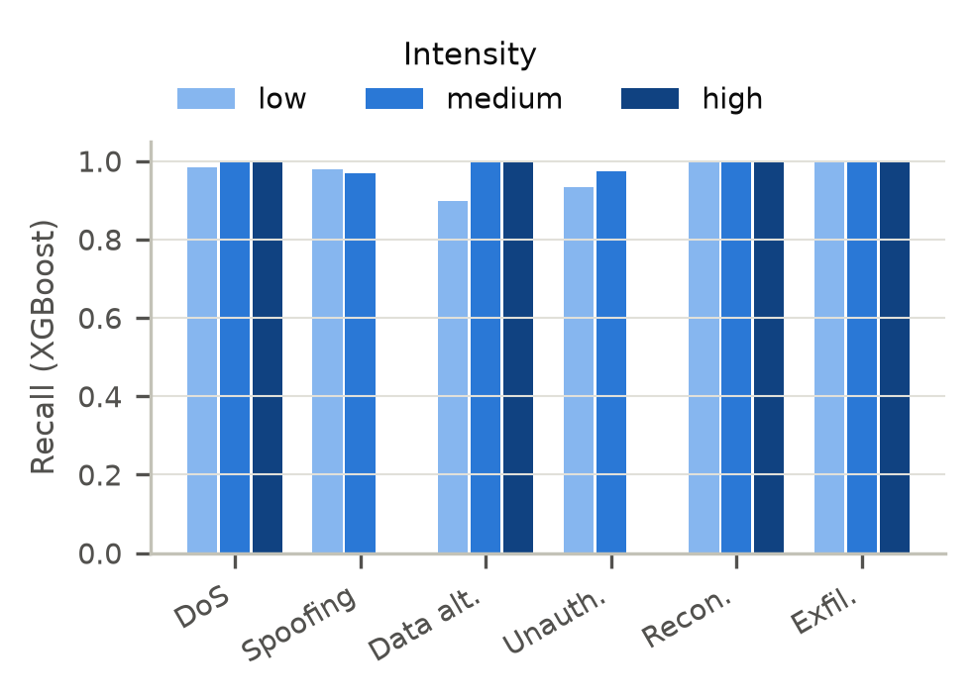
- Recall of XGBoost by attack intensity on the test run.
Intensity. Fig. 4 shows that recall is 1.00 for every high-intensity campaign in the test run. Low intensity is hardest for data alteration (XGBoost: 0.90 at low versus 1.00 at high intensity), where the in-transit offset is only 6 to 10 beats per minute and the ARP poisoning rate is one round (two forged replies) every five seconds. For RF, spoofing recall is 0.97 (low) and 0.71 (medium), against 0.98 and 0.97 for XGBoost. The random schedule placed no high-intensity spoofing or unauthorised-access campaign in the test run, so those cells are empty (Appendix C).
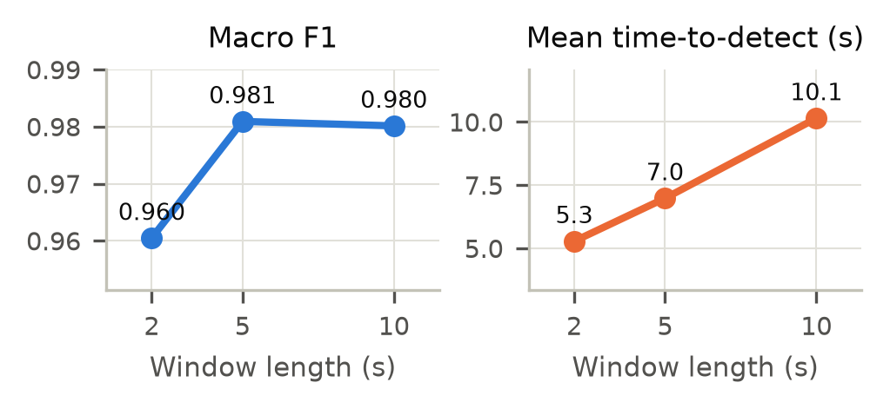
- Effect of the flow-window length on macro F1-score and mean time-to-detect (XGBoost, test run).
Window length. Shorter windows react faster but see fewer packets per flow (Fig. 5). Moving from 10 s to 5 s windows cuts the mean time-to-detect from 10.1 s to 7.0 s with macro F1 of 0.980 and 0.981; 2 s windows give 5.3 s and 0.960. We keep 5 s as the operating point. The means include exfiltration, which is only visible once the upload starts after the staging phase.

Explainability
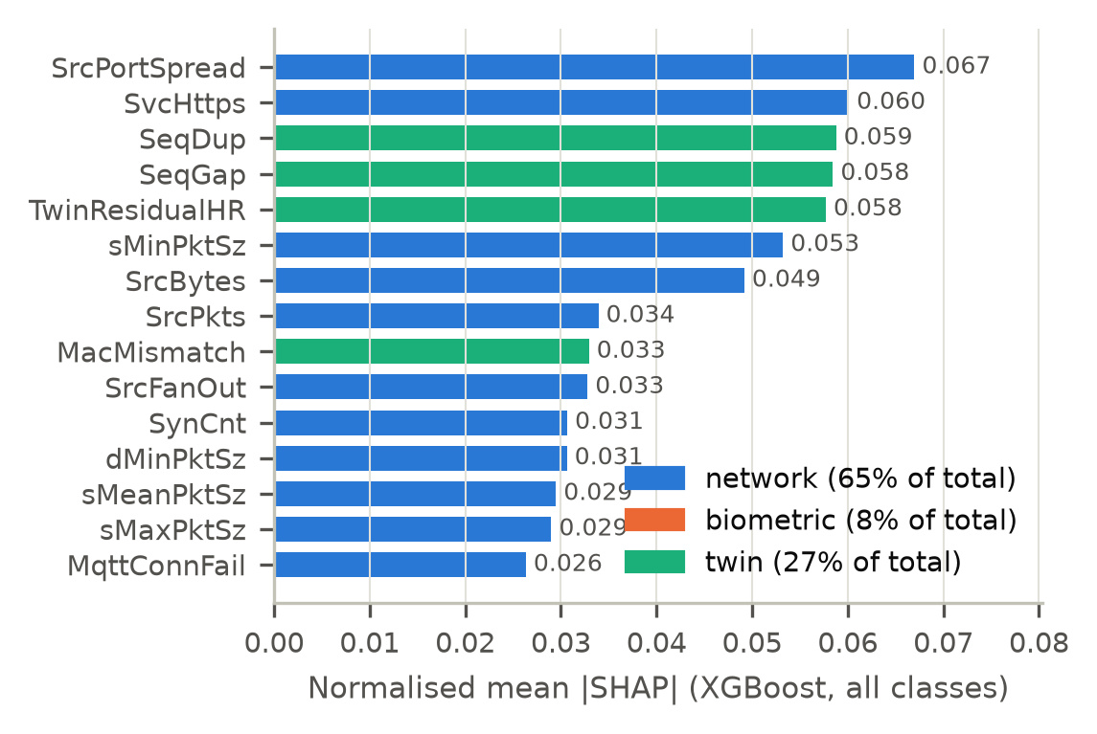
- Top 15 features by mean absolute SHAP value for XGBoost, coloured by group.
SHAP [19] explains the selected model (Fig. 6). Network features carry 65% of the total attribution, twin features 27% and biometric features 8%; twin features are only 20% of the inputs but hold ranks 3, 4, 5, 9 of the top ten. Per class, the model's reasoning matches the attack mechanics: reconnaissance is recognised by SrcPortSpread and SrcFanOut, DoS by SrcBytes and SrcPkts, exfiltration by SvcHttps and TotBytes, unauthorised access by MqttConnFail and PumpRateDelta, spoofing by SeqGap and SeqDup, and data alteration by TwinResidualHR and MacMismatch. Fig. 7 shows why the residual works: in a real clinical episode the monitor and the wearable move together, while an in-transit alteration changes only the monitor. The dashboard's Explainability page shows these attributions next to the per-incident explanations.
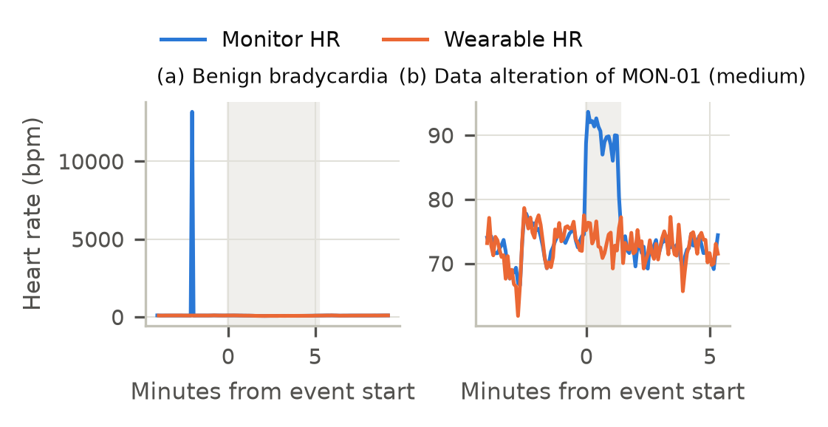
- Monitor and wearable heart rate for one patient: (a) a benign clinical episode, where both sensors move together, and (b) a data-alteration attack, where only the monitor's reported value changes.

E6: Real-time Detection and Risk Scoring
We streamed the 3 h test log through the live detector window by window, and ran a new twin (seed 99, 60 min, 12 campaigns) end to end. Table VI gives the results. In replay, 30 of 30 campaigns are detected with a median time-to-detect of 3.7 s; in the live run, 12 of 12 with a median of 3.5 s. Exfiltration is the slow case (about 40 s): its staging phase looks like a large but ordinary EHR download, and the alert fires once records start leaving for the external host. Processing a 5 s window takes 128 ms on average (95th percentile 171 ms), about 39 times faster than real time. Grouping turns 4,782 alerts into 34 incidents. Fig. 8 plots the four devices with the highest peak risk (GW-01, PMP-03, PMP-06, MON-06): an attacked device jumps above 80 (Critical) as soon as its first alert fires and decays once its traffic is clean. PMP-06 peaks only on a false alarm from a routine nurse pump command. Of the 36 alerts on flows labelled normal, 26 came from the Isolation Forest safety net, 6 were wearables whose paired monitor was being spoofed or altered (the residual is symmetric, so the right bed is flagged even though that flow carries no attack packets), 3 were nurse pump commands, including restores after an attack, and 1 was a wearable motion artefact (RQ5).
- Streaming Detection per Attack Family
Attack | Replay detected | Replay median s | Live detected | Live median s
DoS flood | 5/5 | 3.8 | 2/2 | 3.5
Spoofing | 5/5 | 3.3 | 2/2 | 0.5
Data alteration | 5/5 | 4.8 | 2/2 | 5.9
Unauth. access | 5/5 | 2.6 | 2/2 | 2.8
Reconnaissance | 5/5 | 2.9 | 2/2 | 3.0
Exfiltration | 5/5 | 37.5 | 2/2 | 42.1
Replay: the 3 h test log streamed window by window. Live: a new twin (seed 99, 60 min). Time-to-detect runs from campaign start to the end of the first alerting window.
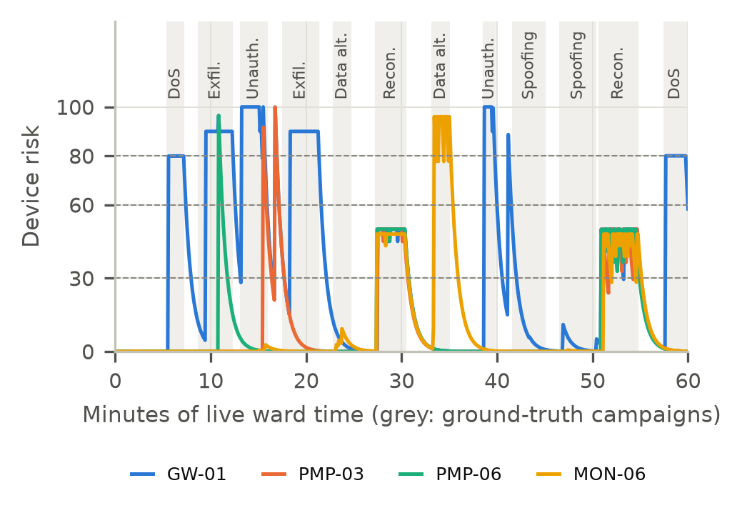
- Risk of the four highest-risk devices during the live run. PMP-06 peaks only on a false alarm from a routine nurse pump command.
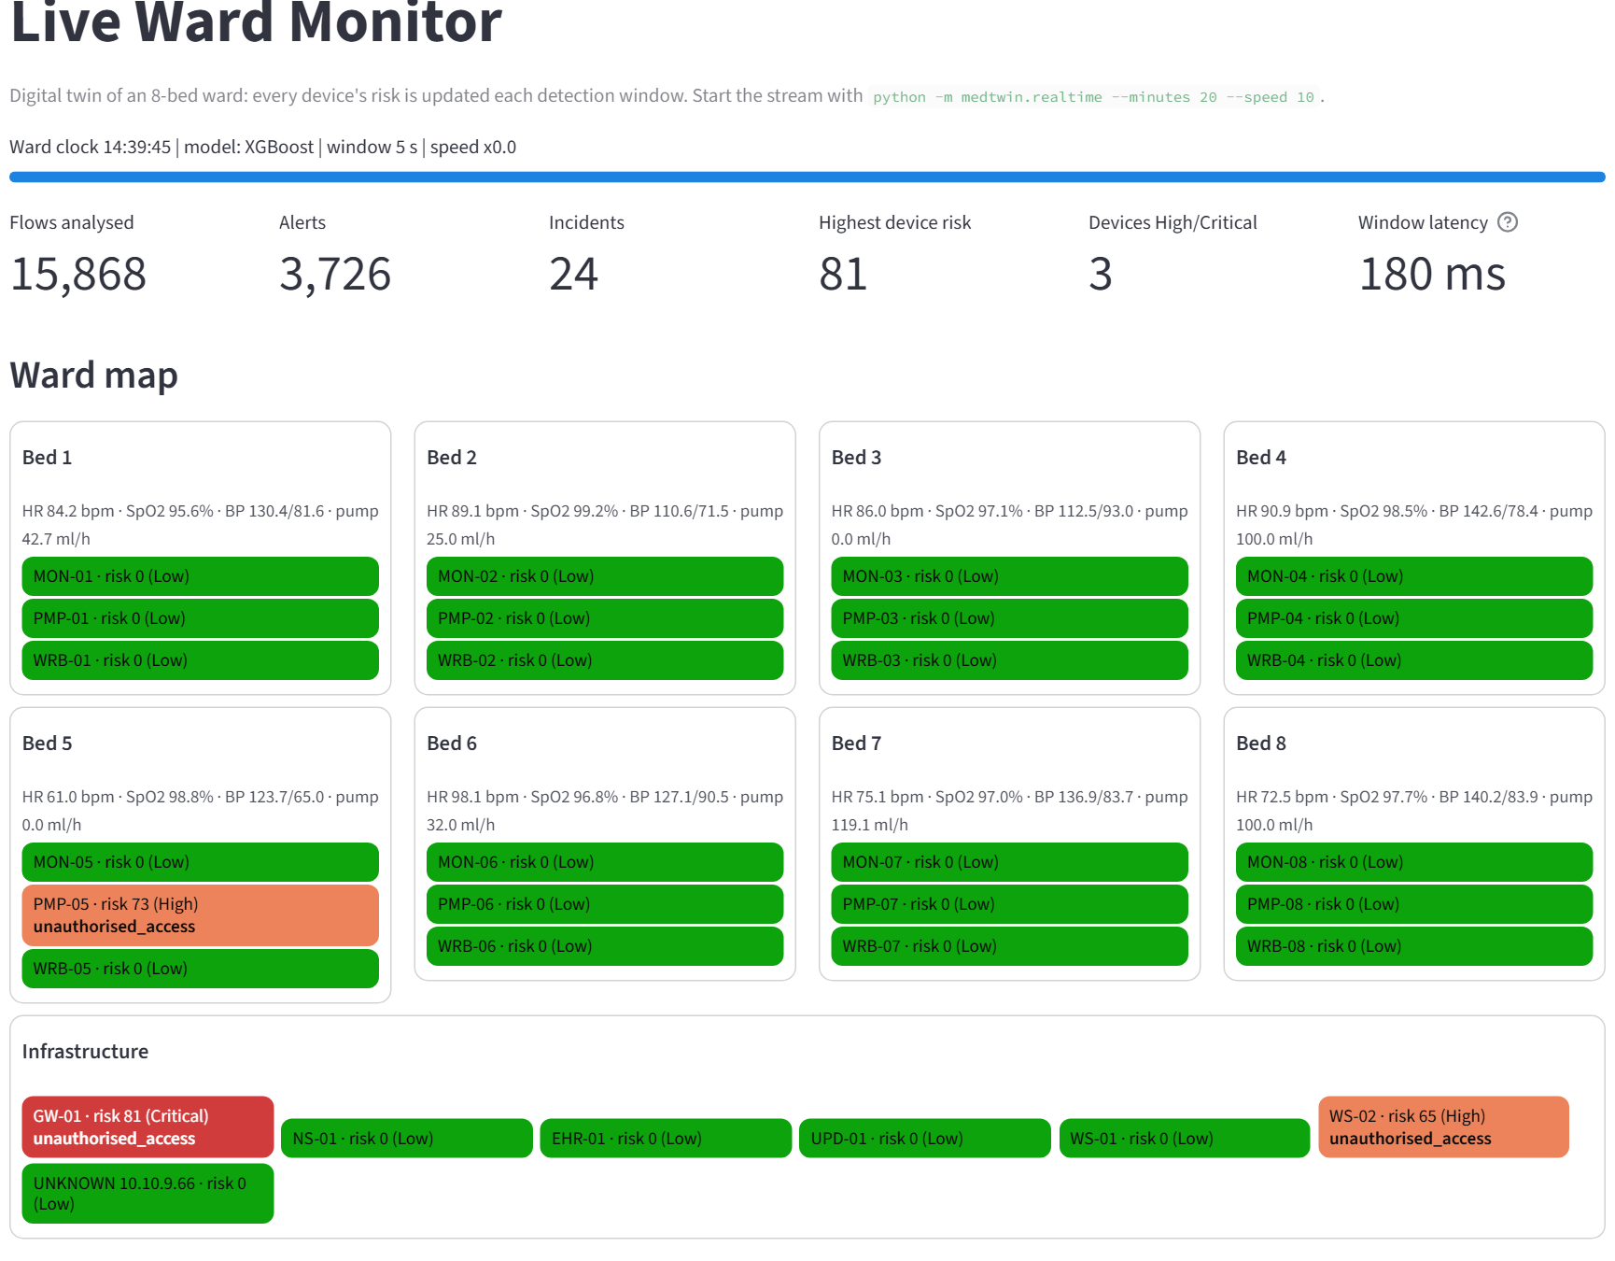
- Live Ward Monitor during the live run: an infusion pump stopped by a rogue command (High), the attacking workstation (High) and the targeted gateway (Critical).

Discussion, Implications and Limitations
Implications. First, the twin is useful twice: as a data source with exact labels and controllable attacks (RQ1), and as a source of features that make integrity attacks visible (RQ3). Second, binary accuracy is a poor guide in this domain; every model exceeds 99.8% accuracy, yet RF misses 10% of impostor flows, which only macro F1 and per-class analysis reveal. Third, model choice matters most for rare, subtle attacks: boosting and the neural network capture weak, combined evidence that bagging dilutes. Fourth, a supervised IDS alone is closed-world [5]; pairing it with an unsupervised model raises recall on unseen attacks but needs alert grouping and context to keep false positives manageable. Fifth, the twin is useful a third time: its invariants become label-free rules that catch the unseen integrity attacks that both learners miss, so the three layers together reach a recall of at least 0.89 on every unseen family. For a hospital, the risk score turns detections into priorities: a compromised pump outranks a scanned workstation.
Limitations. The data is simulated: real devices, protocols and attackers are more varied, and our benign confounders cover only some sources of noise, so absolute scores are optimistic. Flow-level labels can disagree with bed-level reality, as the paired-sensor alerts show. Nurse pump commands, including restores after an attack, still trigger unauthorised-access alerts because the pump-side flow does not reveal who sent the command. The twin rules encode invariants of our simulated ward; real devices can break them for benign reasons, so their thresholds would need calibrating on each ward's own traffic. Some test cells (high-intensity spoofing) are empty, and we could not yet run the WUSTL-EHMS-2020 benchmark in our environment; the script is provided.

Conclusion and Future Work
We built MedTwin-IDS, a digital twin of an eight-bed ward that generates exactly labelled medical IoT traffic and supplies consistency features for detection. Among Random Forest, XGBoost and an MLP, XGBoost gives the best balance: macro F1-score 0.981 and binary F1-score 0.9966 on an independent run, with 2.28 ms per flow; it ties with the MLP on that run but is more stable across folds and best on three extra wards. Twin features are what make spoofing and data alteration detectable, an Isolation Forest and label-free twin rules together extend coverage to unseen attacks (mean recall 0.97), and the streaming detector finds every test campaign within seconds while ranking devices by risk.
Future work: (i) validate on real captures and on WUSTL-EHMS-2020 [3] and other public sets; (ii) pass the command source and clinical orders into the pump's features to remove false pump alerts; (iii) replace the Isolation Forest with an online sequence model such as an autoencoder ensemble [14] and calibrate the twin rules per device to cut their false alerts; (iv) correlate alerts at bed level; and (v) close the loop with automatic, clinician-approved isolation of high-risk devices.

References
- D. Halperin et al., "Pacemakers and implantable cardiac defibrillators: Software radio attacks and zero-power defenses," in Proc. IEEE Symp. Security and Privacy, Oakland, CA, USA, 2008, pp. 129–142.
- A. Ghubaish et al., "Recent advances in the Internet-of-Medical-Things (IoMT) systems security," IEEE Internet Things J., vol. 8, no. 11, pp. 8707–8718, Jun. 2021.
- A. A. Hady, A. Ghubaish, T. Salman, D. Unal, and R. Jain, "Intrusion detection system for healthcare systems using medical and network data: A comparison study," IEEE Access, vol. 8, pp. 106576–106584, 2020, doi: 10.1109/ACCESS.2020.3000421.
- M. Ahmed, S. Byreddy, A. Nutakki, L. F. Sikos, and P. Haskell-Dowland, "ECU-IoHT: A dataset for analyzing cyberattacks in Internet of Health Things," Ad Hoc Netw., vol. 122, Art. no. 102621, 2021, doi: 10.1016/j.adhoc.2021.102621.
- R. Sommer and V. Paxson, "Outside the closed world: On using machine learning for network intrusion detection," in Proc. IEEE Symp. Security and Privacy, Oakland, CA, USA, 2010, pp. 305–316, doi: 10.1109/SP.2010.25.
- D. Arp et al., "Dos and don'ts of machine learning in computer security," in Proc. 31st USENIX Security Symp., Boston, MA, USA, 2022, pp. 3971–3988.
- I. Vaccari, G. Chiola, M. Aiello, M. Mongelli, and E. Cambiaso, "MQTTset, a new dataset for machine learning techniques on MQTT," Sensors, vol. 20, no. 22, Art. no. 6578, 2020, doi: 10.3390/s20226578.
- H. Hindy, E. Bayne, M. Bures, R. Atkinson, C. Tachtatzis, and X. Bellekens, "Machine learning based IoT intrusion detection system: An MQTT case study (MQTT-IoT-IDS2020 dataset)," in Selected Papers From the 12th Int. Netw. Conf. (INC 2020), B. Ghita and S. Shiaeles, Eds., Lecture Notes in Networks and Systems, vol. 180. Cham, Switzerland: Springer, 2021, pp. 73–84, doi: 10.1007/978-3-030-64758-2_6.
- I. Sharafaldin, A. H. Lashkari, and A. A. Ghorbani, "Toward generating a new intrusion detection dataset and intrusion traffic characterization," in Proc. 4th Int. Conf. Inf. Syst. Security Privacy (ICISSP), Funchal, Portugal, 2018, pp. 108–116, doi: 10.5220/0006639801080116.
- N. Moustafa and J. Slay, "UNSW-NB15: A comprehensive data set for network intrusion detection systems (UNSW-NB15 network data set)," in Proc. Mil. Commun. Inf. Syst. Conf. (MilCIS), Canberra, ACT, Australia, 2015, pp. 1–6, doi: 10.1109/MilCIS.2015.7348942.
- L. Breiman, "Random forests," Mach. Learn., vol. 45, no. 1, pp. 5–32, 2001.
- T. Chen and C. Guestrin, "XGBoost: A scalable tree boosting system," in Proc. 22nd ACM SIGKDD Int. Conf. Knowl. Discov. Data Mining, San Francisco, CA, USA, 2016, pp. 785–794.
- Y. Meidan et al., "N-BaIoT: Network-based detection of IoT botnet attacks using deep autoencoders," IEEE Pervasive Comput., vol. 17, no. 3, pp. 12–22, 2018.
- Y. Mirsky, T. Doitshman, Y. Elovici, and A. Shabtai, "Kitsune: An ensemble of autoencoders for online network intrusion detection," in Proc. Netw. Distrib. Syst. Security Symp. (NDSS), San Diego, CA, USA, 2018. [Online]. Available: https://arxiv.org/abs/1802.09089
- F. T. Liu, K. M. Ting, and Z.-H. Zhou, "Isolation forest," in Proc. 8th IEEE Int. Conf. Data Mining (ICDM), Pisa, Italy, 2008, pp. 413–422, doi: 10.1109/ICDM.2008.17.
- V. Chandola, A. Banerjee, and V. Kumar, "Anomaly detection: A survey," ACM Comput. Surv., vol. 41, no. 3, Art. no. 15, 2009.
- F. Tao, H. Zhang, A. Liu, and A. Y. C. Nee, "Digital twin in industry: State-of-the-art," IEEE Trans. Ind. Informat., vol. 15, no. 4, pp. 2405–2415, Apr. 2019, doi: 10.1109/TII.2018.2873186.
- F. Pedregosa et al., "Scikit-learn: Machine learning in Python," J. Mach. Learn. Res., vol. 12, pp. 2825–2830, 2011.
- S. M. Lundberg and S.-I. Lee, "A unified approach to interpreting model predictions," in Advances in Neural Information Processing Systems 30 (NIPS 2017), Long Beach, CA, USA, 2017, pp. 4765–4774.

Appendix A: Task Allocation and Contributions
Replace the placeholders with each member's name and agreed contribution share before submission.
- Task Allocation and Contribution
Member | Main tasks | Share
[Member 1 Full Name] | Project lead; patient physiology and device layer of the twin; report integration | 20%
[Member 2 Full Name] | Network layer and attack campaign generator; dataset validation | 20%
[Member 3 Full Name] | Parser, cleaner and feature engineering; WUSTL-EHMS-2020 benchmark script | 20%
[Member 4 Full Name] | Models, tuning, evaluation protocol, experiments E1 to E5, SHAP | 20%
[Member 5 Full Name] | Real-time detector, risk engine, dashboard, user manual | 20%
All members contributed to the literature review, slides, presentation and proofreading.

Appendix B: Reflections
Group reflection. Building our own data source changed how we thought about evaluation. Our first models scored almost perfectly, which made us suspicious rather than satisfied, and checking the errors showed two parser problems: flows were oriented by port number, which flipped some scan probes, and an over-strict plausibility filter deleted extreme vital signs that were in fact evidence of tampering. Fixing both, and adding benign look-alike events, gave results we trust more. We also learnt to separate model selection from testing, and that the best model on the binary task is not always the best on rare classes.
[Member 1 Full Name]. [Individual reflection: what you did, what you learnt, what you would do differently.]
[Member 2 Full Name]. [Individual reflection: what you did, what you learnt, what you would do differently.]
[Member 3 Full Name]. [Individual reflection: what you did, what you learnt, what you would do differently.]
[Member 4 Full Name]. [Individual reflection: what you did, what you learnt, what you would do differently.]
[Member 5 Full Name]. [Individual reflection: what you did, what you learnt, what you would do differently.]

Appendix C: Additional Results
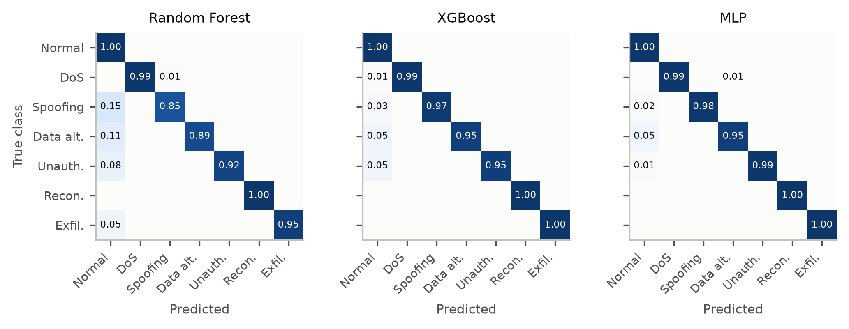
- Row-normalised confusion matrices of the three models on the independent test run.
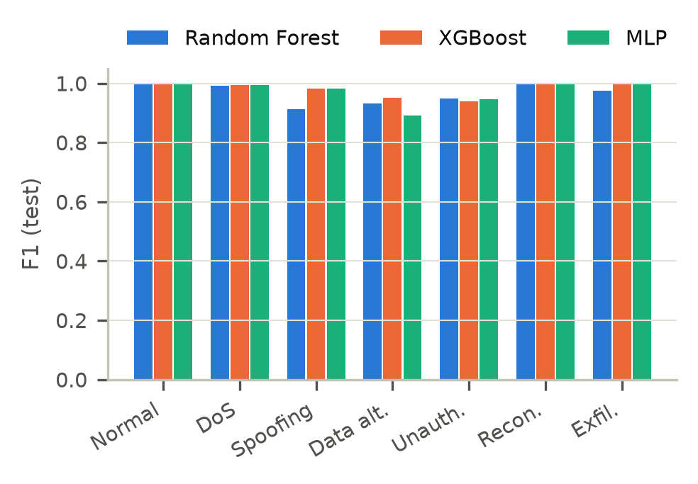
- Per-class F1-score of each model on the independent test run.
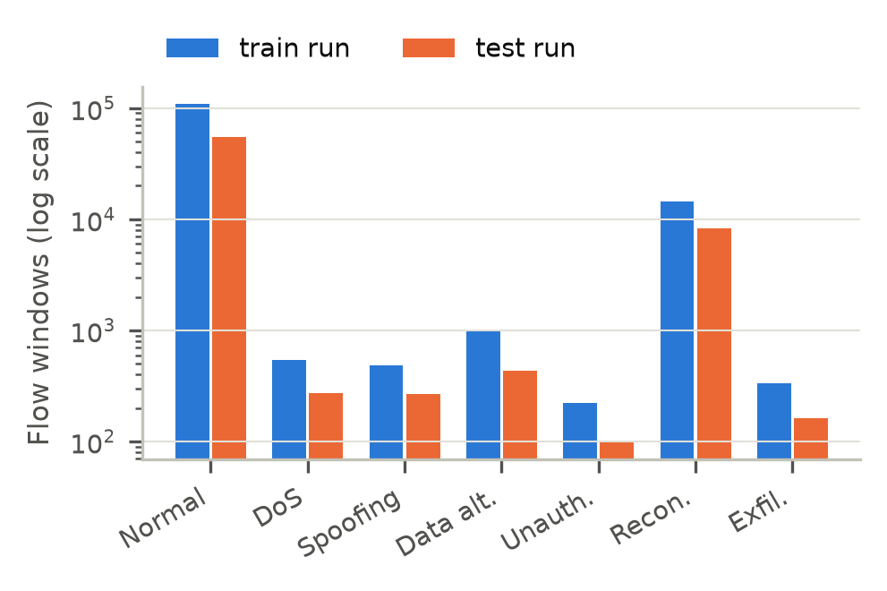
- Flow windows per class in the training and test runs (log scale).
- Cross-validation and Additional Test Metrics
Model | CV macro F1 | CV binary F1 | Test FPR | Test AUC | µs/flow | MB
Random Forest | 0.953 ± 0.006 | 0.9869 ± 0.0080 | 0.0002 | 0.99990 | 12.8 | 6.42
XGBoost | 0.974 ± 0.009 | 0.9931 ± 0.0058 | 0.0005 | 0.99994 | 6.1 | 1.21
MLP | 0.947 ± 0.011 | 0.9890 ± 0.0071 | 0.0018 | 0.99989 | 2.3 | 0.61

- Selected Hyperparameters (Temporal Hold-out Search)
Model | Setting
Random Forest | n_estimators=400, max_depth=24, min_samples_leaf=1
XGBoost | max_depth=10, learning_rate=0.05, n_estimators=500
MLP | hidden_layer_sizes=[256, 128, 64], alpha=0.001

- Saved Models on Three Extra Unseen Wards (1 h Each)
Seed | Start | Flows | RF macro F1 | XGB macro F1 | MLP macro F1 | RF F1 | XGB F1 | MLP F1
3001 | 02:00 | 21,536 | 0.974 | 0.992 | 0.980 | 0.9941 | 0.9984 | 0.9946
3002 | 11:00 | 18,821 | 0.978 | 0.995 | 0.983 | 0.9635 | 0.9900 | 0.9666
3003 | 17:00 | 19,413 | 0.985 | 0.991 | 0.982 | 0.9918 | 0.9936 | 0.9840

- Recall by Attack Family and Intensity on the Test Run
Attack | Intensity | RF | XGBoost | MLP
DoS flood | low | 1.000 | 0.983 | 0.994
DoS flood | medium | 0.952 | 1.000 | 1.000
DoS flood | high | 1.000 | 1.000 | 1.000
Spoofing | low | 0.965 | 0.979 | 0.993
Spoofing | medium | 0.714 | 0.968 | 0.968
Spoofing | high | no campaign
Data alteration | low | 0.858 | 0.898 | 0.951
Data alteration | medium | 0.667 | 1.000 | 0.804
Data alteration | high | 1.000 | 1.000 | 1.000
Unauth. access | low | 0.917 | 0.933 | 0.983
Unauth. access | medium | 0.923 | 0.974 | 1.000
Unauth. access | high | no campaign
Reconnaissance | low | 1.000 | 1.000 | 1.000
Reconnaissance | medium | 1.000 | 1.000 | 1.000
Reconnaissance | high | 1.000 | 1.000 | 1.000
Exfiltration | low | 0.889 | 1.000 | 1.000
Exfiltration | medium | 1.000 | 1.000 | 1.000
Exfiltration | high | 1.000 | 1.000 | 1.000

- Twin Consistency Rules and Thresholds (99.9th Percentile of Normal Training Traffic)
Rule | Flags a flow when | Threshold
R1 | Sender is not in the asset registry | none (any)
R2 | MAC address or TTL differs from the registry | none (any)
R3 | Duplicated or missing sequence numbers in a window | duplicates > 1, gaps > 0
R4 | Monitor and wearable on one patient disagree | heart rate > 13.5 bpm, SpO2 > 2.9 points
R5 | Relative pump-rate change | > 0 (any change)

- Twin Rules: Recall on Each Unseen Family and False Positive Rate by Threshold Percentile
Percentile | FPR | DoS flood | Spoofing | Data alteration | Unauth. access | Reconnaissance | Exfiltration
99.90th | 0.39% | 0.08 | 0.99 | 0.89 | 0.65 | 0.43 | 0.00
99.95th | 0.22% | 0.08 | 0.98 | 0.84 | 0.65 | 0.43 | 0.00
99.99th | 0.12% | 0.08 | 0.84 | 0.84 | 0.58 | 0.43 | 0.00

Appendix D: Dashboard
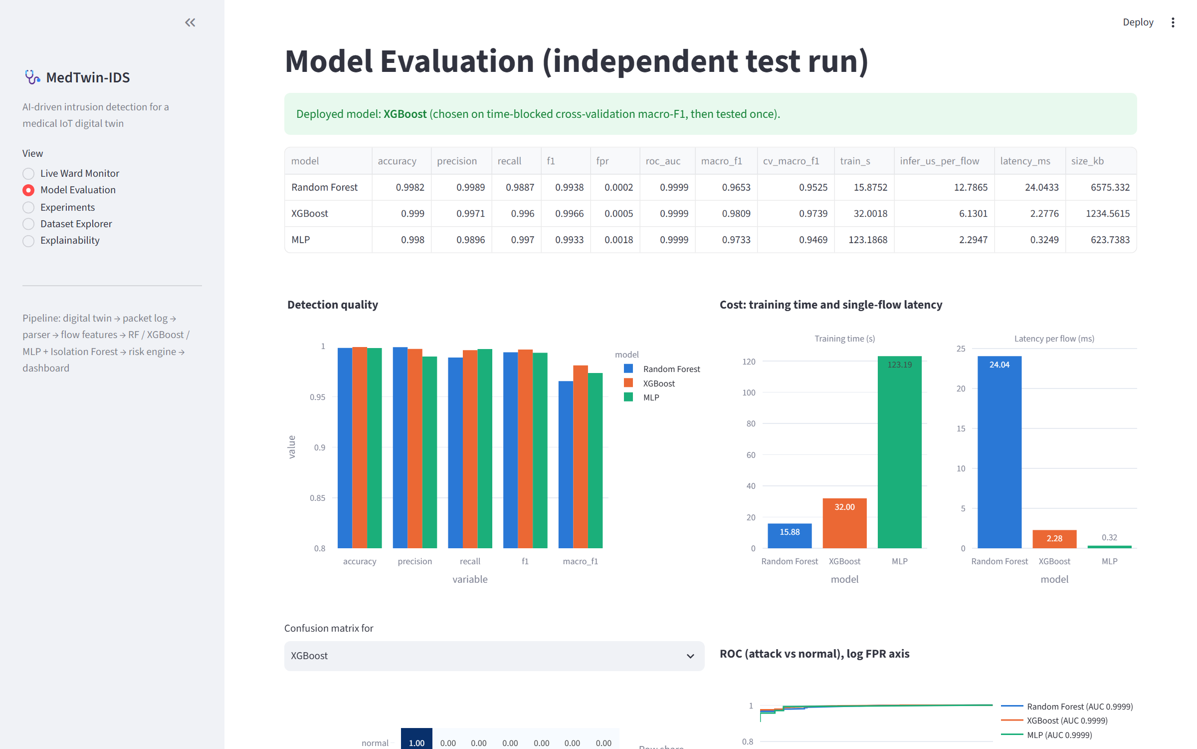
- Dashboard: model evaluation page.
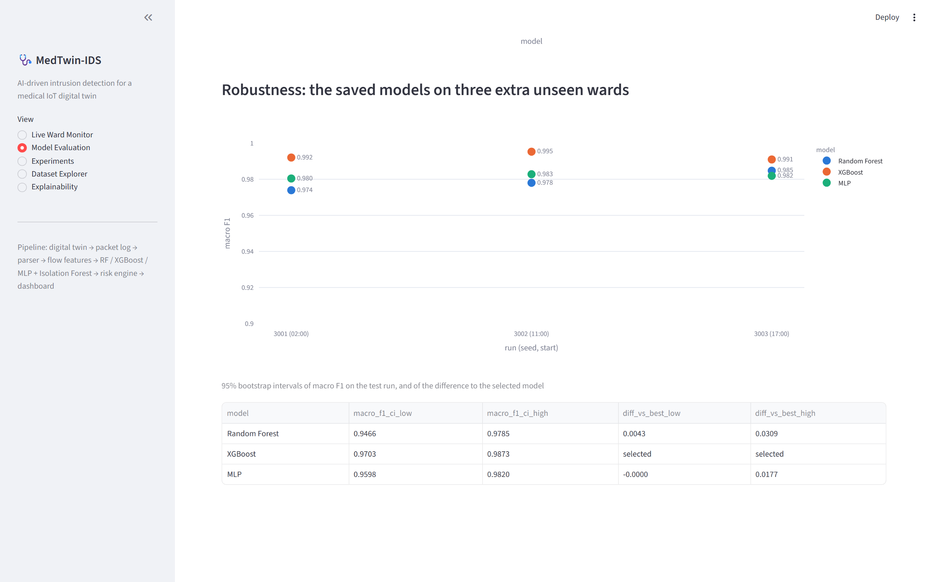
- Dashboard: robustness of the saved models on three extra wards and bootstrap intervals.
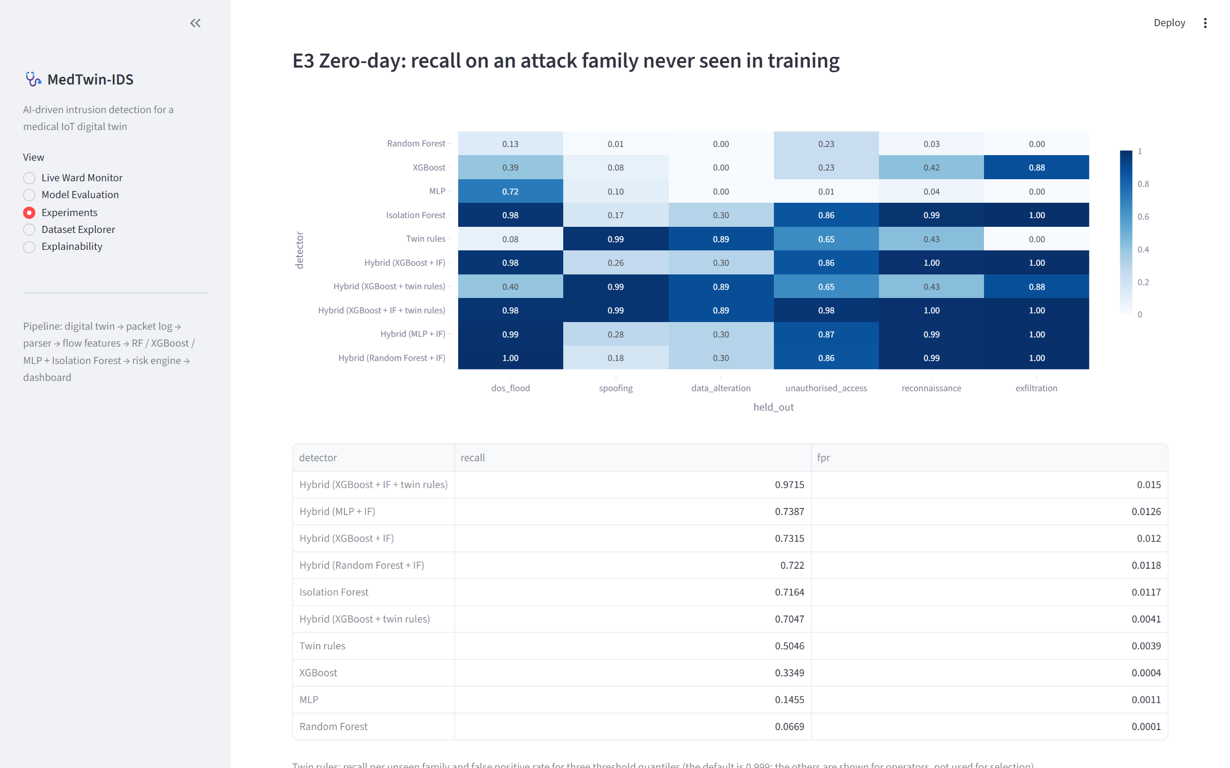
- Dashboard: zero-day results with the Isolation Forest, twin rules and hybrids.
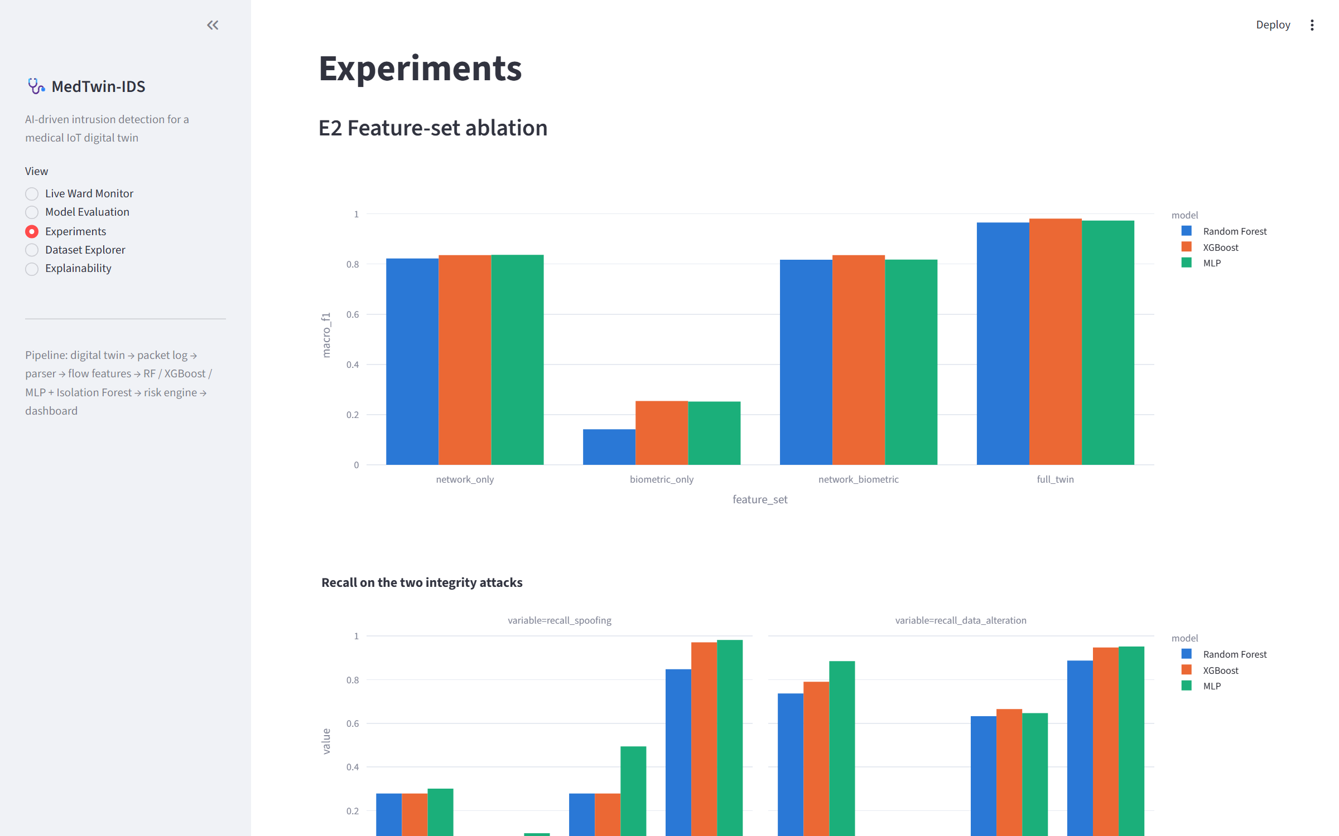
- Dashboard: experiments page (ablation).

Appendix E: Screenshots of Programming Results
Console output of the main programs, captured by running the command in each title bar. Long logs are shortened where marked; nothing else is edited.
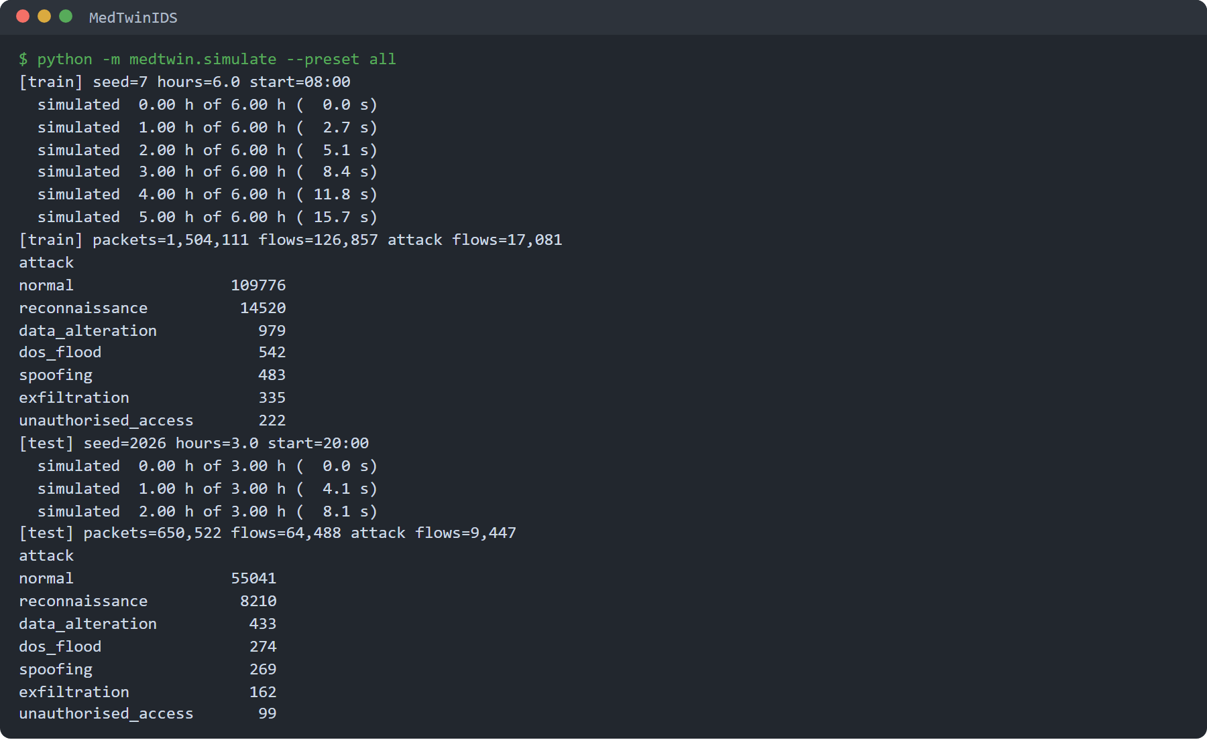
- Dataset generation: for the training and test runs the twin reports its seed, length and start time, the packets and flow windows produced, and the flow windows per class.
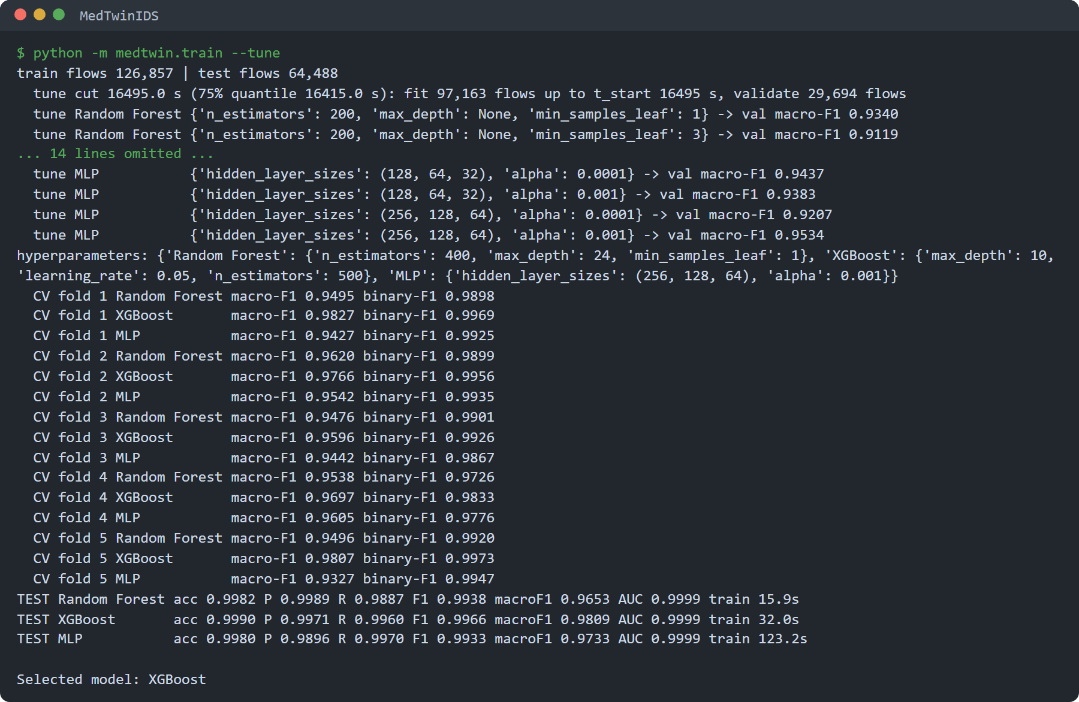
- Model training: temporal hold-out tuning, time-blocked cross-validation, the single test on the independent run and the selection of XGBoost.
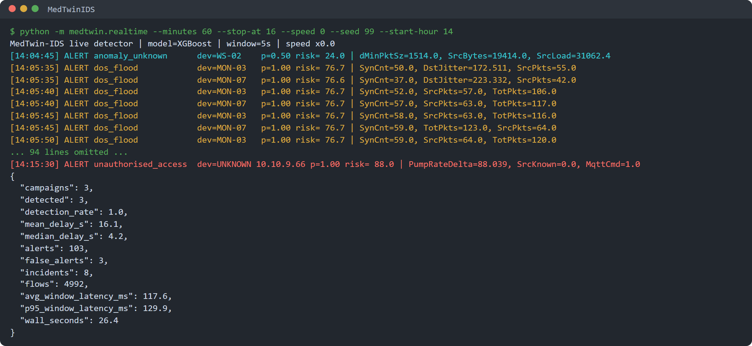
- Real-time detection on a new live twin: colour-coded alerts with ward time, attack class, device, confidence, risk score and the three most abnormal features, then the run summary.
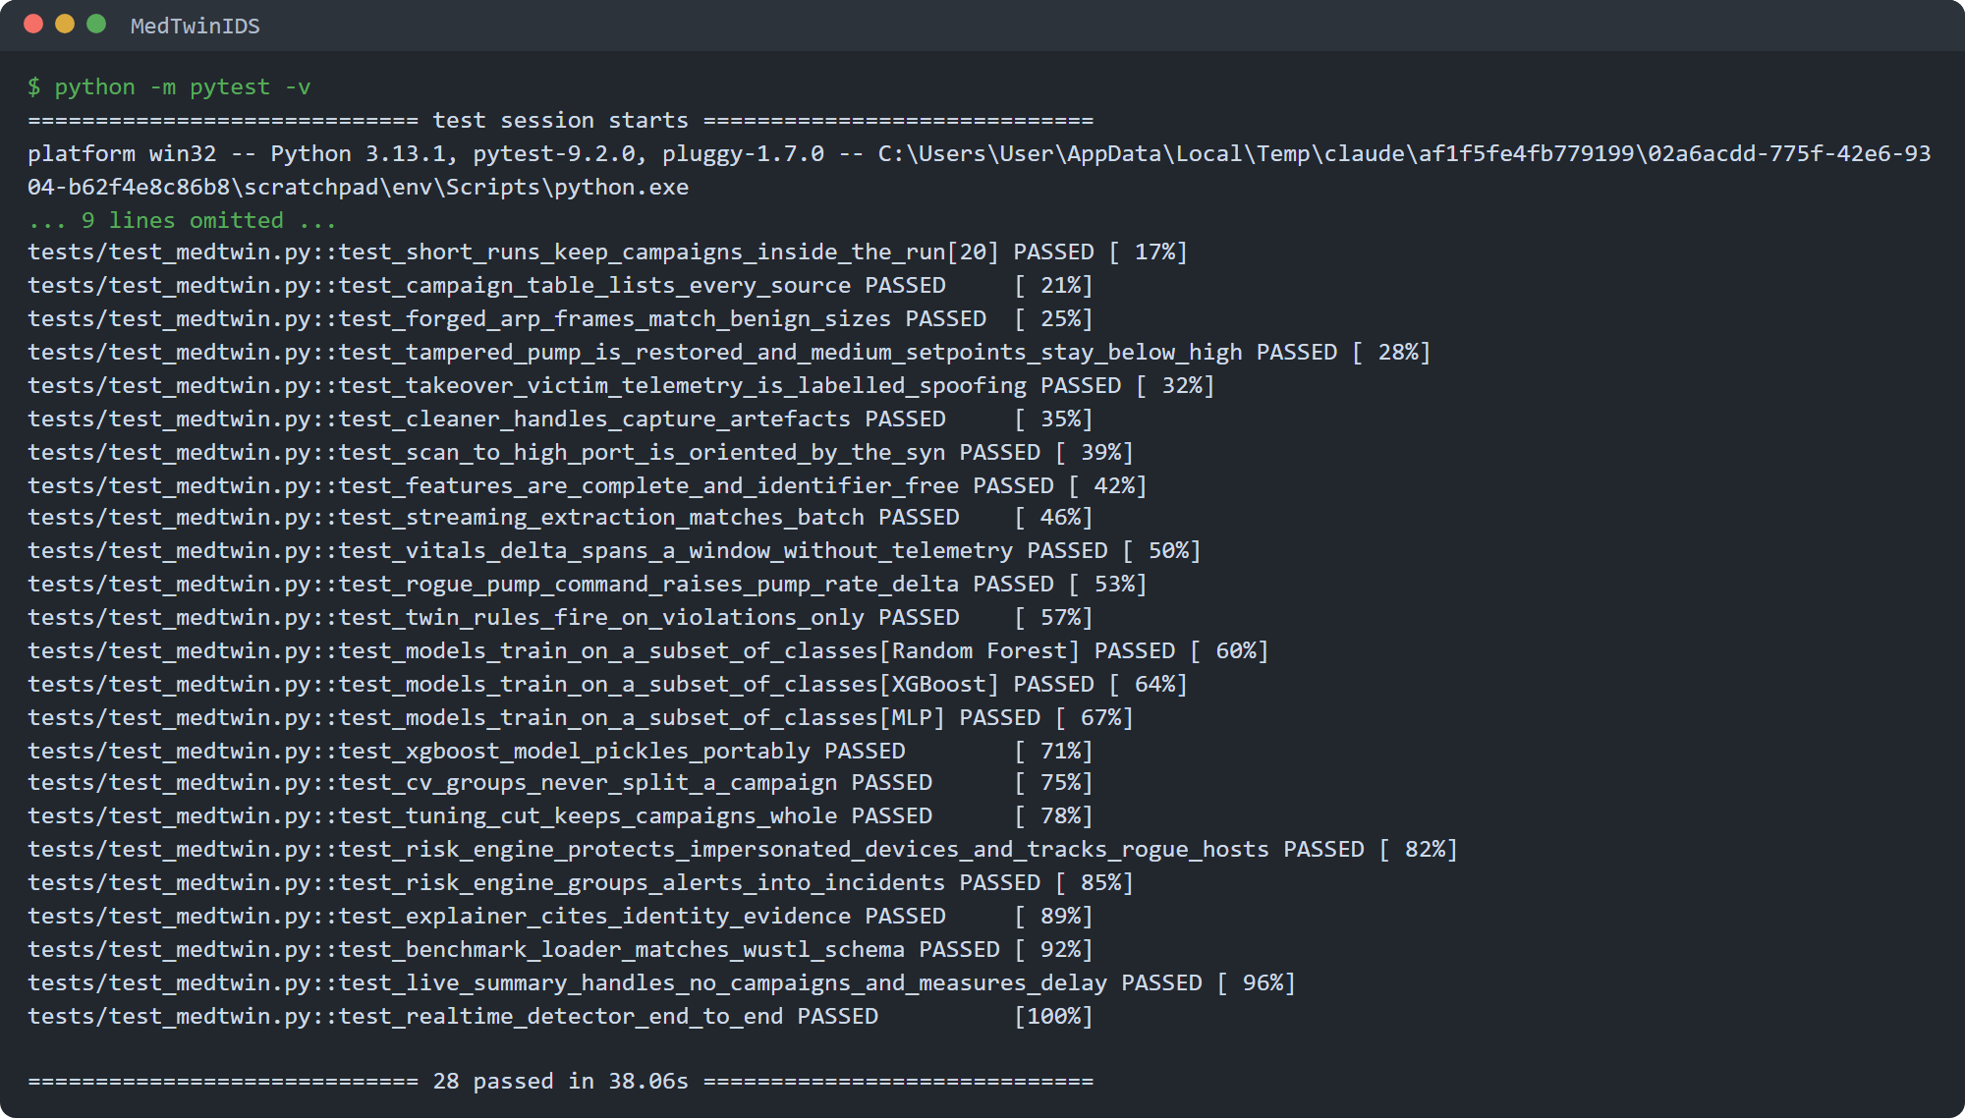
- Automated tests: all 28 tests pass.

Appendix F: Source Code and Reproduction
The submission contains the MedTwinIDS source code, generated datasets, trained models, result files and a user manual. The full pipeline is reproduced with: python -m medtwin.simulate --preset all, python -m medtwin.train --tune, python -m medtwin.experiments, python -m medtwin.realtime --replay test --minutes 180 --speed 0 --quiet --save-as replay, python -m medtwin.realtime --minutes 60 --speed 0 --seed 99 --start-hour 14 --quiet --save-as live (and the same command with --twin-rules --save-as live_rules), python -m medtwin.figures and streamlit run dashboard/app.py; python -m pytest -v runs the tests. The optional python -m medtwin.benchmark_wustl script evaluates the same models on WUSTL-EHMS-2020.

