AI绘画-角色、服装与cosplay
位置：
角色、服装的prompt一般位于元数据标签之后。
首先描述人物数量：如1girl,2girls,1girl and 1 boy, 2girls and 1boy
其次描述人物间的互动：如 2girls,holding hands;1girl and 1boy, walking together;......

角色特征：
anima需要使用标准的角色特征词来绘制某个作品的特定角色，以及可能的多种服装。具体特征词可在以下网站中查询：https://animadex.net/?mode=characters
其中，绘制其他服装时，推荐使用https://prompt.newzone.top/zh 等tag集合网站寻找服饰tag。
如：
nice nature \(umamusume\), umamusume
原始角色tag

nice nature \(casual\) \(umamusume\), umamusume, 1girl, horse_ears, animal_ears, horse_girl, twintails, shirt, brown_eyes, ear_covers, solo, brown_hair, horse_tail, multicolored_hair, tail, breasts, streaked_hair, skirt, red_hair, white_shirt
默认决胜服tag
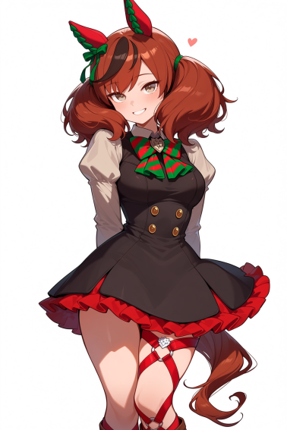

nice nature \(run&win\) \(umamusume\), umamusume, 1girl, horse girl, horse ears, horse tail, brown eyes, brown hair, streaked hair, medium hair, ponytail, navel, white skirt, blue jacket, white shirt, open jacket, cheerleader, midriff, cheerleader, crop top, pom pom \(cheerleading\)
啦啦队决胜服tag
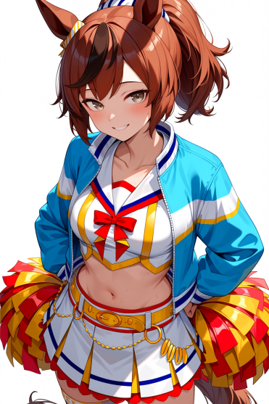

nice nature \(converging wishes\) \(umamusume\), umamusume, 1girl, horse girl, horse ears, horse tail, ear covers, brown eyes, hair between eyes, official alternate hairstyle, long hair, red hair, brown hair, streaked hair, medium hair, hair ornament, medium breasts, green kimono, striped kimono, kimono, striped clothes, green kimono, long sleeves, wide sleeves
新年决胜服tag
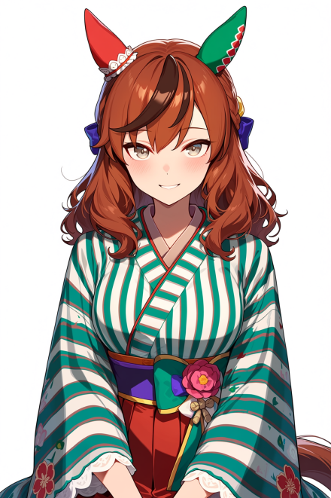

anima同样支持方便地绘制特定角色的cosplay(让一个角色穿另一个角色的衣服)。
具体操作方式如下：
首先绘制主角色名，只保留角色姓名的tag；然后绘制你要cosplay的角色名，在此名称后加入(cosplay)，随后详细描写cosplay的服装tag。
例：绘制一副 king halo 穿着 silence suzuka 泳装的cosplay：
1girl, king halo \(umamusume\), umamusume, silence suzuka \(emerald on the waves\) \(cosplay\), hair flower, navel, bare shoulders, necklace, bracelet, navel, bracelet, necklace, hair ornament, bare shoulders, blue sarong, aqua bikini, collarbone, braided bun, garter jewelry, armlet,
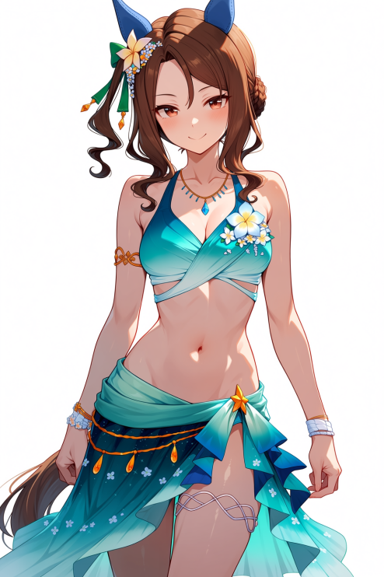

绘制一副 silence suzuka 穿着 king halo 婚纱服装的cosplay：
1girl, silence suzuka \(umamusume\), umamusume, king halo \(evergreen identity\) \(umamusume\)(cosplay), single ear cover, white dress, elbow gloves, white gloves, wedding dress, bare shoulders, necklace, bride
