AI Drawing - Characters, Outfits & Cosplay
Placement:
Character and outfit prompts are generally placed after metadata tags.
First, describe the number of characters: e.g., 1girl, 2girls, 1girl and 1 boy, 2girls and 1boy
Then describe interactions between characters: e.g., 2girls, holding hands; 1girl and 1boy, walking together; ...

Character Features:
Anima requires standard character feature tags to draw a specific character from a given franchise, along with possible alternate outfits. Specific feature tags can be looked up at: https://animadex.net/?mode=characters
When drawing alternate outfits, it is recommended to use tag collection sites such as https://prompt.newzone.top/zh to find clothing tags.
Examples:
nice nature \(umamusume\), umamusume
Base character tag

nice nature \(casual\) \(umamusume\), umamusume, 1girl, horse_ears, animal_ears, horse_girl, twintails, shirt, brown_eyes, ear_covers, solo, brown_hair, horse_tail, multicolored_hair, tail, breasts, streaked_hair, skirt, red_hair, white_shirt
Default racing uniform tag
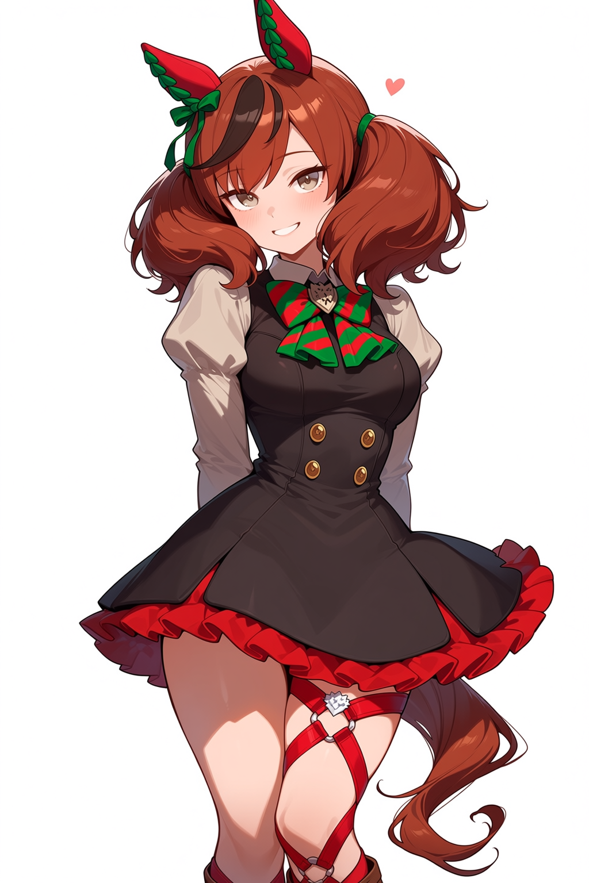

nice nature \(run&win\) \(umamusume\), umamusume, 1girl, horse girl, horse ears, horse tail, brown eyes, brown hair, streaked hair, medium hair, ponytail, navel, white skirt, blue jacket, white shirt, open jacket, cheerleader, midriff, cheerleader, crop top, pom pom \(cheerleading\)
Cheerleader racing uniform tag
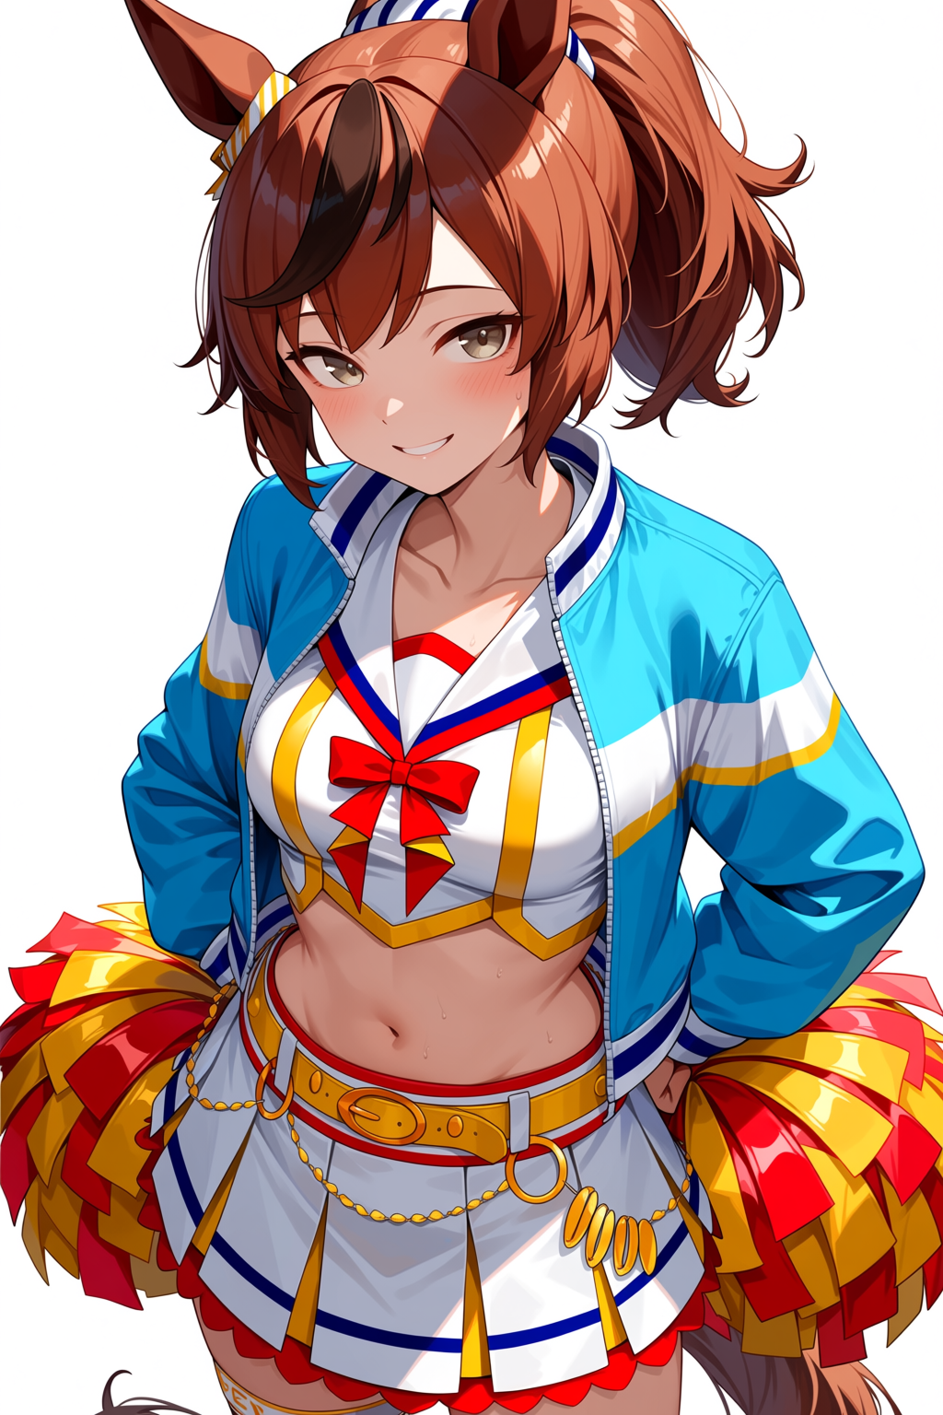

nice nature \(converging wishes\) \(umamusume\), umamusume, 1girl, horse girl, horse ears, horse tail, ear covers, brown eyes, hair between eyes, official alternate hairstyle, long hair, red hair, brown hair, streaked hair, medium hair, hair ornament, medium breasts, green kimono, striped kimono, kimono, striped clothes, green kimono, long sleeves, wide sleeves
New Year racing uniform tag
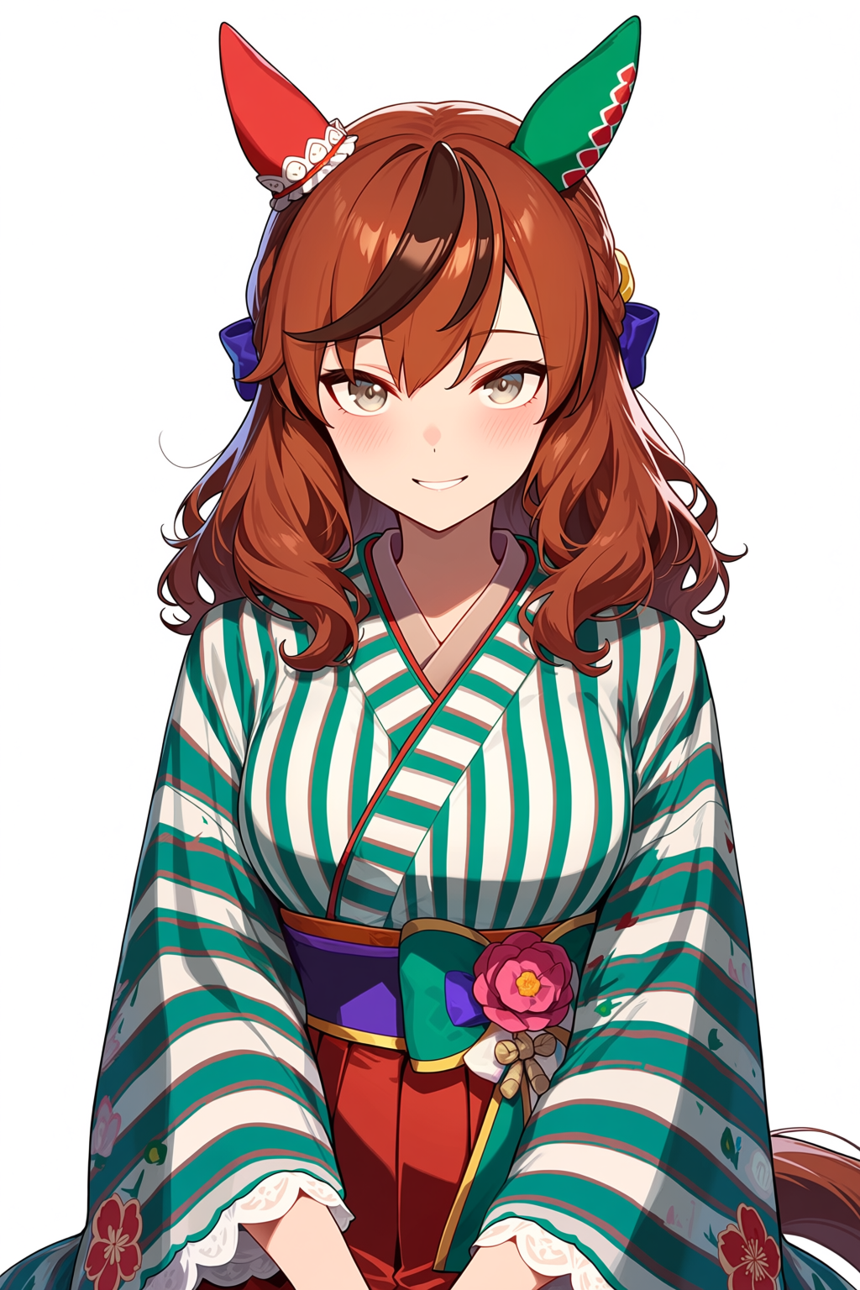

Anima also conveniently supports drawing cosplay of specific characters (having one character wear another character's outfit).
The specific procedure is as follows:
First, write the name of the main character, keeping only the character's name tags; then write the name of the character you want to cosplay, adding (cosplay) after the name, followed by a detailed description of the cosplay outfit tags.
Example: Drawing a cosplay of king halo wearing silence suzuka's swimsuit:
1girl, king halo \(umamusume\), umamusume, silence suzuka \(emerald on the waves\) \(cosplay\), hair flower, navel, bare shoulders, necklace, bracelet, navel, bracelet, necklace, hair ornament, bare shoulders, blue sarong, aqua bikini, collarbone, braided bun, garter jewelry, armlet,
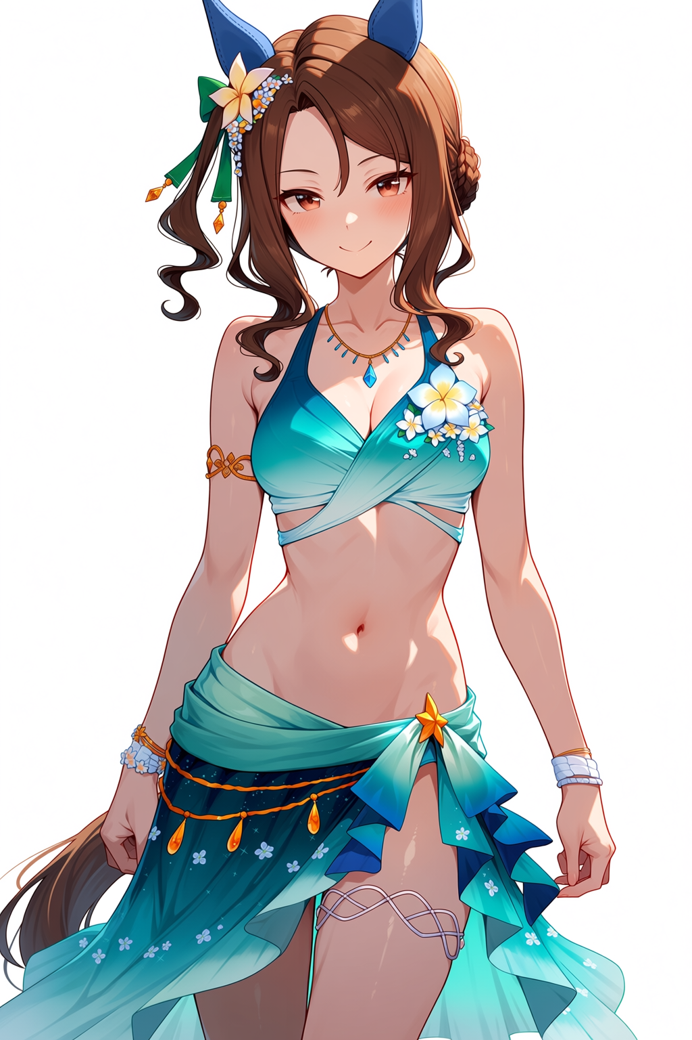

Drawing a cosplay of silence suzuka wearing king halo's wedding dress:
1girl, silence suzuka \(umamusume\), umamusume, king halo \(evergreen identity\) \(umamusume\)(cosplay), single ear cover, white dress, elbow gloves, white gloves, wedding dress, bare shoulders, necklace, bride
