Dictionary

Tiwaloluwa Ojo (100700622) **|** Aaditya Rajput (100622434) **|** Group 7

# Objective

Dictionaries are widely used and we often take spellchecking for granted. You will be required to create a dictionary that not only provides the ability to search a word, but also to add new words, delete existing words, and edit the definition of a word in the dictionary. For this project you must ensure that you meet all of the following criteria.

# Criteria

## Original criteria

* You must implement a dictionary that contains not only words but also their definition.
* You will be provided with a list of six different Comma-Separated Values (CSV) files containing words and their definitions, as well as for each a list of operations to perform.
* Your solution must be able to read in the data provided and create the dictionary as well as process the accompanying file with the list of operations to perform.
* Your program should also have a CLI so that a user can perform each of the operations from the terminal such as searching for a word to retrieve the definition.

## Revised criteria

* Implement a dictionary to search, delete, and insert words from a text file.
* The text file is composed of words.
* Definitions requirements have been truncated from the requirements.

# Tools

## Ide: Android studio

* The Dictionary project utilized the programming environment of Android Studio. This IDE allowed us to design the project as a mobile application while still adhering to appropriate Java and object-oriented principles. This should provide an interactable and visually appealing aesthetic to the user.

## Programming Language: JAva

* We used the Java programming language along with Android Studios to program and implement our algorithms as well as manipulate the app UI to change and listen to event.

# The UI: Main Activity Page

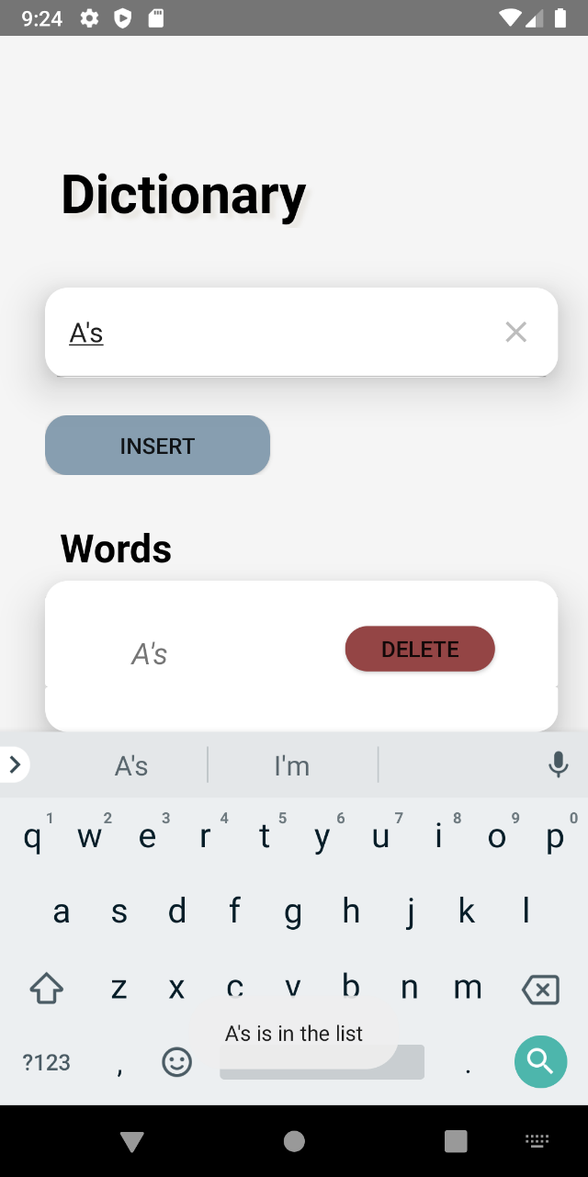

**1**

**2**

**3**

**4**

**5**

**6**

## Dictionary

* Displays the title of the document.

## SearchView

* The user can search for their desired word in this search bar. It will display a confirmation of whether the searched word exists or not.

## Insert Button

* Sends the user to another activity page so as they might insert their new word.

## Words recycleview

* This Recycleview is where the user can view the words that exist on file as well as the ones they insert.

## RecycleView Cards

* The words exist horizontally stacked upon each other. Each card has both a word and a delete button.

## Leadership

* Are you president of your fraternity, head of the condo board, or a team lead for your favorite charity? You’re a natural leader—tell it like it is!

# Experience

## Job Title 1 | Company | Dates From - To

* This is the place for a brief summary of your key responsibilities and most stellar accomplishments.

## job title 2 | Company | Dates From - To