**SSN College of Engineering, Kalavakkam**

**Department of Computer Science and Engineering**

**UCS1711-Mobile Application Development Lab**

**Exercise 3**: **Graphical primitives**

**Name : S.NACHAMMAI DEVI POOJA**

**Class :CSE Sec: B**

**Reg no: 185001096**

**AIM:**

To develop an application using graphic primitives.

**CODE:**

activity_main.xml :

<?xml version="1.0" encoding="utf-8"?>  
<androidx.constraintlayout.widget.ConstraintLayout xmlns:android="http://schemas.android.com/apk/res/android"  
xmlns:app="http://schemas.android.com/apk/res-auto"  
xmlns:tools="http://schemas.android.com/tools"  
android:layout_width="match_parent"  
android:layout_height="match_parent"  
tools:context=".MainActivity">  
  
<TextView  
 android:id="@+id/textView"  
 android:layout_width="wrap_content"  
 android:layout_height="wrap_content"  
 android:layout_marginLeft="114dp"  
 android:layout_marginRight="115dp"  
 android:layout_marginStart="114dp"  
 android:layout_marginTop="25dp"  
 android:layout_marginEnd="115dp"  
 android:layout_marginBottom="44dp"  
 android:text="Ex 3 - Graphical Premitives"  
 android:textColor="@color/design_default_color_error"  
 android:textSize="20dp"  
 android:textStyle="bold"  
 app:layout_constraintBottom_toTopOf="@+id/imageView"  
 app:layout_constraintEnd_toEndOf="parent"  
 app:layout_constraintStart_toStartOf="parent"  
 app:layout_constraintTop_toTopOf="parent" />  
  
<ImageView  
 android:id="@+id/imageView"  
 android:layout_width="288dp"  
 android:layout_height="390dp"  
 android:layout_marginStart="61dp"  
 android:layout_marginTop="100dp"  
 android:layout_marginEnd="61dp"  
 app:layout_constraintEnd_toEndOf="parent"  
 app:layout_constraintHorizontal_bias="0.642"  
 app:layout_constraintStart_toStartOf="parent"  
 app:layout_constraintTop_toTopOf="parent"  
 app:srcCompat="@android:color/transparent" />  
  
<Button  
 android:id="@+id/button1"  
 android:layout_width="wrap_content"  
 android:layout_height="wrap_content"  
 android:layout_marginStart="61dp"  
 android:layout_marginLeft="61dp"  
 android:layout_marginTop="20dp"  
 android:layout_marginEnd="262dp"  
 android:layout_marginRight="262dp"  
 android:layout_marginBottom="140dp"  
 android:text="Rectangle"  
 android:textAppearance="@style/TextAppearance.AppCompat.Large"  
 app:layout_constraintBottom_toBottomOf="parent"  
 app:layout_constraintEnd_toEndOf="parent"  
 app:layout_constraintStart_toStartOf="parent"  
 app:layout_constraintTop_toBottomOf="@+id/imageView" />  
  
<Button  
 android:id="@+id/button2"  
 android:layout_width="wrap_content"  
 android:layout_height="wrap_content"  
 android:layout_marginStart="12dp"  
 android:layout_marginLeft="12dp"  
 android:layout_marginTop="20dp"  
 android:layout_marginEnd="161dp"  
 android:layout_marginRight="161dp"  
 android:layout_marginBottom="140dp"  
 android:text="Circle"  
 android:textAppearance="@style/TextAppearance.AppCompat.Large"  
 app:layout_constraintBottom_toBottomOf="parent"  
 app:layout_constraintEnd_toEndOf="parent"  
 app:layout_constraintStart_toEndOf="@+id/button1"  
 app:layout_constraintTop_toBottomOf="@+id/imageView" />  
  
<Button  
 android:id="@+id/button3"  
 android:layout_width="wrap_content"  
 android:layout_height="wrap_content"  
 android:layout_marginStart="12dp"  
 android:layout_marginLeft="12dp"  
 android:layout_marginTop="20dp"  
 android:layout_marginEnd="61dp"  
 android:layout_marginRight="61dp"  
 android:layout_marginBottom="140dp"  
 android:text="Line"  
 android:textAppearance="@style/TextAppearance.AppCompat.Large"  
 app:layout_constraintBottom_toBottomOf="parent"  
 app:layout_constraintEnd_toEndOf="parent"  
 app:layout_constraintStart_toEndOf="@+id/button2"  
 app:layout_constraintTop_toBottomOf="@+id/imageView" />  
  
<Button  
 android:id="@+id/button4"  
 android:layout_width="wrap_content"  
 android:layout_height="wrap_content"  
 android:layout_marginStart="162dp"  
 android:layout_marginTop="4dp"  
 android:layout_marginLeft="161dp"  
 android:layout_marginRight="161dp"  
 android:layout_marginEnd="161dp"  
 android:layout_marginBottom="76dp"  
 android:text="Arc"  
 android:textAppearance="@style/TextAppearance.AppCompat.Large"  
 app:layout_constraintBottom_toBottomOf="parent"  
 app:layout_constraintEnd_toEndOf="parent"  
 app:layout_constraintHorizontal_bias="0.742"  
 app:layout_constraintStart_toStartOf="parent"  
 app:layout_constraintTop_toBottomOf="@+id/button2"  
 app:layout_constraintVertical_bias="0.0" />  
  
<Button  
 android:id="@+id/button5"  
 android:layout_width="wrap_content"  
 android:layout_height="wrap_content"  
 android:layout_marginStart="96dp"  
 android:layout_marginLeft="96dp"  
 android:layout_marginTop="4dp"  
 android:layout_marginEnd="30dp"  
 android:layout_marginRight="30dp"  
 android:text="Image"  
 android:textAppearance="@style/TextAppearance.AppCompat.Large"  
 app:layout_constraintEnd_toStartOf="@+id/button4"  
 app:layout_constraintHorizontal_bias="0.673"  
 app:layout_constraintStart_toStartOf="parent"  
 app:layout_constraintTop_toBottomOf="@+id/button1" />  
  
<Button  
 android:id="@+id/button6"  
 android:layout_width="wrap_content"  
 android:layout_height="wrap_content"  
 android:layout_marginEnd="56dp"  
 android:textAppearance="@style/TextAppearance.AppCompat.Large"  
 android:layout_marginStart="99dp"  
 android:layout_marginLeft="96dp"  
 android:layout_marginRight="30dp"  
 android:text="Car"  
 app:layout_constraintStart_toStartOf="parent"  
 app:layout_constraintTop_toBottomOf="@+id/button4" />  
  
<Button  
 android:id="@+id/button7"  
 android:layout_width="wrap_content"  
 android:layout_height="wrap_content"  
 android:layout_marginTop="4dp"  
 android:layout_marginEnd="40dp"  
 android:layout_marginRight="60dp"  
 android:text="Rotation"  
 android:textAppearance="@style/TextAppearance.AppCompat.Large"  
 app:layout_constraintEnd_toEndOf="parent"  
 app:layout_constraintTop_toBottomOf="@+id/button3" />  
  
<Button  
 android:id="@+id/button8"  
 android:layout_width="wrap_content"  
 android:layout_height="wrap_content"  
 android:layout_marginTop="52dp"  
 android:layout_marginEnd="75dp"  
 android:layout_marginRight="70dp"  
 android:text="Zoom"  
 android:textAppearance="@style/TextAppearance.AppCompat.Large"  
 app:layout_constraintEnd_toEndOf="parent"  
 app:layout_constraintTop_toBottomOf="@+id/button3" />  
  
</androidx.constraintlayout.widget.ConstraintLayout>

MainActivity.java

package com.example.graphicalprimitives;  
  
 import androidx.appcompat.app.AppCompatActivity;  
 import android.os.Bundle;  
 import android.animation.AnimatorSet;  
 import android.animation.ObjectAnimator;  
 import android.annotation.SuppressLint;  
 import android.graphics.Bitmap;  
 import android.graphics.BitmapFactory;  
 import android.graphics.Canvas;  
 import android.graphics.Color;  
 import android.graphics.Matrix;  
 import android.graphics.Paint;  
 import android.graphics.RectF;  
 import android.graphics.drawable.AnimationDrawable;  
 import android.view.animation.Animation;  
 import android.view.animation.AnimationUtils;  
 import android.graphics.drawable.BitmapDrawable;  
 import android.graphics.drawable.Drawable;  
 import android.os.Handler;  
 import android.view.View;  
 import android.widget.Button;  
 import android.widget.ImageView;  
  
 import java.util.EventListener;  
  
 import static android.os.SystemClock.*sleep*;  
  
public class MainActivity extends AppCompatActivity {  
 ImageView im;  
 Button b1, b2, b3, b4, b5, b6, b7, b8, b9;  
 int clicks;  
  
 public void reset_im() {  
 im.setScaleX(1);  
 im.setScaleY(1);  
 im.setRotation(0);  
 im.setBackgroundResource(0);  
 im.setImageResource(0);  
 }  
 @Override  
 protected void onCreate(Bundle savedInstanceState) {  
 super.onCreate(savedInstanceState);  
 setContentView(R.layout.*activity_main*);  
 im = (ImageView)findViewById(R.id.*imageView*);  
 b1 = (Button)findViewById(R.id.*button1*);  
 b2 = (Button)findViewById(R.id.*button2*);  
 b3 = (Button)findViewById(R.id.*button3*);  
 b4 = (Button)findViewById(R.id.*button4*);  
 b5 = (Button)findViewById(R.id.*button5*);  
 b6 = (Button)findViewById(R.id.*button6*);  
 b7 = (Button)findViewById(R.id.*button7*);  
 b8 = (Button)findViewById(R.id.*button8*);  
 clicks = 0;  
 final Paint paint = new Paint();  
 paint.setColor(Color.*RED*);  
 paint.setAntiAlias(true);  
 b1.setOnClickListener(new View.OnClickListener() {  
 @Override  
 public void onClick(View v) {  
 reset_im();  
 Bitmap tempBitmap = Bitmap.*createBitmap*(100, 100, Bitmap.Config.*ARGB_8888*);  
 Canvas tempCanvas = new Canvas(tempBitmap);  
 tempCanvas.drawRect(25, 50, 75, 75, paint);  
 im.setImageBitmap(tempBitmap);  
 }  
 });  
 b2.setOnClickListener(new View.OnClickListener() {  
 @Override  
 public void onClick(View v) {  
 reset_im();  
 Bitmap tempBitmap = Bitmap.*createBitmap*(100, 100, Bitmap.Config.*ARGB_8888*);  
 Canvas tempCanvas = new Canvas(tempBitmap);  
 tempCanvas.drawCircle(50, 50, 20, paint);  
 im.setImageBitmap(tempBitmap);  
 }  
 });  
 b3.setOnClickListener(new View.OnClickListener() {  
 @Override  
 public void onClick(View v) {  
 reset_im();  
 Bitmap tempBitmap = Bitmap.*createBitmap*(100, 100, Bitmap.Config.*ARGB_8888*);  
 Canvas tempCanvas = new Canvas(tempBitmap);  
 tempCanvas.drawLine(0, 0, 100, 100, paint);  
 im.setImageBitmap(tempBitmap);  
 }  
 });  
 b4.setOnClickListener(new View.OnClickListener() {  
 @Override  
 public void onClick(View v) {  
 reset_im();  
 Bitmap tempBitmap = Bitmap.*createBitmap*(100, 100, Bitmap.Config.*ARGB_8888*);  
 Canvas tempCanvas = new Canvas(tempBitmap);  
 RectF a = new RectF(10, 10, 90, 90);  
 tempCanvas.drawArc(a, 225, 90, true, paint);  
 im.setImageBitmap(tempBitmap);  
 }  
 });  
 b5.setOnClickListener(new View.OnClickListener() {  
 @Override  
 public void onClick(View v) {  
 reset_im();  
 im.setBackgroundResource(R.drawable.*movie*);  
 AnimationDrawable anim = (AnimationDrawable) im.getBackground();  
 anim.start();  
 }  
 });  
 b6.setOnClickListener(new View.OnClickListener() {  
 @Override  
 public void onClick(View v) {  
 Bitmap bitmap = Bitmap.*createBitmap*(300, 300,  
 Bitmap.Config.*ARGB_8888*);  
 Canvas canvas = new Canvas(bitmap);  
 Paint paint = new Paint(Paint.*ANTI_ALIAS_FLAG*);  
 paint.setColor(Color.*BLACK*);  
 canvas.drawLine(50, 150, 250, 150, paint);  
 paint.setColor(Color.*BLACK*);  
 canvas.drawLine(50, 150, 50, 200, paint);  
 paint.setColor(Color.*BLACK*);  
 canvas.drawLine(50, 200, 250, 200, paint);  
 paint.setColor(Color.*BLACK*);  
 canvas.drawLine(250, 150, 250, 200, paint);  
 paint.setColor(Color.*BLACK*);  
 canvas.drawLine(100, 150, 100, 100, paint);  
 paint.setColor(Color.*BLACK*);  
 canvas.drawLine(200, 150, 100, 150, paint);  
 paint.setColor(Color.*BLACK*);  
 canvas.drawLine(200, 100, 200, 150, paint);  
 paint.setColor(Color.*BLACK*);  
 canvas.drawLine(100, 100, 200, 100, paint);  
 paint.setColor(Color.*BLACK*);  
 canvas.drawCircle(100, 200, 20, paint);  
 paint.setColor(Color.*BLACK*);  
 canvas.drawCircle(200, 200, 20, paint);  
 paint.setColor(Color.*YELLOW*);  
 canvas.drawCircle(230, 175, 8, paint);  
 im.setImageBitmap(bitmap);  
 float x = im.getX();  
 ObjectAnimator animCar = ObjectAnimator.*ofFloat*(im, "x", x + 400);  
 animCar.setDuration(1000);  
 AnimatorSet a = new AnimatorSet();  
 a.play(animCar).before(ObjectAnimator.*ofFloat*(im, "x", x).setDuration(1000));  
 a.start();  
 }  
 });  
 b7.setOnClickListener(new View.OnClickListener() {  
 @Override  
 public void onClick(View v) {  
 reset_im();  
 im.setImageResource(R.drawable.*image*);  
 if(clicks == 0) {  
 im.setScaleX(1f);  
 im.setScaleY(1f);  
 }  
 else {  
 im.setRotation(180f);  
 }  
 clicks++;  
 clicks %= 2;  
 }  
 });  
 b8.setOnClickListener(new View.OnClickListener() {  
 @Override  
 public void onClick(View v) {  
 reset_im();  
 im.setImageResource(R.drawable.*image*);  
 if(clicks == 0) {  
 im.setScaleX(0.5f);  
 im.setScaleY(0.5f);  
 }  
 else {  
 im.setScaleX(1.05f);  
 im.setScaleY(1.05f);  
 }  
 clicks++;  
 clicks %= 2;  
 }  
 });  
 }  
}

**Output Screenshot:**

**Shapes:**

**i) Rectangle ii)Arc**

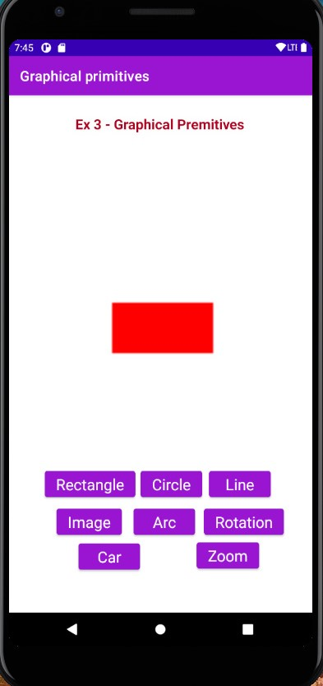 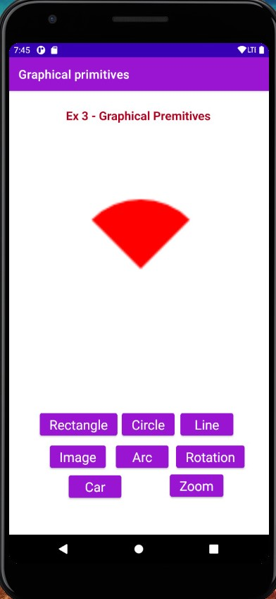

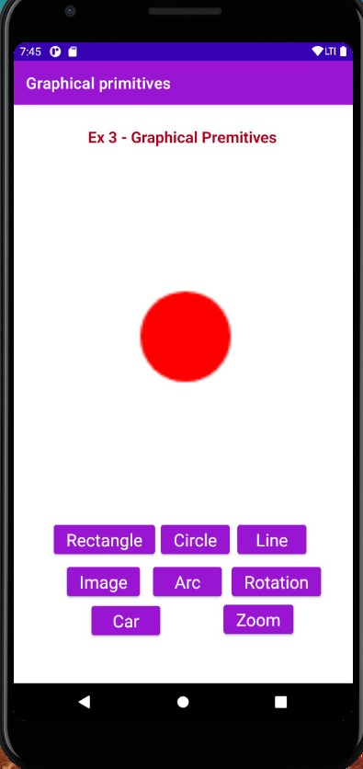**iiI) Circle iv) Line**

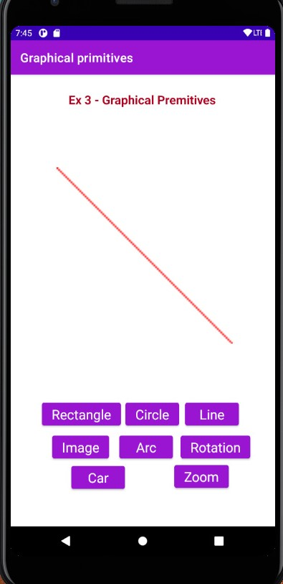

**Animation using Image:**

**Bulb On: Bulb Off:**

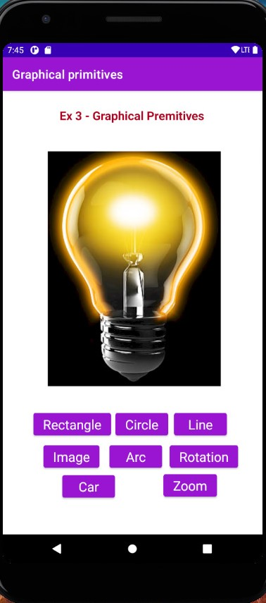 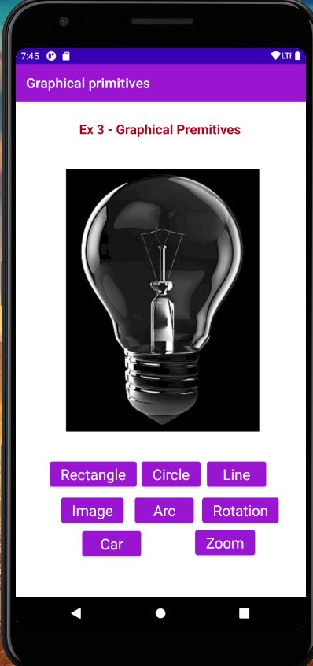

**Image –**

**Wheel :**

**Zooming:**

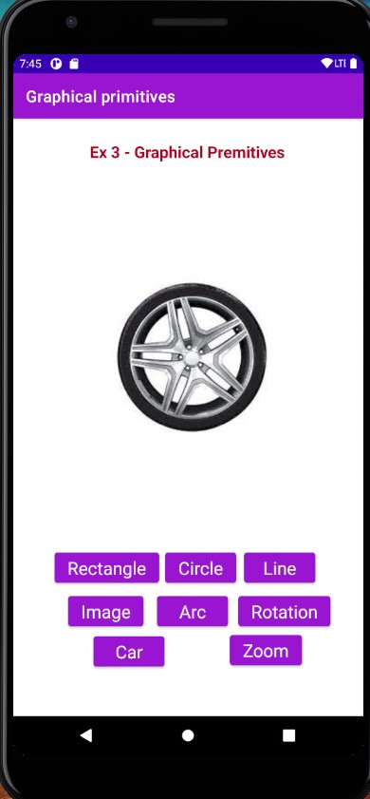 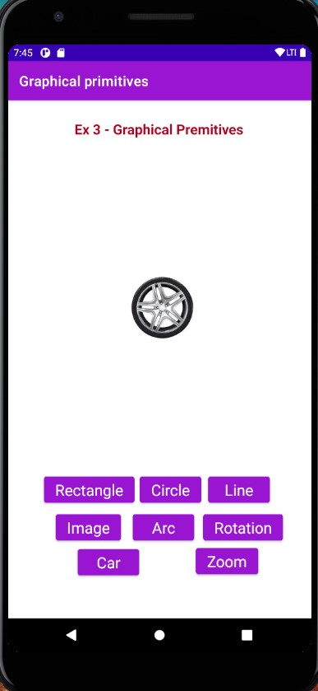

**Rotation:**

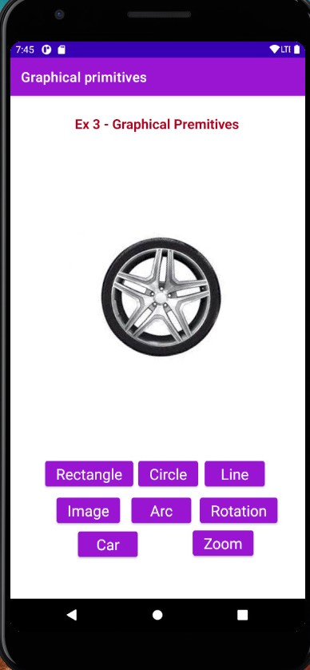

**Car :**

**Initial:**

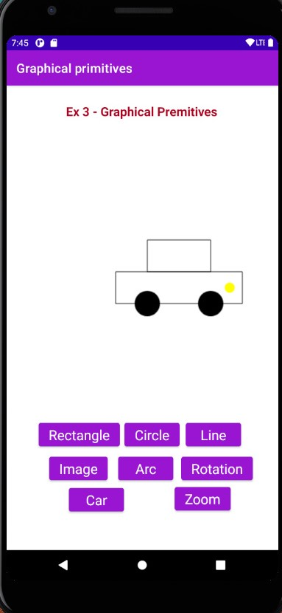

**Right : Left:**

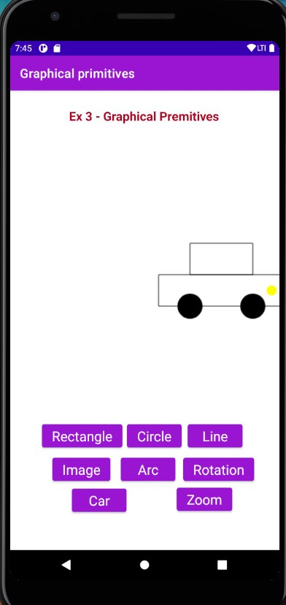 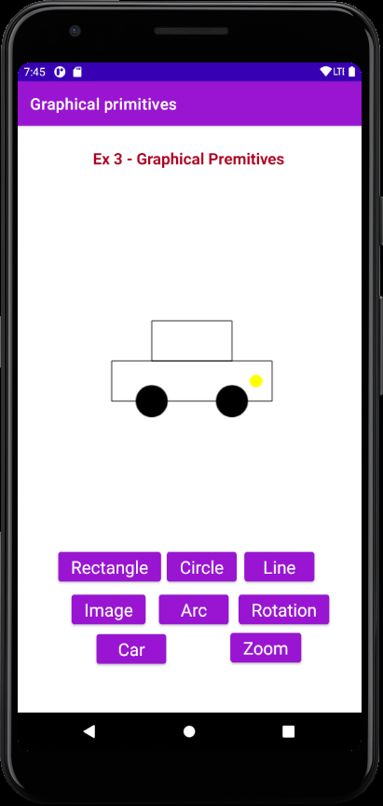

**Result:**

An application using graphic primitives has been created.