**SSN College of Engineering, Kalavakkam**

**Department of Computer Science and Engineering**

**UCS1711-Mobile Application Development Lab**

**Exercise 3**: **Calculator Application**

**Name : S.NACHAMMAI DEVI POOJA**

**Class :CSE Sec: B**

**Reg no: 185001096**

**AIM:**

To Create a Calculator Application using Andriod with the operations specified.

**CODE:**

activity_main.xml :

<?xml version="1.0" encoding="utf-8"?>  
<androidx.constraintlayout.widget.ConstraintLayout xmlns:android="http://schemas.android.com/apk/res/android"  
xmlns:app="http://schemas.android.com/apk/res-auto"  
xmlns:tools="http://schemas.android.com/tools"  
android:layout_width="match_parent"  
android:layout_height="match_parent"  
tools:context=".MainActivity">  
  
<Button  
 android:id="@+id/button9"  
 android:layout_width="66dp"  
 android:layout_height="55dp"  
 android:layout_marginStart="38dp"  
 android:layout_marginLeft="38dp"  
 android:layout_marginTop="46dp"  
 android:onClick="typeChar"  
 android:text="4"  
 android:textColor="@color/white"  
 android:textSize="20sp"  
 app:backgroundTint="#128075"  
 app:layout_constraintStart_toStartOf="parent"  
 app:layout_constraintTop_toBottomOf="@+id/button5" />  
  
<Button  
 android:id="@+id/button10"  
 android:layout_width="66dp"  
 android:layout_height="55dp"  
 android:layout_marginStart="28dp"  
 android:layout_marginLeft="28dp"  
 android:layout_marginTop="46dp"  
 android:onClick="typeChar"  
 android:text="5"  
 android:textColor="@color/white"  
 android:textSize="20sp"  
 app:backgroundTint="#128075"  
 app:layout_constraintStart_toEndOf="@+id/button9"  
 app:layout_constraintTop_toBottomOf="@+id/button6" />  
  
<Button  
 android:id="@+id/button11"  
 android:layout_width="66dp"  
 android:layout_height="55dp"  
 android:layout_marginStart="28dp"  
 android:layout_marginLeft="28dp"  
 android:layout_marginTop="46dp"  
 android:onClick="typeChar"  
 android:text="6"  
 android:textColor="@color/white"  
 android:textSize="20sp"  
 app:backgroundTint="#128075"  
 app:layout_constraintStart_toEndOf="@+id/button10"  
 app:layout_constraintTop_toBottomOf="@+id/button7" />  
  
<Button  
 android:id="@+id/button12"  
 android:layout_width="66dp"  
 android:layout_height="55dp"  
 android:layout_marginStart="25dp"  
 android:layout_marginLeft="25dp"  
 android:layout_marginTop="46dp"  
 android:layout_marginEnd="28dp"  
 android:layout_marginRight="28dp"  
 android:onClick="operandPress"  
 android:text="x"  
 android:textColor="@color/white"  
 android:textSize="20sp"  
 app:backgroundTint="#179A8E"  
 app:layout_constraintEnd_toEndOf="parent"  
 app:layout_constraintStart_toEndOf="@+id/button11"  
 app:layout_constraintTop_toBottomOf="@+id/button8" />  
  
<Button  
 android:id="@+id/button13"  
 android:layout_width="66dp"  
 android:layout_height="55dp"  
 android:layout_marginStart="38dp"  
 android:layout_marginLeft="38dp"  
 android:layout_marginTop="36dp"  
 android:onClick="typeChar"  
 android:text="1"  
 android:textColor="@color/white"  
 android:textSize="20sp"  
 app:backgroundTint="#128075"  
 app:layout_constraintStart_toStartOf="parent"  
 app:layout_constraintTop_toBottomOf="@+id/button9" />  
  
<Button  
 android:id="@+id/button17"  
 android:layout_width="66dp"  
 android:layout_height="55dp"  
 android:layout_marginStart="39dp"  
 android:layout_marginLeft="39dp"  
 android:layout_marginTop="34dp"  
 android:onClick="typeChar"  
 android:text="0"  
 android:textColor="@color/white"  
 android:textSize="20sp"  
 app:backgroundTint="#128075"  
 app:layout_constraintStart_toStartOf="parent"  
 app:layout_constraintTop_toBottomOf="@+id/button13" />  
  
<Button  
 android:id="@+id/button18"  
 android:layout_width="66dp"  
 android:layout_height="55dp"  
 android:layout_marginStart="27dp"  
 android:layout_marginLeft="27dp"  
 android:layout_marginTop="34dp"  
 android:onClick="typeChar"  
 android:text="."  
 android:textColor="@color/white"  
 android:textSize="20sp"  
 app:backgroundTint="#179A8E"  
 app:layout_constraintStart_toEndOf="@+id/button17"  
 app:layout_constraintTop_toBottomOf="@+id/button14" />  
  
<Button  
 android:id="@+id/button19"  
 android:layout_width="66dp"  
 android:layout_height="55dp"  
 android:layout_marginStart="28dp"  
 android:layout_marginLeft="28dp"  
 android:layout_marginTop="34dp"  
 android:onClick="calculate"  
 android:text="="  
 android:textColor="@color/black"  
 android:textSize="20sp"  
 app:backgroundTint="#FF03DAC5"  
 app:layout_constraintStart_toEndOf="@+id/button18"  
 app:layout_constraintTop_toBottomOf="@+id/button15" />  
  
<Button  
 android:id="@+id/button20"  
 android:layout_width="66dp"  
 android:layout_height="55dp"  
 android:layout_marginStart="25dp"  
 android:layout_marginLeft="25dp"  
 android:layout_marginTop="34dp"  
 android:layout_marginEnd="28dp"  
 android:layout_marginRight="28dp"  
 android:onClick="operandPress"  
 android:text="+"  
 android:textColor="@color/white"  
 android:textSize="20sp"  
 app:backgroundTint="#179A8E"  
 app:layout_constraintEnd_toEndOf="parent"  
 app:layout_constraintStart_toEndOf="@+id/button19"  
 app:layout_constraintTop_toBottomOf="@+id/button16" />  
  
<Button  
 android:id="@+id/button14"  
 android:layout_width="66dp"  
 android:layout_height="55dp"  
 android:layout_marginStart="28dp"  
 android:layout_marginLeft="28dp"  
 android:layout_marginTop="36dp"  
 android:onClick="typeChar"  
 android:text="2"  
 android:textColor="@color/white"  
 android:textSize="20sp"  
 app:backgroundTint="#128075"  
 app:layout_constraintStart_toEndOf="@+id/button13"  
 app:layout_constraintTop_toBottomOf="@+id/button10" />  
  
<Button  
 android:id="@+id/button15"  
 android:layout_width="66dp"  
 android:layout_height="55dp"  
 android:layout_marginStart="28dp"  
 android:layout_marginLeft="28dp"  
 android:layout_marginTop="36dp"  
 android:onClick="typeChar"  
 android:text="3"  
 android:textColor="@color/white"  
 android:textSize="20sp"  
 app:backgroundTint="#128075"  
 app:layout_constraintStart_toEndOf="@+id/button14"  
 app:layout_constraintTop_toBottomOf="@+id/button11" />  
  
<Button  
 android:id="@+id/button16"  
 android:layout_width="66dp"  
 android:layout_height="55dp"  
 android:layout_marginStart="25dp"  
 android:layout_marginLeft="25dp"  
 android:layout_marginTop="36dp"  
 android:layout_marginEnd="28dp"  
 android:layout_marginRight="28dp"  
 android:onClick="operandPress"  
 android:text="-"  
 android:textColor="@color/white"  
 android:textSize="20sp"  
 app:backgroundTint="#179A8E"  
 app:layout_constraintEnd_toEndOf="parent"  
 app:layout_constraintStart_toEndOf="@+id/button15"  
 app:layout_constraintTop_toBottomOf="@+id/button12" />  
  
<TextView  
 android:id="@+id/TextField"  
 android:layout_width="341dp"  
 android:layout_height="57dp"  
 android:layout_marginStart="35dp"  
 android:layout_marginLeft="35dp"  
 android:layout_marginTop="83dp"  
 android:layout_marginEnd="30dp"  
 android:layout_marginRight="30dp"  
 android:background="#E3DBDB"  
 android:textAppearance="@style/TextAppearance.AppCompat.Large"  
 android:textSize="34sp"  
 app:layout_constraintEnd_toEndOf="parent"  
 app:layout_constraintStart_toStartOf="parent"  
 app:layout_constraintTop_toTopOf="parent" />  
  
<Button  
 android:id="@+id/button"  
 android:layout_width="67dp"  
 android:layout_height="55dp"  
 android:layout_marginStart="38dp"  
 android:layout_marginLeft="38dp"  
 android:layout_marginTop="27dp"  
 android:text="("  
 android:textColor="@color/white"  
 android:textSize="24sp"  
 app:backgroundTint="#179A8E"  
 app:layout_constraintStart_toStartOf="parent"  
 app:layout_constraintTop_toBottomOf="@+id/TextField" />  
  
<Button  
 android:id="@+id/button2"  
 android:layout_width="65dp"  
 android:layout_height="57dp"  
 android:layout_marginStart="27dp"  
 android:layout_marginLeft="27dp"  
 android:layout_marginTop="27dp"  
 android:text=")"  
 android:textColor="@color/white"  
 android:textSize="24sp"  
 app:backgroundTint="#179A8E"  
 app:layout_constraintStart_toEndOf="@+id/button"  
 app:layout_constraintTop_toBottomOf="@+id/TextField" />  
  
<Button  
 android:id="@+id/button3"  
 android:layout_width="65dp"  
 android:layout_height="56dp"  
 android:layout_marginStart="28dp"  
 android:layout_marginLeft="28dp"  
 android:layout_marginTop="27dp"  
 android:text="%"  
 android:textColor="@color/white"  
 android:textSize="24sp"  
 app:backgroundTint="#179A8E"  
 app:layout_constraintStart_toEndOf="@+id/button2"  
 app:layout_constraintTop_toBottomOf="@+id/TextField" />  
  
<Button  
 android:id="@+id/button4"  
 android:layout_width="63dp"  
 android:layout_height="58dp"  
 android:layout_marginStart="26dp"  
 android:layout_marginLeft="26dp"  
 android:layout_marginTop="27dp"  
 android:layout_marginEnd="31dp"  
 android:layout_marginRight="31dp"  
 android:onClick="clearText"  
 android:text="AC"  
 android:textColor="@color/white"  
 android:textSize="20sp"  
 app:backgroundTint="#179A8E"  
 app:layout_constraintEnd_toEndOf="parent"  
 app:layout_constraintStart_toEndOf="@+id/button3"  
 app:layout_constraintTop_toBottomOf="@+id/TextField" />  
  
<Button  
 android:id="@+id/button5"  
 android:layout_width="66dp"  
 android:layout_height="55dp"  
 android:layout_marginStart="39dp"  
 android:layout_marginLeft="39dp"  
 android:layout_marginTop="44dp"  
 android:onClick="typeChar"  
 android:text="7"  
 android:textColor="@color/white"  
 android:textSize="20sp"  
 app:backgroundTint="#128075"  
 app:layout_constraintStart_toStartOf="parent"  
 app:layout_constraintTop_toBottomOf="@+id/button" />  
  
<Button  
 android:id="@+id/button6"  
 android:layout_width="66dp"  
 android:layout_height="55dp"  
 android:layout_marginStart="27dp"  
 android:layout_marginLeft="27dp"  
 android:layout_marginTop="42dp"  
 android:onClick="typeChar"  
 android:text="8"  
 android:textColor="@color/white"  
 android:textSize="20sp"  
 app:backgroundTint="#128075"  
 app:layout_constraintStart_toEndOf="@+id/button5"  
 app:layout_constraintTop_toBottomOf="@+id/button2" />  
  
<Button  
 android:id="@+id/button7"  
 android:layout_width="66dp"  
 android:layout_height="55dp"  
 android:layout_marginStart="28dp"  
 android:layout_marginLeft="28dp"  
 android:layout_marginTop="43dp"  
 android:onClick="typeChar"  
 android:text="9"  
 android:textColor="@color/white"  
 android:textSize="20sp"  
 app:backgroundTint="#128075"  
 app:layout_constraintStart_toEndOf="@+id/button6"  
 app:layout_constraintTop_toBottomOf="@+id/button3" />  
  
<Button  
 android:id="@+id/button8"  
 android:layout_width="66dp"  
 android:layout_height="55dp"  
 android:layout_marginStart="25dp"  
 android:layout_marginLeft="25dp"  
 android:layout_marginTop="41dp"  
 android:layout_marginEnd="28dp"  
 android:layout_marginRight="28dp"  
 android:onClick="operandPress"  
 android:text="/"  
 android:textColor="@color/white"  
 android:textSize="20sp"  
 app:backgroundTint="#179A8E"  
 app:layout_constraintEnd_toEndOf="parent"  
 app:layout_constraintStart_toEndOf="@+id/button7"  
 app:layout_constraintTop_toBottomOf="@+id/button4" />  
</androidx.constraintlayout.widget.ConstraintLayout>

MainActivity.java

package com.example.calc;  
  
 import androidx.appcompat.app.AppCompatActivity;  
 import android.os.Bundle;  
 import android.view.View;  
 import android.widget.Button;  
 import android.widget.TextView;  
  
public class MainActivity extends AppCompatActivity {  
 static String *operator*;  
 static int *operand1*;  
 static int *operand2*;  
 static float *floatOp1*;  
 static float *floatOp2*;  
 static boolean *float_flag*;  
  
 @Override  
 protected void onCreate(Bundle savedInstanceState) {  
 super.onCreate(savedInstanceState);  
 setContentView(R.layout.*activity_main*);  
 }  
  
 public void typeChar(View view) {  
 String txt = ((Button)view).getText().toString();  
 if(txt.charAt(0)=='.')  
 {  
 *float_flag*=true;  
 System.*out*.println("float flag is set");  
 }  
 TextView display = (TextView)findViewById(R.id.*TextField*);  
 display.setText(display.getText().toString()+txt);  
 }  
  
 public void clearText(View view) {  
 TextView display = (TextView)findViewById(R.id.*TextField*);  
 display.setText("");  
  
 }  
  
 public void operandPress(View view) {  
 *operator* = ((Button)view).getText().toString();  
 System.*out*.println(*operator* + " pressed");  
 TextView display = (TextView)findViewById(R.id.*TextField*);  
 if(display.getText().toString().isEmpty())  
 {  
 return;  
 }  
 if(*float_flag*)  
 {  
 *floatOp1*= Float.*parseFloat*(display.getText().toString());  
 }  
 else{  
 *operand1* = Integer.*parseInt*(display.getText().toString());  
 }  
 clearText(view);  
 }  
  
 public void calculate(View view) {  
 TextView display = (TextView)findViewById(R.id.*TextField*);  
 if(display.getText().toString().isEmpty())  
 {  
 return;  
 }  
 if(*float_flag*)  
 {  
 *floatOp2*= Float.*parseFloat*(display.getText().toString());  
 }  
 else{  
 *operand2* = Integer.*parseInt*(display.getText().toString());  
 }  
 if(*float_flag*)  
 {  
 if(*operator*.charAt(0)=='+')  
 {  
 float result = *floatOp1*+*floatOp2*;  
 display.setText(Float.*toString*(result));  
 }  
 else if(*operator*.charAt(0)=='-')  
 {  
 float result = *floatOp1*-*floatOp2*;  
 display.setText(Float.*toString*(result));  
  
 }  
 else if(*operator*.charAt(0)=='x')  
 {  
 float result = *floatOp1*\**floatOp2*;  
 display.setText(Float.*toString*(result));  
  
 }  
 else if(*operator*.charAt(0)=='/')  
 {  
 float result = *floatOp1*/*floatOp2*;  
 display.setText(Float.*toString*(result));  
  
 }  
 else if(*operator*.charAt(0)=='%')  
 {  
 float result = *floatOp1*%*floatOp2*;  
 display.setText(Float.*toString*(result));  
  
 }  
  
 }  
 else {  
 if(*operator*.charAt(0)=='+')  
 {  
 int result = *operand1*+*operand2*;  
 display.setText(Integer.*toString*(result));  
 }  
 else if(*operator*.charAt(0)=='-')  
 {  
 int result = *operand1*-*operand2*;  
 display.setText(Integer.*toString*(result));  
  
 }  
 else if(*operator*.charAt(0)=='x')  
 {  
 int result = *operand1*\**operand2*;  
 display.setText(Integer.*toString*(result));  
  
 }  
 else if(*operator*.charAt(0)=='/')  
 {  
 int result = *operand1*/*operand2*;  
 display.setText(Integer.*toString*(result));  
 }  
 else if(*operator*.charAt(0)=='%')  
 {  
 int result = *operand1*%*operand2*;  
 display.setText(Integer.*toString*(result));  
  
 }  
 }  
 }  
}

**Output Screenshot:**

**Initial Calculator-**

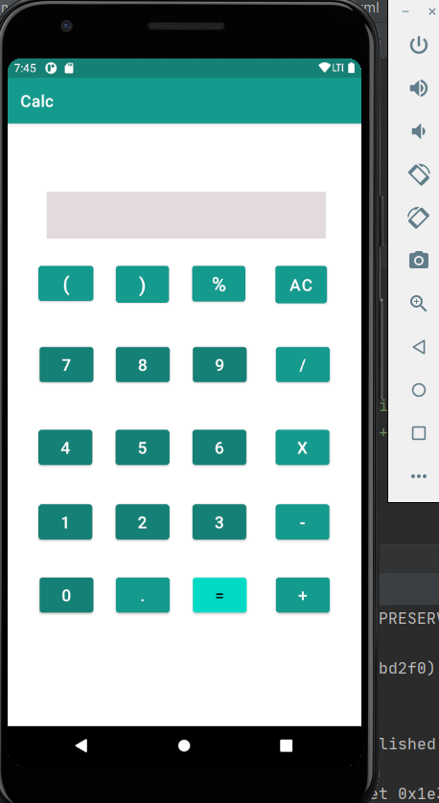

**Operand 1:96-**

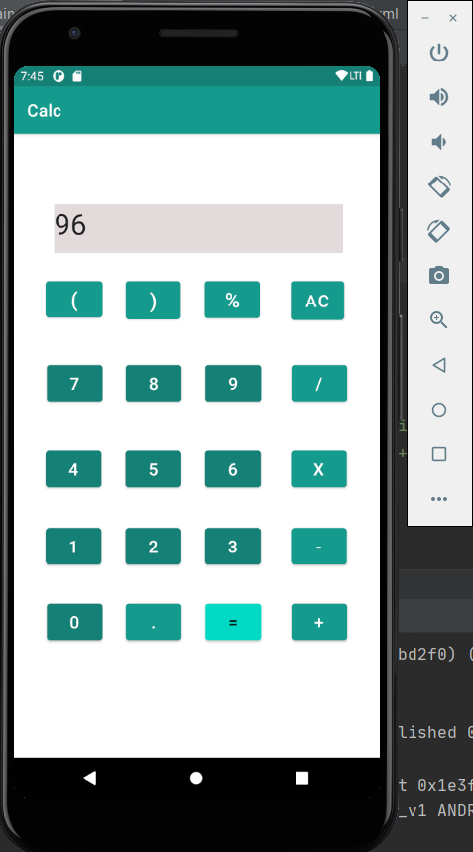

**Operand 2:3-**

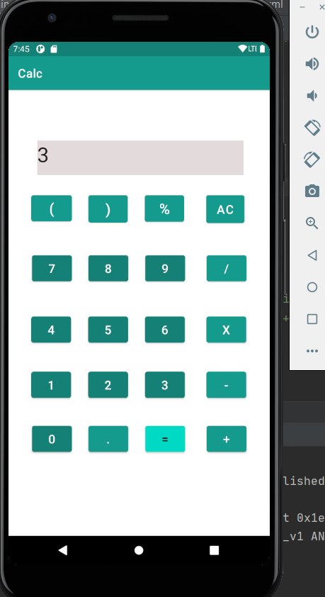

**Computation Result:**

**96/3=32**

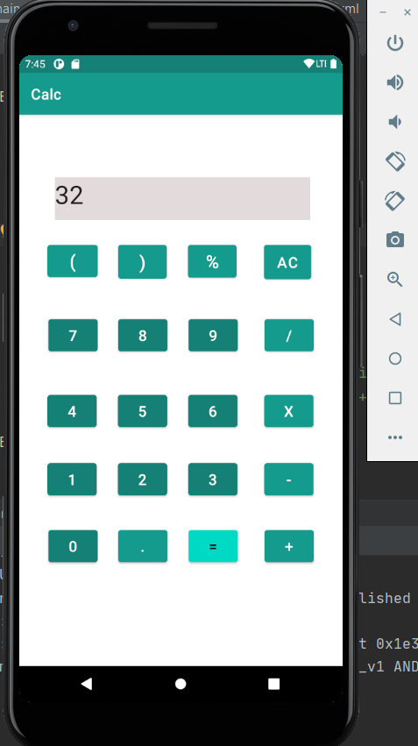

**Result:**

A Calculator application using andriod with the specified operations has been created.