**SSN College of Engineering, Kalavakkam**

**Department of Computer Science and Engineering**

**UCS1711-Mobile Application Development Lab**

**Exercise 5:Andriod Application for CRUD Operations on Database**

**Name : S.NACHAMMAI DEVI POOJA**

**Class :CSE Sec: B**

**Reg no: 185001096**

**AIM:**

To develop an android application for CRUD operations in Database.

**CODE:**

MainActivity.java:

package com.example.database;

import androidx.appcompat.app.AlertDialog;

import androidx.appcompat.app.AppCompatActivity;

import android.database.Cursor;

import android.os.Bundle;

import android.view.View;

import android.widget.Button;

import android.widget.EditText;

import android.widget.Toast;

public class MainActivity extends AppCompatActivity {

EditText name, contact, dob, email;

Button insert, update, delete, view;

DBHelper DB;

@Override

protected void onCreate(Bundle savedInstanceState) {

super.onCreate(savedInstanceState);

setContentView(R.layout.*activity_main*);

name = findViewById(R.id.*name*);

contact = findViewById(R.id.*contact*);

dob = findViewById(R.id.*dob*);

email = findViewById(R.id.*email*);

insert = findViewById(R.id.*btnInsert*);

update = findViewById(R.id.*btnUpdate*);

delete = findViewById(R.id.*btnDelete*);

view = findViewById(R.id.*btnView*);

DB = new DBHelper(this);

insert.setOnClickListener(new View.OnClickListener() {

@Override

public void onClick(View view) {

String nameTXT = name.getText().toString();

String contactTXT = contact.getText().toString();

String dobTXT = dob.getText().toString();

String emailTXT = email.getText().toString();

Boolean checkinsertdata = DB.insertuserdata(nameTXT, contactTXT, dobTXT, emailTXT);

if(checkinsertdata==true)

Toast.*makeText*(MainActivity.this, "New Entry Inserted", Toast.*LENGTH_SHORT*).show();

else

Toast.*makeText*(MainActivity.this, "New Entry Not Inserted", Toast.*LENGTH_SHORT*).show();

} });

update.setOnClickListener(new View.OnClickListener() {

@Override

public void onClick(View view) {

String nameTXT = name.getText().toString();

String contactTXT = contact.getText().toString();

String dobTXT = dob.getText().toString();

String emailTXT = email.getText().toString();

Boolean checkupdatedata = DB.updateuserdata(nameTXT, contactTXT, dobTXT, emailTXT);

if(checkupdatedata==true)

Toast.*makeText*(MainActivity.this, "Entry Updated", Toast.*LENGTH_SHORT*).show();

else

Toast.*makeText*(MainActivity.this, "New Entry Not Updated", Toast.*LENGTH_SHORT*).show();

} });

delete.setOnClickListener(new View.OnClickListener() {

@Override

public void onClick(View view) {

String nameTXT = name.getText().toString();

Boolean checkudeletedata = DB.deletedata(nameTXT);

if(checkudeletedata==true)

Toast.*makeText*(MainActivity.this, "Entry Deleted", Toast.*LENGTH_SHORT*).show();

else

Toast.*makeText*(MainActivity.this, "Entry Not Deleted", Toast.*LENGTH_SHORT*).show();

} });

view.setOnClickListener(new View.OnClickListener() {

@Override

public void onClick(View view) {

Cursor res = DB.getdata();

if(res.getCount()==0){

Toast.*makeText*(MainActivity.this, "No Entry Exists", Toast.*LENGTH_SHORT*).show();

return;

}

StringBuffer buffer = new StringBuffer();

while(res.moveToNext()){

buffer.append("Name :"+res.getString(0)+"\n");

buffer.append("Contact :"+res.getString(1)+"\n");

buffer.append("Address :"+res.getString(2)+"\n");

buffer.append("Email :"+res.getString(3)+"\n\n");

}

AlertDialog.Builder builder = new AlertDialog.Builder(MainActivity.this);

builder.setCancelable(true);

builder.setTitle("User Entries");

builder.setMessage(buffer.toString());

builder.show();

} });

}}

activity_main.xml :

<?xml version="1.0" encoding="UTF-8"?>

<RelativeLayout tools:context=".MainActivity" android:padding="10dp" android:layout_height="match_parent" android:layout_width="match_parent" xmlns:tools="http://schemas.android.com/tools" xmlns:app="http://schemas.android.com/apk/res-auto" xmlns:android="http://schemas.android.com/apk/res/android">

<TextView android:layout_height="wrap_content" android:layout_width="match_parent" android:textColor="@color/colorPrimary" android:layout_marginTop="20dp" android:textSize="28dp" android:text=" Fill the required details" android:id="@+id/texttitle"/>

<EditText android:layout_height="wrap_content" android:layout_width="match_parent" android:textColor="@color/colorPrimary" android:textSize="24dp" android:id="@+id/name" android:inputType="textPersonName" android:layout_below="@+id/texttitle" android:hint="Enter Name"/>

<EditText android:layout_height="wrap_content" android:layout_width="match_parent" android:textColor="@color/colorPrimary" android:textSize="24dp" android:id="@+id/contact" android:inputType="number" android:layout_below="@+id/name" android:hint="Enter Contact"/>

<EditText android:layout_height="wrap_content" android:layout_width="match_parent" android:textColor="@color/colorPrimary" android:textSize="24dp" android:id="@+id/dob" android:inputType="text" android:layout_below="@+id/contact" android:hint="Enter Address"/>

<EditText android:layout_height="wrap_content" android:layout_width="match_parent" android:textColor="@color/colorPrimary" android:textSize="24dp" android:id="@+id/email" android:inputType="text" android:layout_below="@+id/dob" android:hint="Enter Email"/>

<Button android:layout_height="wrap_content" android:textColor="@color/colorPrimary" android:background="@color/colorAccent" android:layout_width="match_parent" android:layout_marginTop="65dp" android:textSize="24dp" android:text="Insert New Data" android:id="@+id/btnInsert" android:layout_below="@id/email"/>

<Button android:layout_height="wrap_content" android:textColor="@color/colorPrimary" android:background="@color/colorAccent" android:layout_width="match_parent" android:layout_marginTop="15dp" android:textSize="24dp" android:text="Update Data" android:id="@+id/btnUpdate" android:layout_below="@id/btnInsert"/>

<Button android:layout_height="wrap_content" android:textColor="@color/colorPrimary" android:background="@color/colorAccent" android:layout_width="match_parent" android:layout_marginTop="15dp" android:textSize="24dp" android:text="Delete Existing Data" android:id="@+id/btnDelete" android:layout_below="@id/btnUpdate"/>

<Button android:layout_height="wrap_content" android:textColor="@color/colorPrimary" android:background="@color/colorAccent" android:layout_width="match_parent" android:layout_marginTop="15dp" android:textSize="24dp" android:text="View Data" android:id="@+id/btnView" android:layout_below="@id/btnDelete"/>

</RelativeLayout>

Colors.xml:

<?xml version="1.0" encoding="utf-8"?>

<resources>

<color name="purple_200">#FFBB86FC</color>

<color name="purple_500">#13299E</color>

<color name="purple_700">#FF3700B3</color>

<color name="teal_200">#FF03DAC5</color>

<color name="teal_700">#FF018786</color>

<color name="black">#FF000000</color>

<color name="white">#FFFFFFFF</color>

<color name="colorPrimary">#9E77E3</color>

<color name="colorAccent">#0B7369</color>

</resources>

DBHelper.java:

package com.example.database;

import android.content.ContentValues;

import android.content.Context;

import android.database.Cursor;

import android.database.sqlite.SQLiteDatabase;

import android.database.sqlite.SQLiteOpenHelper;

import androidx.annotation.Nullable;

public class DBHelper extends SQLiteOpenHelper {

public DBHelper(Context context) {

super(context, "Userdata.db", null, 1);

}

@Override

public void onCreate(SQLiteDatabase DB) {

DB.execSQL("create Table Userdetails(name TEXT primary key, contact TEXT, dob TEXT, email TEXT)");

}

@Override

public void onUpgrade(SQLiteDatabase DB, int i, int i1) {

DB.execSQL("drop Table if exists Userdetails");

}

public Boolean insertuserdata(String name, String contact, String dob, String email)

{

SQLiteDatabase DB = this.getWritableDatabase();

ContentValues contentValues = new ContentValues();

contentValues.put("name", name);

contentValues.put("contact", contact);

contentValues.put("dob", dob);

contentValues.put("email", email);

long result=DB.insert("Userdetails", null, contentValues);

if(result==-1){

return false;

}else{

return true;

}

}

public Boolean updateuserdata(String name, String contact, String dob, String email) {

SQLiteDatabase DB = this.getWritableDatabase();

ContentValues contentValues = new ContentValues();

contentValues.put("contact", contact);

contentValues.put("dob", dob);

contentValues.put("email", email);

Cursor cursor = DB.rawQuery("Select * from Userdetails where name = ?", new String[]{name});

if (cursor.getCount() > 0) {

long result = DB.update("Userdetails", contentValues, "name=?", new String[]{name});

if (result == -1) {

return false;

} else {

return true;

}

} else {

return false;

}}

public Boolean deletedata (String name)

{

SQLiteDatabase DB = this.getWritableDatabase();

Cursor cursor = DB.rawQuery("Select * from Userdetails where name = ?", new String[]{name});

if (cursor.getCount() > 0) {

long result = DB.delete("Userdetails", "name=?", new String[]{name});

if (result == -1) {

return false;

} else {

return true;

}

} else {

return false;

}

}

public Cursor getdata ()

{

SQLiteDatabase DB = this.getWritableDatabase();

Cursor cursor = DB.rawQuery("Select * from Userdetails", null);

return cursor;

}

}

**OUTPUT:**

Insert Data:

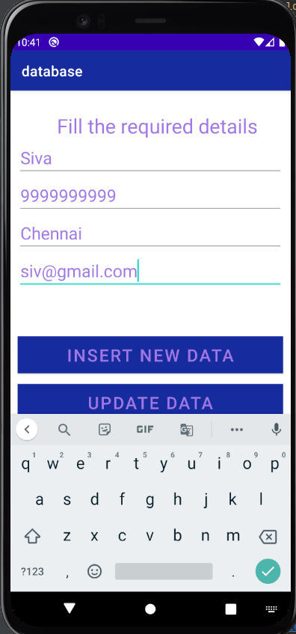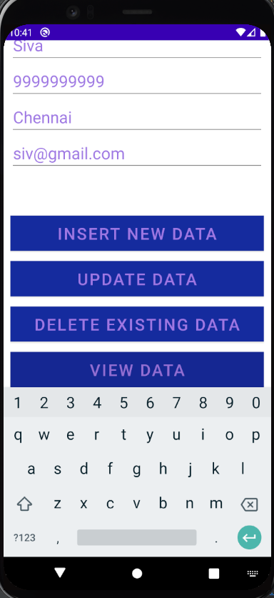

View Data:

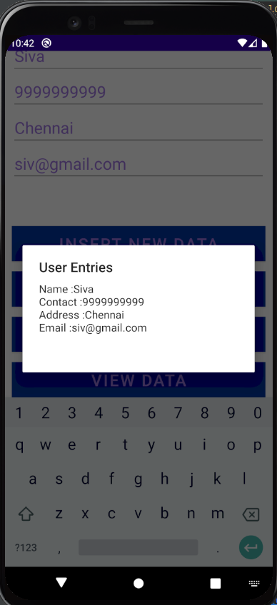

Insert new data:

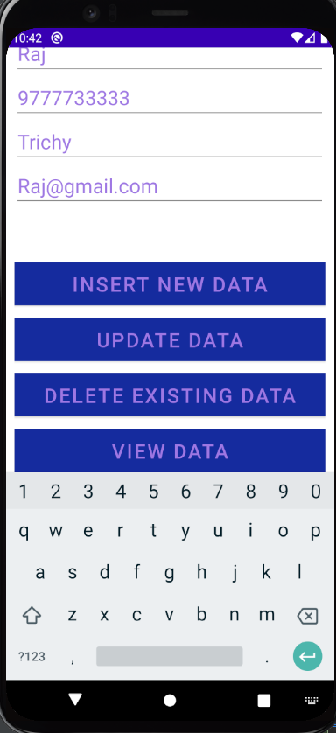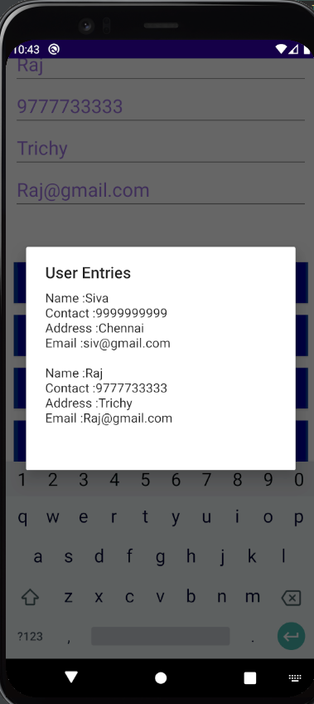

Update data: Delete Data:

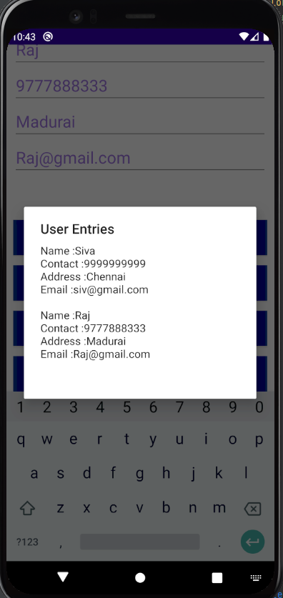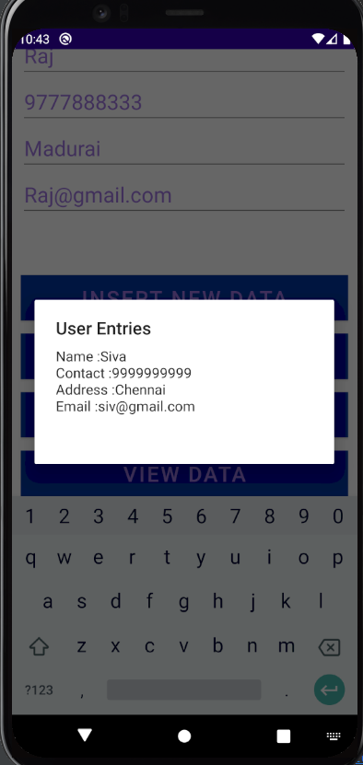

**RESULT:**

An android application for CRUD operations in Database has been successfully developed.