**SSN College of Engineering, Kalavakkam**

**Department of Computer Science and Engineering**

**UCS1711-Mobile Application Development Lab**

**Exercise 6:Android Application using Multi-threading**

**Name : S.NACHAMMAI DEVI POOJA**

**Class :CSE Sec: B**

**Reg no: 185001096**

**AIM:**

To develop an android application using Multi-threading.

**CODE:**

MainActivity.java:

package com.example.movingbanner;

import androidx.appcompat.app.AppCompatActivity;

import android.graphics.Color;

import android.os.Bundle;

import android.view.View;

import android.widget.Button;

import android.widget.TextView;

import java.util.Random;

public class MainActivity extends AppCompatActivity {

private TextView banner, coord, counter_text;

private Button counter;

@Override

protected void onCreate(Bundle savedInstanceState) {

super.onCreate(savedInstanceState);

setContentView(R.layout.*activity_main*);

banner = (TextView) findViewById(R.id.*banner*);

counter_text = (TextView) findViewById(R.id.*counter*);

coord = (TextView) findViewById(R.id.*coord*);

counter = (Button) findViewById(R.id.*button*);

counter.setOnClickListener(new View.OnClickListener() {

@Override

public void onClick(View v) {

int current = Integer.*parseInt*(counter_text.getText().toString());

current++;

counter_text.setText(String.*valueOf*(current));

}});

new Thread(new Runnable() {

public void run() {

int i = 0;

while (i < 100) {

try {

Thread.*sleep*(100);

} catch (InterruptedException e) {

e.printStackTrace();

}

runOnUiThread(new Runnable() {

@Override

public void run() {

banner.animate().translationXBy(20f);

coord.animate().translationXBy(20f);

int[] location = new int[2];

banner.getLocationOnScreen(location);

coord.setText("Location: (" + location[0] + ", " + location[1] + ")");

Random random = new Random();

int color = Color.*argb*(255, random.nextInt(256), random.nextInt(256), random.nextInt(256));

banner.setTextColor(color);

}

});

}

}

}).start();

}

}

Activity_main.xml:

<?xml version="1.0" encoding="utf-8"?>

<androidx.constraintlayout.widget.ConstraintLayout xmlns:android="http://schemas.android.com/apk/res/android"

xmlns:app="http://schemas.android.com/apk/res-auto"

xmlns:tools="http://schemas.android.com/tools"

android:layout_width="match_parent"

android:layout_height="match_parent"

tools:context=".MainActivity">

<TextView

android:id="@+id/banner"

android:layout_width="133dp"

android:layout_height="45dp"

android:layout_marginStart="16dp"

android:layout_marginTop="204dp"

android:background="#6F1A7E"

android:backgroundTint="#5FDACE"

android:text="Hello World !!!"

android:textSize="20sp"

android:textStyle="bold"

app:layout_constraintStart_toStartOf="parent"

app:layout_constraintTop_toTopOf="parent" />

<TextView

android:id="@+id/coord"

android:layout_width="133dp"

android:layout_height="45dp"

android:layout_marginStart="16dp"

android:layout_marginTop="260dp"

android:text="TextView"

android:textColor="#144C47"

app:layout_constraintStart_toStartOf="parent"

app:layout_constraintTop_toTopOf="parent" />

<Button

android:id="@+id/button"

android:layout_width="wrap_content"

android:layout_height="wrap_content"

android:layout_marginStart="156dp"

android:layout_marginTop="552dp"

android:backgroundTint="#1A857B"

android:text="Click me"

app:layout_constraintStart_toStartOf="parent"

app:layout_constraintTop_toTopOf="parent" />

<TextView

android:id="@+id/counter"

android:layout_width="105dp"

android:layout_height="35dp"

android:layout_marginStart="194dp"

android:layout_marginTop="502dp"

android:text="1"

android:textColor="#264744"

android:textSize="20sp"

android:textStyle="bold"

app:layout_constraintStart_toStartOf="parent"

app:layout_constraintTop_toTopOf="parent" />

</androidx.constraintlayout.widget.ConstraintLayout>

colors.xml:

**<?xml version="1.0" encoding="utf-8"?>**

**<resources>**

**<color name="purple_200">#FFBB86FC</color>**

**<color name="purple_500">#41B5AA</color>**

**<color name="purple_700">#318A82</color>**

**<color name="teal_200">#FF03DAC5</color>**

**<color name="teal_700">#FF018786</color>**

**<color name="black">#FF000000</color>**

**<color name="white">#FFFFFFFF</color>**

**</resources>**

**OUTPUT:**

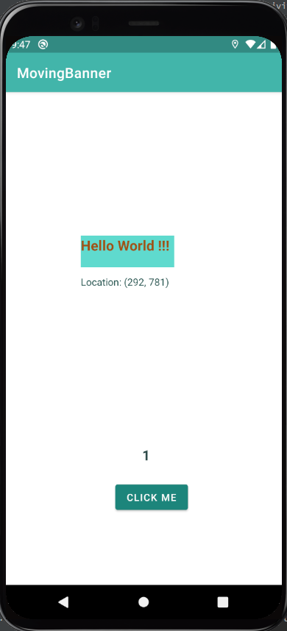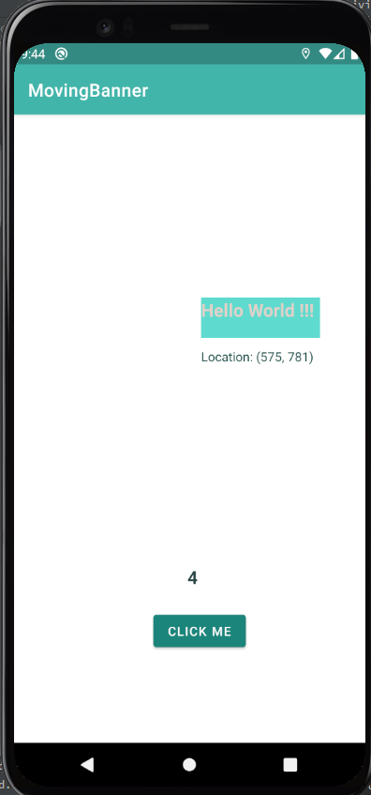

**RESULT:**

An android application using Multi-threading has been successfully developed.