Matthew Clockel

Southern New Hampshire University

1 April 2021

DAD 220 – 21EW4

Professor Singapura

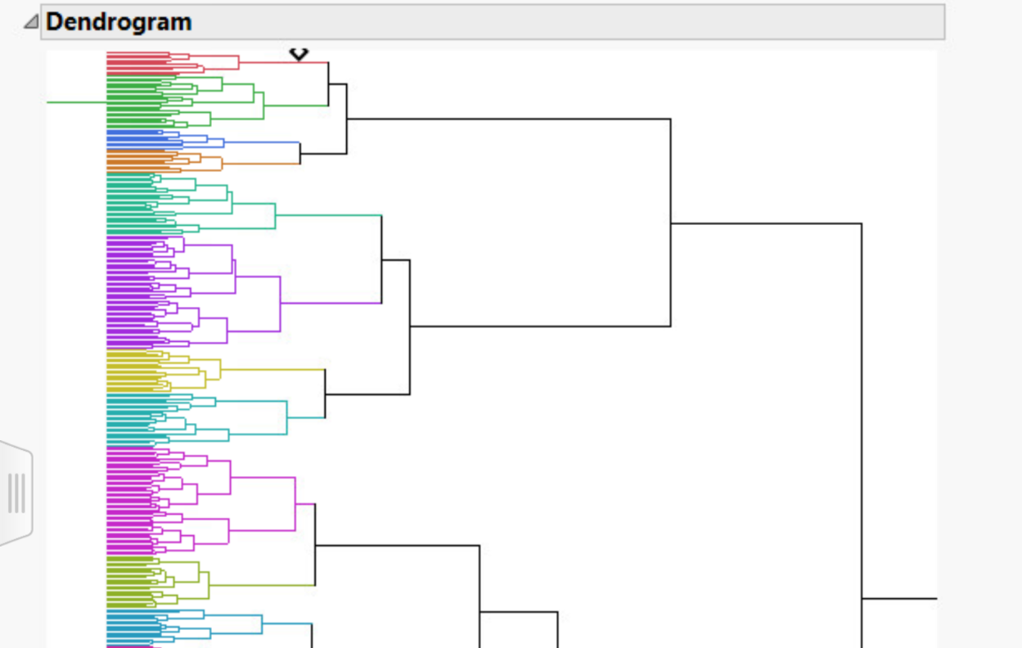

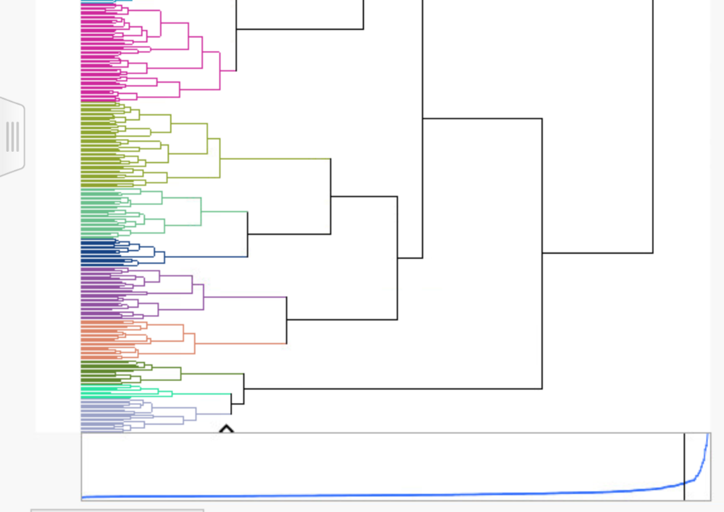

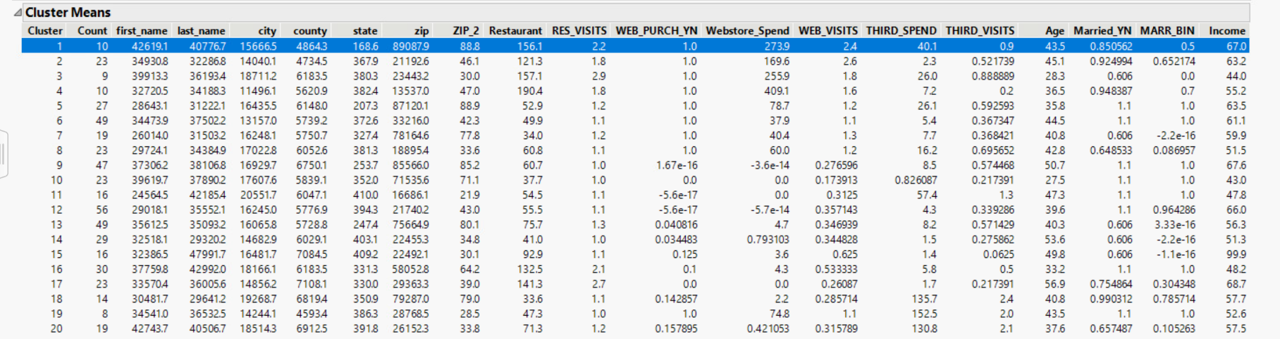

The dendrogram shows the hierarchical clustering of the Bubba Gump data set. The dendrogram has been colored to sperate each natural cluster. There are a total of twenty natural clusters in this dendrogram. There is not much difference in web channel activity across the clusters. Cluster four has the highest webstore spend amount of 409.1. The average age of cluster four is 36.5 years old and an average income of 55.2 per year. This data also shows that the highest web purchases have visited restaurant number 190.4. The data also shows that there is a high probability of webstore visits and restaurant visits. To increase Bubba Gump webstore sales more traffic to the webstore must be generated. The more customers visit the restaurants the more webstore visits and webstore spending.

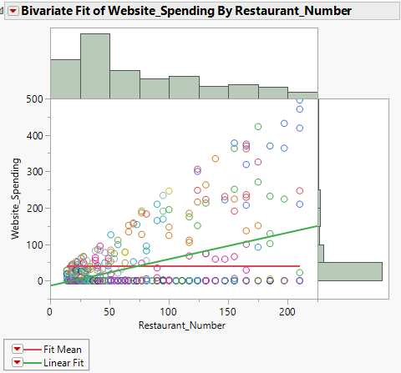

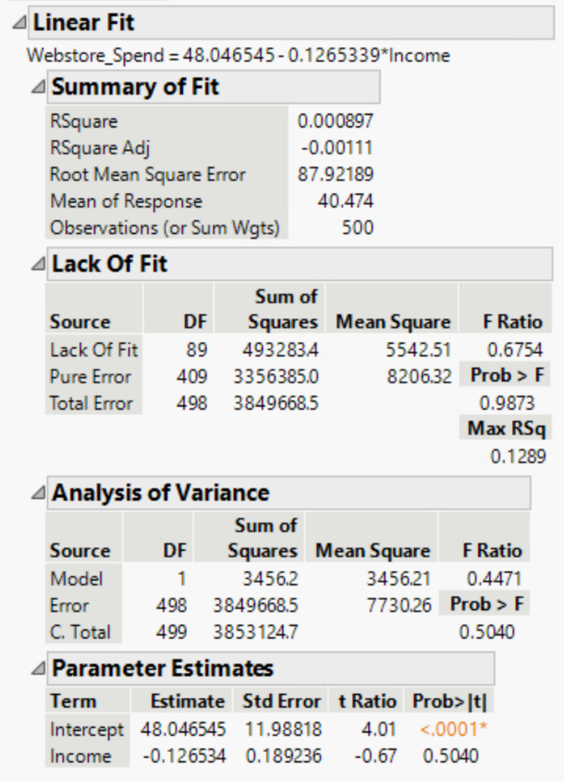

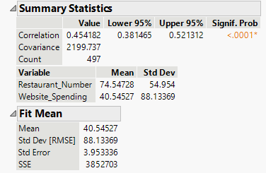

Here is a simple linear regression line that shows restaurant and website spending. Customers spend $40.54 on average on the website. The chart shows that the website spending goes up as the restaurant number goes up. The highest webstore spending happens with the higher restaurant numbers. There is a problem here that Bubba Gump can address. The lower number restaurants are generating more traffic but much lower webstore spending amounts. The histogram on top shows a positive left skew of data. This data shows that the mode is right around restaurant 35. The mode shows the most webstore spending.

Bubba Gump sales have declined in each of the last two years. One solution could be to increasing the amount a customer spends in the webstore for the lower number restaurants. The data does show that there are more customers total spending in the lower number restaurants just smaller amounts. Another solution would be to increase the number of customers spending in the higher number restaurants. The higher number restaurants spend more money overall but lack customers.

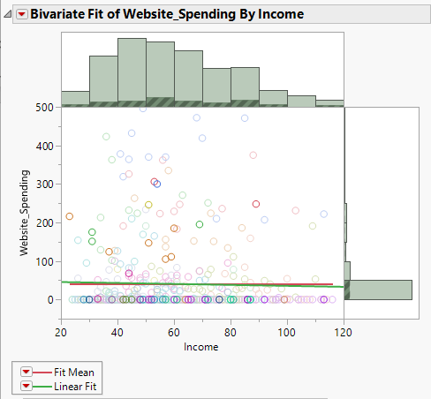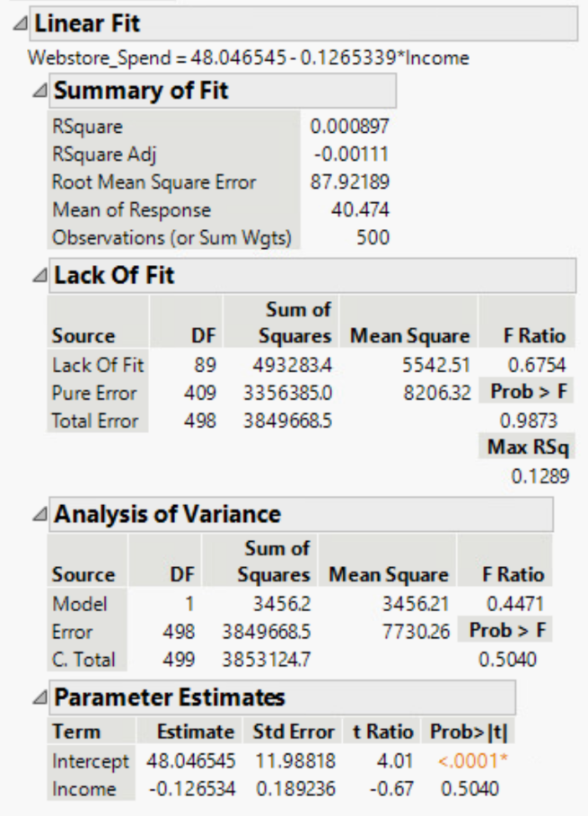

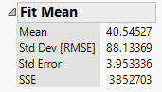

This simple linear regression model shows webstore spending and the relationship with customers income. The fit line shows a decline of spending as the customer income increases. The lower income customers are spending more in the webstore compared to the higher income customers. This could also be because there are more customers within the lower income brackets. The histogram shows that there is a positive left skew in the bell curve. The most spending occurs in the 45-50 income range.

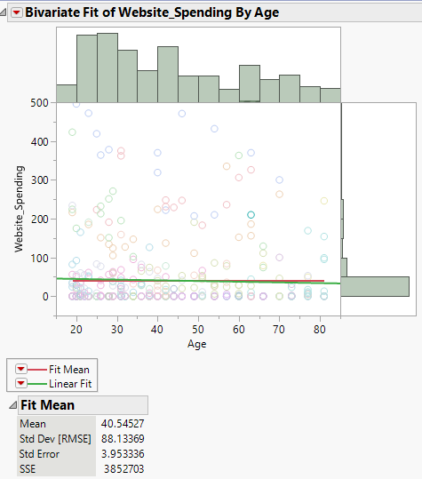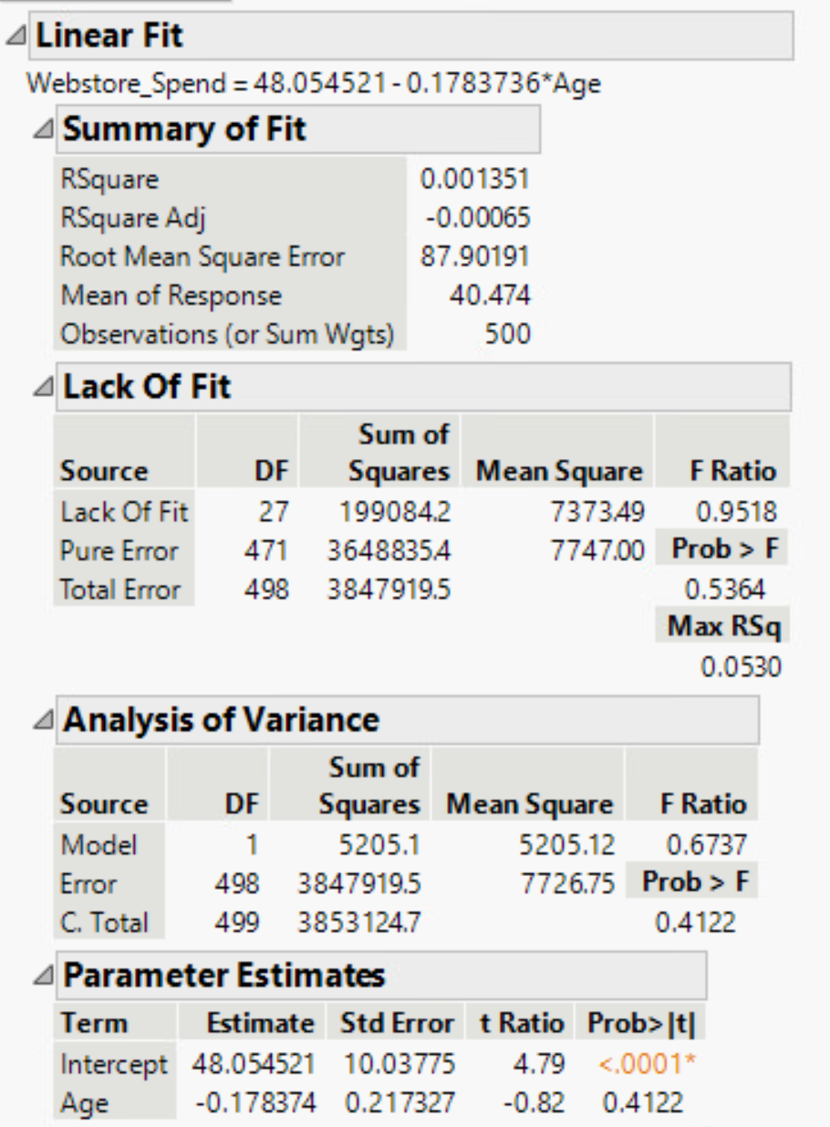Increasing more customers with higher incomes could reverse this trend line. There are many customers who did not spend any money at all in the webstore. There must be some sort of incentive to bring in sales from the customers who did not make a purchase. Click funnels are a great way to solve this problem and pulling the customers email addresses to market material to increase spending.

The simple linear regression model shows the relationship between webstore spending and age. There is a trend here showing that the younger customers spend more. The webstore spending declines as the customers age increases. The histogram shows that most customers spending in the webstore are between the ages of 25-30.

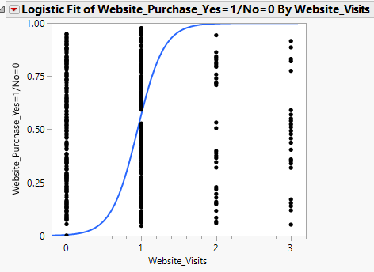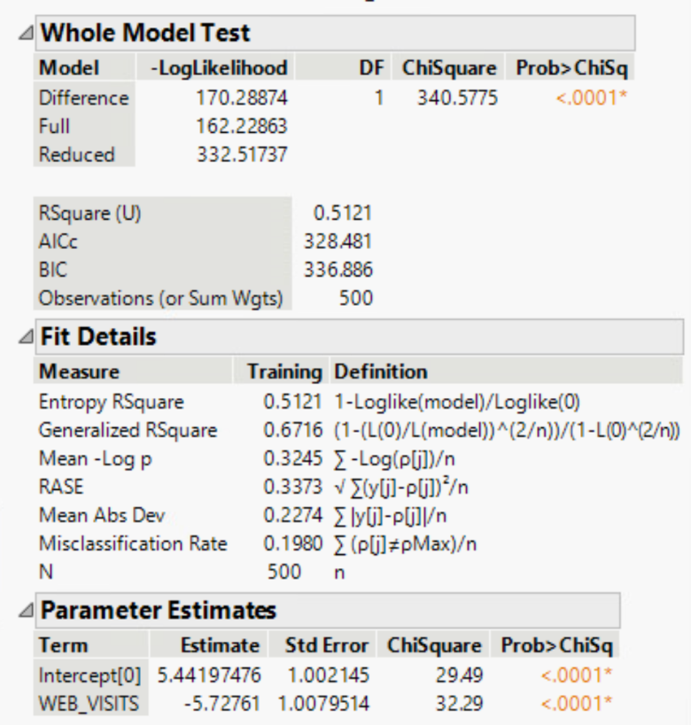

This simple logistic regression graph compares web store purchases by web visits. There is a lot of valuable input in this data. The WEB_PURCH_YN variable shows that 1 is no and 0 is yes. With zero webstore visits results in zero webstore purchases. The data shows that there is a 50% probability that one webstore visit results in a webstore purchase. There is a 100% probability that a customer who visits the webstore two or three times makes a purchase. The p-value shows less than 0.0001 which is significance.

The maximum webstore visits by any customer are three visits. This is another problem and there should be more visits to the webstore. Creating a mobile application linked to the webstore so customers are obligated visit the webstore can increase sales heavily. Most Bubba Gump customers do not make a visit to the webstore at all. This is also a problem and should be addressed to increase the declining sales at Bubba Gump.

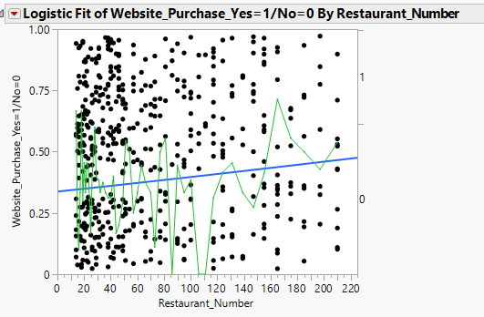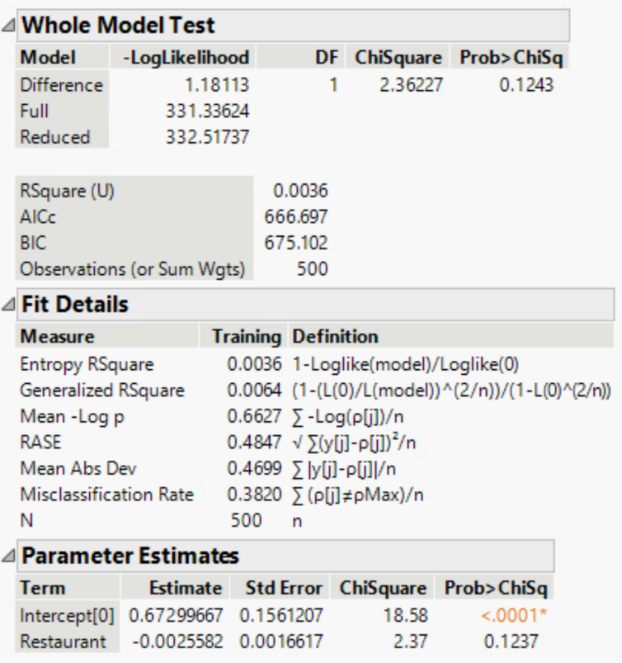

The simple logistic regression model shows webstore purchases by restaurant. The fit line shows a decline of purchases as the restaurant number increases. The lower number restaurants have the most webstore purchases. There is significance here to these variables. The p-value shows less than 0.0001 which show significance in the relationship between the variables.