TEAM PANACEA

TOPIC :

SOCIAL JUSTICE – WOMEN SAFETY

MEMBERS:

1. Agnes M Paul [agnespaul255@gmail.com](mailto:agnespaul255@gmail.com) 7994050936
2. Mohammed Mikdhad C [mikdhadcr7@gmail.com](mailto:mikdhadcr7@gmail.com) 9567487724
3. Irfad KP [alirfad7@gmail.com](mailto:alirfad7@gmail.com) 8547786738
4. Sam Sunny [samsunny0716@gmail.com](mailto:samsunny0716@gmail.com) 7025332562
5. Shivani Sanjay [shivani27anjali@gmail.com](mailto:shivani27anjali@gmail.com) 6282514141
6. Gloria Thomas [gloria00thomas@gmail.com](mailto:gloria00thomas@gmail.com) 6238171050

SAFER

--- mobile app and electronic device

Overview:

Safer app is an easy to use and reliable mobile app designed for those who use smartphone in their day to day life. The app provides a prompt alert signal in a single trigger to nearby police station and family or relatives in case of an attack or abuse.

As the app is limited to people who have smartphones and moreover, people who keep themselves updated with new technologies , we have designed a very simple electronic device for the common people, using GSM and GPS technology.

INDEX

1. Application setup
2. Basic Architecture of the solution
3. Features
4. Electronic Device
5. Comparison with Similar Apps
6. Advantages
7. . BASIC ARCHITECTURE OF THE SOLUTION

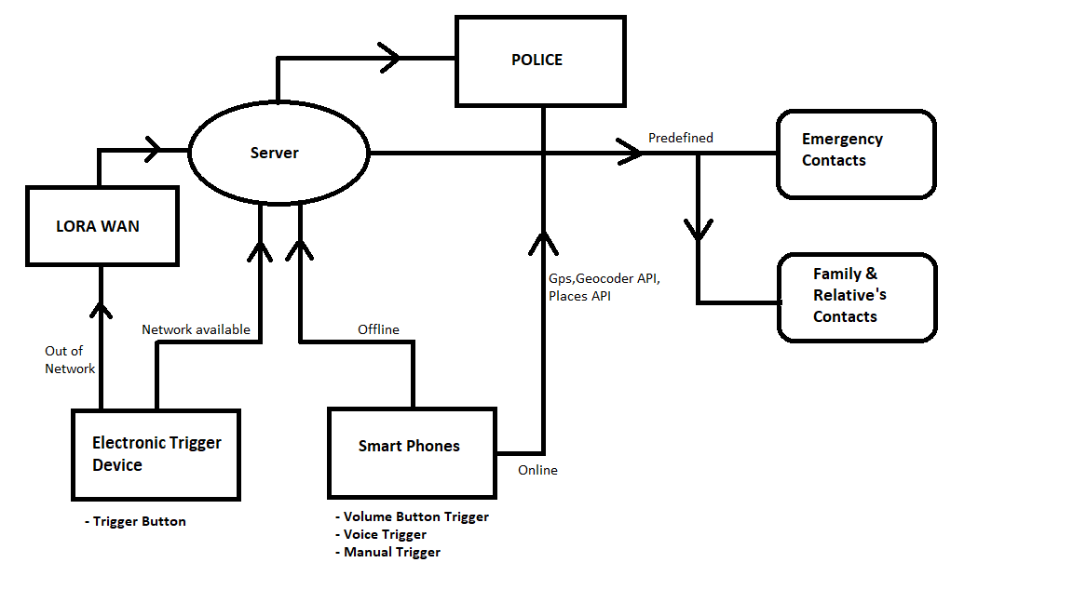

APPLICATION

1. Setup:

When the application is installed , the details such as name address phone number is asked from the user and registered in the application. The app also stores emergency contact details like Helpline numbers and emergency family contact , to send alert signal.

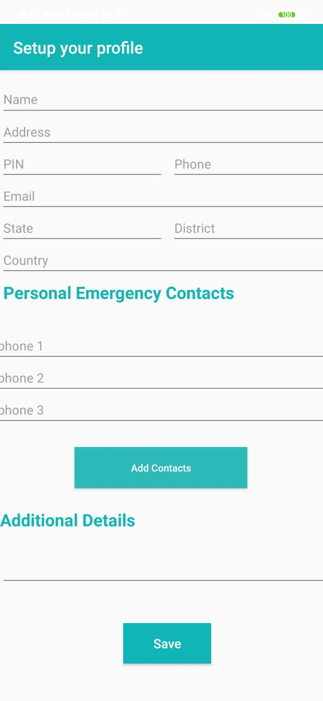

1. FEATURES
2. TRIGGER

Various options are available to send SOS message. Depending on the situation the user can use any one of these methods to instantly direct alert messages to nearest police and saved emergency contacts simultaneously.

The various methods of triggering SOS are:

1. More than three clicks on volume button: In cases where the victim cannot open the app and press SOS button, the app has the feature to send the location and a pre-set message without unlocking the phone and pressing the volume button more than thrice.
2. SOS Button: It can be used in situations where opening the app is more convenient than pressing the volume button thrice.
3. Voice Trigger : There is voice trigger facility where the user can say the default command and SOS will be activated. The user can customise the command to one which is suitable for them.

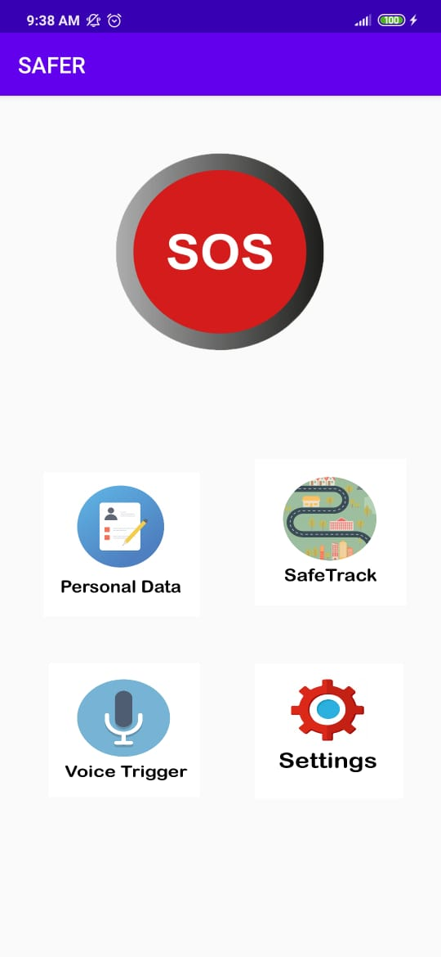

1. ‘Track My Location’

Consider the situation when you are feeling unsafe. You don’t want to press trigger but you get an intuition that you may be attacked.

In such cases ,the app provides the facility to allow track my location, where the persons location is traced . In essence ,if the user travels from A to B, the user enters the “Origin” and “Destination” and the app checks for the possible paths and tracaes the location of the user. If before reaching the destination, the location deviates from the available paths, an alert signal is sent to relatives or family members (whichever is pre-set in the app).This will allow family members to investigate and inform police.(Direct message to police is not sent to avoid false alert signals.)

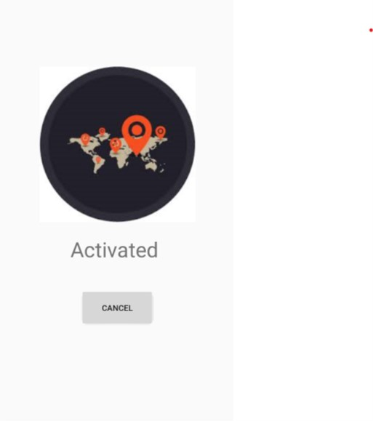

Screenshot of ‘Track My Location’ Activated

1. SAFE TRACK:

The information about the number of signals received is stored in fireabase realtime database. Thus, the number of crimes reported is stored in the database. This data can be analysed and used to classify the nearby locations as red zone (Large number of attacks) or green zone(less or no attacks yet).

As the user enters the, Google maps returns all the possible paths along with the coordinates of all localities in each path. These coordinates are compared with the coordinates of each locality and the crime index is plotted accordingly. Three paths with lowest danger index are selected and displayed to the user. K means cLustering algorithm is used to find the safest path to the destination

The information is stored in the database as key value pairs of location and Crime Index of the localities.

Information like no. of crimes in a specified location be retrieved from the app.

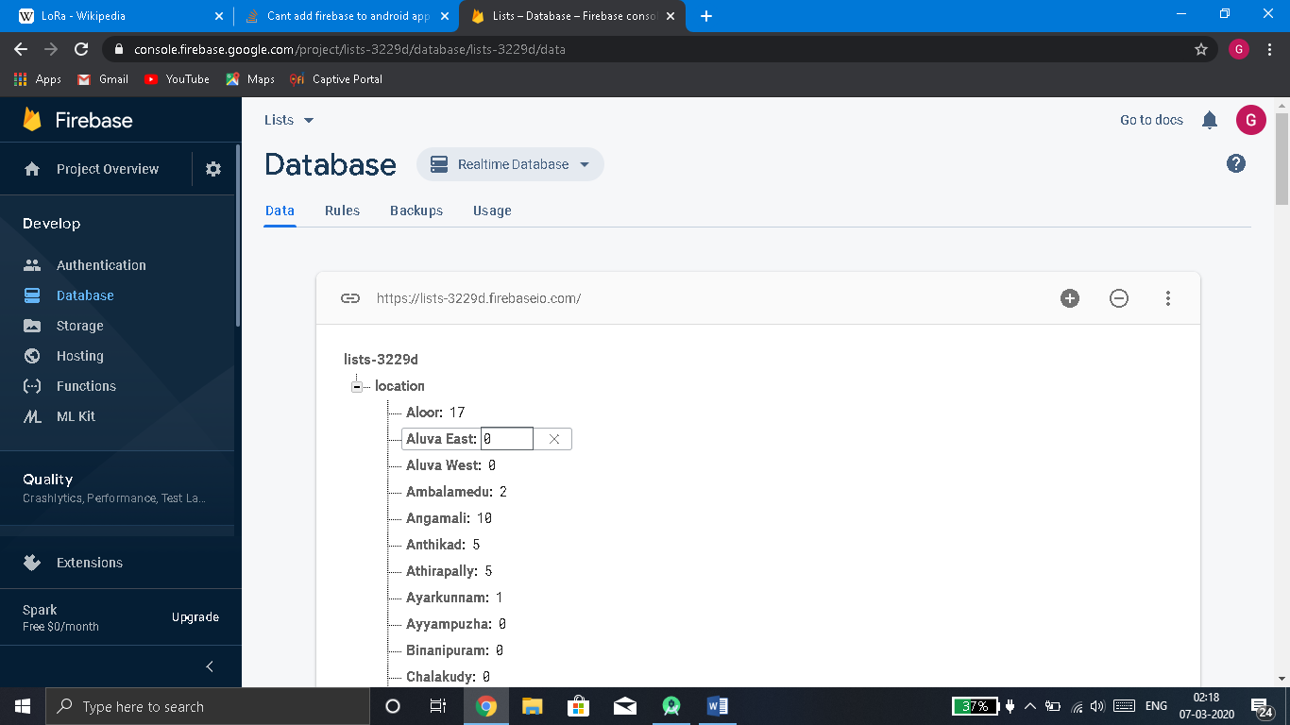

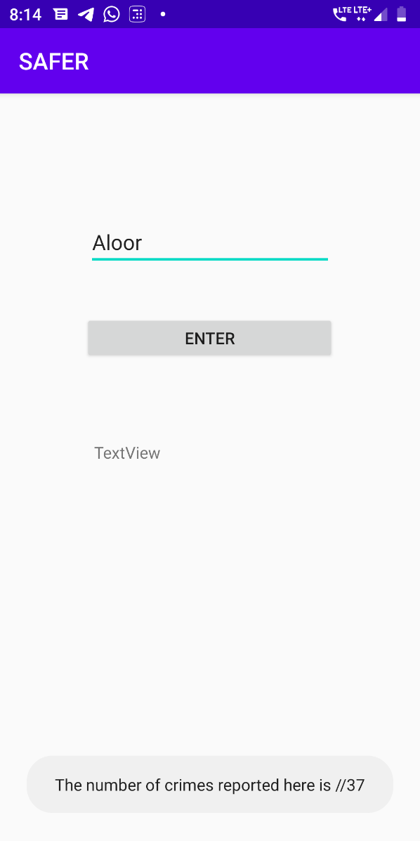

We can classify regions based on number of crimes as red , yellow, green zone and thus the police will know the areas where patrolling needs to be increased.

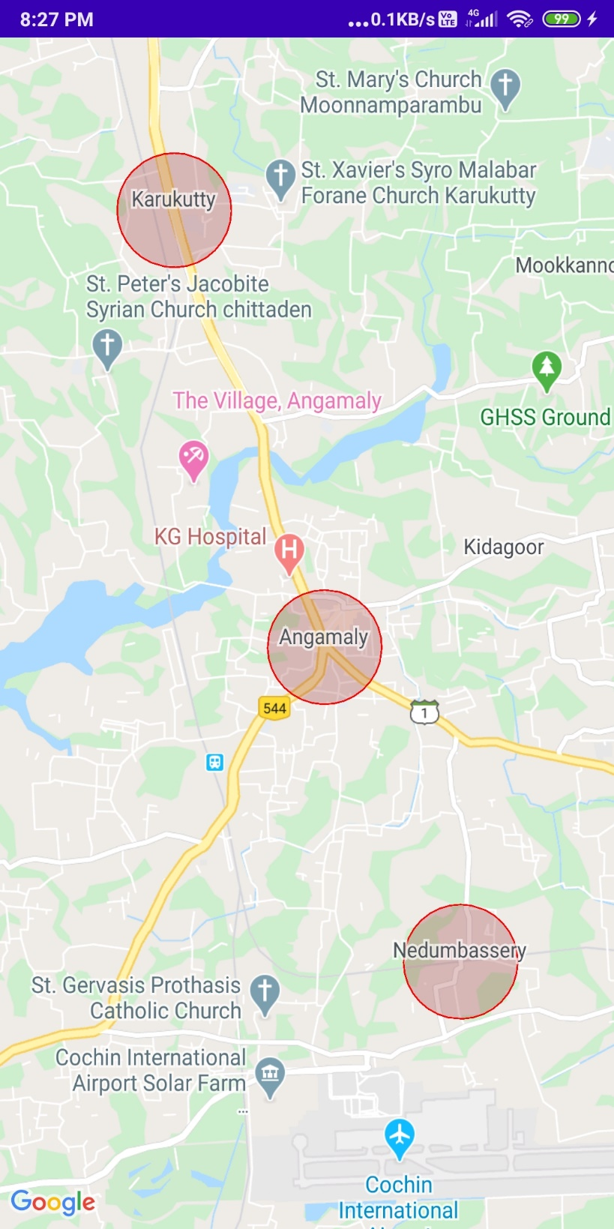

1. SAFER ELECTRONIC DEVICE:

The device has a trigger button which will send the location calculated by GPS module and send it to server via GSM communication. The device updates the current location of the device user at a definite time interval to a server as ‘current location’.

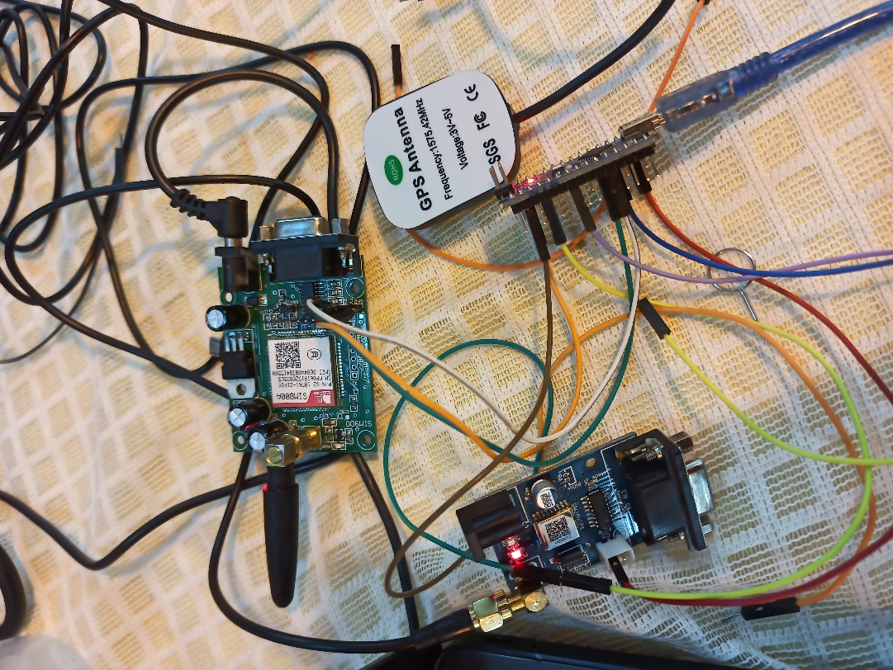

When the button is triggered , the time interval between consecutive updations of the location decreases and the message now includes an additional command “I AM UNDER ATTACK”.

The location is fetched using a GPS module and updation of fetched location to server is

done using a GSM module as sms.

If the component is out of the network area , the sms is transmitted through the lorawan gateway.

1. COMPARISON WITH SIMILAR APPS

When comparing with existing similar apps, our solution has its own uniqueness.Many SoS apps existing which uses single triggers does not work properly on background.But our application is developed to work perfectly in background.

Another important feature that distinguishes our application is that,there I no need for explicitly defining any emergency contacts.The app finds the nearby police stations by itself.Trigger customisation is also included to make it convenient for user.

1. ADVANTAGES

This architecture we introduced will implement a easy trigger,works on offline mode and even on no network availablility.Devices or apps integrated on this architecture gets the nearest police station location,people of any age group can use this app very easily,different customised trigger devices can be used for easiness of access.