Use Case: Login to Account

**1. Brief Description**

The goal of this use case it to log into your account to play the online portion of the chess game. The player tells the system that they wish to login. The system asks for login credentials. The player provides the information. The system verifies the information and logs the player in.

**2. Included Use Cases**

**3. Preconditions**

The user already has the application installed and an account created.

**4. Flow of Events**

**4.1 Basic Flow – The user performs the sign in process**

1. This use case begins when the user navigates to the sign on page

2. The user will input their username and password

3. The system will verify the username exists and the password matches the saved password

4. The system will grant the user access to play online

5. The use case ends

**4.2 Alternative Flows**

None

**4.3 Exception Flows**

E1: The user supplied password does not match what is stored.

1. This flow begins when the system determines the user supplied password and the saved password does not match

2. The system asks the user to retry their username and password

3. The use case ends

E2: The user supplied username does not exist in the database

1. This flow begins when the system determines the user supplied username does not exist

2. The system asks the user to retry their username and password

3. The use case ends

**5. Requirements**

None

**6. Post-conditions**

1. The system gives the client a sign on token with a set date for expiration

**7. Notes & Open Issues**

**8. Out of Scope (Future Functionality)**

1. Reset password functionality

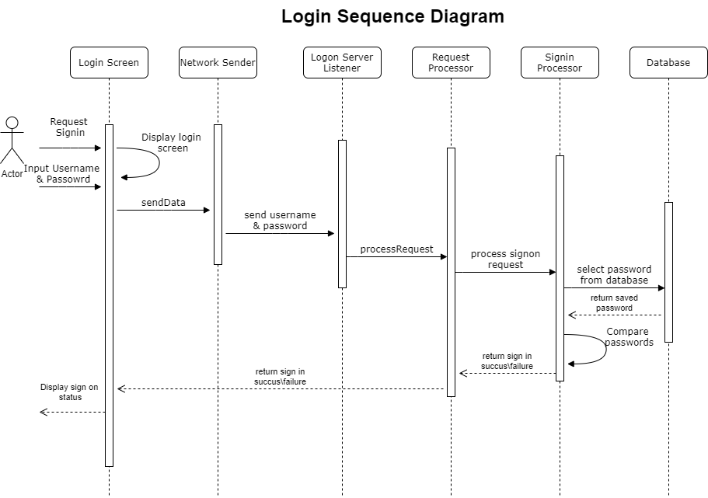**Appendix A: Login Sequence Diagram**