**Department of Informatics**

**University of Leicester**

**CO7201 Individual Project**

**DRAFT Final Report**

**[Android Puzzle Game Clone: Tic Tac Toe ]**

**[Shaheer Saleem]**

**[shaheersprinter@gmail.com]**

**[**199041862**]**

**Project Supervisor: [Gary Hill]**

**Second Marker: [XXXX]**

**Word Count: [1500]**

**[03/05/21]**

**DECLARATION**

All sentences or passages quoted in this report, or computer code of any form whatsoever used and/or submitted at any stages, which are taken from other people’s work have been specifically acknowledged by clear citation of the source, specifying author, work, date and page(s). Any part of my own written work, or software coding, which is substantially based upon other people’s work, is duly accompanied by clear citation of the source, specifying author, work, date and page(s). I understand that failure to do this amounts to plagiarism and will be considered grounds for failure in this module and the degree examination as a whole.

Name: [Shaheer saleem]

Date:[03/05/21]

Contents

**1.****Aims and Objectives** 3

**2.****Requirements** 3

**3.****Technical Specification** 3

**4.****Requirements Evaluation Plan** 3

**5.****Background Research and Reading list** 3

**6.****Time-plan and Risk Plan** 3

**7.****References** 3

# **INTRODUCTION**

1. The puzzle will be a clone of Tic tac toe. It is a game where two players put Xs and Os in specific sections of a figure made by two vertical lines crossing two horizontal lines. The goal is to try to get a row of three Xs or three Os before the other person does.

# **Aim and Objectives**

**Aim:**

One of the main goals of the project is to implement single and multiplayer player options in the game. In single player option the player opponent is the computer such as the AI which goes against the player. It will also have difficulty levels such as easy, normal, and hard. The other option is the multiplayer where a player goes against another player. There may be implementation of a league game as-well in the multiplayer. Further more, the other challenge is to develop a database such as the Firebase which would let a user to save their scores and the number of times they have played. Moreover, one of the biggest motivation for this project is to implement all of the things mentioned above. This not just a simple game with a few codes written since there are complicated algorithms behind the game which makes it very unique and worth it.

**Objectives:**

In order to achieve the aim stated above, in creating a prototype Android Puzzle Game Clone application, the following objectives need to be met:

* Develop a Tic tac toe game clone in android studio.
* Learn Java coding in android studio.
* Have AI beat user and compete the game.
* Build a mulitplayer game where players will go against each other.

# **Requirements**

Essential

* The game should be played on a grid which is 3 squares by three.
* The player is X and the opponent is O.
* Who ever gets 3 of the marks in a row up, down, across, or diagonally will be winner.

Recommended

* When all the squares are full then the game is over.

Optional

* To beat your opponent you would be need a good strategy. One of the strategy is to get 3 Xs in one row, and the other is trying to stop the computer getting three Os in a row.

1. (**Essential** - against the computer)**Phase 1 Essential** - local 1 (or **2 players – pass the device between 2 players, before implementing AI**)?

One of the most essential part of the project is to have the computer go against the player with the help of the AI. Phase 1 the player goes against another player such as play locally or the two players pass the device to each other.

2. 2 player (**Optional** – 2 player online - against friends, league table).

network 2 players?

The multiplayer part is optional where a player goes against another player such as family or in a league game.

1. **Essential** - Yes, the game will use AI. AI play against the game?

What algorithms will use implement - basic, medium, advanced?

**Recommended** – beginner, medium and expert?

1. Database (Optional) A fire base database would save the user’s information such as the score or number of times they have played. This is optional since the game finishes very quickly according to players.

# **Technical Specification**

**Technical specifications of the project;**

The task is divided into two phases

1. The gameplay mechanisms: This phase includes the players movements such as where a certain X or O is placed. This phase also includes the GUI which will be built inside the android studio.
2. Artificial Intelligence: there will be an algorithm which will try to beat the user and it will be coded in java. Implementing such algorithm in games need something such as a mini-max algorithm.

**Strategies**

One of the strategies to win the game is to make a fork that is placing the marker in a way which you will the get a chance to win in 2 ways on the your next turn. The opponent will only block you once, but you will win after that move.

Some of the must have rules are the following;

1.The game must be played on a grid of 3 squares by 3 squares.

2. The player is the X and the opponent is the O (Computer or human), and both of them take turns by having their marks on the empty square.

3. If a player is to get a 3 of the marks in a row will become the winner.

4. If all the 9 squares are full the game will be over, and if a player has 3 strikes in one row, the game will end in a draw.

**Design:**

**The grid will be a 3x3 2D array?**

**Below are the win scenarios for the cell values?**

**Pseudo code:**

**If (0,0) (0,1) (0,2) = O or X = win**

**If (1,0) (1,1) (1,2) = O or X = win**

**If (2,0) (2,1) (2,2) = O or X = win**

A pre-populated cell will be disabled if the player presses it.

To decide which player will go first the system will do a coin toss such as heads or tails. Who ever picks a side and which ever side comes first will go first.

# **Requirements Evaluation Plan**

What criteria to use to evaluate your system or experimental results? Who will be involved in the evaluation? What type of testing will you do to verify the quality of your software? In short, how will you verify that your project achieves what it sets out to do?

The criteria I will use to evaluate the software are speed, volume, performance, and scalability.

I will be manually test the software to check if there are any bugs or any other glitches which might occur during the game. There will be many testing such as

1. Performance testing: This test will show us the reliability, and the speed of the application during high load times.

2. Usability testing: This test will indicate if there are any bugs in the software or any glitches.

3.Volume testing: In this test the software’s data is opened up in a database, and the overall application behavior is observed. The goal is to check the software performance during different database volumes.

4.Load testing: This will help me to check the capability of the software during high load times. The main goal of this type of test is to identify performance bottlenecks before the actual application goes live.

The things mentioned above will help me verify and achieve what the application is set out to do.

# **Background Research and Reading list**

Background material (including a reading list and literature review where appropriate);

# **Time-plan and Risk Plan**

A detailed timetable and plan for achieving the objectives of the project (this could be tabulated or in the form of a Gantt chart), including the milestones of the project and a risk plan; Explain target dates and amount of time required for the completion of aspects of the project

On 03/08/21 I will start the first phase of the project which is the design part. I will spend two days maximum on it. After that I will start the coding part where I will do my best to complete it.

The coding part will be divided such as the first part will be development of the AI computer against the player. The other part will be the multiplayer where two players go against each other; Each part will take 2 weeks to execute.

Finally, After the coding part I will start to test the application for any bugs or any other glitches which would interrupt the gameplay for the users, this would take me a few days to execute.

|  |  |
| --- | --- |
| **Tasks** | **week** |
| Design and implementation of the project  Do more Research about the mechanisms of the game  Study AI and the mini-max | Week 1 |
| Start the coding part and also the preliminary report  Implement the rules of the games | Week 2 |
| Code the single player | Week 3 |
| Code the AI | Week 4 |
| Test the application, and remove any bugs. | Week 5 |
| Write the Interim report | Week 6 |

Design

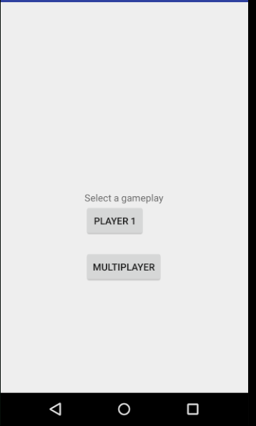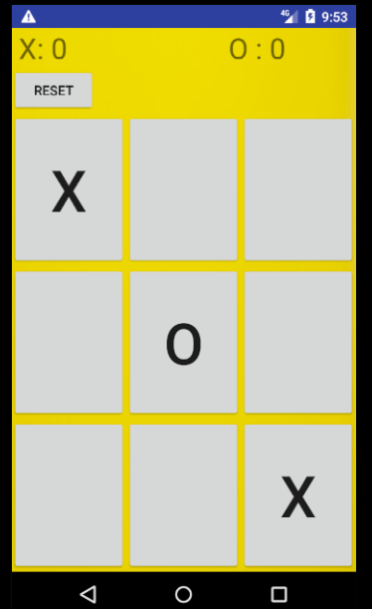

AI

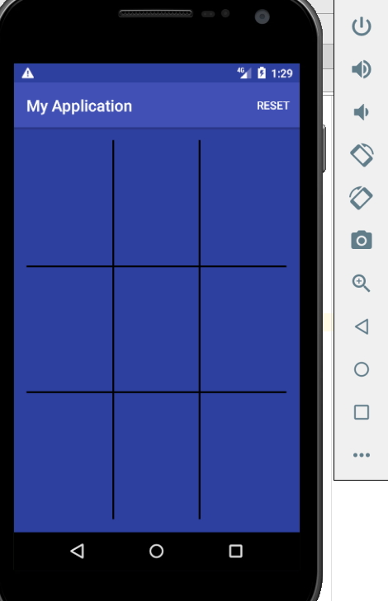

Implementation

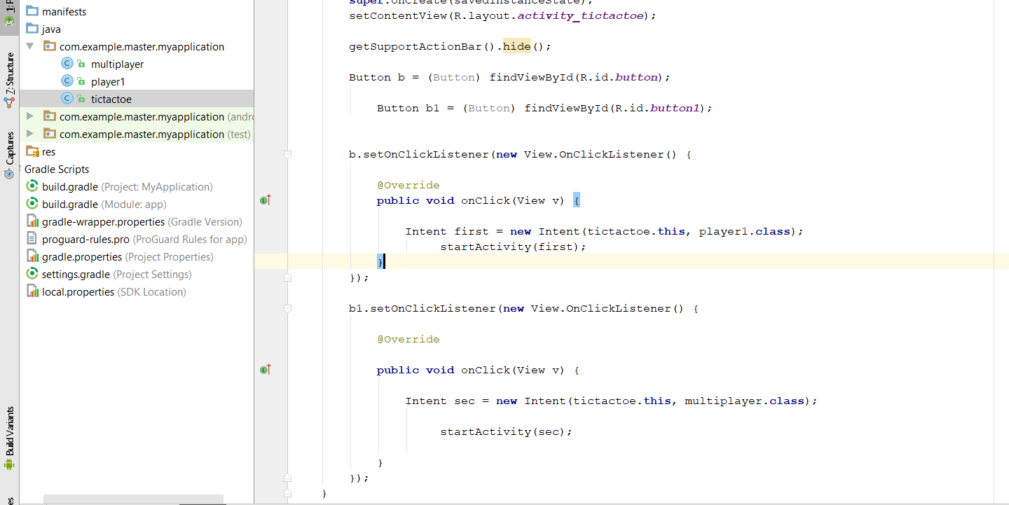

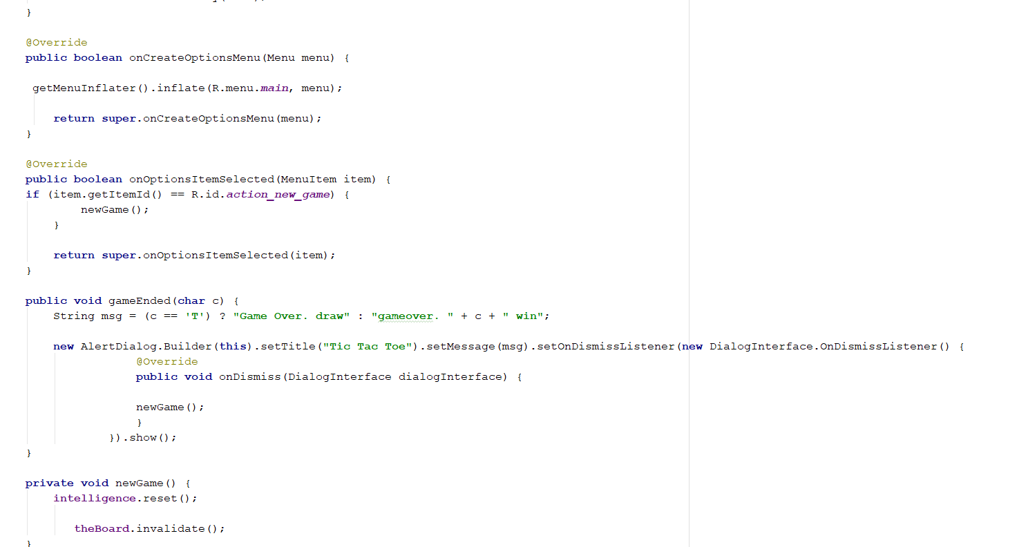

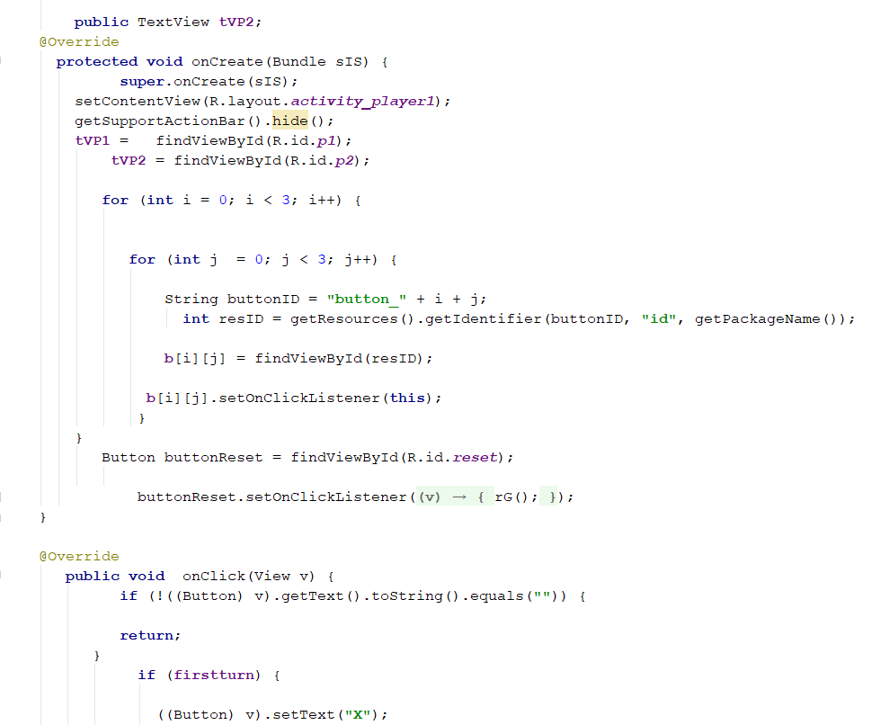

# **References**

The reference list should contain a mixture of books, research papers (if appropriate) and internet resources, and should not consist only (or mainly) of Internet resources;

# [Erik Arneson](https://www.thesprucecrafts.com/erik-arneson-409240) (2020) How to Play Tic-Tac-Toe

Retrieved from <https://www.thesprucecrafts.com/tic-tac-toe-game-rules-412170>

# **Performance Testing Tutorial: What is, Types, Metrics & Example Retrievedfrom https://www.guru99.com/performance-testing.html**