**BUG FIX REPORT**

**CS427**

**Miguel Riano**

[**mriano2@illinois.edu**](mailto:mriano2@illinois.edu)

**BUG LISTING:**

**BUG 1 – 10469 - [BUG][PYTHON] Client response is not respecting capital letters**

* Issue Link - <https://github.com/OpenAPITools/openapi-generator/issues/10469>
* Local Github repository - <https://github.com/miloriano/openapi-generator-forked-local/commits/bug-10469>

**BUG 2 – 10607 - [BUG] Unable to unpickle an object in python**

* Issue Link - <https://github.com/OpenAPITools/openapi-generator/issues/10607>
* Github repository - <https://github.com/miloriano/openapi-generator-forked-local/commits/bug-10607>

**BUG 3 – 10321 - [BUG] NullPointerException in parser when referencing invalid schema**

* Issue Link - <https://github.com/OpenAPITools/openapi-generator/issues/10321>
* Github repository - <https://github.com/miloriano/openapi-generator-forked-local/commits/bug-10321>

**BUG 4 – 10167 - [BUG][JAVA] Deserialization of array with uniqueItems=true doesn't preserve order**

* Issue Link - <https://github.com/OpenAPITools/openapi-generator/issues/10167>
* Github repository - <https://github.com/miloriano/openapi-generator-forked-local/commits/bug-10167>

**Step 1**

1. **Run MVN Package (All Success)**

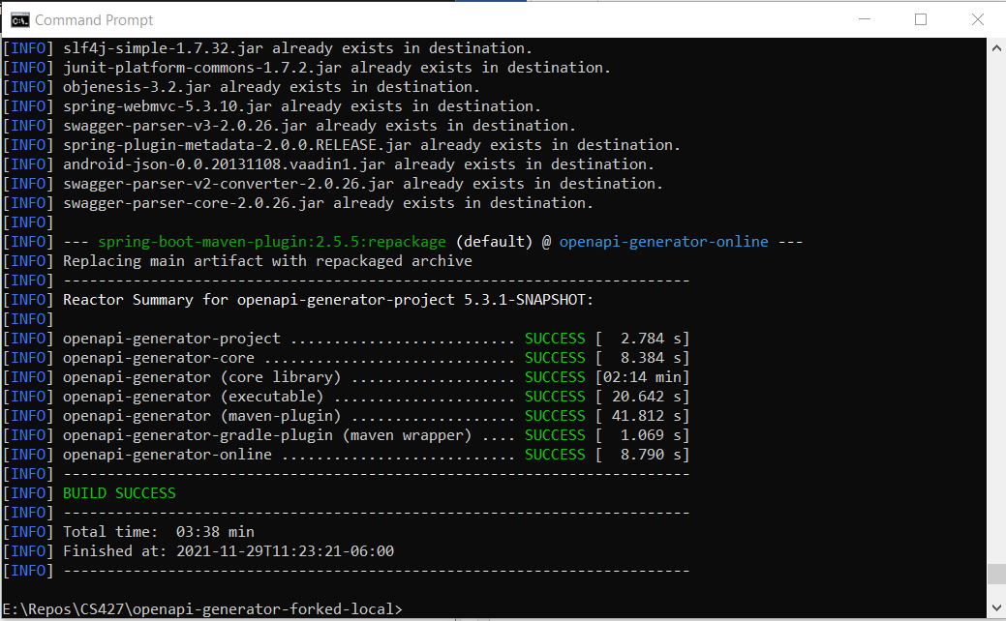

**BUG 1 – 10469 - [BUG][PYTHON] Client response is not respecting capital letters**

**Github branch -** [**https://github.com/miloriano/openapi-generator-forked-local/tree/bug-10469**](https://github.com/miloriano/openapi-generator-forked-local/tree/bug-10469)

**Case is using modelPropertyNaming, to set convention. In Python it is not working. Below is the reproduction of the error:**

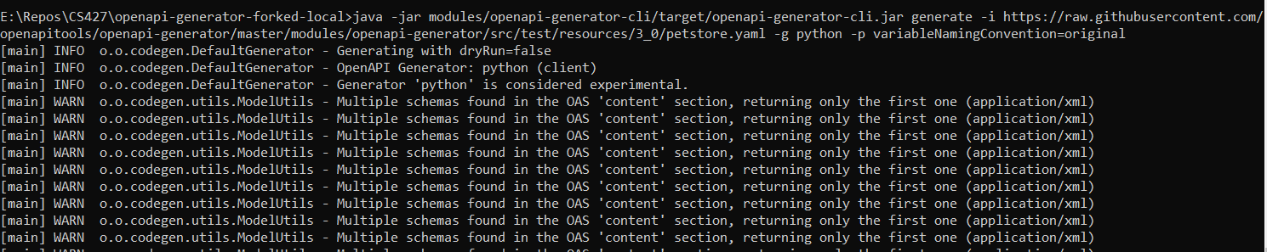

**After using the command above, the PetId converted everything to lowercase:**

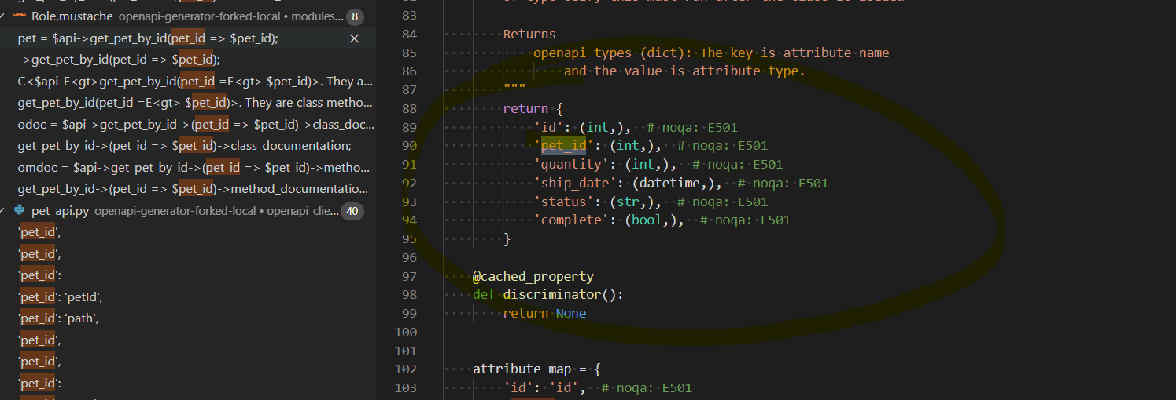

**As per investigation it is not working because the code which checks for original naming convention is not included. As such changes to the file AbstractPythonCodegen.java was done. The file is found here “openapi-generator-forked-local\modules\openapi-generator\src\main\java\org\openapitools\codegen\languages\ AbstractPythonCodegen.java”.**

**On the method name “toVarName”, this was added:**

**if ("original".equals(variableNamingConvention)) {**

**// return the name in camelCase style**

**// phone_number => phoneNumber**

**return name;**

**}**

**Code Changes made here --** [**https://github.com/miloriano/openapi-generator-forked-local/commit/051690eb58e42521c1986100467fcc1bddbdbe37**](https://github.com/miloriano/openapi-generator-forked-local/commit/051690eb58e42521c1986100467fcc1bddbdbe37)

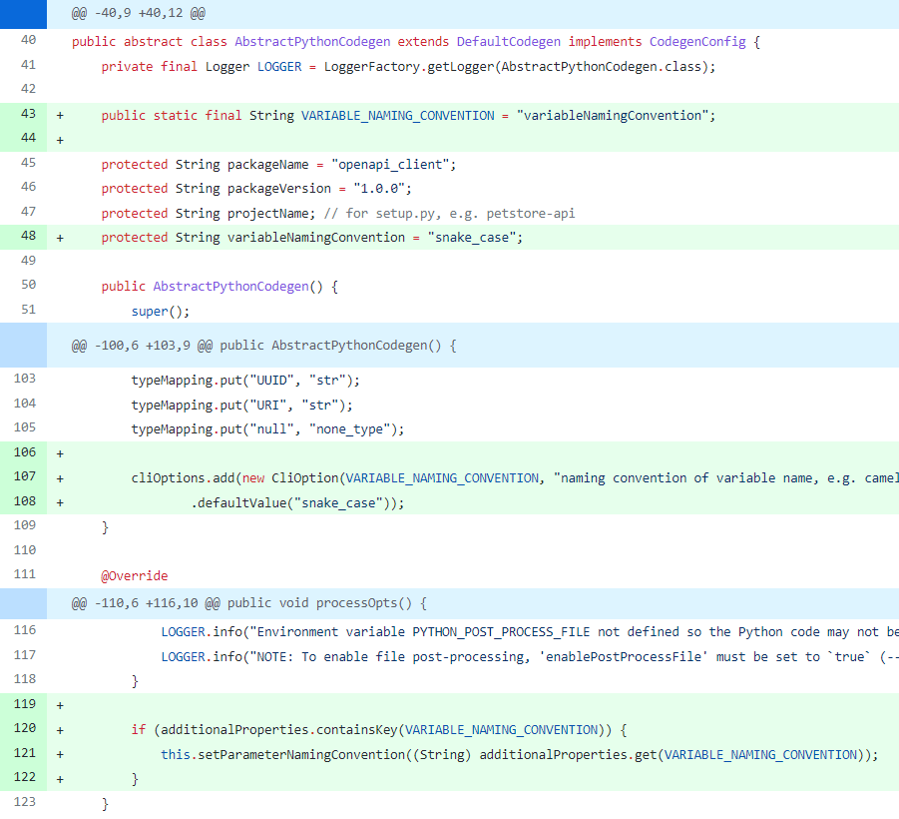

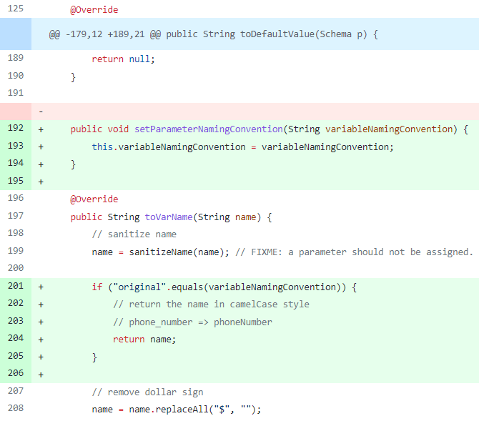

**To Test, the following command line using the additional properties added to the code is used:**



**TESTING, after the changes made it is now Respecting Capital Case:**

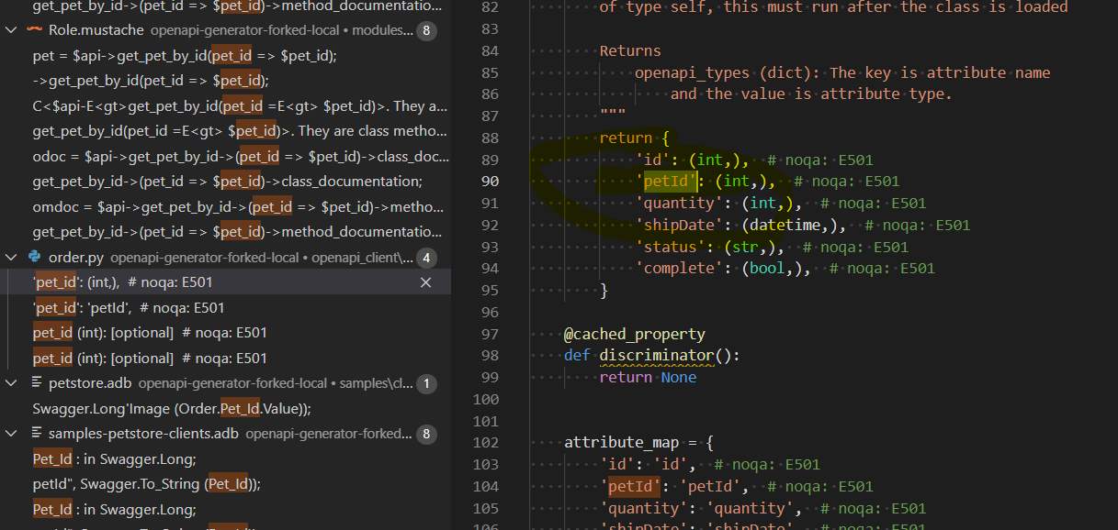

**Likewise changes to the constructor and everything was also done.**

**Code pushed to --** [**https://github.com/miloriano/openapi-generator-forked-local/tree/bug-10469**](https://github.com/miloriano/openapi-generator-forked-local/tree/bug-10469)

**Before editing Bug 10469, branch main**

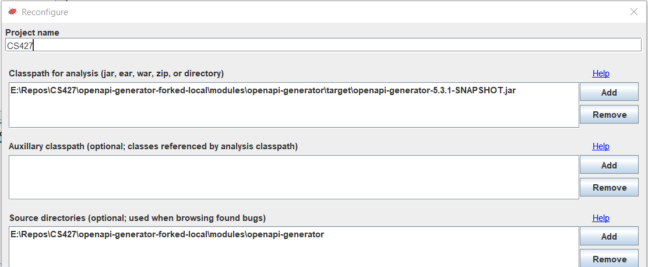

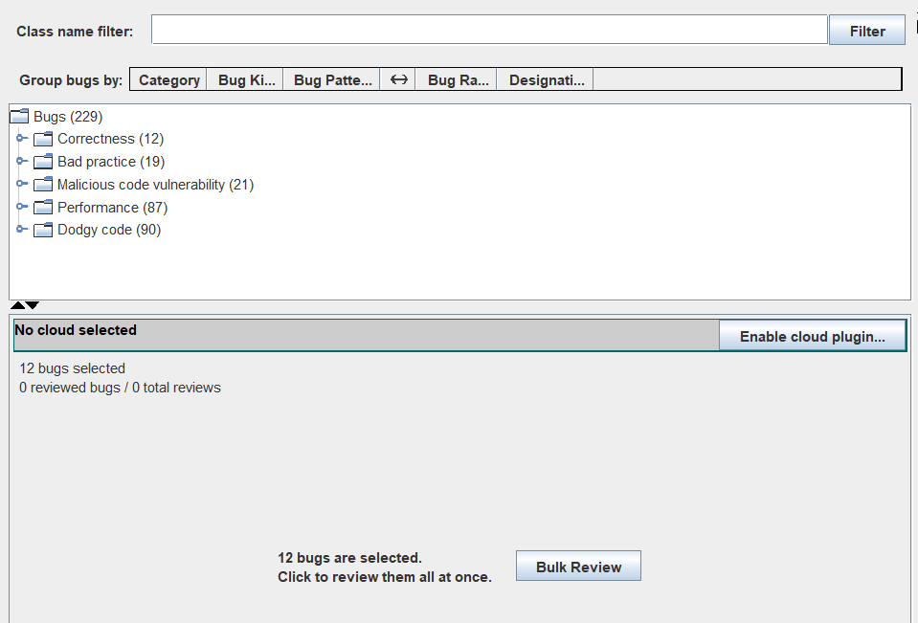

**After editing Bug 10469, branch main, no new bugs introduced.**

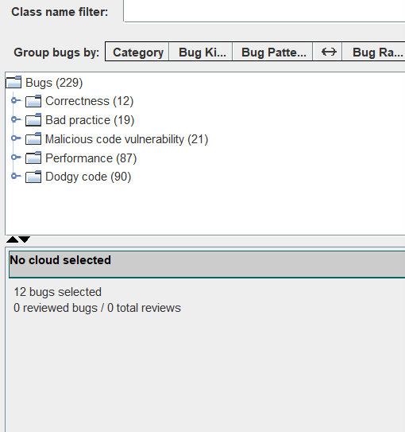

**openapi-generator-forked-local\modules\openapi-generator\src\main\java\org\openapitools\codegen\languages\** **AbstractPythonCodegen.java**

**See Report Below:**



**USING PMD BRANCH BUG-10469**

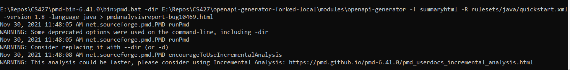

**See Report Below, no new bugs or warnings introduced after code change:**



**BUG 2 – 10607 - [BUG] Unable to unpickle an object in python**

**Github branch --** [**https://github.com/miloriano/openapi-generator-forked-local/tree/bug-10607**](https://github.com/miloriano/openapi-generator-forked-local/tree/bug-10607)

**Reproduced the error by running the following:**

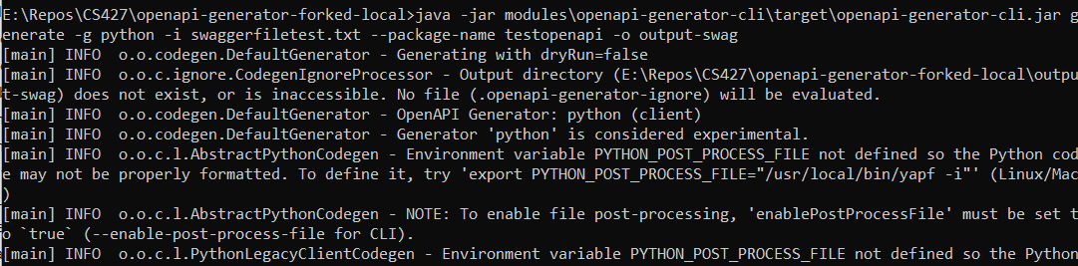

**Type the following to reproduce the exact error:**

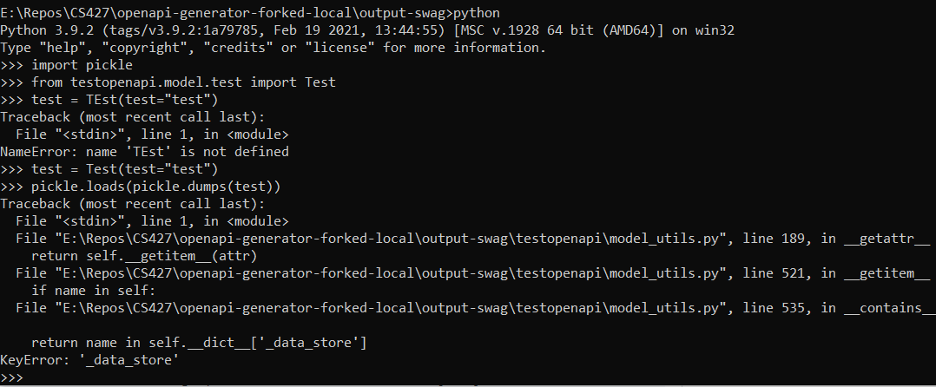

**Code Changes to solve the bug:**

[**https://github.com/miloriano/openapi-generator-forked-local/commit/6571e8e8db7f0c99e43e311e2bab9ef2a448a52d**](https://github.com/miloriano/openapi-generator-forked-local/commit/6571e8e8db7f0c99e43e311e2bab9ef2a448a52d)

**Changes to the following file is needed:**

*The code changes are removing “[e for e in [self._path_to_item, name] if e]” and adding*

*if '_data_store' not in self.__dict__:*

*return False*

\openapi-generator-forked-local\modules\openapi-generator\src\main\resources\python\model_templates\ methods_setattr_getattr_normal.mustache

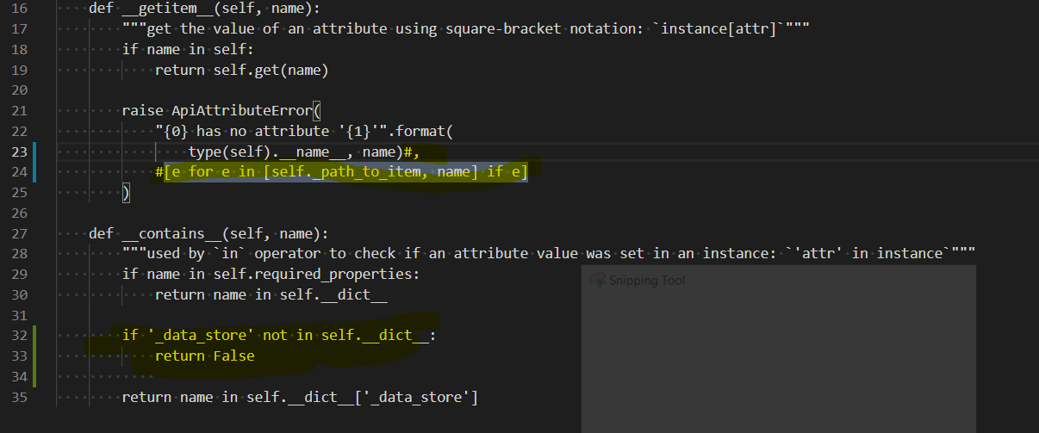

to check the code you can also use samples model_utils.py  
openapi-generator-forked-local\samples\client\petstore\python\petstore_api\model_utils.py

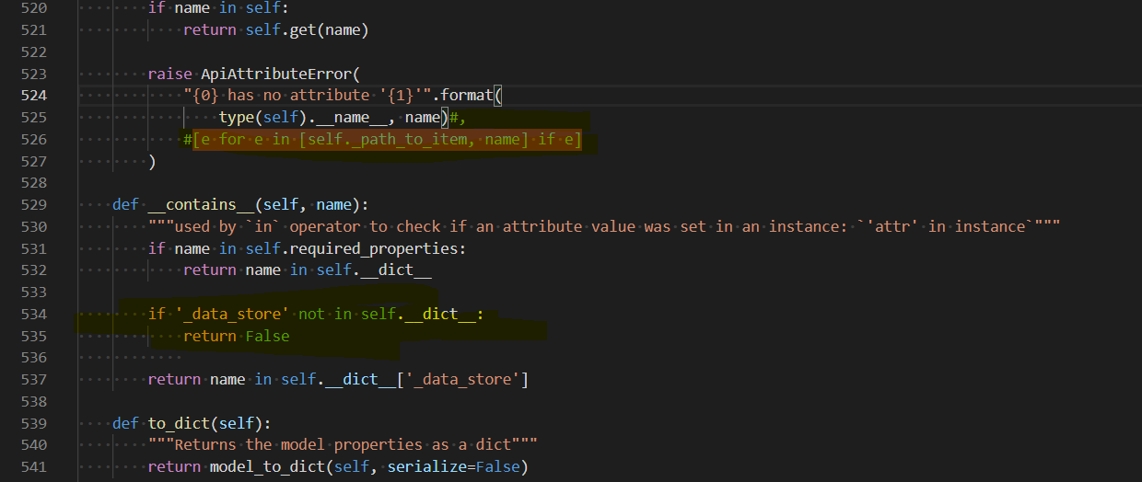

**To Build the new modifications:**

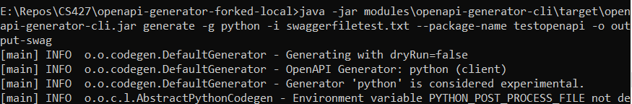

**To test the modifications (PASSED):**

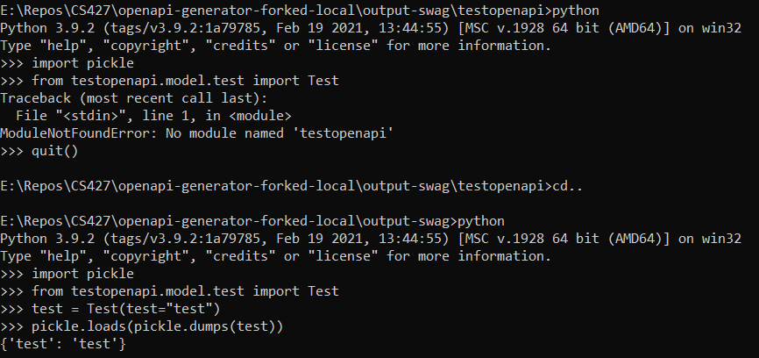

**Before editing Bug 10607, branch main**





**After editing Bug 10607, branch bug-10607**



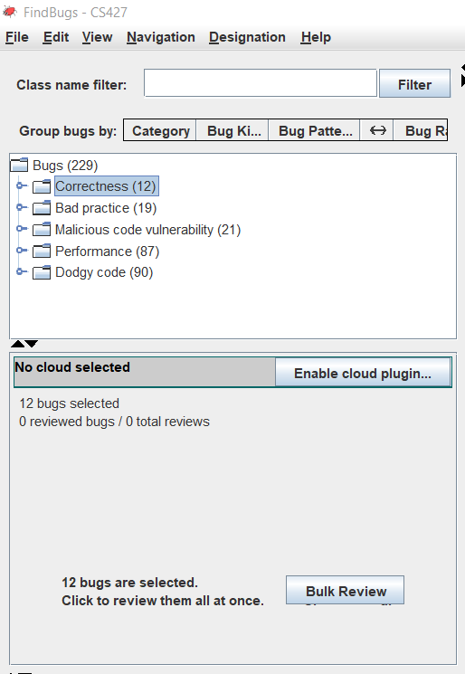

**USING PMD BRANCH MAIN**

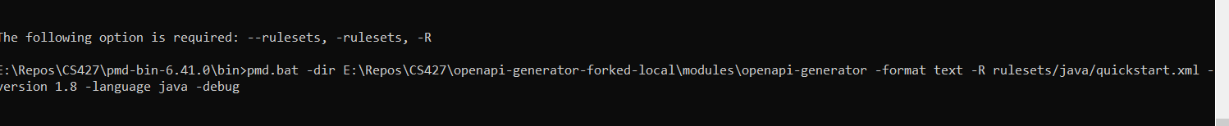



**See Report Below:**



**USING PMD BRANCH BUG-10607**



**See Report Below, no new bugs or warnings introduced after code change:**



**BUG 3 – 10321 - [BUG] NullPointerException in parser when referencing invalid schema**

**Github Branch --** [**https://github.com/miloriano/openapi-generator-forked-local/tree/bug-10321**](https://github.com/miloriano/openapi-generator-forked-local/tree/bug-10321)

**Before editing Bug 10321, branch main**

1. **Create test files to reproduce**
   1. **Other.yaml**
   2. **Test.yaml**
2. **Run mvn clean package**

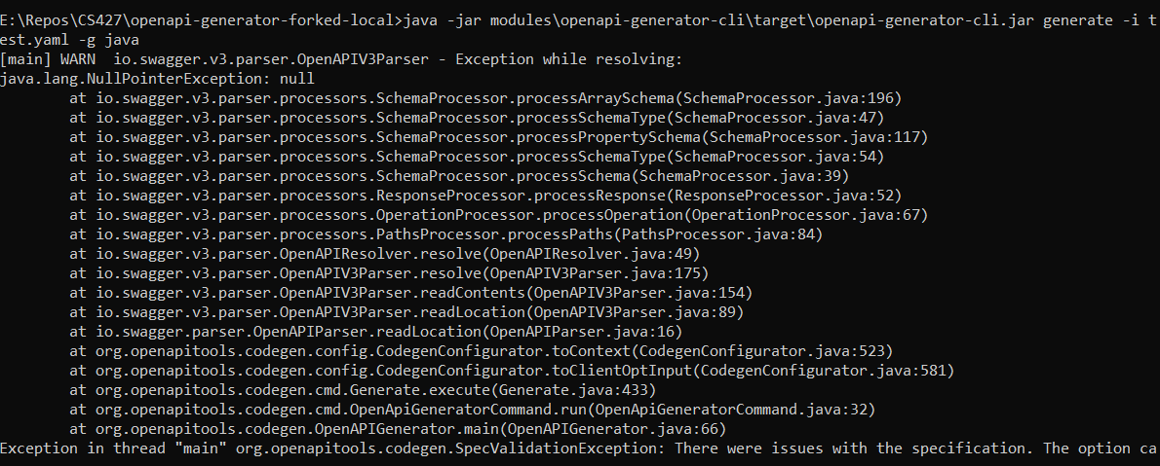

**The code now prints “There were issues with the input specification, test.yaml”. We caught the error and made sure we removed the null pointer exception.**

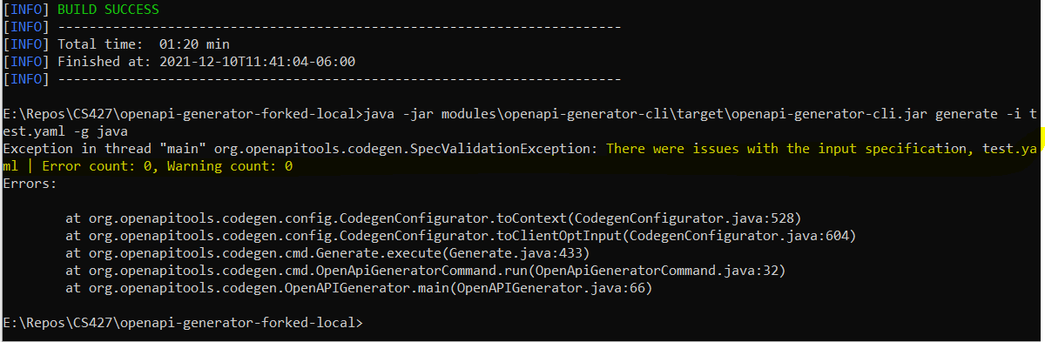

**BUG 4 – 10167 - [BUG][JAVA] Deserialization of array with uniqueItems=true doesn't preserve order**

File analyzed -- openapi-generator-forked-local\modules\openapi-generator\src\main\java\org\openapitools\codegen\utils\ModelUtils.java

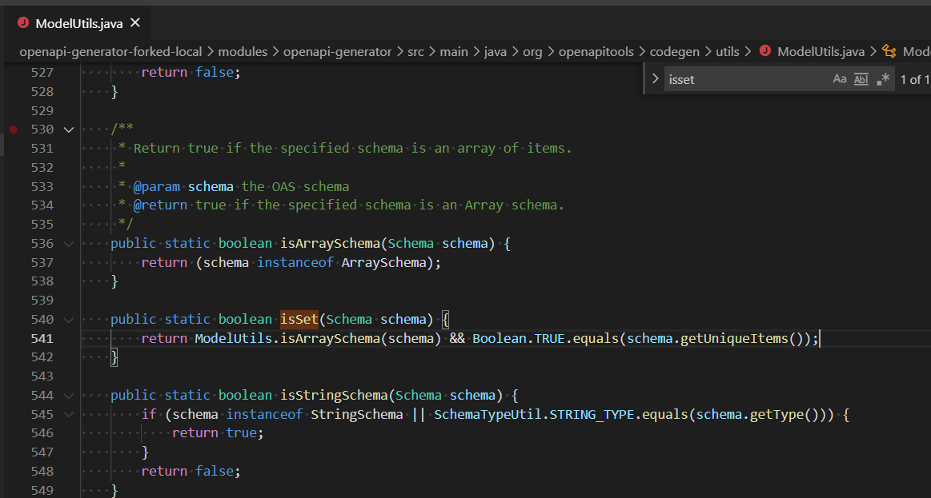

**Another merged was done to fix this one --** [**https://github.com/OpenAPITools/openapi-generator/pull/10241**](https://github.com/OpenAPITools/openapi-generator/pull/10241)**, which is a workaround.**

**The issue was caused by a change made in** [**https://github.com/OpenAPITools/openapi-generator/pull/5466**](https://github.com/OpenAPITools/openapi-generator/pull/5466)**, which created bug-10167. The number of files that was changed was 348 files.**

[**https://github.com/OpenAPITools/openapi-generator/issues/5254**](https://github.com/OpenAPITools/openapi-generator/issues/5254) **- another set of changes that caused the bug.**

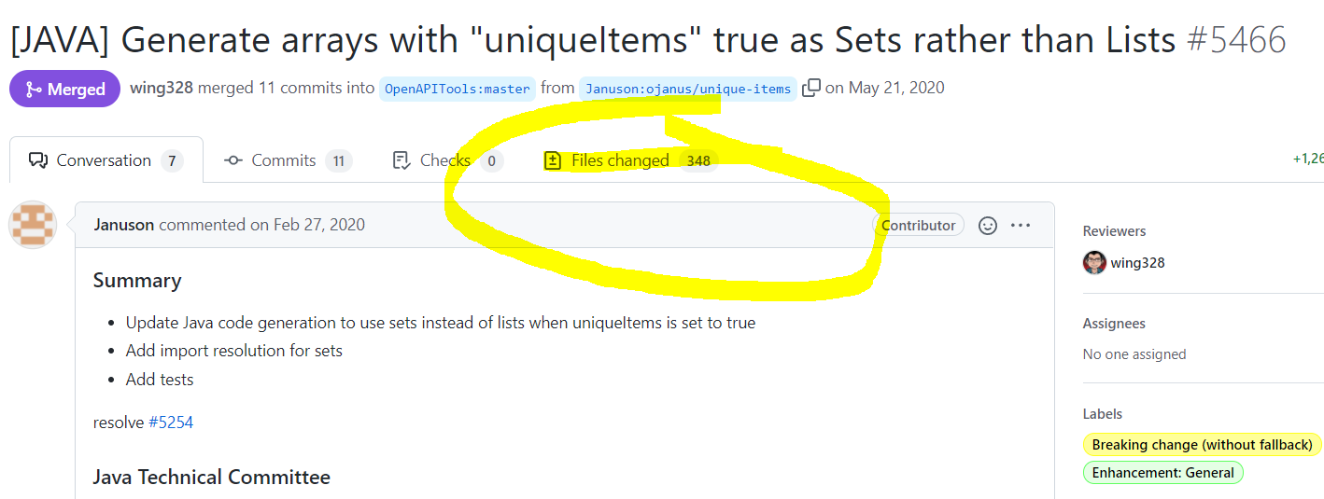

**Link here explains that the bug is not just a bug, but need to re-code, re-architecture from Hashsets to ArrayList.**

Posting some conclusions from IRC discussions:

Even though this workaround will work for preserving order, using any hash-based data structure (HashSet, LinkedHashSet, HashMap) would cause another problem with a use case we had not considered before: if the user sent duplicate items (e.g. 'a, b, c, a'), one of the duplicates would be silently dropped.

What we should probably do is use an ArrayList, which will both a) preserve insertion order, and b) allow duplicates, so that we can explicitly iterate it and if we find duplicates throw an error.

Given that we don't want to use a LinkedHashSet, then I'd say applying this workaround is unneeded, so I'll close this PR

[**https://github.com/candlepin/candlepin/pull/3127#pullrequestreview-749248125**](https://github.com/candlepin/candlepin/pull/3127#pullrequestreview-749248125)