Project Planning – CIS Flower Shop

CIS 2250 – Kendall Fowler

# Custom Icon

Background image sourced from <https://pixabay.com/illustrations/floral-pattern-background-1814372/>

# Screen and Functionality Design

## Colour Scheme

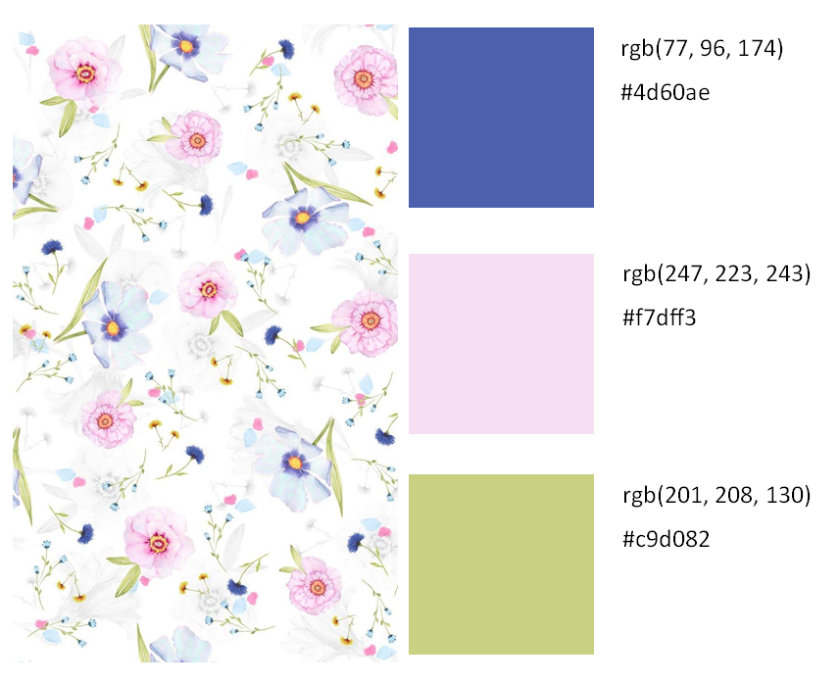

## Welcome Page

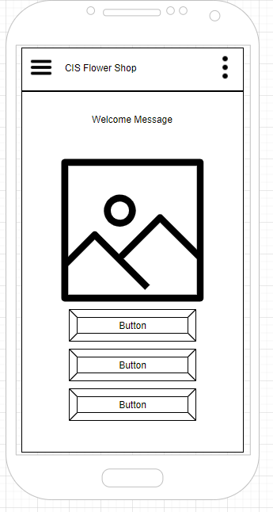

The application will open to the home page, here the user will be greeted by an image carousel of flower related images. To the top right will be an overflow menu and to the left will be a hamburger menu.

Depending on the requirements of the project there will be two to three buttons below the images taking the user to content screens.

## Nav Drawer

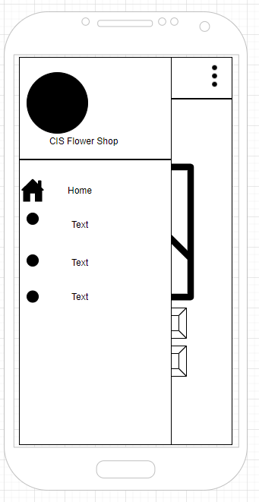

When the hamburger menu is engaged the user will be led to a nav drawer menu, they will see the company logo, application name and a series of buttons. One to lead the user back home, and the others will lead to content pages depending on the project requirements. These buttons will likely match the button content on the front page.

## Overflow Menu

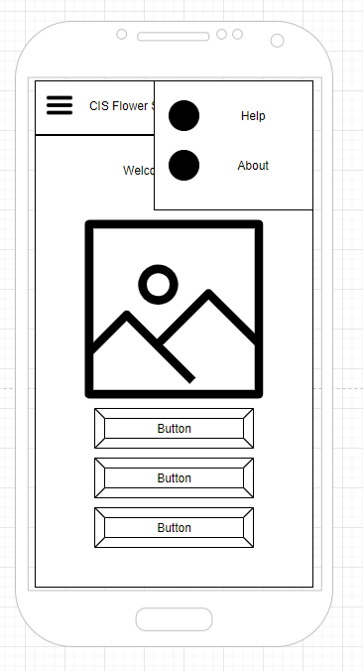The overflow menu will have two links, one for Help and one for About, when clicked these will take the user to separate pages for each content.

## Basic Content Page

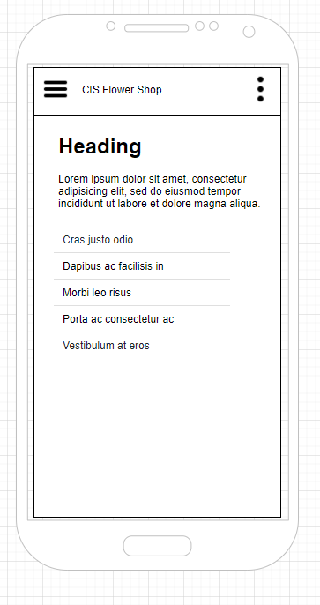Pages that display content will have a header that shows the user where they are with a sentence of information. Depending on the content it can be a series of lists or links to Social Media.