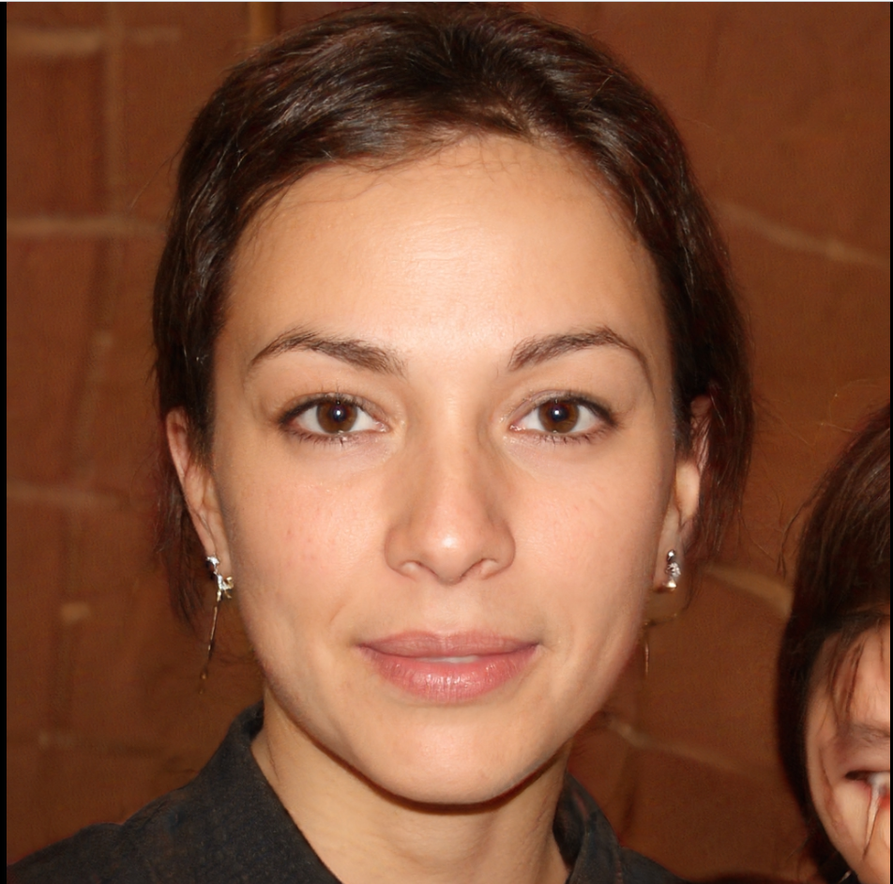

**Name Violette Baudelaire**

**Age 22**

*“My followers are always asking me how I am managing my videos and other contents. But I can not show them my planner, I am too ashamed of it.”*

Violette is a youtuber and an influencer. She is sharing her passion for science and parts of her private life on social media. She is well organized. She is currently using a bullet journal but she hates her writing and always loses it. She wants to be more organized because she has a very busy schedule. Indeed, she has to take care of her two younger siblings and she is working on her own. Moreover, she would like to add content to her channel as videos about her way of organizing herself, but she can not show her messy planner.

**Characteristics :**

* Works as a youtuber and an influencer
* is passionate about science
* loves to take care of her family
* has not found a way of organization that fits her

**Goals :**

* finding a system of organization that she can not lose
* being able to share her way of organizing with her followers
* having her personal and her professional planning in the same space, but not mixed together

**User case scenario :**

Violette has to post a video on Monday and to take care of her siblings the whole week-end. She needs to plan activities for her siblings but also the steps of the making of the video. She has a notebook that she uses as a planner but she is afraid of forgetting it or that her siblings will destroy it.

**Behaviors :**

Organisation 💙💙💙♡♡

Social media 💙💙💙💙💙

Interesting in mobile app 💙💙💙♡♡

Time spent with family 💙💙💙💙♡

Interest in technology 💙💙💙💙💙