Lab 1 Care Corner Product Description

Ernest Webb

Old Dominion University

CS410

Professor Ajay Gupta

December 05, 2020

Version 1

**Table Of Contents**

**1. Introduction 3**

**2. Care Corner Product Description 3**

**2.1 Key Product Features and Capabilities 3**

**2.2 Major Components (Hardware/Software) 4**

**3. Identification of Case Study 5**

**4. Care Corner Product Prototype Description 5**

**4.1 Prototype Architecture (Hardware/Software) 5**

**4.2 Prototype Features and Capabilities 5**

**4.3 Prototype Development Challenges 5**

**5. Glossary 6**

**6. References 7**

# **1. Introduction**

In today’s society, Women are taught and almost forced to have a plan whenever they go anywhere just in case something bad happens to them and this is backed up by statistics such as, 7 out of 10 women saying that their phone is always prepared when they are walking alone and 61% of women polled in another study say that they take regular steps to avoid being sexually assaulted. This is an unfortunate, but true reality many women have to deal with daily.

The other main issue women have to contend with besides the fear of being sexually assaulted is what do they do after getting sexually assaulted because most women simply don’t know where to go for help or what to even do in that situation. After doing much research on this topic, our team learned that one in three women are a victim of rape or attempted rape, but only 1/5 of those cases are ever reported and based on this statistic, one can clearly see that there is a disconnect between an assault happening and the crime being reported.

Now we arrive at a solution to this problem – our product aptly named Care Corner which is a mobile application that will provide ways for victims of sexual assault to find the resources they need quickly, prevent a situation like that from occurring altogether, and to report the crime if one does occur.

**2. Care Corner Product Description**

As stated previously, Care Corner is a mobile application that will provide ways for victims of sexual assault to find the resources they need quickly, prevent a situation like that from occurring altogether, and to report the crime if one does occur. Care Corner accomplishes this by having a multitude of features including a panic button, fake phone call, Mombot, built-in resources, journal, and education of reporting. Furthermore, having all of these features in one convenient application and being easy to access and use is one of the things that set it apart from other products on the market.

**2.1 Key Product Features and Capabilities**

Previously, I described all the features that will come with the Care Corner application and now I will describe exactly what each of the main features do and just to reiterate each feature again -- they are the panic button, fake phone call, Mombot, built-in resources, journal, and education of reporting.

Firstly, the panic button when activated will send an alert to trusted contacts (that you setup in advance) and it will be begin automatically recording audio and video which can then be used as evidence in case something does occur, and all that data will be placed on our servers for a period of time.

Secondly, we have the fake phone call feature which can get one of out a potentially bad situation for example if somebody is trying to hit on you at a bar and you aren’t interested or feel threatened you could use the fake phone call as a way to get away safely and similarly if you are walking alone, it might make one feel better and potentially prevent somebody from assaulting you because you are on a phone.

Thirdly, we have what we have aptly named Mombot – which is simply a chat bot which will analyze your words for certain keywords and direct you where you need to go or give you helpful feedback of some kind. This is essentially just a chat bot (which will also include a voice chat feature) and the information that it will give you are ones found in our resources section of the application or maybe it will direct you to the nearest women’s shelter or similar location.

Fourthly, we have an entire section in our application dedicated to sexual assault resources and you do not even have to sign up to use this information. The resources will include things like what to do in ‘x’ situation and it will have a list of national or local phone numbers to call in case you are sexually assaulted which can be very helpful in the aftermath of such a traumatic event.

Fifthly, we have a built-in journal application which is helpful for those who have been sexually assaulted because it helps them come to terms with what happened and just assists with their recovery.

Lastly, our mobile application provides education of reporting which is important because crime simply needs to be reported and most people simply don’t report crimes or don’t know how to go about doing so and our application teach users the various ways to go about reporting crimes like these.

## **2.2 Major Components (Hardware/Software)**

Care Corner will be supported for Android and iOS operating systems. The external APIs that will be used in this product will be Jsoup, Google Maps API, and Twilio. Jsoup will be used in web scraping various resources from google and other sites. The Google Maps API will be used to find the nearest place and direct the user to that location (using their preset location data). Twilio will be used to create a chat bot to direct users via text or voice to find the help they need.

The web and file servers will be hosted on a Linux machine and we will also utilize JavaScript and PHP in conjunction with our website and database respectively. Furthermore, the web server is mainly just there to host our website whereas the file server will store data that our app will use that has been data scraped.

The database will be created using MySQL and be hosted on AWS. The database will be used to store the video/audio recordings, resource information, contact information, optional school information, user information (profiles, settings, location data, etc.).

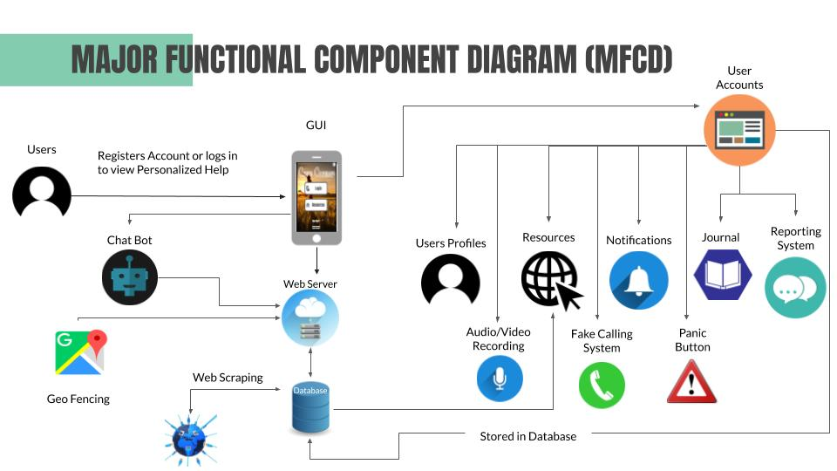

**3. Identification of Case Study**

1. Who is this product for:
   1. Women (mostly anyways)
   2. Indirectly the Friends/Family of said Women
2. What will it be used for:
   1. To help people combat sexual assault by offering them an easy way to get help or information fast
3. Who else might this benefit from this:
   1. Health Organizations
   2. Authorities
   3. Society

# **4. Care Corner Product Prototype Description**

**4.1 Prototype Architecture (Hardware/Software)**

## **4.2 Prototype Features and Capabilities**

## **4.3 Prototype Development Challenges**

# **5. Glossary**

**Agile**: Set of frameworks and practices where solutions evolve through collaboration between self-organizing cross-functional teams

**Amazon Web Services (AWS)**: Cloud computing platform provided by Amazon

**Android**:Mobile operating system primarily developed by Google

**API:** Application Programming Interface

**Client-server**: Computer system where a central server provides data to a number of networked workstations

**Cloud Based Database Server**:Virtual infrastructurethat performs application and information-processing storage

**Data Retention**: Storage of an organization’s data for compliance or business reasons

**Database**: Structured data held in a computer

**File Server**:Controls access to separately stored files

**Geofencing**:Using GPS to create a virtual geographic boundary

**GitHub**: Web-based collaboration platform for software developers

**GPS:** Global positioning system

**Gradle**: Build automation tool for multi-language software development

**GUI**: Graphical user interface

**HTML**:Standard markup language for documents designed to be displayed in a web browser

**iOS**:Mobile operating system developed by Apple

**JavaScript**:Object-oriented computer programming language commonly used to create interactive effects within web browsers

**Jsoup**: Open source Java library used mainly for extracting data from HTML

**Kotlin**:Object-oriented programming language initially designed for Android and Java Virtual Machine (JVM)

**Linux**: Unix-like, open source operating system for computers, servers, mainframes, etc.

**MySQL**: A freely available open source relational database management system that uses structured query language (SQL)

**PHP**:General-purpose scripting language suited to web development

**RSS** **Feed**: Set of instructions on the computer server of a Web site. The feed tells the reader when new material has been published on the Web site

**Scrum**: A process framework used to manage product development and other knowledge work

**Stakeholder(direct)**: Those involved in the company’s day-to-day activities

**Stakeholder(indirect):** Those more interested in the result of the production

**Twilio**: A developer platform for communications

**UI / UX**: User Interface / User Experience

**Web Scraping**: Extracting/scraping data from websites

**Web Server**:A computer that runs websites

**Windows**: Series of operating systems developed by Microsoft

# **6. References**

“About 211.” 211.Org, www.211.org/pages/about. (1)

“List of Hotlines.” Please Live, Davo Productions, 15 Jan. 2020, www.pleaselive.org/hotlines/.  (2)

Amin. “Step by Step Guide on Scraping Data from a Website and Saving It to a Database.” How PC Rules My Life, 13 Dec. 2017, howpcrules.com/step-by-step-guide-on-scraping-data-from-a-website-and-saving-it-to-a-database/. (3)

Miles, Stephanie. “5 On-Demand Apps for Emergency Services.” Street Fight, 1 Apr. 2016, streetfightmag.com/2016/04/01/5-on-demand-apps-for-emergency-services/. (4)

Self-Care for Friends and Family. (n.d.). Retrieved September 27, 2020, from <https://www.rainn.org/articles/self-care-friends-and-family>. (5)

Staff, Psyche Central. “Common Hotline Phone Numbers.” Psych Central, 6 Mar. 2019, psychcentral.com/lib/common-hotline-phone-numbers/. (6)

Tips for Talking with Survivors of Sexual Assault. (n.d.). Retrieved September 27, 2020, from https://www.rainn.org/articles/tips-talking-survivors-sexual-assault. (7)

Questions & Answers on Sponsorship(2019). Alcoholics Anonymous World Services, Inc. https://www.aa.org/assets/en_US/p-15_Q&AonSpon.pdf. (8)

Jain, A. (2019, April 09). Database Hacking & Its Prevention. Retrieved October 07, 2020, from https://thecybersecurityplace.com/database-hacking-its-prevention/ (9)

“Suicide Statistics and Facts.” SAVE, save.org/about-suicide/suicide-facts/. (10)

“Preventing Suicide |Violence Prevention|Injury Center|CDC.” Centers for Disease Control and Prevention, Centers for Disease Control and Prevention, 21 Apr. 2020, www.cdc.gov/violenceprevention/suicide/fastfact.html. (11)

“The Relationship Between Mental Health Care Access and Suicide.” RAND Corporation, www.rand.org/research/gun-policy/analysis/essays/mental-health-access-and-suicide.html.) (12)

“Addiction Statistics - Facts on Drug and Alcohol Use.” Addiction Center, 18 Sept. 2020, www.addictioncenter.com/addiction/addiction-statistics/. (13)

Duration of Suicidal Crises.” Means Matter, 7 Mar. 2017, www.hsph.harvard.edu/means-matter/means-matter/duration/. (14)

Renninson, Callie. “Rape and Sexual Assault: Reporting to Police and Medical Attention.” Bureau of Justice Statistics (15)

“Why Don't They Tell?” Nctsn.org. (16)

What Is Sexual Abuse?” Hope Alliance, www.hopealliancetx.org/sexual-assault-statistics/. (17)

50 Obstacles to Leaving.” The Hotline, www.thehotline.org/resources/50-obstacles-to-leaving/. (18)

“Find Support.” Aspergillosis Patients and Carers, 29 May 2020, aspergillosis.org/find-support/. (19)

“Support Groups.” MHA Screening - Mental Health America, screening.mhanational.org/content/support-groups. (20)

Basler AG. “Sales and Support: Basler.” Basler AG, 7 Oct. 2020, www.baslerweb.com/en/sales-support/. (21)

“The US System Didn't Protect These Women - so Now They're Taking a Stand for Others.” *Amnesty International*, [www.amnesty.org/en/latest/news/2019/10/gun-violence-report/.(22)](http://www.amnesty.org/en/latest/news/2019/10/gun-violence-report/.(22))

Davey, Melissa. “Domestic Violence: Five Women Tell Their Stories of Leaving - the Most Dangerous Time.” *The Guardian*, Guardian News and Media, [www.theguardian.com/society/ng-interactive/2015/jun/02/domestic-violence-five-women-tell-their-stories-of-leaving-the-most-dangerous-time.(23)](http://www.theguardian.com/society/ng-interactive/2015/jun/02/domestic-violence-five-women-tell-their-stories-of-leaving-the-most-dangerous-time.(23))

“How Long Does It Take for an Addiction to Develop?” *Drug Rehab*, www.drugrehab.com/addiction/how-long-does-it-take-to-develop/.(24)

“SQL Injection Prevention.” OWASP, Open Web Application Security Project, cheatsheetseries.owasp.org/cheatsheets/SQL_Injection_Prevention_Cheat_Sheet.htmL (25)

Movil, Noticiero. “News.” Noticiero Movil, 22 Oct. 2016, noticieromovil.com/what-women-worry-about-when-theyre-out-at-night/(26).

“Parenting, Baby Names, Celebrities, and Royal News.” CafeMomcom, cafemom.com/lifestyle/215107-things-women-do-to-protect-themselves/255361-katz_then_compares_the_reaction_and_responses_from_the_men_in_the_room_to_the_women_and_unsurprisingly_they_are_drastically_different (27)

Dewan, Shaila. “Why Women Can Take Years to Come Forward With Sexual Assault Allegations.” The New York Times, The New York Times, 18 Sept. 2018, www.nytimes.com/2018/09/18/us/kavanaugh-christine-blasey-ford.html.(28)

“SCRUM Methodology.” Zaynab's Blog, Zaynabzahra, 7 Oct. 2017, zaynabzahrablog.wordpress.com/2017/10/07/scrum-methodology/. (29)