**Lab 1 - Care Corner Product Description**

**Thorrell Turner**

**Old Dominion University**

**CS410**

**Professor Ajay Gupta**

**7 December 2020**

**Version 1 - Draft**

### **Table of Contents**

1. Introduction 3

2. Care Corner Product Description 4

2.1 Key Product Features and Capabilities 5

2.2 Major Components (Hardware/Software) 6

3. Identification of Case Study 8

4. Care Corner Product Prototype Description 8

4.1 Prototype Architecture (Hardware/Software) 8

4.2 Prototype Features and Capabilities 8

4.3 Prototype Development Challenges 8

5. Glossary 8

6. References 10

### 

### **1. Introduction**

Sexual assault is far too common, and it primarily effects women. It is reported that one in three women have been the victim of rape or attempted rape.(1) Sexual assault on women has become so prevalent that a majority of them admit to taking regular steps to avoid being sexually assaulted.(2) Approximately 70% of women also admit to always having their phone with them when preparing to walk alone.(2)

The high-frequency of sexual assaults against women is only exacerbated when the realities of how few assaults are actually reported is taken into account. Only around one in five rapes are ever reported.(1) Not only is there a lack of education in regards to how to report rape or sexual assault, there is also a lack of education on what rape or assault even is. In addition to not knowing if what happened to them is considered rape or sexual assault, women often have to deal with other barriers including confusion, fear of judgment, and perceived lack of evidence.(3)

These two elements couple to create a negative cycle amongst women and assault victims. Women live in fear of being assaulted, and if they are assaulted, the assailant is not held accountable. This means that a woman's mental health can be negatively affected, while their assailant is free to continue to victimize others.

Care Corner is a tool that is meant to serve as an aid to reduce the frequency of these assaults, build an appropriate confidence in women as a travel alone, and increase the frequency of reporting attacks, so guilty parties are held accountable. Care Corner offers preventive measures, such as a panic button to notify friends of emergencies, and a fake phone call feature to excuse yourself from uncomfortable situations. Care Corner also looks to assist those who have been assaulted by offering local and national resources to aid and assist with the reporting process.

### **2. Care Corner Product Description**

Care corner is a mobile app, for both Android and iOS, meant to aid anyone who feels they are at risk of being assaulted. The application consist of two main areas, that of prevention and that of reporting.

Care Corner offers several options to assist in the prevention of assault. This extends from making sure your friends and family are aware of your location, to planning your night accordingly to maximize your safety.

Care Corner also looks to educate our users, and ensure if an assault does occur, that the user has all the necessary tools needed to properly report any assailants. In addition, Care Corner also looks to assist users with recovery by connecting them with local and national aid.

A review of the market in a similar space revealed that there are other applications which look to either aid in prevention or education on the subject of assault. However, none of which cover this subject as completely, and with as many options, as Care Corner.

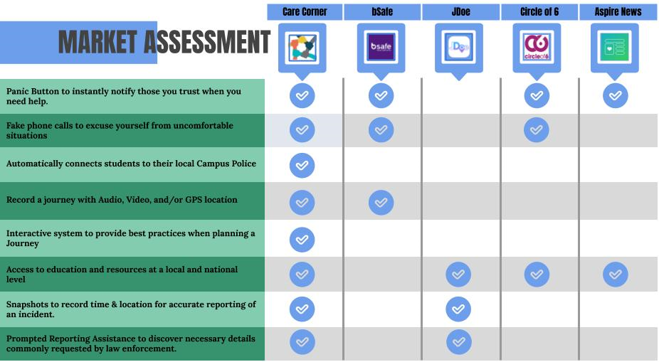

### **2.1 Key Product Features and Capabilities**

Care Corner offers a lot of solutions to aid in the safety of its users. The first of which is the Armed Journey Mode. In this mode the user's location and destination can be sent to select contacts in order to ensure friends and family are aware of the user's location. The user will have complete control over which contacts receive what information.

Care Corner also features a Fake Phone Call feature. This can be pre-programmed to occur at a specified time, or can be activated to use in real time. This feature is to be utilized by the userin excusing themselves from uncomfortable situations. It also puts the phone in a more alert state, in case an emergency happens.

While the phone is in Armed Journey mode, or in a fake phone call, the Panic Button feature can be activated. The Panic Button feature is to be used if the caller feels as though they are in any imminent danger. The user can preset what the activation of the Panic Button does. Activating the Panic Button can result in messaging pre-selected contacts, sending GPS location to pre-selected contacts, recording audio video or GPS location, noting the time and GPS location of the activation of the button, and offering Emergency Services contact information such as 911 or campus police.

Care Corner also looks to educate its users, so that they can make more informed decisions, and have direction in case an assault takes place. We offer a Mombot feature, which the user can verbally state that plans for the evening, and receive informative feedback in return. Mombit will also issue a battery warning, so the user may be reminded to charge their phone before starting their journey. Mombot also connects users to a plethora of resources, both local and national, that can assist with everything from shelter, to reporting and education.

In the case of an assault, Care Corner will assist with the reporting process. First, when the panic button is activated, the GPS location and time will be noted. This will be instrumental and Reporting exactly where and when and assault took place. Care corner will also prompt the user to note relevant information quickly, before the important details become lost in a user's memory.

### **2.2 Major Components (Hardware/Software)**

Care Corner is a mobile application, so the first required component to use if is a cell phone. Care Corner will be available on both Android and iOS platforms. Our server infrastructure will be supported entirely through Amazon Web Services(AWS.) The web server for the Care Corner site will be provided through the AWS- S3 web service. The database server will run on AWS- RDS (relational database) service using MYSQL. In the file server will be hosted through the AWS-FSx service.

The Care Corner website, which will serve as an information landing point about the app, will be constructed using a combination of HTML, CSS, JS, and PHP. The development of the app will take place primarily within the Windows operating system. The Care Corner team will utilize GitHub for development and software control. Gradle will be used as the primary build management tool, and the organization regarding the development of the app will be done in Jira.

Care Corner will also rely on certain external dependencies and APIs. The user's GPS location will be used in conjunction with the Google Maps API to geofence local resources for the user. Twilio service will be used to message users contacts in case a journey is started, or the panic button is activated. We will utilize web scraping and RSS feeds together resource information and educational information for the users.

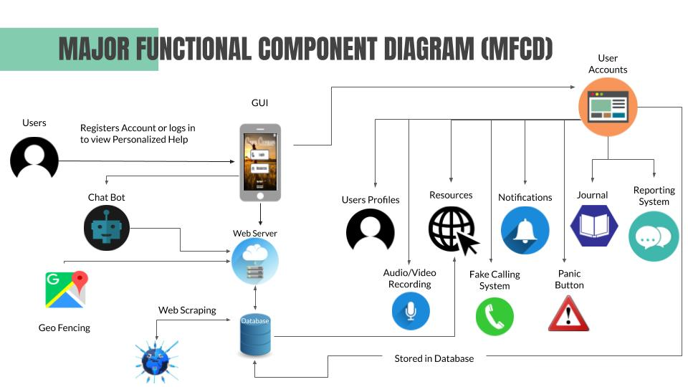

### **3. Identification of Case Study**

Care Corner was designed with the safety of women in mind, because the issue of sexual assault affects them at a higher rate than men. However, care corner is not designed for only women, instead it can be used by anyone who feels the need to take additional precautions in regards to their safety. The featured offered with Care Corner directly impact the users of Care Corner, but indirectly have a positive impact on the user's friends and family. As the user is safer, and more open about their safety, the comfort of their friends and family is increased as well.

Since care corner is a tool to Aid in the fight against assault, it can be used by professionals in related fields as another tool for their clients. This means entities like health organization or local authorities can offer this to those in need to assist.

### **4. Care Corner Product Prototype Description**

### **4.1 Prototype Architecture (Hardware/Software)**

### **4.2 Prototype Features and Capabilities**

### **4.3 Prototype Development Challenges**

### **5. Glossary**

**Amazon Web Services (AWS)**: Cloud computing platform provided by Amazon

**Android**:Mobile operating system primarily developed by Google

**API:** Application Programming Interface

**Database**: Structured data held in a computer

**File Server**:Controls access to separately stored files

**Geofencing**:Using GPS to create a virtual geographic boundary

**GitHub**: Web-based collaboration platform for software developers

**GPS:** Global positioning system

**Gradle**: Build automation tool for multi-language software development

**HTML**:Standard markup language for documents designed to be displayed in a web browser

**iOS**:Mobile operating system developed by Apple

**JS (JavaScript)**:Object-oriented computer programming language commonly used to create interactive effects within web browsers

**MySQL**: A freely available open source relational database management system that uses structured query language (SQL)

**PHP**:General-purpose scripting language suited to web development

**RSS** **Feed**: Set of instructions on the computer server of a Web site. The feed tells the reader when new material has been published on the Web site

**Scrum**: A process framework used to manage product development and other knowledge work

**Twilio**: A developer platform for communications

**Web Scraping**: Extracting/scraping data from websites

**Web Server**:A computer that runs websites

**Windows**: Series of operating systems developed by Microsoft

### 

### **6. References**

What Is Sexual Abuse?” Hope Alliance, www.hopealliancetx.org/sexual-assault-statistics/. (1)

“Support Groups.” MHA Screening - Mental Health America, screening.mhanational.org/content/support-groups. (2)

“The US System Didn't Protect These Women - so Now They're Taking a Stand for Others.” *Amnesty International*, [www.amnesty.org/en/latest/news/2019/10/gun-violence-report/.(3)](http://www.amnesty.org/en/latest/news/2019/10/gun-violence-report/.(22))